Kiro Robot Project
SO-101 Mobile Dual-Arm Robot
Electrical Power System Design, Schematics and Wiring Documentation

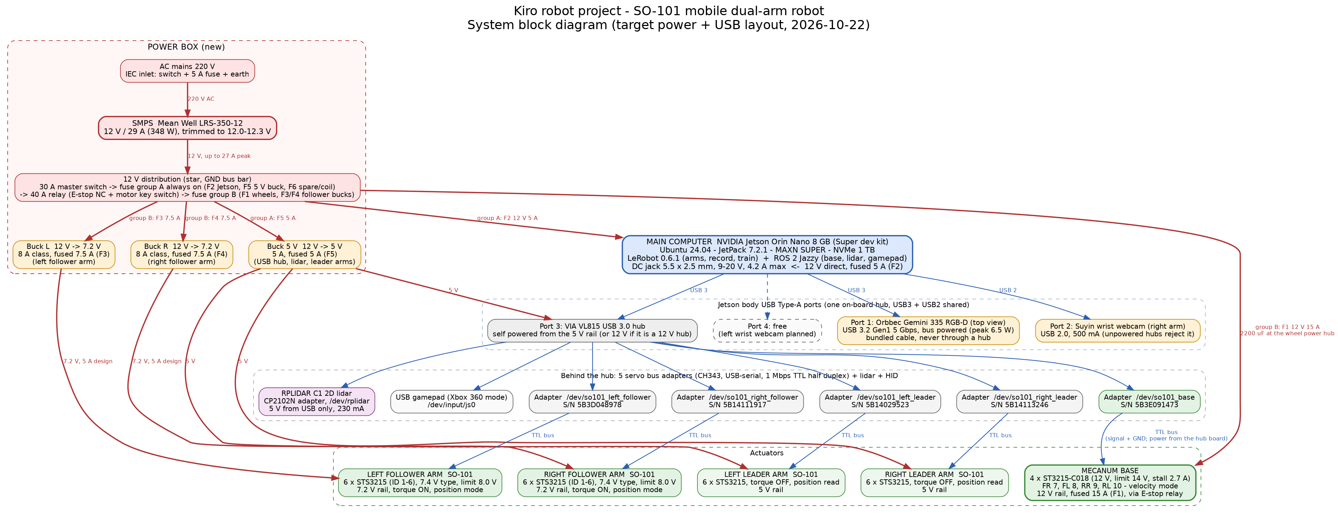
Figure 1: System block diagram (overview; the full-size drawing is in chapter 4)

Document | Power system design - SMPS + buck converter rewiring
Project | Kiro robot project (SO-101 mobile dual-arm robot on NVIDIA Jetson Orin Nano 8 GB)
Revision | Rev A (first issue)
Date | 2026-10-22
Author | Lee Sang-won (Donghwa University), prepared with Claude
Status | Design proposal - for review before purchasing and building
Companion files | context.docx, power_calculation.docx, parts_list.docx, README.docx; diagrams/ (schematic sheets 1-5 as PNG and SVG with schematic.py source; Graphviz block / power / wiring diagrams); images/web/ (reference photos with sources.json); markdown_source/

Contents

(In Microsoft Word: right-click the table of contents and choose "Update field", or press F9, to fill in the page numbers.)

1. Introduction

1.1 Purpose
This document is the complete electrical design package for rewiring the power system of the SO-101 mobile dual-arm robot built for the Kiro project. Today the robot runs from four or more separate wall adapters without fuses or an emergency stop. The new design replaces them with one mains switch-mode power supply (SMPS), three DC-DC buck converters, two fused distribution groups, a relay-based emergency stop and a defined harness.

1.2 Scope
- Project context, hardware inventory and the electrical rules learned so far (chapter 2).
- Load budget, rail design, SMPS and converter sizing, fuses, wire gauges, protections and the bring-up procedure (chapter 3).
- Electrical schematics (five sheets) with reference designators and ratings, reference designator list and net list (chapter 4).
- Harness and cable schedule, USB cabling, assembly notes (chapter 5).
- Parts list with specifications and sources (chapter 6).
- Image sources and licences, source documents and revision history (appendices).

1.3 How to read the drawings
Reference designators follow common electrical practice: PSU = power supply, F = fuse, SW = switch, K = relay, D = diode, U = converter module, C = capacitor, X = connector pair, J = jack or inlet, TB = terminal/bus bar, FB = fuse block, A = assembly (computer, adapter boards, hub), M = motor/servo, CAM = camera, B = sensor. Net names start with the voltage (+12V_WHEEL, +7V2_L, +5V_LOGIC); 0V is the common return at the GND bus bar TB1. Every power path carries its rating (voltage, current, fuse, wire gauge). Photos of typical parts are included to make the parts recognisable; they show representative products, not the exact purchased items.

1.4 Safety summary
- Follower arms must never receive 12 V. The follower servos alarm above 8.0 V. Their rails are 7.2 V and use a different connector (XT30) from the 12 V branches (XT60).
- Mains (220 V) is only present at the IEC inlet J1 and the SMPS AC terminals. Cover the AC terminals and earth the SMPS frame (FG).
- The E-stop SW4 removes power from the wheels and both follower arms. The Jetson, hub, lidar and leader arms stay on so the software can shut down cleanly. The follower arms go limp when power is cut.
- Set the SMPS and the three converters with a meter before any load is connected (chapter 3, section 10).
- All returns meet at TB1 (star ground). Never daisy-chain grounds through the servo boards or USB cables.

2. Project context and existing hardware
Written 2026-10-22 from the project records on this Jetson (~/so101 repository, its CLAUDE.md, docs/, the company handover package of 2026-10-15, and the Claude Code session history). Purpose of this folder: plan the rewiring of the robot's power system (one SMPS + buck converters instead of a pile of wall adapters) and give the company/students a clear picture of the machine.
Naming note: in the records "Kiro" (키로) is the company-side group for which the robot and the student curriculum are being prepared. The robot itself is called SO-101 mobile dual-arm robot in the repository and the handover documents. Both names refer to the same project.

1. What the project is
An XLeRobot-style mobile manipulator built around one NVIDIA Jetson Orin Nano 8 GB:
- two SO-101 leader arms (moved by hand) and two SO-101 follower arms (copy the leaders),
- a mecanum-wheel base driven by four Feetech ST3215-C018 bus servos,
- an Orbbec Gemini 335 RGB-D camera (top view) and a Suyin USB webcam on the right wrist,
- a Slamtec RPLIDAR C1 2D lidar (tested, not yet mounted),
- a USB gamepad for driving the base.
Use cases: leader-follower teleoperation, recording imitation-learning datasets (LeRobot 0.6.1, ACT policy), driving the base (ROS 2 Jazzy), and later autonomous navigation (SLAM / Nav2). The robot is also the platform for a student curriculum (교안) requested by the company; the students are meant to modify the data-collection and training parts of the code.

People and milestones
Date | Event
2026-09-07 | Dual-arm teleoperation working (one process per arm), udev fixed names, GUI control panel
2026-09-15 | AMR extension reviewed: mecanum + Gemini 335 + RPLIDAR C1 + ST3215-C018, LeRobot upgraded to 0.6.1
2026-09-16 | Wheel servos ID 7–10 assigned, wheel board registered as /dev/so101_base, 12 V 6 A bench adapter
2026-09-19 | Base mounted on chassis, 2-chain wiring, floor driving verified (forward, strafe, rotate), gamepad teleop
2026-10-12 | Progress report to the company, USB hub replaced by VIA VL815, arms confirmed running on 5 V
2026-10-15 | Technical handover package SO101_기술자료_2026-10-15.zip delivered (system, code, training, interfaces, Q&A)
2026-10-21 | Live demo for the company at 16:00, zero-base install of a spare Jetson, hardware test wizard, right-arm data collection prepared
2026-10-22 | This folder: power rewiring plan (SMPS + buck converters)

Owner/developer: 이상원 (Donghwa University, student researcher). Company side: Kiro (client group) and Indi Solution (curriculum coordinator). Standing project rules from the records: keep CLAUDE.md updated, commit helpful changes, never push (no remote), the user runs sudo steps themselves.

2. Hardware inventory (as of 2026-10-21)
Representative photos of the main components:
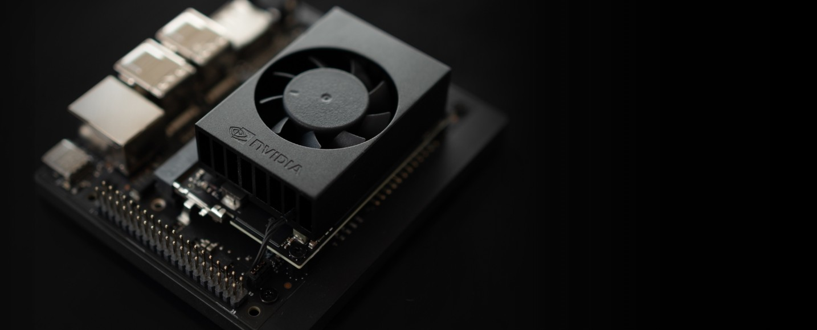
Figure 2: A1 - NVIDIA Jetson Orin Nano Super Developer Kit (main computer; DC jack 5.5 x 2.5 mm, 9-20 V)
Source: NVIDIA: Jetson Orin Nano Super Developer Kit page (cropped) - https://www.nvidia.com/content/dam/en-zz/Solutions/autonomous-machines/embedded-systems/nano-super-developer-kit/jetson-orin-nano-super-developer-kit-bbm-d.jpg (manufacturer product image (credited))
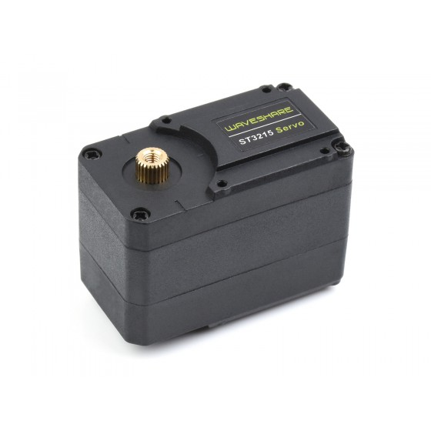
Figure 3: Feetech ST3215 / STS3215 bus servo (24 in the arms, 4 of the 12 V C018 type on the wheels)
Source: Waveshare product page: ST3215 servo - https://www.waveshare.com/media/catalog/product/cache/1/image/560x560/9df78eab33525d08d6e5fb8d27136e95/s/t/st3215-servo-1_5.jpg (manufacturer product image (credited))
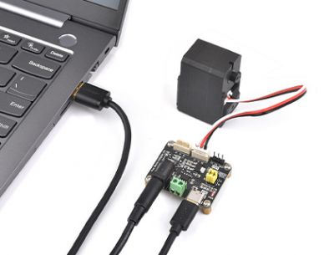
Figure 4: A3-A7 - Bus servo adapter board (CH343 USB-serial) with its DC jack, screw power terminal and 3-pin servo ports, shown with one servo
Source: Waveshare wiki: Bus Servo Adapter (A) interfaces - https://www.waveshare.com/w/upload/4/45/Bus_Servo_Adapter_%28A%29_B.jpg (manufacturer product image (used for documentation, credited))
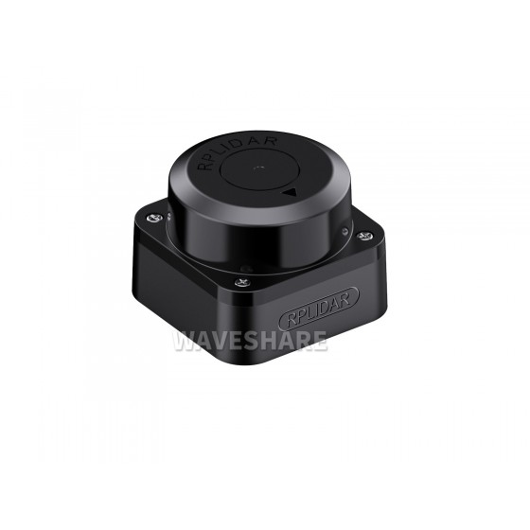
Figure 5: B1 - Slamtec RPLIDAR C1 2D lidar (5 V, 230 mA, USB powered through its CP2102N adapter)
Source: Waveshare product page: RPLIDAR C1 - https://www.waveshare.com/media/catalog/product/cache/1/image/560x560/9df78eab33525d08d6e5fb8d27136e95/r/p/rplidar-c1-1.jpg (manufacturer product image (credited))
Item | Model | Qty | Key facts | Identification
Main computer | NVIDIA Jetson Orin Nano Super Developer Kit, 8 GB | 1 | JetPack 7.2.1, Ubuntu 24.04, CUDA 13.2, power mode MAXN SUPER, Samsung 990 1 TB NVMe boot | bundled 19 V barrel adapter
Spare computer | Jetson Orin Nano dev kit (unopened) + 1 TB NVMe | 1 | zero-base install done 2026-10-21 via Jetson ISO | –
Follower arms | SO-101 Follower | 2 | 6 × STS3215 each (ID 1–6). 7.4 V type: Max_Voltage_Limit 8.0 V (register read). Run on 5 V so far (5.2–5.3 V measured) | /dev/so101_left_follower S/N 5B3D048978, /dev/so101_right_follower S/N 5B14111917
Leader arms | SO-101 Leader | 2 | 6 × STS3215 each, torque off, position read only. Mixed limits (ID 2 = 8.0 V, others 12.0 V) | /dev/so101_left_leader S/N 5B14029523, /dev/so101_right_leader S/N 5B14113246
Wheel servos | Feetech ST3215-C018 (12 V, 30 kg·cm, 1:345) | 4 | input 7.4–12.6 V nominal, Max_Voltage_Limit 14.0 V, stall 2.7 A each, velocity mode | IDs FR 7, FL 8, RR 9, RL 10 on /dev/so101_base S/N 5B3E091473
Servo bus adapters | CH343 USB-UART boards (USB 1a86:55d3, "USB Single Serial") – most likely Waveshare Bus Servo Adapter (A): 2 servo ports, DC jack 5.5×2.1 mm, screw power terminal | 5 | one adapter = one TTL half-duplex bus at 1 Mbps. Logic is USB powered; the power terminal only feeds the servo VCC pins | serial-number based udev links above
RGB-D camera | Orbbec Gemini 335 | 1 | USB 3.2 Gen1, bus powered, bMaxPower 896 mA, peak < 6.5 W, colour 1280×720 + depth 848×480 @ 30 fps | S/N CP0F46300035, fw 1.4.60, body port 1
Wrist camera | Suyin HD webcam (1e45:8022) | 1 (+1 planned left) | needs 500 mA; unpowered hubs reject it, body port works | body port 2
2D lidar | Slamtec RPLIDAR C1 + CP2102N adapter | 1 | 5 V, 230 mA / 1.15 W typical, UART 460800, /scan 10 Hz 720 pts | /dev/rplidar, on the hub
USB hub | VIA VL815 USB 3.0, self-powered (own adapter) | 1 | replaced a Genesys 05e3:0608 hub that failed to enumerate the serial boards | body port 3
Gamepad | cheap USB pad in Xbox 360 XInput mode (045e:028e) | 1 | /dev/input/js0; currently on the hub (worked after the VL815 swap) | –
Power (today) | 19 V Jetson adapter, 5 V adapter(s) for the arm boards, 12 V 6 A adapter for the wheel board, hub adapter | – | see section 3 | –

Servo joint order on every arm bus: 1 shoulder_pan, 2 shoulder_lift, 3 elbow_flex, 4 wrist_flex, 5 wrist_roll, 6 gripper. All servos are model 777 (STS3215 family), firmware 3.10, 4096 steps per turn, protocol 0 (little-endian).

3. Current power architecture (as-is, before rewiring)
Power is split into three buses plus the hub, each with its own wall adapter:
Bus | Current source | Load and measured values | Rules learned
Arm servos (4 arms, 24 servos) | 5 V adapter(s) into the arm boards' DC jacks | teleop works at 5 V, Present_Voltage 5.2–5.3 V | Followers must never see 12 V (limit 8.0 V). A 7.4 V supply gives more torque but was not required
Wheel servos (4) | 12 V 6 A adapter (bench use only) | no-load 46–176 mA per wheel, floor driving a few hundred mA per wheel, servo voltage 12.2–12.4 V, 27–30 °C | 4-wheel stall ≈ 10.8 A exceeds 6 A; a 12 V 10 A class supply or battery was already planned
Jetson | bundled 19 V adapter | MAXN SUPER mode | if the Jetson reboots when the camera is plugged, suspect the adapter first
USB hub | own adapter (voltage not recorded – check the label) | powers 5 serial boards' logic, lidar, gamepad, dongle | power the hub before plugging devices

Other electrical facts already established:
- All grounds are already common because every servo board and sensor is connected to the Jetson by USB.
- The servo connector is Molex 5264 (2.5 mm pitch) 3-pin, pin order GND / VCC / SIGNAL, contacts rated about 3 A with 22 AWG. Four wheel servos in one daisy chain would overload the first connector, so the base is wired as two chains: board port 1 → ID 7 (FR) → ID 9 (RR), board port 2 → ID 8 (FL) → ID 10 (RL).
- The adapter board's barrel jack is a 5 A class part; 10 A must go through the screw terminal, not the jack.
- A paper that ran XLeRobot on the same Orin Nano reported a brown-out (12.2 V collapsing to 0.3 V) when wheels, arms and Jetson shared one line, and fixed it by separating the buses.
- The lidar is 5 V only: never near 12 V wiring, sensor cable connected only with USB unplugged.
- Gemini 335 goes straight into a Jetson USB 3 port with the bundled cable; never through a hub or a charging cable.
- Software voltage guards: arm_tuck.py and the mode tester treat a servo voltage below 4.5 V as "power off" and refuse to move.
- No hardware emergency stop exists yet (listed as "planned" in the handover package).

USB layout (2026-10-21)
Jetson body port | Device
1 | Orbbec Gemini 335 (USB 3, 5 Gbps) – top view camera
2 | Suyin wrist webcam (right arm)
3 | VIA VL815 hub → 5 × CH343 servo boards, RPLIDAR C1 adapter, gamepad, keyboard dongle
4 | free

The four body ports share one on-board Realtek hub (USB 3 and USB 2 bandwidth shared).

4. Software that touches power or safety
- LeRobot 0.6.1 (venv ~/lerobot-venv): lerobot-teleoperate 60 Hz, lerobot-record 30 Hz; followers torque on, position mode, P16/I0/D32; gripper torque limited to 50 %. Torque is released on disconnect, so followers fall under gravity when stopped.
- ROS 2 Jazzy (~/ros2_ws, package so101_base): mecanum_base_node at 20 Hz; velocity limits 0.3 m/s and 1.5 rad/s; watchdog sends zero velocity 0.5 s after the last /cmd_vel; torque off on SIGINT; refuses to start if any wheel servo does not answer a ping.
- GUIs: control panel, servo tester (shows voltage, current, temperature live), mode tester (mode A record / mode B drive with pre-checks), hardware test wizard, camera test, record GUI.
- udev rules bind every serial board to its USB serial number, so USB ports can be moved freely.

5. Goal of the rewiring
- Replace the separate wall adapters with one mains SMPS and derive the other rails with buck converters.
- Give every rail a fuse, proper wire gauge and connectors, and a hardware E-stop for the motion rails.
- Supply the followers at their proper 7.4 V class voltage (set to 7.2 V) instead of 5 V, giving more torque while staying below the 8.0 V servo limit.
- Keep the Jetson, the hub, the lidar and the leaders on a rail that is not cut by the E-stop, so the computer survives a stop.
- Keep the design battery-ready: a 12 V main bus lets a regulated 12 V power station (XLeRobot uses an Anker SOLIX C300) replace the SMPS later without any other change.
The result of this task is in the companion files (all in this folder):
- Kiro_SO101_Power_System_Design_RevA.docx – the complete design package: context, calculations, schematics (5 sheets), designator and net lists, cable schedule, parts list, image sources
- context.docx, power_calculation.docx, parts_list.docx, README.docx – the individual documents as Word files
- diagrams/schematic_sheet1..5.png|svg – electrical schematics (sheet 1 AC input and distribution, 2 Jetson and follower rails, 3 logic rail, 4 wheel rail, 5 connector pinouts); source schematic.py (schemdraw)
- diagrams/block_diagram.png, power_diagram.png, power_diagram_tb.png, wiring_diagram.png – Graphviz overview diagrams with .dot sources
- images/web/ – downloaded reference photos with sources.json (origin and licence of every image)
- markdown_source/ – the original Markdown text of the documents

6. Things to confirm on the bench before building
- The exact model printed on the five servo adapter boards (assumed Waveshare Bus Servo Adapter (A)).
- The hub adapter's voltage and current (5 V or 12 V input?), to decide which rail feeds the hub.
- How many 5 V adapters are in use today for the arm boards, and their connector types (to reuse plugs).
- The bundled Jetson adapter rating (expected 19 V, about 45 W) for comparison with the 12 V feed.
- Cable lengths from the planned power box to each arm board, the wheel board and the Jetson.
- Robot mass with arms, to refine the wheel current estimate under load.
- Whether the left wrist camera will be added (one more 500 mA USB load on a body port).

7. Source documents (on the Jetson)
- ~/so101/CLAUDE.md – living project log (hardware table, AMR section, power notes, USB hub history)
- ~/so101/docs/handover/01_시스템_구성_및_운영_프로토콜.md – system configuration, power structure (2.3), USB (2.4), servo IDs and wiring (2.5), start/stop procedures (6.x)
- ~/so101/docs/handover/04_통신_인터페이스_및_포팅_규격.md – USB and servo bus protocol specifications
- ~/so101/docs/handover/05_기술_확인_QnA.md – answers to the company (camera path, "no STM32 board")
- ~/so101/docs/mecanum_base_assembly_refs.md – mecanum coupling references, connector ratings, 12 V supply and cable shopping list (2026-09-16)
- ~/so101/docs/wheel_servo_id_guide.md, docs/lidar_c1_test_guide.md, docs/gemini335_connection_guide.md – device-level power and safety notes
- ~/so101/docs/hw_test_guide_2026-10-21.md, docs/demo_runbook_2026-10-21.md – test and demo procedures
- Handover package on the Desktop: SO101_기술자료_2026-10-15.zip

3. Power system design and calculations
Written 2026-10-22. Companion to context.md. Numbers marked measured come from this robot, spec from manufacturer data, estimate from engineering judgement (stated how).

1. Architecture decision: one 12 V main bus
Option | Pros | Cons | Verdict
12 V SMPS main bus (chosen) | Wheels (largest load) and the Jetson (accepts 9–20 V) run directly with no converter. Only two 7.2 V rails and one 5 V rail need bucks. Drop-in compatible with a 12 V battery / power station later. Cheap, common parts | Higher bus current → thicker wire (12–14 AWG main run). Wheel stall transients appear on the same bus as the Jetson, so distribution must be star-wired and the SMPS must be stiff | Recommended
24 V SMPS main bus | Half the bus current | Every load needs a converter (19 V or 12 V for Jetson, 12 V 11 A for wheels, 7.2 V, 5 V); more parts, more loss, no direct battery path | Not needed
Keep separate adapters | Nothing to build | 4–5 mains adapters, no fusing, no E-stop, wheels under-powered (6 A) | Current state, to be replaced

Rails after rewiring:
Rail | Voltage | Source | Loads | Cut by E-stop?
R1 wheels | 12 V | SMPS direct | 4 × ST3215-C018 | yes
R2 Jetson | 12 V | SMPS direct | Jetson Orin Nano + its USB loads (Gemini, wrist cam, dongles) | no
R3 follower L | 7.2 V | buck L | left follower, 6 × STS3215 | yes
R4 follower R | 7.2 V | buck R | right follower, 6 × STS3215 | yes
R5 logic 5 V | 5 V | buck 5 V | VL815 hub (if it is a 5 V hub), lidar via hub, both leader arms' servo power | no

Why 7.2 V and not 7.4 V for the followers: the follower servos trip a voltage alarm above 8.0 V (Max_Voltage_Limit, measured). A 7.2 V set point leaves 0.8 V for converter tolerance, ripple and back-EMF when an arm is pushed by hand. 7.2 V is the usual "7.4 V class" operating level (2S Li-ion nominal).
Why the leaders stay on 5 V: torque is off, they only report positions, and 5 V operation is already proven on this robot. One fewer 7.2 V converter.

2. Load budget

2.1 Per device
Device | V | Typical | Design continuous | Peak | Basis
ST3215-C018 wheel servo (each) | 12 | 0.3 A | 1.5 A | 2.7 A stall | measured no-load 0.05–0.18 A, floor driving a few hundred mA; stall spec
STS3215 follower servo (each, 7.2 V) | 7.2 | 0.25 A | 0.8 A | ~2.5 A stall | spec no-load 0.15 A, stall ≈ 2 A @ 6 V (scaled to 7.2 V); holding under gravity estimate 0.2–0.5 A
STS3215 leader servo (each, torque off) | 5 | 0.04 A | 0.05 A | 0.1 A | estimate (logic + encoder only)
Jetson Orin Nano Super dev kit, MAXN SUPER | 12 | 20 W | 30 W | 36 W | spec: module up to 25 W + carrier/NVMe/fan
Orbbec Gemini 335 | 5 (USB) | 3 W | 3 W | 6.5 W | spec avg < 3 W, peak < 6.5 W; bMaxPower 896 mA measured
Suyin wrist webcam | 5 (USB) | 1.5 W | 2.5 W | 2.5 W | measured 500 mA descriptor
Dongles / mouse / keyboard | 5 (USB) | 0.3 W | 0.5 W | 0.5 W | estimate
VIA VL815 hub (own logic) | 5 | 0.5 W | 0.5 W | 1 W | estimate
CH343 servo adapter logic (each × 5, via hub) | 5 (USB) | 0.03 A | 0.05 A | 0.05 A | estimate
RPLIDAR C1 (via hub) | 5 (USB) | 0.23 A | 0.3 A | 0.5 A start | spec 230 mA / 1.15 W; start-up estimate
Gamepad (via hub) | 5 (USB) | 0.05 A | 0.1 A | 0.1 A | estimate

2.2 Per rail
Rail | Typical | Design continuous | Coincident peak | Notes
R1 wheels 12 V | 4 × 0.3 = 1.2 A (14 W) | 4 × 1.5 = 6 A (72 W) | 4 × 2.7 = 10.8 A (130 W) | peak = all four wheels stalled, e.g. pushing against an obstacle
R2 Jetson 12 V | 20 W + 5 W USB = 25 W → 2.1 A | 30 W + 6 W = 36 W → 3.0 A | 36 W + 9.5 W = 45 W → 3.8 A | Jetson dev kit jack rated 9–20 V, 4.2 A max (spec) → 50 W ceiling at 12 V, so 45 W peak fits
R3 follower L 7.2 V | 6 × 0.25 = 1.5 A (11 W) | 5 A (36 W) | 8 A burst (58 W) | design = 3 joints loaded + 3 holding; six simultaneous stalls (15 A) is not a design case, the buck's current limit handles it
R4 follower R 7.2 V | 1.5 A | 5 A | 8 A | same
R5 logic 5 V | hub 0.1 + boards 0.15 + lidar 0.23 + pad 0.05 + leaders 12 × 0.04 = 1.0 A (5 W) | 3 A (15 W) | 4 A (20 W) | pick a 5 A converter

Totals at the loads: typical ≈ 60 W, design continuous ≈ 195 W, coincident peak ≈ 300 W.

2.3 Referred to the 12 V bus (converter efficiency 90 %)
Branch | Typical | Design continuous | Peak
Wheels (direct) | 1.2 A | 6.0 A | 10.8 A
Jetson (direct) | 2.1 A | 3.0 A | 3.8 A
Buck L input (36 W / 0.9 / 12 V) | 1.0 A | 3.3 A | 5.4 A
Buck R input | 1.0 A | 3.3 A | 5.4 A
Buck 5 V input (15 W / 0.9 / 12 V) | 0.5 A | 1.4 A | 1.9 A
Total 12 V bus | 5.8 A (70 W) | 17 A (204 W) | 27 A (326 W)

3. SMPS selection
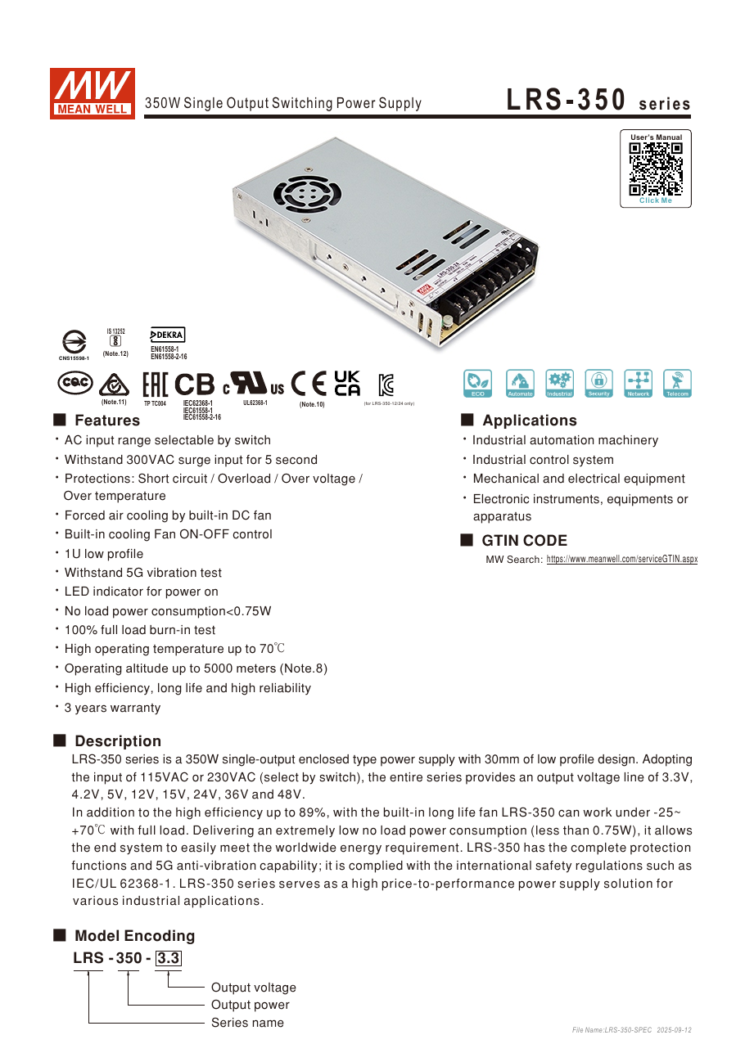
Figure 6: PSU1 - Mean Well LRS-350 series datasheet, page 1 (product photo, features, fan on/off control, protections)
Source: Mean Well LRS-350 series datasheet, page 1 - https://www.meanwell.com/Upload/PDF/LRS-350/LRS-350-SPEC.PDF (manufacturer datasheet (credited))
Requirement: 12 V, ≥ 17 A continuous, able to ride through ~27 A for a second or two, trimmable, mains 220 V.
Candidate | Rating | Fits? | Comment
Mean Well LRS-350-12 (chosen) | 12 V, 29 A, 348 W, 215 × 115 × 30 mm, 0.76 kg, built-in fan | continuous 59 %, worst-case peak 93 % | Headroom for every coincidence case, so no hiccup shutdowns. Fan noise only under heavy load. Adjustable 10.2–13.8 V
Mean Well LRS-200-12 | 12 V, 17 A, 204 W, fanless, 0.66 kg | continuous 100 %, peak 160 % | Works for typical operation but enters overload protection (hiccup) if wheels stall while the arms are working. Acceptable only if weight/noise matter more than margin
Mean Well LRS-150-12 (in the old shopping list) | 12 V, 12.5 A | no | Enough for the wheels alone, not for the whole robot
12 V 10 A barrel adapter (old plan) | 120 W | no | Wheels only; barrel jack is a 5 A class connector

Set the SMPS output to 12.0–12.3 V with the V-ADJ trimmer and a meter before connecting loads (the wheel servos tolerate up to 14 V, the Jetson up to 20 V, so 12.x V is safe on both direct rails).
Mains side: IEC C14 inlet module with switch and 5 A fuse, earth (FG) wired to the SMPS FG terminal, AC terminals covered. The LRS-350 draws a cold-start inrush of tens of amps for one cycle; a normal wall outlet handles it.

4. Converter selection
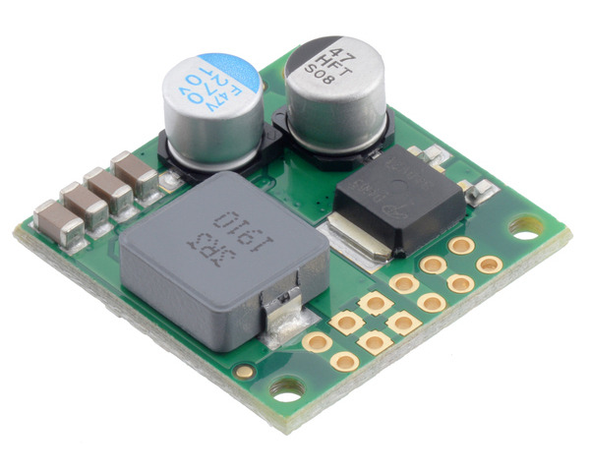
Figure 7: U1 / U2 quality option - Pololu D36V50F7 7.5 V 5 A step-down regulator (compact, current and thermal protection)
Source: Pololu product 4093 (D36V50F7 7.5 V 5 A step-down regulator) - https://a.pololu-files.com/picture/0J10725.600x480.jpg (manufacturer product image (used for documentation, credited))
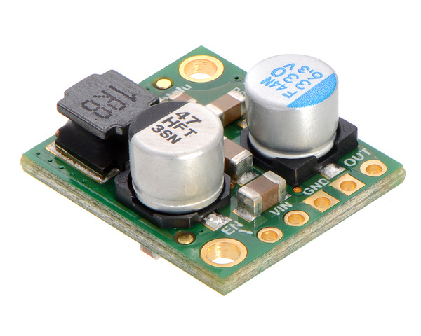
Figure 8: U3 option - Pololu D24V50F5 5 V 5 A step-down regulator
Source: https://www.pololu.com/product/2851 - https://a.pololu-files.com/picture/0J5851.600x480.jpg?d7ecfd2d1dd922f537ce44c02e13305b (manufacturer product image (used for documentation, credited))
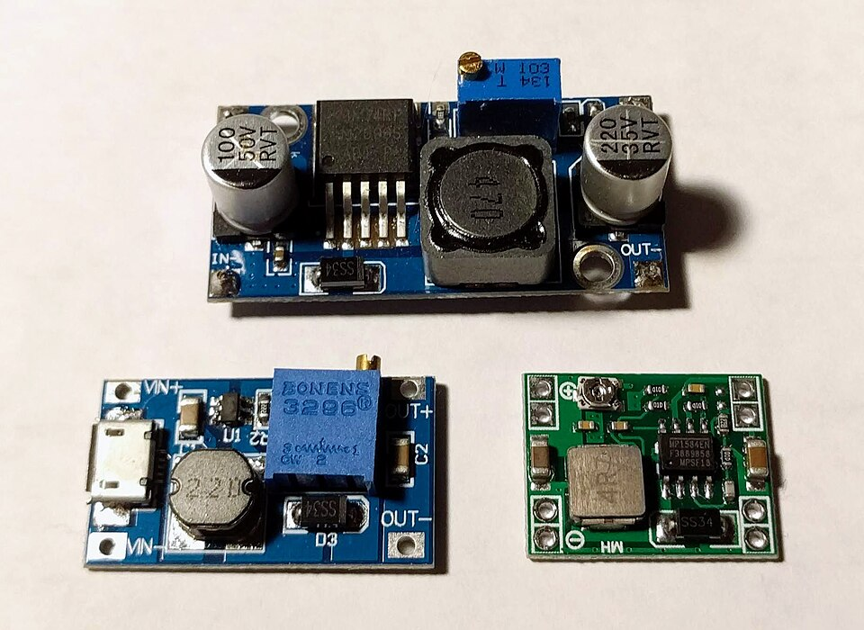
Figure 9: Typical small adjustable modules (LM2596, MP1584, SDB628). The LM2596 class (realistic 1.5-2 A) is too small for the 7.2 V follower rails; use an 8 A class synchronous module or the Pololu parts above
Source: Wikimedia Commons: File:LM2596 buck converter module, MP1584 buck converter module, and SDB628 boost converter module.jpg - https://upload.wikimedia.org/wikipedia/commons/6/66/LM2596_buck_converter_module%2C_MP1584_buck_converter_module%2C_and_SDB628_boost_converter_module.jpg?utm_source=commons.wikimedia.org&utm_campaign=imageinfo&utm_content=original (CC BY-SA 4.0, Matthew Berardi)

4.1 Follower rails (12 V → 7.2 V, two identical units)
Needs: 5 A continuous, 8 A short bursts, adjustable (or fixed 7.2–7.5 V), input 12 V, current limit. Output power 36 W design; at 90 % efficiency each buck dissipates ≈ 4 W → needs a heatsink or airflow.
Choice | Spec | Comment
Synchronous buck module, 8–12 A class, adjustable (e.g. "DC-DC 12 A / 300 W step-down" boards with a real heatsink, CC/CV versions are fine) | in 6–40 V, out 1.2–36 V, 8–12 A continuous with heatsink | Budget choice from Korean shops. Verify the output with a meter at no load and under load. Prefer a model with an output voltage lock (trimmer with glue or a fixed-resistor divider)
Pololu D36V50F7 (fixed 7.5 V) | in 8.3–50 V, 5 A at 36 V in, more at 12 V in, thermal and current protection | Compact, reliable, no trimmer to drift. 7.5 V is still 0.5 V below the 8.0 V limit. Good "quality" choice
XL4016-based "8 A" module | in 8–40 V, out 1.25–36 V, realistic 5–6 A with heatsink and fan, non-synchronous ~85 % | Cheapest; needs a fan for 5 A continuous. Acceptable fallback
LM2596 "3 A" modules | realistic 1.5–2 A | Too small

4.2 Logic rail (12 V → 5 V)
Needs: 5 A rated (3 A design). Choice: a sealed automotive-style 12 V → 5 V 5 A step-down module, or Pololu D24V50F5 (5 V, 5 A, in 6–38 V). Feed the hub's DC input and both leader boards' screw terminals. If the hub turns out to be a 12 V-input hub, feed it from a spare 12 V fuse instead and the 5 V rail only serves the leaders.

4.3 Not needed
- No converter for the Jetson: 12 V is inside its 9–20 V window. Optional upgrade if resets are ever seen: a 12 V → 15 V buck-boost (5 A) in front of the Jetson isolates it from bus sag.
- No converter for the wheels: 12 V direct.

5. Fuses, switch, E-stop
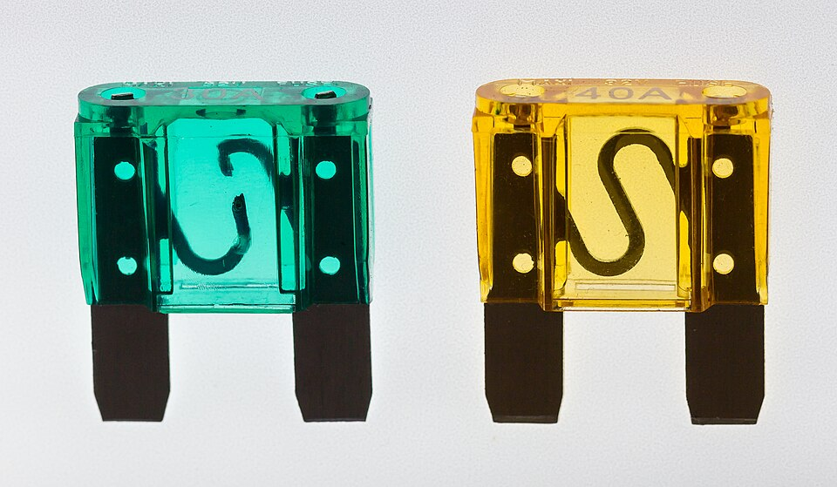
Figure 10: Automotive blade fuses (MAXI size shown; the branch fuses F1-F6 are the smaller ATO size, F7 may be ATO or MAXI). Colour codes the rating
Source: Wikimedia Commons: File:Kfz-Flachstecksicherung, Typ maxi-5427.jpg - https://upload.wikimedia.org/wikipedia/commons/9/92/Kfz-Flachstecksicherung%2C_Typ_maxi-5427.jpg?utm_source=commons.wikimedia.org&utm_campaign=imageinfo&utm_content=original (CC BY-SA 4.0, Raimond Spekking)
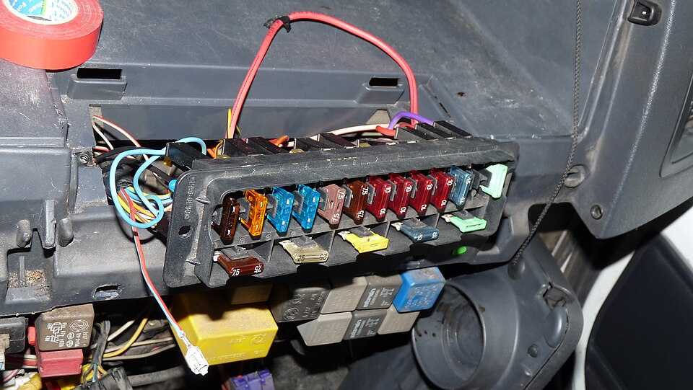
Figure 11: Blade fuses in an automotive fuse block - the same block type is used for FB1 (always on) and FB2 (relay switched)
Source: Wikimedia Commons: File:Blade fuses on Citroen Jumper.JPG - https://upload.wikimedia.org/wikipedia/commons/5/59/Blade_fuses_on_Citroen_Jumper.JPG?utm_source=commons.wikimedia.org&utm_campaign=imageinfo&utm_content=original (CC BY-SA 3.0, Dmitry G)
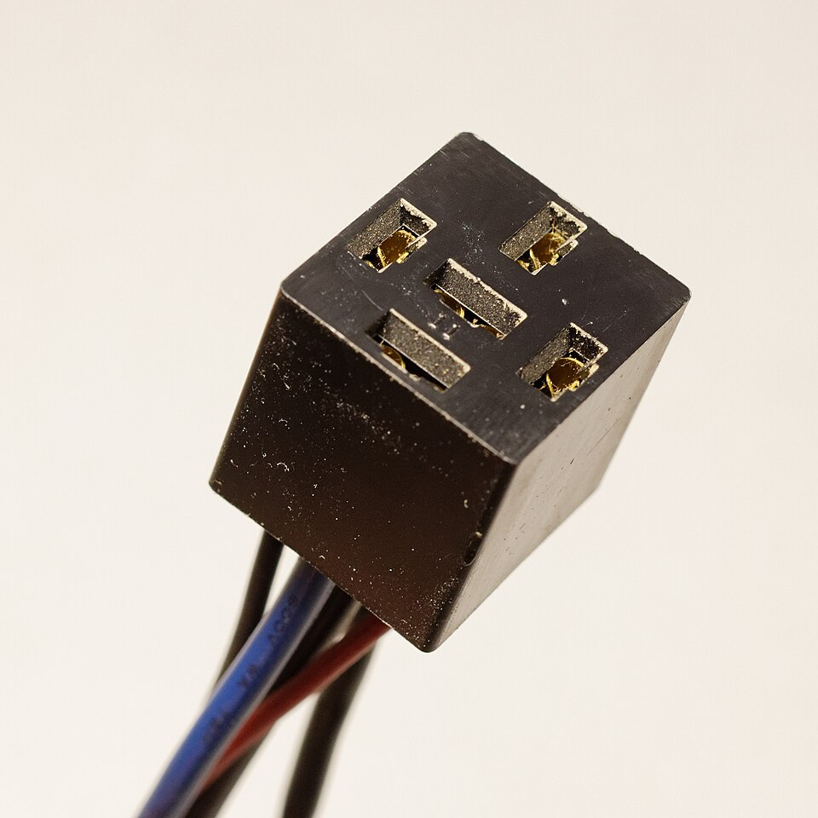
Figure 12: K1 - standard automotive relay socket (pins 30 / 87 / 85 / 86). Use a 40 A SPST relay with a 12 V coil
Source: Wikimedia Commons: File:Socket for automotive relays.jpg - https://upload.wikimedia.org/wikipedia/commons/4/40/Socket_for_automotive_relays.jpg?utm_source=commons.wikimedia.org&utm_campaign=imageinfo&utm_content=original (CC0, Retired electrician)
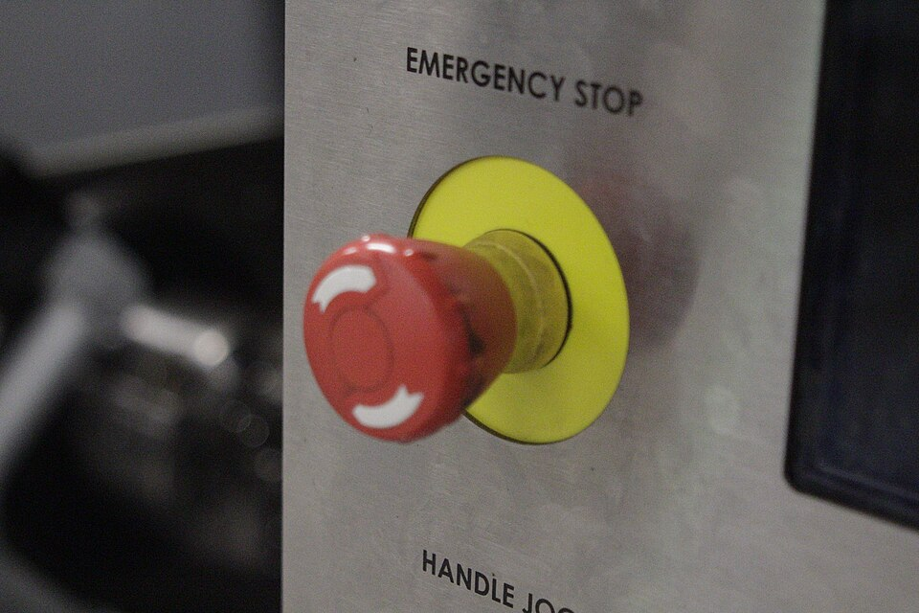
Figure 13: SW4 - mushroom-head emergency stop button (normally closed contact, twist to release) as used on machine tools
Source: Wikimedia Commons: File:Emergency stop button on a HAAS CNC.jpg - https://upload.wikimedia.org/wikipedia/commons/1/1a/Emergency_stop_button_on_a_HAAS_CNC.jpg?utm_source=commons.wikimedia.org&utm_campaign=imageinfo&utm_content=original (CC BY-SA 4.0, Flygklubben)
The 12 V bus is split into two blade (ATO) fuse groups right after the 30 A master switch (or 30 A DC breaker):
- Group A – always on (F2, F5, F6): Jetson, 5 V buck, spare / relay-coil feed.
- Group B – relay switched (F1, F3, F4): wheels and the two follower bucks. Its common bus is fed from the E-stop relay contact (pin 87).
Use two small fuse blocks, or one 12-way block with two independent positive inputs. Never join fused branches together after the fuses (that parallels the fuses and removes the per-branch protection).
Pos | Group | Branch | Fuse | Reason
F1 | B | Wheels 12 V | 15 A | 10.8 A worst case; 15 A allows a short all-wheel stall, still protects 14 AWG wire
F2 | A | Jetson 12 V | 5 A | 3.8 A peak, jack limit 4.2 A
F3 | B | Buck L input | 7.5 A | 5.4 A peak input
F4 | B | Buck R input | 7.5 A | 5.4 A peak input
F5 | A | Buck 5 V input | 5 A | 1.9 A peak; 5 A avoids nuisance trips on converter inrush
F6 | A | Spare (relay coil feed, 12 V hub or fan) | 3 A | coil draws 0.15 A
Main | – | SMPS → master switch → group A bus and relay pin 30 | 30 A | protects the 12 AWG main run; mandatory once a battery is used

E-stop: a mushroom head NC switch drives the coil of a 12 V automotive relay, 40 A (SPST, pins 30/87 power, 85/86 coil). Pin 30 comes from the master switch, pin 87 feeds the group B bus. The contact carries at most 10.8 + 5.4 + 5.4 ≈ 22 A, well inside 40 A. Pressing the E-stop drops the relay → wheels and both follower arms lose power. The Jetson, the hub, the lidar and the leaders (group A) stay on, so software keeps running and no file system is hurt. Coil circuit (0.15 A): F6 → motor key switch → E-stop NC contact → relay 86; relay 85 → GND bus. With the key off the motors are dead at power-up until the operator arms them. Note: cutting follower power makes the arms go limp; lower them or hold them before pressing in a non-emergency. A 1N4007 diode across the relay coil (cathode to 86) suppresses the coil spike.

6. Wire gauges and voltage drop
Copper resistance used: 12 AWG 5.2 mΩ/m, 14 AWG 8.3 mΩ/m, 18 AWG 21 mΩ/m, 20 AWG 33 mΩ/m, 22 AWG 53 mΩ/m. Drop is for the round trip (out and back).
Run | Current | Wire | Length (one way) | Drop
SMPS → master switch → group A bus / relay pin 30 | 27 A peak | 12 AWG (or 2 × 14 AWG on the SMPS' double terminals) | 0.3 m | 0.08 V
Relay pin 87 → group B bus | 22 A peak | 12 AWG | 0.2 m | 0.05 V
F1 → wheel power hub | 10.8 A peak | 14 AWG | 1.0 m | 0.18 V
Wheel power hub → each wheel servo | 2.7 A | 22 AWG (Molex 5264 limit) | ≤ 0.3 m | 0.09 V
F2 → Jetson barrel plug (5.5 × 2.5 mm, centre +) | 3.8 A | 18 AWG | 1.0 m | 0.16 V
F3/F4 → buck inputs | 5.4 A | 18 AWG | 0.5 m | 0.11 V
Buck output → follower board screw terminal | 8 A burst | 18 AWG | 0.5 m | 0.17 V
Follower board → servo chain | up to 8 A at the first link | 22 AWG pigtails, keep ≤ 0.3 m, two chains of 3 if the board has two ports | 0.3 m | 0.25 V
F5 → buck 5 V → hub / leader boards | 3 A | 20 AWG | 1.0 m | 0.20 V

All drops are below 0.3 V, i.e. invisible to the servos (they regulate their own motor drive) and to the Jetson.
Star grounding: bring every −V return to one bus bar next to the fuse block (the SMPS −V terminals). Do not daisy-chain grounds from board to board; the USB cables must not become the return path for motor current.

7. Connector plan
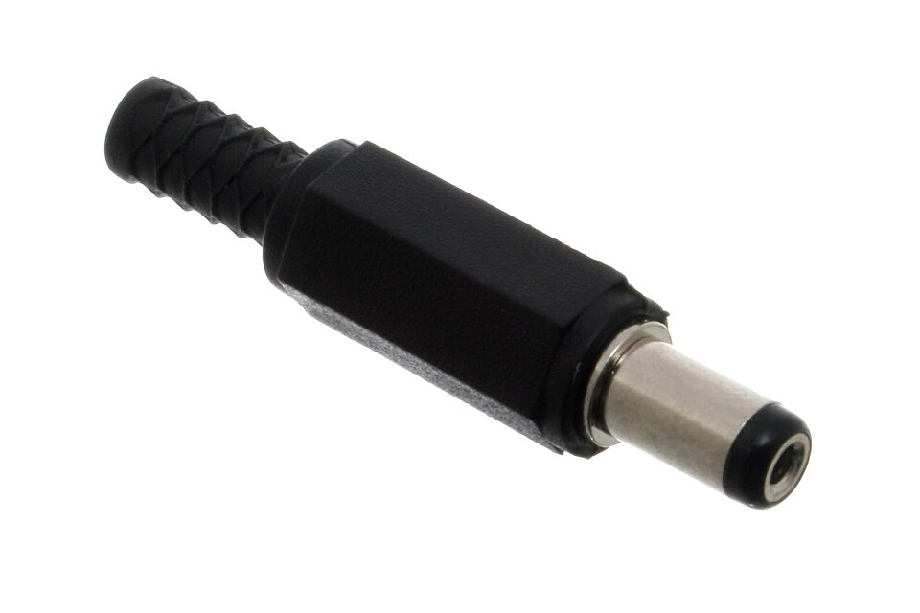
Figure 14: J2 - DC barrel plug (the Jetson needs the 5.5 x 2.5 mm size, centre positive; the 5.5 x 2.1 mm type shown fits the servo adapter jacks, which are not used for power in this design)
Source: Wikimedia Commons: File:2.1 mm DC Plug.jpg - https://upload.wikimedia.org/wikipedia/commons/3/3e/2.1_mm_DC_Plug.jpg?utm_source=commons.wikimedia.org&utm_campaign=imageinfo&utm_content=original (CC BY-SA 2.0, oomlout)
Where | Connector | Why
12 V branches (wheels, buck inputs) | XT60 | 60 A class, polarised, cheap
7.2 V and 5 V outputs to boards | XT30 | polarised, 30 A class, small
Jetson | 5.5 × 2.5 mm barrel plug, centre positive, strain relieved | matches the dev kit jack
Servo adapter boards | existing screw power terminal (not the barrel jack) | jack is a 5 A part
Servos | Molex 5264 3-pin, 22 AWG pre-crimped leads, pin order GND / VCC / SIG | reverse polarity damages servos; keep the factory orientation
Wheel power hub (recommended) | small board with 4 × Molex 5264 wafers in parallel on an 18 AWG bus, one signal-only pigtail (GND + SIG, VCC pin removed) to the servo board | gives each wheel its own power lead, so no 5264 contact carries more than one servo; the board carries only signal

If the wheel power hub is skipped, keep today's two chains (port 1 → 7 → 9, port 2 → 8 → 10). The first connector of each chain then sees up to 5.4 A at stall for a short time; acceptable but not ideal.

8. Protections and decoupling
- Bulk capacitor at the wheel power hub: 2200 µF / 25 V low-ESR electrolytic across 12 V / GND. Absorbs stall transients and regenerative energy when the robot is pushed.
- Bulk capacitor at each follower board: 1000–2200 µF / 16 V across the 7.2 V terminal. A pushed follower arm back-drives its servos and pumps the rail up; a buck cannot sink current, so the capacitor plus the 0.8 V margin keep the rail under 8.0 V. Optional extra: a 9.1 V 5 W zener or SMBJ8.0A TVS as a clamp.
- Reverse polarity: XT30/XT60 are keyed; still mark + leads red, − black everywhere.
- SMPS: built-in overload (hiccup), over-voltage and over-temperature protection.
- Thermal: mount both 7.2 V bucks and the 5 V buck on a metal plate or heatsink with airflow; the SMPS fan needs 2 cm of free air at both ends. Keep the power box away from the lidar head.
- Power-up order: mains on → SMPS 12 V → Jetson boots, 5 V rail up (hub, lidar, leaders) → wait for the desktop → motor key switch on, E-stop released → run software. Shutdown: stop software (torque off) → motor key off → shut down the Jetson → mains off.

9. Battery path (later)
The 12 V bus is chosen so a battery can replace the SMPS at the master switch:
Option | Fit | Caveat
Regulated 12 V portable power station (e.g. Anker SOLIX C300 as used by XLeRobot, 12 V / 10 A DC out) | easy, regulated, built-in BMS and charger | 10 A limit → wheels and arms cannot peak together; fine for demos
3S Li-ion / LiPo pack (12.6 V full, 9.0 V empty) with a 40 A BMS | direct | sags to 9 V near empty (Jetson minimum 9 V); add a low-voltage alarm
4S LiFePO4 (14.6 V full, 12.8 V nominal) | best energy, flat curve | 14.6 V exceeds the wheel servo 14.0 V limit right after charging → needs a 12 V regulator or a lower charge cut-off

Energy estimate for a 30 min demo at the typical 70 W: 35 Wh; at the design 200 W continuous: 100 Wh. A 300 Wh power station gives 1.5–4 h.

10. Bring-up checklist
- Wire the AC side, SMPS, master switch, fuse block and bus bar. No loads yet. Power on, set 12.0–12.3 V.
- Connect the bucks with no load. Set buck L and buck R to 7.20 V, buck 5 V to 5.0–5.1 V. Lock the trimmers.
- Fit fuses F2 and F5 only. Connect the Jetson and the hub. Boot, check nvidia-smi/desktop, check hub devices (lsusb -t).
- Fit F3/F4. Connect the follower boards. Open the servo tester: each follower servo should read 7.1–7.3 V, no alarms. Run the left/right teleop for a minute, watch temperatures.
- Fit F1. Connect the wheel board / wheel hub. Servo tester: wheels 12.0–12.4 V. Run mecanum_test.py with the robot on blocks, then on the floor. Measure wheel currents in the tester during a push-stall (expect ≤ 2.7 A each).
- Press the E-stop while driving: wheels and followers must stop, Jetson and lidar must stay up. Release, re-arm with the key.
- Clamp-meter the SMPS output during the full demo sequence; note the peak for the record.
- Update ~/so101/CLAUDE.md power section with the final set points and measurements.

4. Electrical schematics
The schematic is drawn on five sheets. Sheet 1 covers the mains input, the SMPS, the 12 V distribution with both fuse groups and the E-stop control circuit. Sheet 2 covers the Jetson supply and the two 7.2 V follower-arm rails, sheet 3 the 5 V logic rail (USB hub, lidar, leader arms), sheet 4 the 12 V wheel rail, and sheet 5 lists connector pinouts and terminal assignments. Nets that leave a sheet end in an open circle with the net name and the destination sheet. Vector versions (SVG) and the drawing source (schematic.py, schemdraw) are in the diagrams folder.
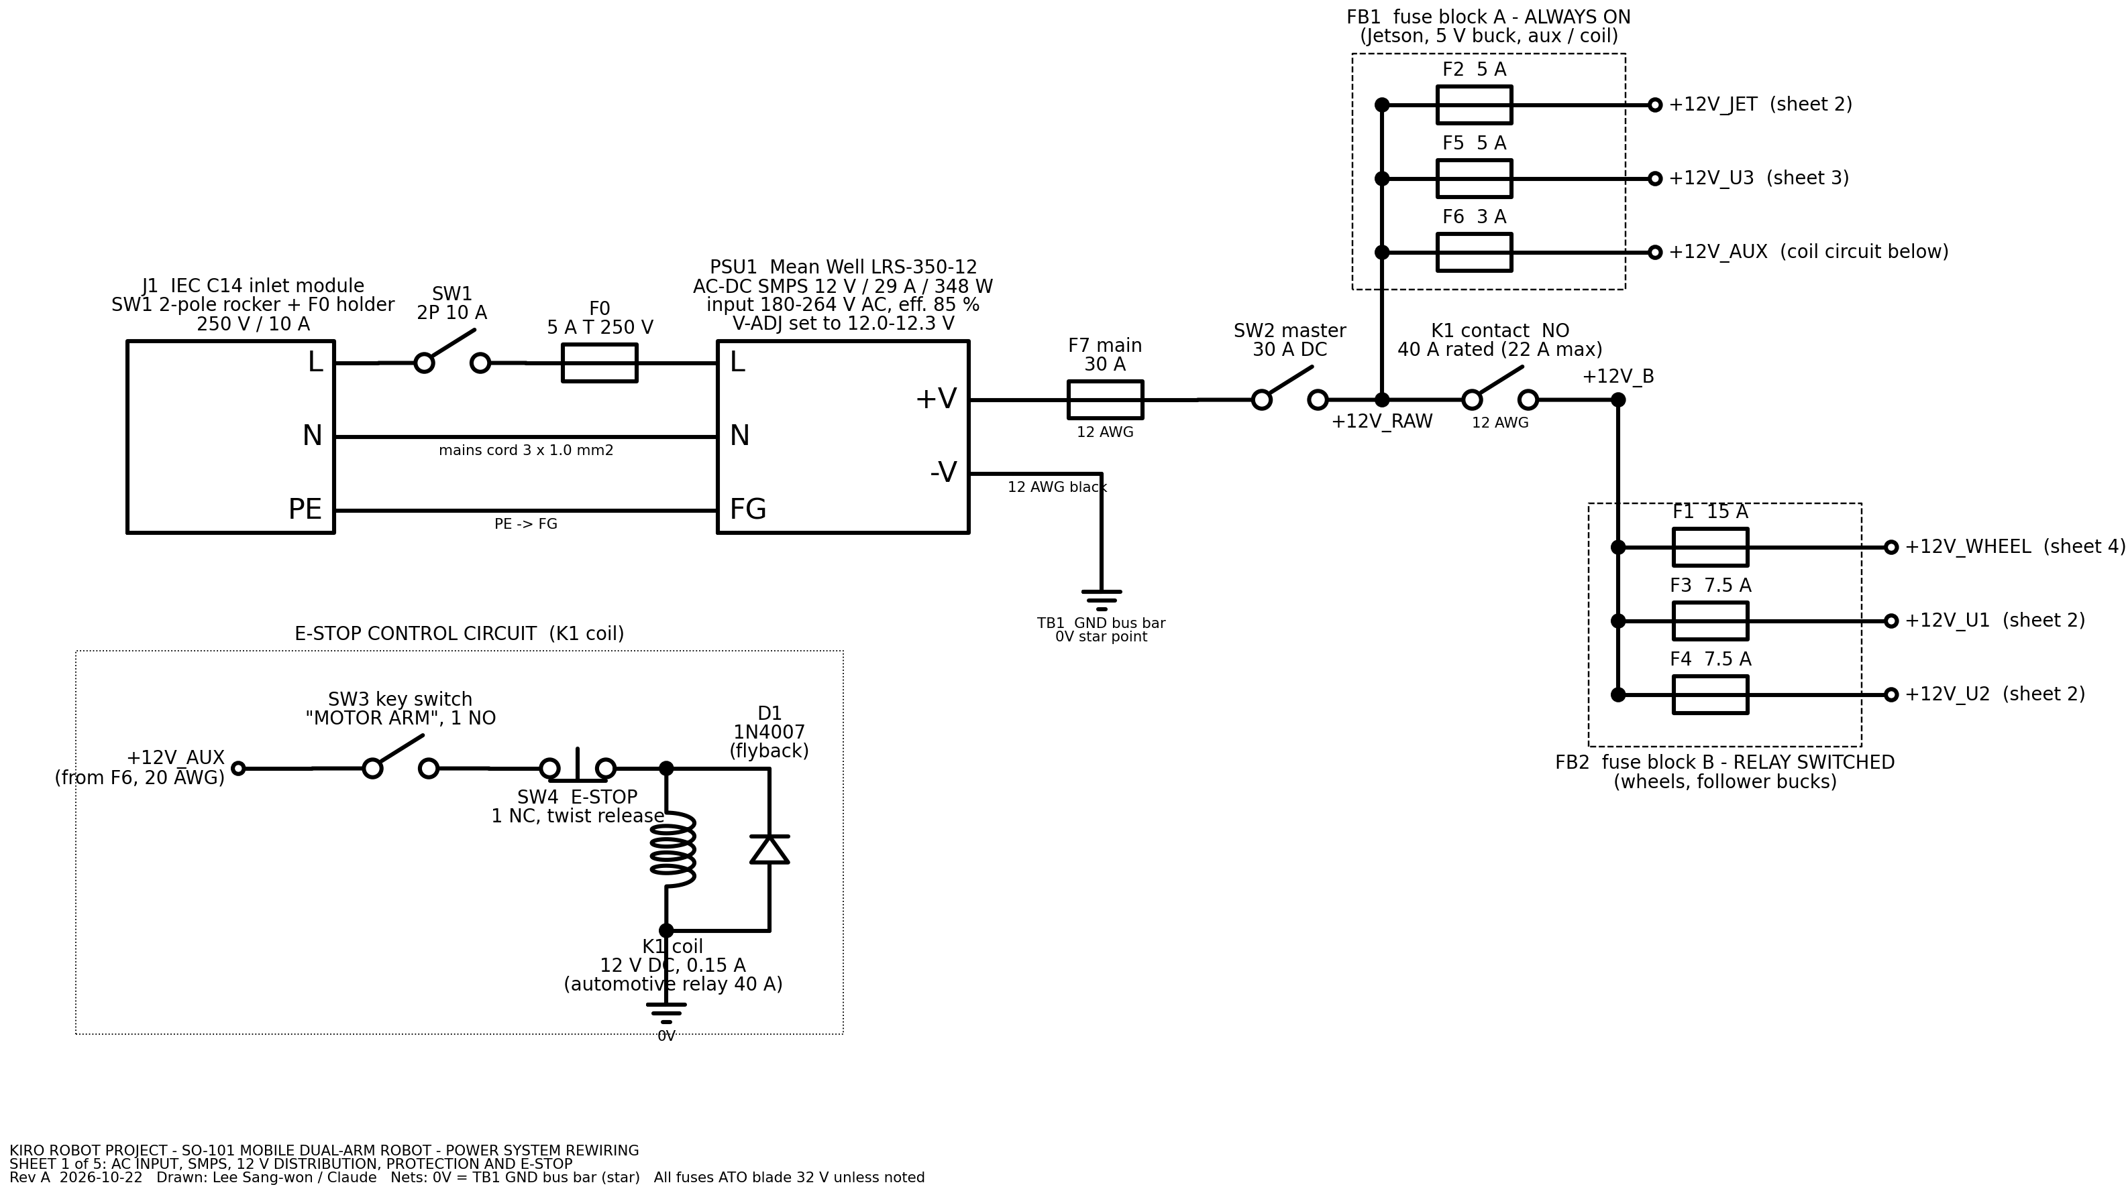
Figure 15: Schematic sheet 1 of 5 - AC input J1, SMPS PSU1, main fuse F7, master switch SW2, fuse groups FB1 (always on) and FB2 (relay switched), relay K1 and E-stop control circuit SW3 / SW4 / D1
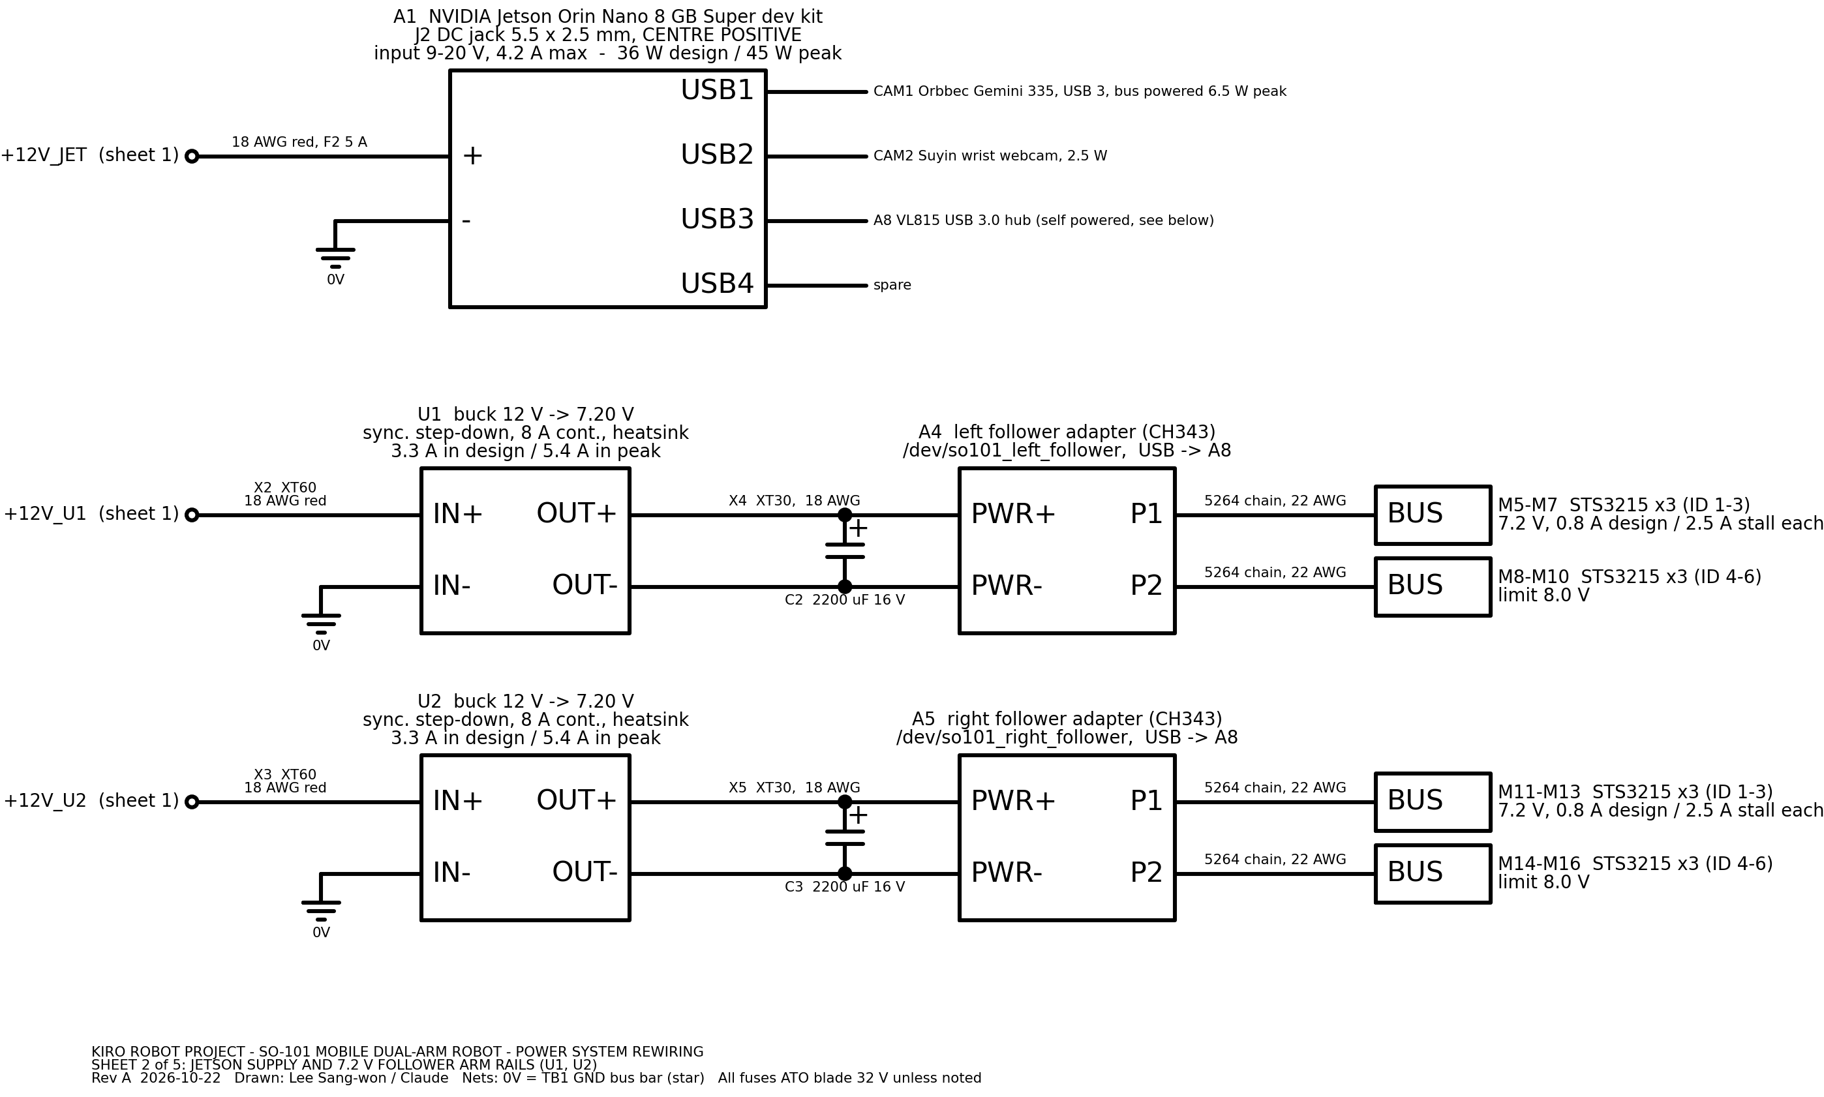
Figure 16: Schematic sheet 2 of 5 - Jetson A1 on +12V_JET; buck converters U1 / U2 (7.20 V), capacitors C2 / C3, follower adapters A4 / A5 and follower servo chains M5-M16
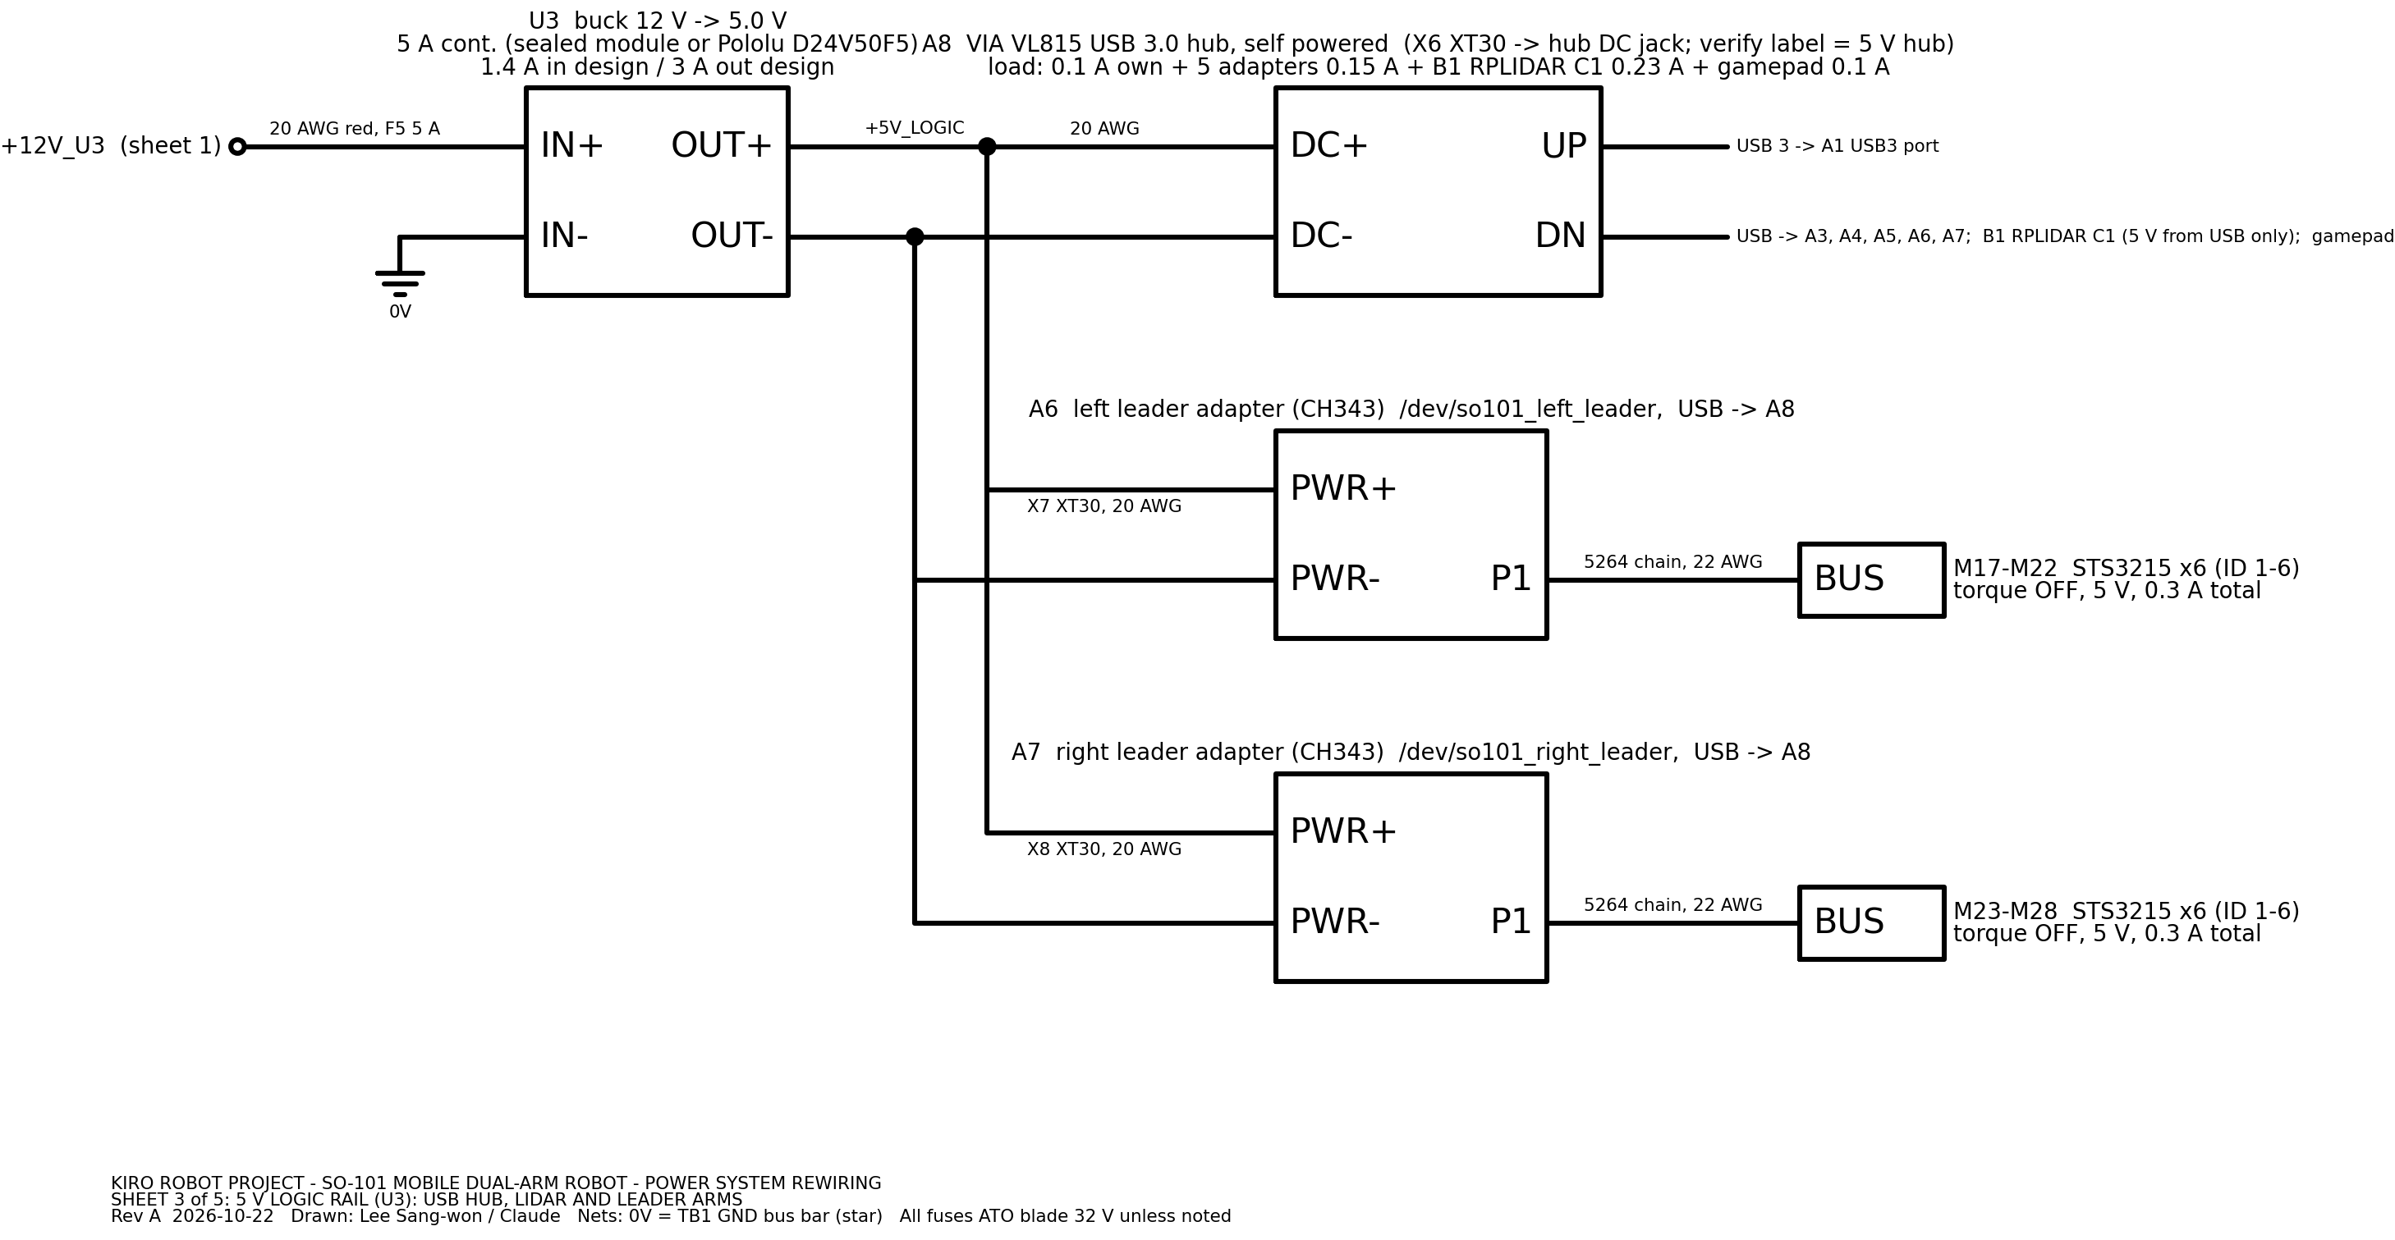
Figure 17: Schematic sheet 3 of 5 - buck converter U3 (5.0 V), USB hub A8, leader adapters A6 / A7 and leader servos M17-M28
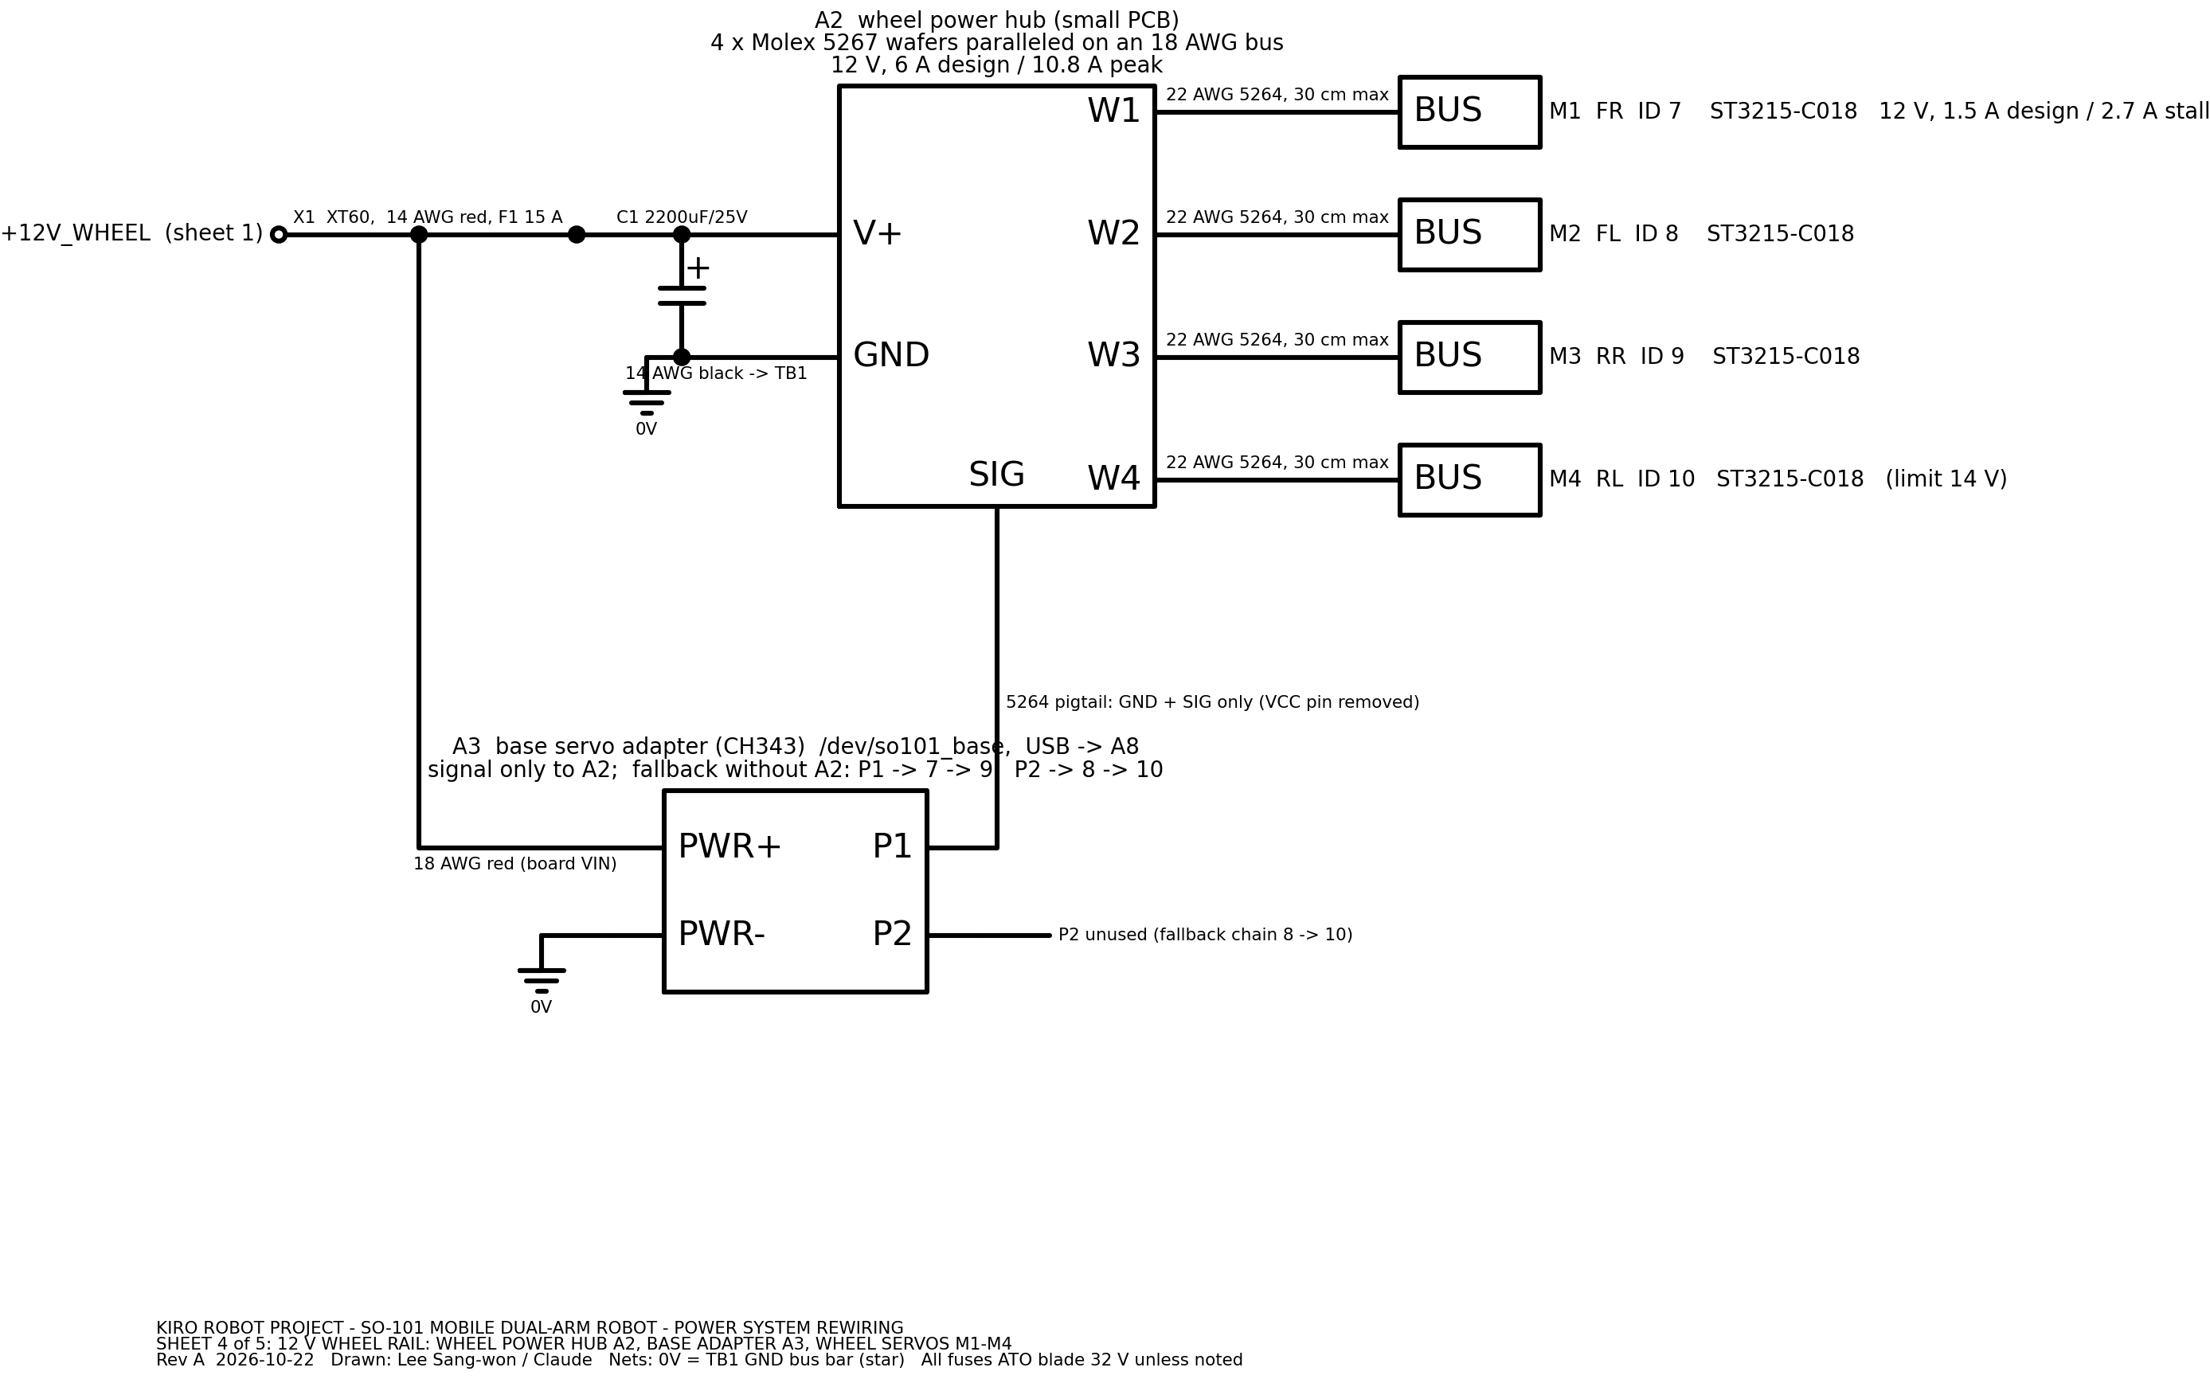
Figure 18: Schematic sheet 4 of 5 - wheel rail +12V_WHEEL: wheel power hub A2 with C1, base servo adapter A3 (signal only), wheel servos M1-M4
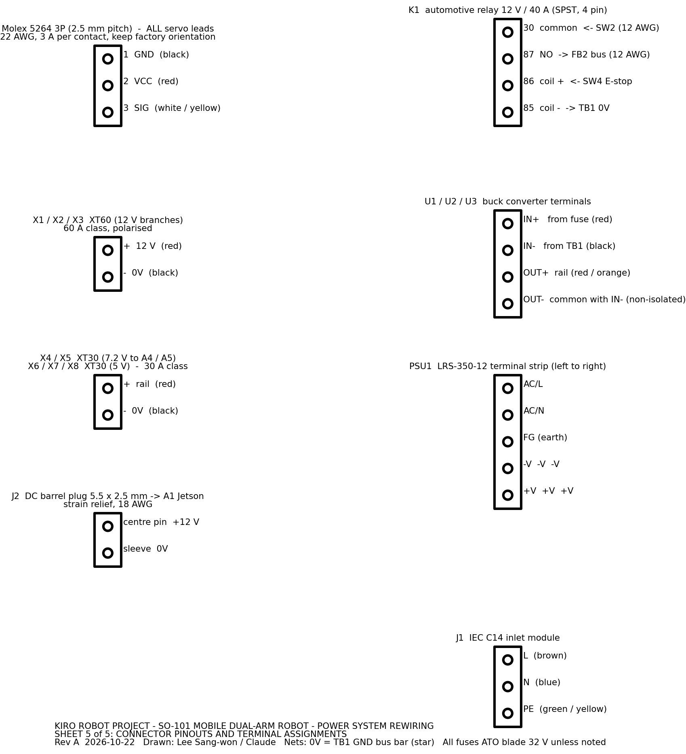
Figure 19: Schematic sheet 5 of 5 - connector pinouts and terminal assignments (Molex 5264, XT60, XT30, J2, K1, U1-U3, PSU1, J1)

4.1 Overview diagrams
Figure 20: System block diagram: power box, Jetson, USB tree, servo adapters and actuators (Graphviz)

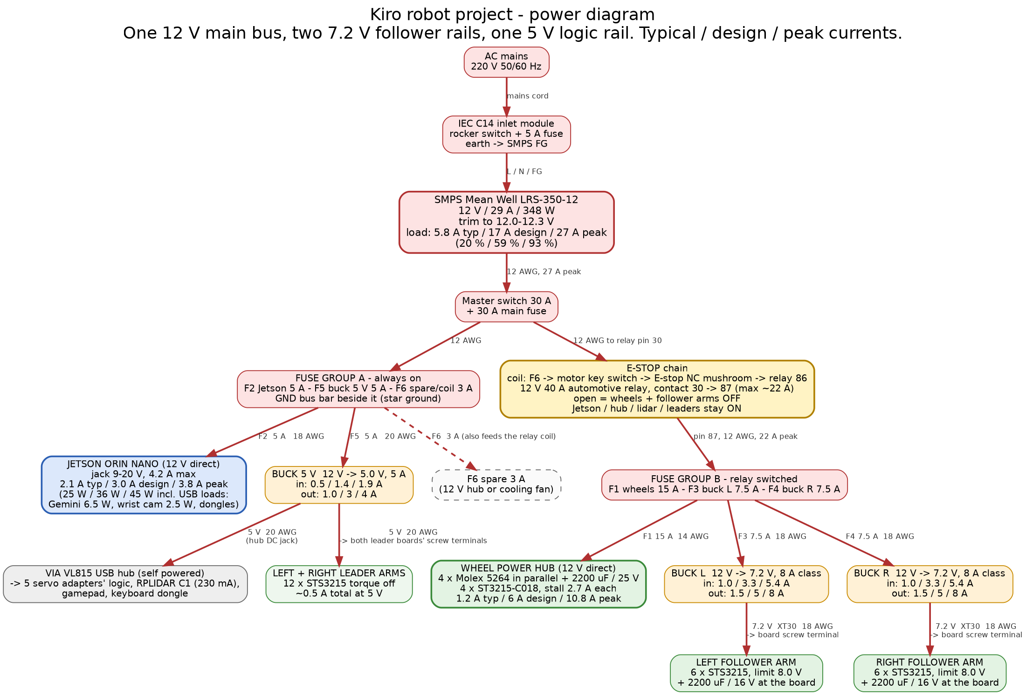
Figure 21: Power tree with typical / design / peak currents per branch (Graphviz). A terminal-level Graphviz wiring overview, wiring_diagram.png, is also in the diagrams folder

4.2 Reference designator list
Table 1: Reference designators, descriptions and ratings
Designator | Description | Rating / key spec | Qty
J1 | IEC C14 inlet module with 2-pole rocker switch SW1 and fuse holder F0 | 250 V AC, 10 A | 1
F0 | AC fuse, 5 x 20 mm glass, slow blow | 5 A T, 250 V | 1 (+2 spare)
PSU1 | Mean Well LRS-350-12 enclosed SMPS, trimmed to 12.0-12.3 V | 12 V, 29 A, 348 W; input 180-264 V AC | 1
F7 | Main DC fuse, blade (ATO or MAXI), inline holder | 30 A, 32 V | 1 (+1 spare)
SW2 | Master switch, DC rated rocker or DC breaker | 30 A DC | 1
TB1 | GND bus bar, 0V star point | >= 30 A, 6-8 screw positions | 1
FB1 | Blade fuse block, group A (always on): F2, F5, F6 | ATO, 3-4 positions, 30 A bus | 1
FB2 | Blade fuse block, group B (relay switched): F1, F3, F4 | ATO, 3-4 positions, 30 A bus | 1
F1 | Wheel branch fuse (+12V_WHEEL) | 15 A ATO | 1
F2 | Jetson branch fuse (+12V_JET) | 5 A ATO | 1
F3 | Buck U1 input fuse (+12V_U1) | 7.5 A ATO | 1
F4 | Buck U2 input fuse (+12V_U2) | 7.5 A ATO | 1
F5 | Buck U3 input fuse (+12V_U3) | 5 A ATO | 1
F6 | Aux / relay coil feed fuse (+12V_AUX) | 3 A ATO | 1
K1 | Automotive relay, SPST NO, 12 V coil, pins 30/87/85/86 | 40 A contact (22 A max in service), coil 0.15 A | 1
D1 | Flyback diode across K1 coil, cathode to pin 86 | 1N4007 (1 A, 1000 V) | 1
SW3 | Key switch "motor arm" | 1 NO, >= 1 A | 1
SW4 | Emergency stop, 22 mm mushroom head, twist to release | 1 NC (2 NC preferred), coil circuit 0.15 A | 1
U1 | Buck converter, left follower rail | 12 V -> 7.20 V, >= 8 A continuous, heatsink | 1
U2 | Buck converter, right follower rail | 12 V -> 7.20 V, >= 8 A continuous, heatsink | 1
U3 | Buck converter, logic rail | 12 V -> 5.0 V, 5 A | 1
C1 | Electrolytic capacitor on wheel power hub A2 | 2200 uF, 25 V, low ESR, 105 C | 1
C2, C3 | Electrolytic capacitors at A4 / A5 PWR terminals | 2200 uF, 16 V, low ESR | 2
X1 | XT60 pair, +12V_WHEEL to A2 | 60 A class, polarised | 1
X2, X3 | XT60 pairs, +12V_U1 / +12V_U2 to U1 / U2 inputs | 60 A class | 2
X4, X5 | XT30 pairs, +7V2_L / +7V2_R to A4 / A5 | 30 A class | 2
X6, X7, X8 | XT30 pairs, +5V_LOGIC to A8 / A6 / A7 | 30 A class | 3
J2 | DC barrel plug 5.5 x 2.5 mm, centre positive, with 18 AWG lead, to A1 | 5 A class | 1
A1 | NVIDIA Jetson Orin Nano 8 GB Super developer kit (MAXN SUPER) | input 9-20 V, 4.2 A max; 36 W design, 45 W peak incl. USB loads | 1
A2 | Wheel power hub PCB: 4 x Molex 5267 3-pin wafers paralleled on 18 AWG bus + C1 | 12 V, 15 A bus | 1
A3 | Base servo bus adapter (CH343, USB 1a86:55d3), /dev/so101_base | USB 2.0; VIN 12 V; signal-only pigtail to A2 | 1
A4, A5 | Follower servo bus adapters, /dev/so101_left_follower, /dev/so101_right_follower | USB 2.0; VIN 7.2 V | 2
A6, A7 | Leader servo bus adapters, /dev/so101_left_leader, /dev/so101_right_leader | USB 2.0; VIN 5 V | 2
A8 | VIA VL815 USB 3.0 hub, self powered (2109:0815 / 2815) | DC input 5 V (verify adapter label), <= 3 A | 1
M1-M4 | Feetech ST3215-C018 wheel servos: M1 FR ID 7, M2 FL ID 8, M3 RR ID 9, M4 RL ID 10 | 12 V (7.4-12.6 V), limit 14 V, stall 2.7 A, 30 kg.cm, 1:345 | 4
M5-M16 | Feetech STS3215 follower servos (7.4 V type), ID 1-6 per arm | 7.2 V, limit 8.0 V, stall ~2.5 A, idle 0.15 A | 12
M17-M28 | Feetech STS3215 leader servos, ID 1-6 per arm, torque off | 5 V, ~0.04 A each | 12
CAM1 | Orbbec Gemini 335 RGB-D camera, A1 USB1 | USB 3.2 Gen1, bus powered, 896 mA descriptor, 6.5 W peak | 1
CAM2 | Suyin HD wrist webcam (1e45:8022), A1 USB2 | USB 2.0, 500 mA | 1
B1 | Slamtec RPLIDAR C1 + CP2102N adapter, via A8, /dev/rplidar | 5 V from USB only, 230 mA (1.15 W) | 1

4.3 Net list
Table 2: Net list
Net | Voltage | Source | Loads / destinations | Protection | Wire
AC_L / AC_N / PE | 230 V AC | J1 (via SW1, F0) | PSU1 L / N / FG | F0 5 A T | 1.0 mm2 brown / blue / green-yellow
+12V_RAW | 12.0-12.3 V | PSU1 +V via F7, SW2 | FB1 bus, K1 pin 30 | F7 30 A | 12 AWG red
+12V_B | 12 V, switched | K1 pin 87 | FB2 bus | K1 40 A | 12 AWG red
+12V_JET | 12 V | FB1 F2 | A1 Jetson via J2 | F2 5 A | 18 AWG red
+12V_U3 | 12 V | FB1 F5 | U3 IN+ | F5 5 A | 20 AWG red
+12V_AUX | 12 V | FB1 F6 | SW3 -> SW4 -> K1 86 (coil); optional 12 V hub / fan | F6 3 A | 20 AWG red
+12V_WHEEL | 12 V, switched | FB2 F1 | A2 V+ (via X1), A3 PWR+, C1 | F1 15 A | 14 AWG red; A3 feed 18 AWG
+12V_U1 | 12 V, switched | FB2 F3 | U1 IN+ (via X2) | F3 7.5 A | 18 AWG red
+12V_U2 | 12 V, switched | FB2 F4 | U2 IN+ (via X3) | F4 7.5 A | 18 AWG red
+7V2_L | 7.20 V | U1 OUT+ | A4 PWR+ (via X4), C2, M5-M10 | U1 current limit | 18 AWG red / orange
+7V2_R | 7.20 V | U2 OUT+ | A5 PWR+ (via X5), C3, M11-M16 | U2 current limit | 18 AWG red / orange
+5V_LOGIC | 5.0 V | U3 OUT+ | A8 DC in (X6), A6 PWR+ (X7), A7 PWR+ (X8); B1 and adapters through USB | U3 current limit | 20 AWG red
K1_COIL | 12 V / 0V | SW4 NC contact 2 | K1 86, D1 cathode | - | 20 AWG
0V | 0 V | PSU1 -V | TB1 bus bar; all returns; USB shields via A1 | - | 12 / 14 / 18 / 20 AWG black

5. Harness, cable schedule and assembly

5.1 Power cable schedule
Lengths are estimates for a power box mounted on the chassis under the arms; measure on the robot before cutting. Colours: red = positive, black = return, orange sleeve or label for 7.2 V, mains per IEC colours.
Table 3: Power cable schedule
Cable | From | To | Wire | Colour | Length | Max current | Connector / termination
W01 | J1 L | SW1 -> F0 -> PSU1 AC/L | 1.0 mm2 (18 AWG) 300 V | brown | 0.3 m | 2 A AC | ferrules, SMPS screw terminal
W02 | J1 N | PSU1 AC/N | 1.0 mm2 300 V | blue | 0.3 m | 2 A AC | ferrule
W03 | J1 PE | PSU1 FG | 1.0 mm2 300 V | green / yellow | 0.3 m | - | ring terminal M4
W04 | PSU1 +V (3 terminals bridged) | F7 -> SW2 -> +12V_RAW node | 12 AWG | red | 0.3 m | 27 A peak | ring terminals / ferrules
W05 | PSU1 -V | TB1 | 12 AWG | black | 0.3 m | 27 A peak | ring terminal
W06 | +12V_RAW node | FB1 bus input | 12 AWG | red | 0.2 m | 10 A | ring terminal
W07 | +12V_RAW node | K1 pin 30 | 12 AWG | red | 0.2 m | 22 A peak | 6.3 mm blade / relay socket
W08 | K1 pin 87 | FB2 bus input | 12 AWG | red | 0.2 m | 22 A peak | 6.3 mm blade / ring
W09 | FB1 F2 | J2 centre (A1 Jetson) | 18 AWG | red | 1.0 m | 3.8 A | J2 barrel plug, strain relief
W10 | J2 sleeve | TB1 | 18 AWG | black | 1.0 m | 3.8 A | ring terminal
W11 | FB1 F5 | U3 IN+ | 20 AWG | red | 0.5 m | 1.9 A | screw terminal / solder
W12 | U3 IN- | TB1 | 20 AWG | black | 0.5 m | 1.9 A | ring terminal
W13 | FB1 F6 | SW3 -> SW4 -> K1 pin 86 | 20 AWG | red | 1.0-1.5 m (to E-stop on top) | 0.15 A | switch screw / blade terminals
W14 | K1 pin 85 | TB1 | 20 AWG | black | 0.3 m | 0.15 A | ring terminal
W15 | FB2 F1 | X1 -> A2 V+ | 14 AWG | red | 1.0 m | 10.8 A peak | XT60 X1, screw terminal on A2
W16 | A2 GND | X1 -> TB1 | 14 AWG | black | 1.0 m | 10.8 A peak | XT60 X1, ring terminal
W17 | +12V_WHEEL (tap at X1) | A3 PWR+ | 18 AWG | red | 0.5 m | 1 A | A3 screw terminal
W18 | A3 PWR- | TB1 (or X1 return) | 18 AWG | black | 0.5 m | 1 A | screw terminal
W19 | FB2 F3 | X2 -> U1 IN+ | 18 AWG | red | 0.5 m | 5.4 A | XT60 X2
W20 | U1 IN- | X2 -> TB1 | 18 AWG | black | 0.5 m | 5.4 A | XT60 X2, ring terminal
W21 | FB2 F4 | X3 -> U2 IN+ | 18 AWG | red | 0.5 m | 5.4 A | XT60 X3
W22 | U2 IN- | X3 -> TB1 | 18 AWG | black | 0.5 m | 5.4 A | XT60 X3, ring terminal
W23 | U1 OUT+ | X4 -> A4 PWR+ (C2 across) | 18 AWG | red + orange label "7.2 V ONLY" | 0.5 m | 8 A burst | XT30 X4, A4 screw terminal
W24 | U1 OUT- | X4 -> A4 PWR- | 18 AWG | black | 0.5 m | 8 A burst | XT30 X4
W25 | U2 OUT+ | X5 -> A5 PWR+ (C3 across) | 18 AWG | red + orange label | 0.5 m | 8 A burst | XT30 X5
W26 | U2 OUT- | X5 -> A5 PWR- | 18 AWG | black | 0.5 m | 8 A burst | XT30 X5
W27 | U3 OUT+ | X6 -> A8 DC in + | 20 AWG | red | 1.0 m | 3 A | XT30 X6 -> hub barrel plug
W28 | U3 OUT- | X6 -> A8 DC in - | 20 AWG | black | 1.0 m | 3 A | XT30 X6
W29 / W30 | U3 OUT+ / OUT- | X7 -> A6 PWR+ / PWR- | 20 AWG | red / black | 1.0 m | 0.3 A | XT30 X7, A6 screw terminal
W31 / W32 | U3 OUT+ / OUT- | X8 -> A7 PWR+ / PWR- | 20 AWG | red / black | 1.0 m | 0.3 A | XT30 X8, A7 screw terminal
W33-W36 | A2 wafers W1-W4 | M1 FR, M2 FL, M3 RR, M4 RL | 3 x 22 AWG | black / red / white (GND / VCC / SIG) | <= 0.3 m each | 2.7 A | Molex 5264 both ends
W37 | A3 servo port P1 | A2 SIG input | 2 x 22 AWG (GND, SIG; VCC pin removed) | black / white | 0.3 m | signal | Molex 5264 both ends
W38 / W39 | A4 P1 / P2 | M5-M7 chain / M8-M10 chain | 3 x 22 AWG | GND / VCC / SIG | <= 0.3 m per link | 8 A burst at first link | Molex 5264 daisy chain
W40 / W41 | A5 P1 / P2 | M11-M13 / M14-M16 chains | 3 x 22 AWG | GND / VCC / SIG | <= 0.3 m per link | 8 A burst at first link | Molex 5264 daisy chain
W42 / W43 | A6 P1 / A7 P1 | M17-M22 / M23-M28 chains | 3 x 22 AWG | GND / VCC / SIG | per arm | 0.3 A | Molex 5264 daisy chain (existing)

5.2 USB and signal cables
Table 4: USB and signal cables
Cable | From | To | Type | Notes
U-1 | A1 USB port 1 (USB 3) | CAM1 Orbbec Gemini 335 | bundled USB 3 A-to-C | 5 Gbps, bus powered; never through a hub or a charging cable
U-2 | A1 USB port 2 | CAM2 Suyin wrist webcam | captive cable | needs 500 mA; body port only
U-3 | A1 USB port 3 (USB 3) | A8 hub upstream | USB 3.0 A-to-B or A-to-C, <= 1 m | power the hub before plugging downstream devices
U-4 .. U-8 | A8 downstream | A3, A4, A5, A6, A7 adapters | USB 2.0 A-to-C (per adapter) | one adapter = one 1 Mbps TTL servo bus; udev binds by serial number
U-9 | A8 downstream | B1 RPLIDAR C1 adapter | bundled USB-C | lidar sensor cable only connected with USB unplugged
U-10 | A8 downstream | gamepad / keyboard dongle | captive | HID

5.3 Assembly notes
- Power box layout (left to right): J1 inlet -> PSU1 (AC end towards the inlet, DC end towards the fuse blocks) -> SW2 + F7 -> TB1 and FB1 / FB2 -> K1 -> U1, U2, U3 on a common aluminium plate. Keep 20 mm free air at both ends of PSU1 for the fan.
- AC segregation: route W01-W03 away from the DC harness, cover the PSU1 AC terminals with the supplied cover and fit a finger guard if the box is open.
- Star ground: every black return lands on TB1. Do not chain returns from board to board; the USB cables must not carry motor current.
- Connector discipline: XT60 only on 12 V, XT30 on 7.2 V and 5 V. Mark the 7.2 V XT30 leads "7.2 V ONLY - never 12 V" and label every connector with its net name.
- Decoupling: C1 directly across the A2 bus terminals, C2 / C3 directly across the A4 / A5 power terminals (observe polarity, stripe = negative).
- E-stop placement: mount SW4 on top of the robot where an operator standing beside it can reach it; SW3 (key) next to it. Both are low-current (relay coil) so thin wire is enough.
- Servo leads: keep every Molex 5264 lead at or below 30 cm and keep the factory pin order (GND / VCC / SIG). A reversed lead destroys the servo.
- Strain relief and routing: tie the harness to the chassis every 15 cm, add service loops at the arm bases, keep cables away from the lidar scan plane and the wheels.
- Thermal: U1 and U2 dissipate about 4 W each at design load; mount them on the plate with thermal pad or a finned heatsink. If the plate exceeds 60 C under load add the 12 V fan from F6.

6. Parts list
Written 2026-10-22. Quantities are for one robot. Prices are rough 2026 estimates for budgeting only – check the shop before ordering. Korean shops to search: 디바이스마트 (devicemart.co.kr), 엘레파츠 (eleparts.co.kr), 아이씨뱅큐 (icbanq.com); global: Pololu, Mouser/Digi-Key (Mean Well), Amazon/AliExpress for cables and connectors.

A. Core power components
# | Item | Spec to look for | Qty | Role | Example / search term | Approx. price
A1 | AC-DC SMPS | Mean Well LRS-350-12 – 12 V, 29 A, 348 W, enclosed, V-ADJ trimmer, built-in fan, 215 × 115 × 30 mm | 1 | single 12 V main bus | search "LRS-350-12" (민웰 12V 29A). Alternative if weight/noise matter: LRS-200-12 (17 A, fanless) – only typical loads, see power_calculation.md §3 | ₩45,000–70,000
A2 | Buck converter 7.2 V, two units | synchronous step-down, in 8–40 V, out adjustable 1.2–30 V, ≥ 8 A continuous with heatsink (10–12 A class boards), current limit | 2 | left / right follower arm rails | search "DC-DC 스텝다운 12A 300W" / "동기식 강압 컨버터 10A"; quality alternative Pololu D36V50F7 (fixed 7.5 V, 5 A at 36 V in, more at 12 V in, protected); budget alternative XL4016E1 8 A module with heatsink + fan (realistic 5–6 A continuous) | ₩8,000–25,000 each
A3 | Buck converter 5 V, 5 A | sealed automotive style "12 V/24 V → 5 V 5 A 25 W" (e.g. WG-1224S0505S or HN25-1224-5 type), or Pololu D24V50F5 (5 V, 5 A, in 6–38 V) | 1 | hub, lidar (via hub), both leader arms | search "12V to 5V 5A 컨버터 방수" | ₩6,000–20,000
A4 | IEC C14 inlet module | with rocker switch and 5 × 20 mm fuse holder, 10 A rated; fit 5 A slow-blow fuses (x3) | 1 | mains switch and fuse | search "IEC 인렛 스위치 퓨즈 일체형" | ₩3,000–6,000
A5 | Mains cord | IEC C13, 1.5–2 m, 3-core with earth | 1 | – | – | ₩3,000
A6 | Master switch 30 A DC | DC-rated rocker/toggle 30 A, or a 30 A DC circuit breaker (then A7 is not needed) | 1 | isolates the whole 12 V bus; also the battery connection point later | search "30A DC 차단기" / "30A 토글 스위치" | ₩5,000–15,000
A7 | Main fuse 30 A | inline ATO/MAXI holder + 30 A fuse (x2) | 1 | protects the 12 AWG main run | search "인라인 퓨즈 홀더 30A" | ₩3,000
A8 | Blade fuse blocks, two groups | automotive ATO/ATC with screw terminals and cover: two 4-way blocks (group A always-on: F2 F5 F6; group B relay-switched: F1 F3 F4), or one 12-way block with two independent positive inputs; one block with an integrated GND bus is ideal | 2 (or 1 dual-input) | branch fusing + star ground | search "4구 블레이드 퓨즈 박스" / "12구 퓨즈박스 독립 2입력" | ₩8,000–20,000
A9 | Blade fuses (ATO) | 15 A ×2, 7.5 A ×4, 5 A ×4, 3 A ×2 (spares included) | 1 set | F1–F6 | assorted kit | ₩5,000
A10 | GND bus bar (if A8 has none) | 6–8 screw positions, 30 A class | 1 | star ground | search "접지 버스바 6P" | ₩3,000

B. E-stop and switching
# | Item | Spec | Qty | Role | Approx. price
B1 | Emergency stop switch | 22 mm mushroom head, twist-to-release, 1 NC contact (2 NC preferred), with box/enclosure | 1 | opens the relay coil circuit | ₩8,000–15,000
B2 | Key switch | 22 mm or 19 mm, 2 positions, 1 NO | 1 | motors off at power-up until armed | ₩5,000
B3 | Automotive relay | 12 V coil, 40 A SPST (4-pin, pins 30/87/85/86), with socket/pigtail | 1 | cuts wheels + both follower rails | ₩4,000–8,000
B4 | Diode 1N4007 | across the coil, cathode to pin 86 | 2 | coil spike suppression | ₩200
B5 | Panel LED 12 V (optional) | "motor power on" indicator wired after pin 87 | 1 | status | ₩1,000

C. Connectors and cable
# | Item | Spec | Qty | Use | Approx. price
C1 | XT60 connector pairs | genuine Amass, with heat-shrink | 4 pairs | 12 V branches: wheel hub, buck L in, buck R in, spare | ₩6,000
C2 | XT30 connector pairs | Amass | 6 pairs | 7.2 V to follower boards, 5 V to hub and leader boards | ₩5,000
C3 | DC barrel plug 5.5 × 2.5 mm | with 18 AWG lead, centre positive, strain relief (or reuse the plug cut from a spare adapter) | 1 | Jetson | ₩2,000
C4 | Silicone wire 12 AWG | red + black, 1 m each | 1 | SMPS → switch → fuse block, GND bar | ₩6,000
C5 | Silicone wire 14 AWG | red + black, 3 m each | 1 | wheel branch | ₩8,000
C6 | Silicone wire 18 AWG | red + black, 5 m each | 1 | Jetson, bucks, follower boards | ₩8,000
C7 | Silicone wire 20 AWG | red + black, 3 m each | 1 | 5 V distribution, relay coil circuit | ₩5,000
C8 | Molex 5264 pre-crimped leads, 22 AWG | kit with 5264-03 housings; e.g. Amazon B0D2W47V8V (XLeRobot BOM item, ~1.2 m leads) or Tcenofoxy 50 cm kit B0F8J2HKZF | 1 kit | wheel servo leads, replacement arm pigtails | ₩20,000–35,000
C9 | Molex 5264-03 housings + 5263 terminals | devicemart goods no. 442 (housing), terminals separately; crimp tool for 2.5 mm pitch if making custom leads | 20 | spares | ₩5,000
C10 | Molex 5267-03 wafers (through-hole, 2.5 mm) | for the wheel power hub board | 6 | wheel power hub | ₩3,000
C11 | Ready harness 3P-3P 5264, 20 cm | devicemart NW3-5264-03 (goods no. 10895279), AWG 26 – signal-only pigtail base adapter → wheel hub | 2 | – | ₩2,000
C12 | Bootlace ferrules + crimper | 12–20 AWG assortment | 1 | every screw terminal (SMPS, fuse block, board PWR terminals) | ₩15,000
C13 | Heat-shrink, cable ties, spiral wrap, adhesive tie mounts | assorted | 1 | harness | ₩10,000
C14 | Fork/ring terminals M4 | for SMPS and bus bar screws, 12–14 AWG | 10 | – | ₩3,000

D. Decoupling, protection, cooling, mechanics
# | Item | Spec | Qty | Use | Approx. price
D1 | Electrolytic capacitor | 2200 µF / 25 V, low ESR, 105 °C | 2 | C1 on the wheel power hub (+1 spare) | ₩1,500
D2 | Electrolytic capacitor | 2200 µF / 16 V, low ESR | 3 | C2/C3 at the follower boards' PWR terminals | ₩1,500
D3 | TVS diode (optional) | SMBJ8.0A (7.2 V rails) ×2, SMCJ15A (12 V wheel hub) ×1 | 3 | clamps spikes from back-driven servos | ₩2,000
D4 | Perfboard / small PCB 5 × 7 cm | for the wheel power hub (4 × 5267 wafers + C1 + 2-pin screw terminal) | 1 | – | ₩1,000
D5 | Screw terminal 2-pin 5.08 mm, 15 A | wheel power hub input | 1 | – | ₩500
D6 | Heatsink + thermal pad for the two 7.2 V bucks | aluminium plate or 40 × 40 mm finned heatsinks | 2 | 4 W dissipation each | ₩4,000
D7 | 12 V fan 40–60 mm (optional) | wired from F6 | 1 | power box airflow | ₩4,000
D8 | Power box / mounting plate | ventilated plastic or aluminium box ~ 300 × 200 × 80 mm, or an open plate under the chassis with finger guards over the SMPS AC end | 1 | holds SMPS, fuse block, bucks, relay | ₩15,000–30,000
D9 | Labels | voltage labels for every connector: 12 V, 7.2 V, 5 V. Mark the follower XT30 leads "7.2 V ONLY – never 12 V" | – | prevents the 12 V-on-follower mistake | ₩2,000

E. Test equipment (have or borrow)
# | Item | Why
E1 | Digital multimeter | set the SMPS and buck voltages before connecting loads
E2 | DC clamp meter (≥ 40 A DC) | measure branch currents and the SMPS peak during the demo
E3 | Dummy load (e.g. 12 V 21 W automotive bulb) | test the 7.2 V bucks under load before connecting arms

F. Later: battery option (not in this build)
Option | Note
Anker SOLIX C300 DC (or similar power station with a regulated 12 V / 10 A DC output) | plugs into the master switch in place of the SMPS; used by XLeRobot
3S Li-ion pack 12.6 V with 40 A BMS + low-voltage alarm | direct, sags to 9 V (Jetson minimum) when empty
4S LiFePO4 | only with a 12 V regulator: full charge 14.6 V exceeds the wheel servo limit (14 V)

Approximate budget
Core (A) ≈ ₩110,000–170,000, E-stop (B) ≈ ₩20,000–35,000, connectors and cable (C) ≈ ₩100,000–130,000, protection and mechanics (D) ≈ ₩35,000–55,000. Total ≈ ₩270,000–390,000 excluding tools.

Appendix A. Image sources and licences
Photographs are included to help identify the parts. Manufacturer images are used for documentation purposes with the source credited; Wikimedia Commons images are used under their stated licences.
Figure | Source / title | URL | Licence / author
Figure 2 | NVIDIA: Jetson Orin Nano Super Developer Kit page (cropped) | https://www.nvidia.com/content/dam/en-zz/Solutions/autonomous-machines/embedded-systems/nano-super-developer-kit/jetson-orin-nano-super-developer-kit-bbm-d.jpg | manufacturer product image (credited)
Figure 3 | Waveshare product page: ST3215 servo | https://www.waveshare.com/media/catalog/product/cache/1/image/560x560/9df78eab33525d08d6e5fb8d27136e95/s/t/st3215-servo-1_5.jpg | manufacturer product image (credited)
Figure 4 | Waveshare wiki: Bus Servo Adapter (A) interfaces | https://www.waveshare.com/w/upload/4/45/Bus_Servo_Adapter_%28A%29_B.jpg | manufacturer product image (used for documentation, credited)
Figure 5 | Waveshare product page: RPLIDAR C1 | https://www.waveshare.com/media/catalog/product/cache/1/image/560x560/9df78eab33525d08d6e5fb8d27136e95/r/p/rplidar-c1-1.jpg | manufacturer product image (credited)
Figure 6 | Mean Well LRS-350 series datasheet, page 1 | https://www.meanwell.com/Upload/PDF/LRS-350/LRS-350-SPEC.PDF | manufacturer datasheet (credited)
Figure 7 | Pololu product 4093 (D36V50F7 7.5 V 5 A step-down regulator) | https://a.pololu-files.com/picture/0J10725.600x480.jpg | manufacturer product image (used for documentation, credited)
Figure 8 | https://www.pololu.com/product/2851 | https://a.pololu-files.com/picture/0J5851.600x480.jpg?d7ecfd2d1dd922f537ce44c02e13305b | manufacturer product image (used for documentation, credited)
Figure 9 | Wikimedia Commons: File:LM2596 buck converter module, MP1584 buck converter module, and SDB628 boost converter module.jpg | https://upload.wikimedia.org/wikipedia/commons/6/66/LM2596_buck_converter_module%2C_MP1584_buck_converter_module%2C_and_SDB628_boost_converter_module.jpg?utm_source=commons.wikimedia.org&utm_campaign=imageinfo&utm_content=original | CC BY-SA 4.0 / Matthew Berardi
Figure 10 | Wikimedia Commons: File:Kfz-Flachstecksicherung, Typ maxi-5427.jpg | https://upload.wikimedia.org/wikipedia/commons/9/92/Kfz-Flachstecksicherung%2C_Typ_maxi-5427.jpg?utm_source=commons.wikimedia.org&utm_campaign=imageinfo&utm_content=original | CC BY-SA 4.0 / Raimond Spekking
Figure 11 | Wikimedia Commons: File:Blade fuses on Citroen Jumper.JPG | https://upload.wikimedia.org/wikipedia/commons/5/59/Blade_fuses_on_Citroen_Jumper.JPG?utm_source=commons.wikimedia.org&utm_campaign=imageinfo&utm_content=original | CC BY-SA 3.0 / Dmitry G
Figure 12 | Wikimedia Commons: File:Socket for automotive relays.jpg | https://upload.wikimedia.org/wikipedia/commons/4/40/Socket_for_automotive_relays.jpg?utm_source=commons.wikimedia.org&utm_campaign=imageinfo&utm_content=original | CC0 / Retired electrician
Figure 13 | Wikimedia Commons: File:Emergency stop button on a HAAS CNC.jpg | https://upload.wikimedia.org/wikipedia/commons/1/1a/Emergency_stop_button_on_a_HAAS_CNC.jpg?utm_source=commons.wikimedia.org&utm_campaign=imageinfo&utm_content=original | CC BY-SA 4.0 / Flygklubben
Figure 14 | Wikimedia Commons: File:2.1 mm DC Plug.jpg | https://upload.wikimedia.org/wikipedia/commons/3/3e/2.1_mm_DC_Plug.jpg?utm_source=commons.wikimedia.org&utm_campaign=imageinfo&utm_content=original | CC BY-SA 2.0 / oomlout

Appendix B. Source documents
- ~/so101/CLAUDE.md - living project log (hardware table, AMR section, power notes, USB hub history)
- ~/so101/docs/handover/01_시스템_구성_및_운영_프로토콜.md - system configuration, power structure, USB, servo IDs, start/stop procedures
- ~/so101/docs/handover/04_통신_인터페이스_및_포팅_규격.md - USB and servo bus protocol specifications
- ~/so101/docs/mecanum_base_assembly_refs.md - connector ratings, 12 V supply and cable shopping list (2026-09-16)
- ~/so101/docs/lidar_c1_test_guide.md, gemini335_connection_guide.md, wheel_servo_id_guide.md - device-level power and safety notes
- NVIDIA Jetson Orin Nano Developer Kit Carrier Board Specification - DC jack 9-20 V, DCJ_IN 4.2 A max
- Mean Well LRS-350 series datasheet (2025-09-12) - ratings, protections, fan control
- Feetech STS3215 / ST3215-C018 retailer specifications - voltage limits, stall and idle currents
- Slamtec RPLIDAR C1 datasheet / Waveshare specification - 5 V, 230 mA, 1.15 W
- Pololu D36V50F7 and D24V50F5 product pages - converter ratings
- arXiv 2603.09051 - XLeRobot on Orin Nano: brown-out when buses were shared, fixed by separating them

Appendix C. Revision history
Rev | Date | Author | Change
A | 2026-10-22 | Lee Sang-won / Claude | First issue: context, load budget, 12 V bus architecture, SMPS + buck selection, fuse groups A/B, E-stop relay, schematics sheets 1-3, cable schedule, parts list

