Jinie EduTech Co., Ltd.
HAEBOT Hand Controller v2
Custom Control Board Blueprint
Summary for the board developer (10 pages) — Electronics only
HAEBOT Hand i2 V1 | Educational robot hand and curriculum (product-grade finish)
※ All 3D images in this document are conceptual generated 3D images, not a real 3D model. They show concept placement only, not a routed PCB or CAD model.
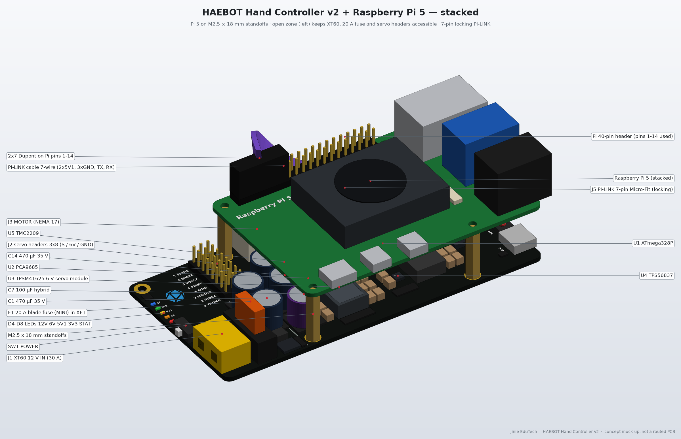
Conceptual generated 3D image, not a real 3D model
For | External PCB / board developer
Stage | v2 · Concept (pre-schematic) · Parts fixed · BOM not production-approved
Date / Author | 13 Nov 2026 / Jinie EduTech Co., Ltd.
Full details | GitHub incom8134-web/robot-hand → electronics/ (power_budget.md, bom_controller_v2.csv, README.md)

Contents
p.2 | Summary at a glance | p.3 | Why a custom board (DIY vs custom board)
p.4 | System · Pi link · firmware upload | p.5 | Key parts and roles
p.6 | Power and protection | p.7 | Connectors, switches, LEDs, zones
p.8–9 | Layout drawings | p.10 | Board developer checklist

1. Summary at a glance
Why this board (3 lines)
• Power: one 12 V input makes separate 6 V (high-current servo) and 5.1 V (Pi) rails → a servo stall cannot reset the Pi.
• Safety and reliability: fuses, reverse-polarity and surge protection on board, locking connectors instead of jumper wires → no miswiring or loose contacts.
• Education and finish: Arduino, PCA9685 and stepper driver on one 4-layer PCB → same result for every student, professional product look.

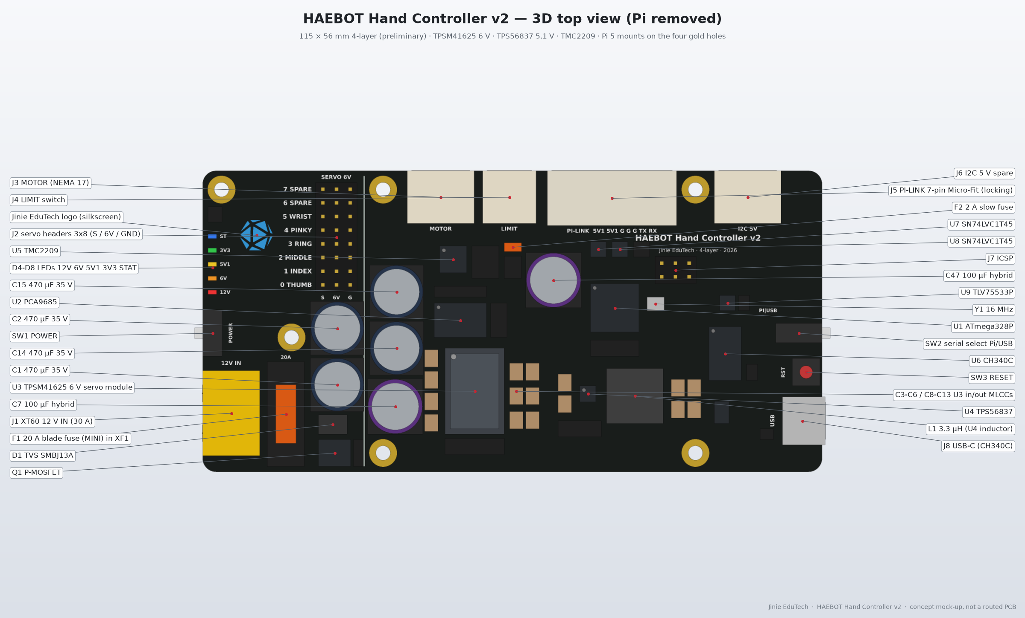
Figure 1. Board top view — conceptual generated 3D image, not a real 3D model (part callouts)
Table 1. Key numbers (for 6× MG996R · prototype 1: ES08MA II on J2, mechanics test)
Item | Specification
Input | 12 V single input · Mean Well 12 V 20 A+ SMPS (LRS-350-12, 12 V 29 A) → J1 XT60
Servo rail | 6 V (5.96 V) · TPSM41625 25 A module (≈20 A rating at 6 V) · worst 15 A (75 %)
Pi rail | 5.1 V · TPS56837 8 A · worst 5.19 A (65 %), 4.19 A at default USB 600 mA
Logic rail | 3.3 V · TLV75533P LDO · worst 42 mA (8 % of 500 mA)
Actuators | 6× MG996R (PCA9685 CH0 thumb – CH4 pinky, CH5 wrist) · NEMA 17 17HS4401S base (TMC2209, 1.0 A RMS, no elbow) · host: Pi 5 + Camera Module 3 (MediaPipe)
Control / link | ATmega328P + CH340C (built-in Arduino Nano, USB-C) · UART to Pi 5 (2× SN74LVC1T45, 7-pin locking connector)
PCB | 4-layer, ≈115 × 56 mm · Pi 5 stacked on top (M2.5, 18 mm standoffs)
Power (12 V) | Typical 3.74 A · 45 W / worst 11.2 A · 135 W (39 % of SMPS)

2. Why a custom board
The existing approach (based on the Bolofofopt/HumanoidRoboticArmVision reference) connects a Raspberry Pi 5 + camera, an Arduino (Mega/Nano), a PCA9685 module, a stepper driver (CNC shield + A4988-class module) and battery-pack (as shown) or buck-module power with jumper wires. The picture below is the current wiring; the custom board replaces this whole setup with one board.
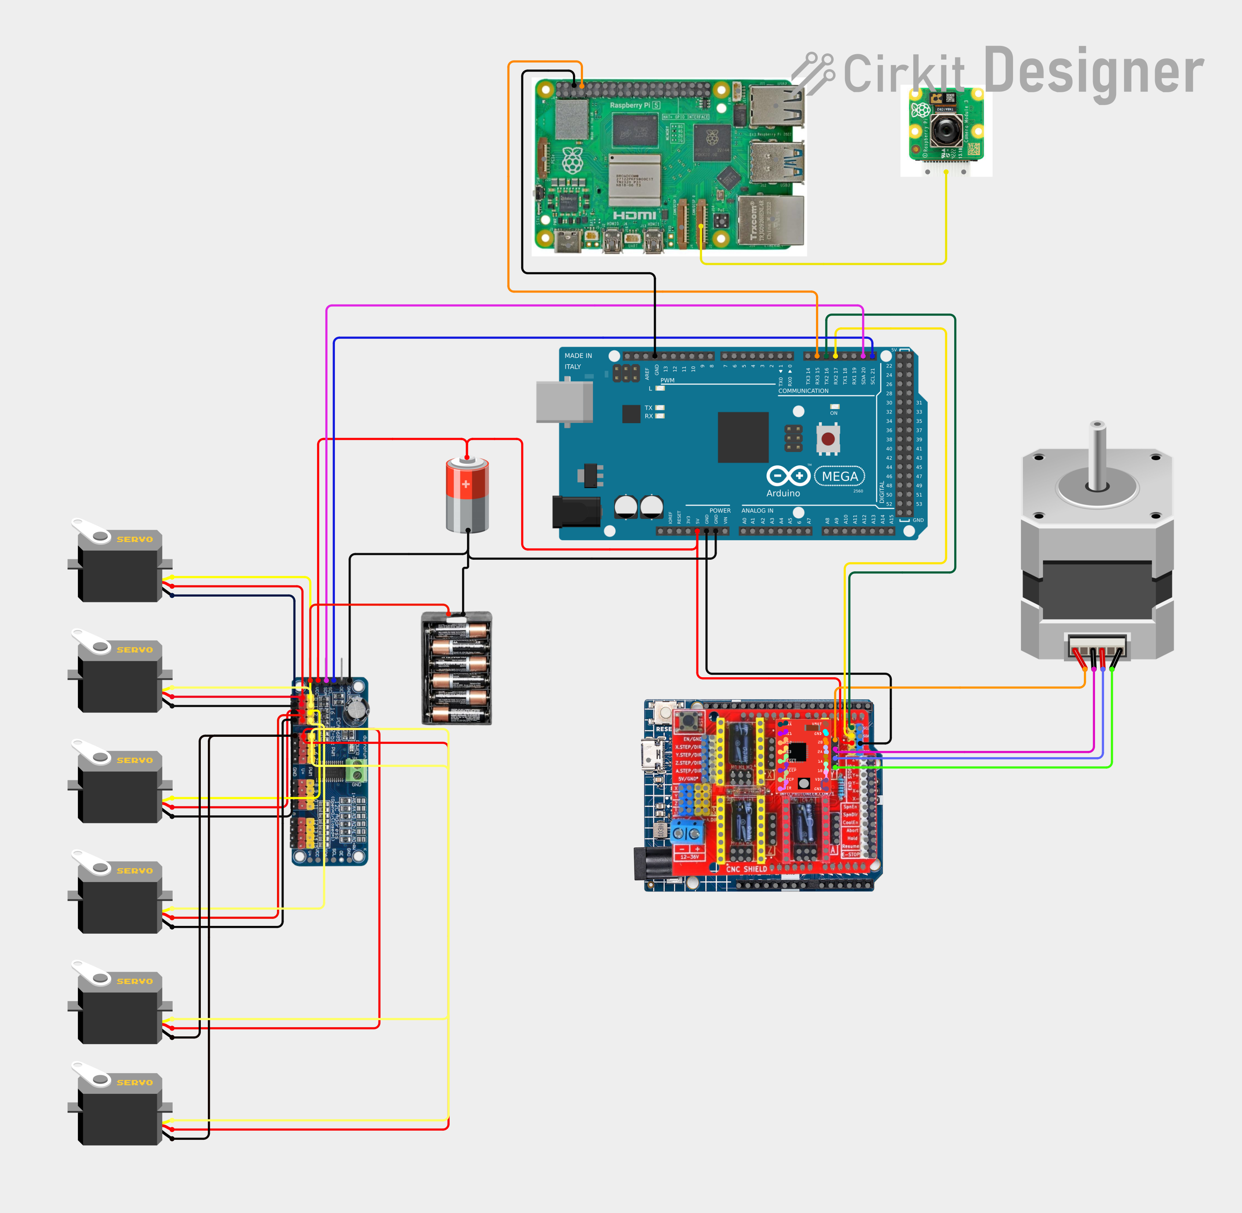
Figure 2. Reference: current module-based wiring (DIY approach, Cirkit Designer) — the setup the custom board replaces
Table 2. DIY approach vs custom board
Item | Problem with DIY (modules + jumpers) | Custom board solution
Servo power | AA packs / LM2596-class modules cannot supply 6 stalled MG996R (up to ≈15 A) → weak torque, overheating | On-board TPSM41625 6 V rail (≈20 A at 6 V, worst 75 %)
Pi power | Shares a weak supply with servos → Pi undervoltage / reset during demos | Dedicated TPS56837 5.1 V 8 A rail, separate from servos
Protection | No fuse, reverse-polarity or surge protection → Pi damage on miswiring / short | F1 20 A · F2 2 A fuses, Q1 reverse polarity, D1 SMBJ13A TVS
Wiring | Many jumpers that come loose → intermittent faults | 12 V XT60 + Pi Micro-Fit 3.0 7-pin locking connector
MCU | Separate Arduino board (Mega/Nano) + jumpers | Built-in ATmega328P + CH340C (same as Nano, USB-C upload)
Stepper | CNC shield + A4988-class driver module: loud, can be inserted backwards | On-board TMC2209, quiet StealthChop, fixed 1.0 A
Pi signals | 5 V signals wired straight into the 3.3 V Pi | 2× SN74LVC1T45 level translation protects the Pi
Teaching / look | Every student wires it differently; DIY look | 4-layer ≈115 × 56 mm PCB, silkscreen labels, visible function blocks

3. System · Pi link · firmware upload
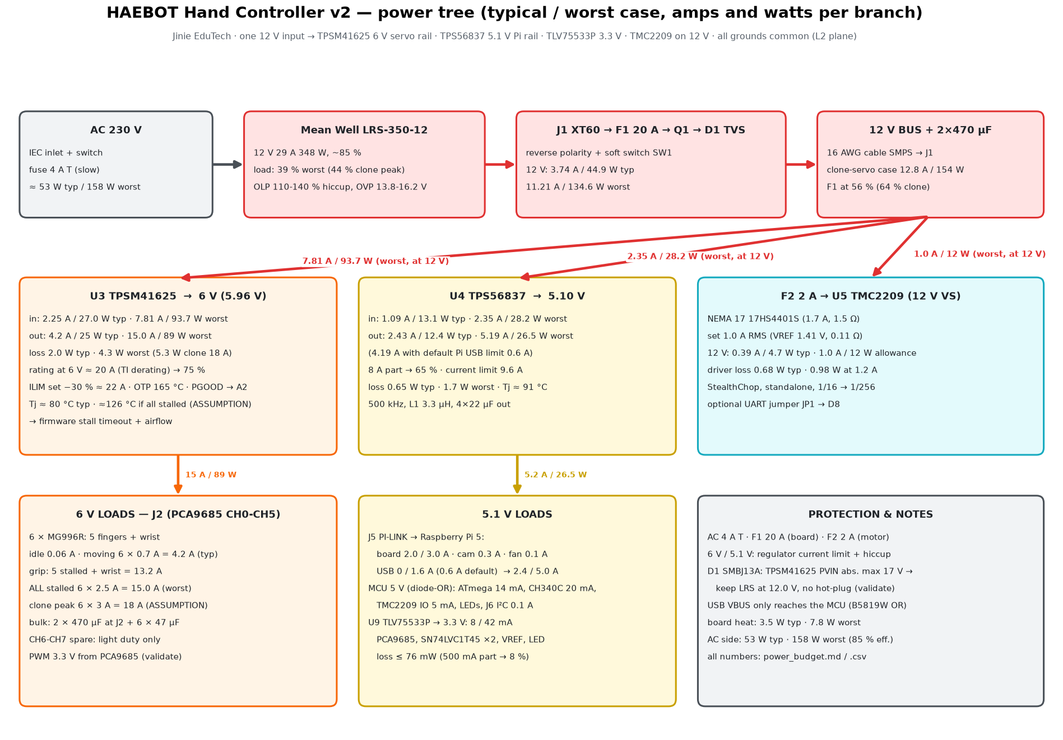
Figure 3. Power tree — current and power per branch (typical / worst)

Power flow
• AC 220 V → LRS-350-12 (12 V 20 A+, selector 230 V) → J1 XT60 → F1 20 A → Q1 → D1 → 3 branches
• U3 TPSM41625 → 6 V: 6 servos (J2) · U4 TPS56837 → 5.1 V: Pi 5 (J5) + logic → U9 TLV75533P → 3.3 V · F2 2 A → U5 TMC2209 (12 V) → NEMA 17 (J3)

Pi ↔ board link (J5 PI-LINK)
• One 7-pin locking cable carries Pi power (5.1 V × 2, GND × 3) and UART (TX, RX).
• Pi end: 2×7 Dupont on GPIO pins 1–14 (5 V = 2, 4 · GND = 6, 9, 14 · TX = 8 · RX = 10), 20/22 AWG, ≤ 100 mm.
• Pi (3.3 V) sends MediaPipe joint targets over UART → 2× SN74LVC1T45 (one per direction) shift levels and protect the Pi → ATmega (5 V) drives the PCA9685 (I²C) and TMC2209 (STEP/DIR).
• Keep Pi USB at the default 600 mA · never use J5 and the Pi's own USB-C supply together.

Firmware upload (built-in Arduino Nano)
• PC ↔ USB-C (J8) → set SW2 to USB → choose "Arduino Nano" in the Arduino IDE and upload (CH340C DTR auto-reset)
• After upload set SW2 back to PI. Burn the bootloader on new boards via J7 ICSP. The 7-pin link has no reset line, so the Pi cannot reflash the MCU.
• USB only: only the MCU is on (upload only), PCA9685 / 3.3 V are off → check the 5 V I²C pull-ups do not back-power the PCA9685.

4. Key parts and roles
Table 3. Key parts and roles (full list: bom_controller_v2.csv)
Ref | Part | Role (one line) | Why this part
U3 | TPSM41625 | 12 V → 5.96 V servo power | Inductor + FETs in one module, ≈20 A at 6 V, built-in protection
U4 | TPS56837 | 12 V → 5.10 V Pi and logic power | 8 A synchronous buck, ≈95 % efficient, few external parts
U9 | TLV75533P | 5.1 V → 3.3 V LDO | Worst 42 mA (8 %)
U1 | ATmega328P-AU | Real-time MCU (receive commands → drive, power monitoring) | Same chip as Arduino Nano, rich teaching material
U6 | CH340C | USB-serial (upload and debug) | No crystal, Nano-style auto-reset
U2 | PCA9685PW | I²C → 16-channel servo PWM | 5.5 V-tolerant inputs → no I²C level shifter
U5 | TMC2209 | Drives the NEMA 17 base stepper | Quiet, standalone mode needs no firmware setup
U7, U8 | SN74LVC1T45 ×2 | Pi 3.3 V ↔ MCU 5 V UART level shift | Protects Pi GPIO from 5 V
Q1 | WSD30L120ADN56 | Reverse polarity + power switch (SW1) | 3.8 mΩ, ≈0.6 W loss at 11 A
D1 | SMBJ13A | 12 V input surge clamp (TVS) | TPSM41625 input: rec. ≤ 16 V, abs. max 17 V
J5 | Molex 43650-0713 | Pi power + UART 7-pin locking connector | 5 A per pin, latch prevents pull-out

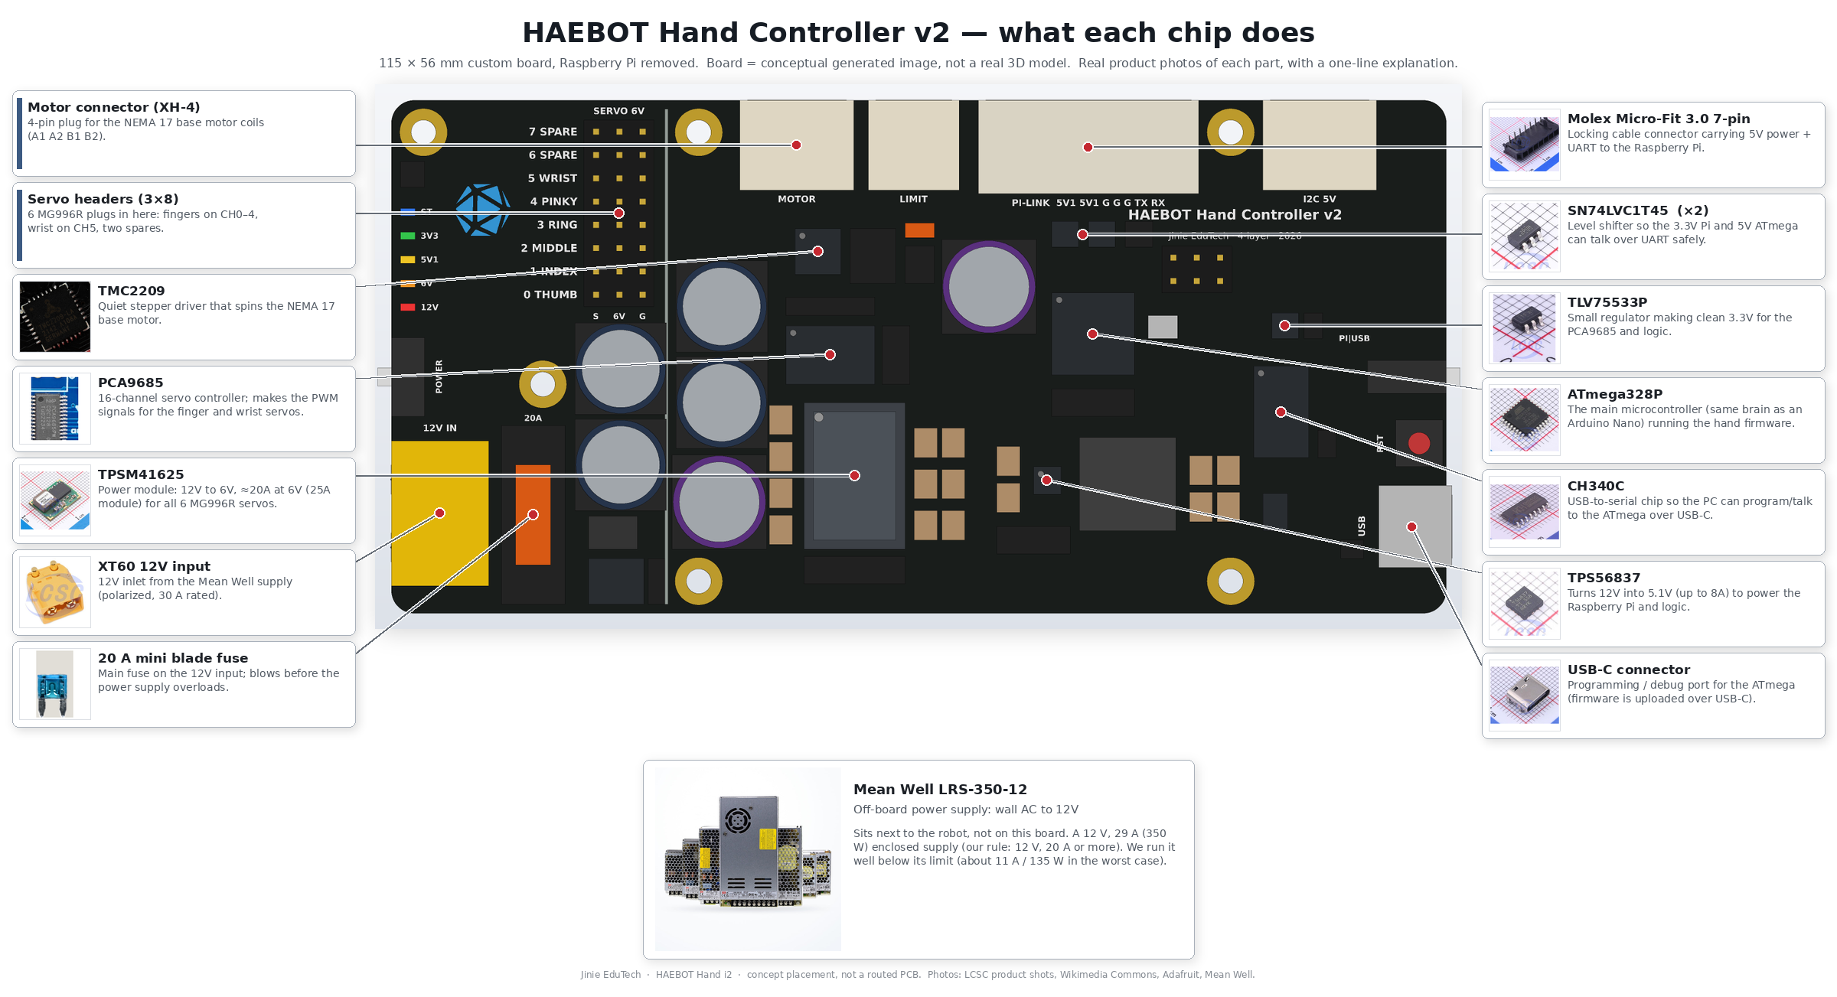
Figure 4. Board top view with real IC photos and one-line roles (IC guide) — board is a conceptual generated image, not a real 3D model

5. Power and protection
Typical = 6 servos moving · Worst = 6 stalled (2.5 A each) + Pi 5 A (USB limit raised) + stepper. Details: power_budget.md
Table 4. Power rails
Rail | Made by | Typical | Worst | Load (worst)
12 V input | LRS-350-12 (20 A+) | 3.74 A · 45 W | 11.2 A · 135 W | 39 % of SMPS
6 V servo | U3 TPSM41625 | 4.2 A · 25 W | 15.0 A · 89 W | 75 % of 20 A at 6 V
5.1 V | U4 TPS56837 | 2.43 A · 12.4 W | 5.19 A · 26.5 W (4.19 A at USB 600 mA) | 65 % of 8 A
3.3 V | U9 TLV75533P | 8 mA | 42 mA | 8 % of 500 mA
12 V motor | U5 TMC2209 | 0.39 A | 1.0 A (allowance) | 50 % of 2 A RMS

Table 5. Protection chain (AC → each rail)
Stage | Protection | Purpose
AC | IEC inlet 4 A T fuse + LRS built-in protection | AC overcurrent; SMPS overload / OVP / OTP
12 V input | J1 XT60 → F1 20 A fast MINI blade fuse (holder XF1) | Worst 11.2 A = 56 %; opens first on a board fault
12 V input | Q1 P-MOSFET + DZ1 15 V zener | Reverse polarity; SW1 switches only the gate
12 V input | D1 SMBJ13A TVS + 940 µF bulk | Surge clamp · residual risk: ≈21.5 V at full surge, LRS OVP up to 16.2 V → test
Stepper branch | F2 2 A time-lag fuse | Protects the 12 V branch to the TMC2209
6 V / 5.1 V / 3.3 V | Regulator built-in protection | Current limit ≈22 A / 9.6 A, OVP / OTP, hiccup
At boot | R40 → PCA9685 /OE, R47 → TMC2209 ENN pull-ups | Servos and motor stay off until the MCU enables them
Signals / USB | R15–R22 220 Ω, D2/D3 B5819W diode-OR | Protect PCA9685 outputs; USB cannot back-feed the Pi
Monitoring | A0/A1 voltage sense, A2/A3 PGOOD/PG (no servo current sensor) | Stall = 6 V sag + PGOOD + elapsed time (if not enough: 6 V shunt + INA)

Thermal essentials
• TPSM41625: ≈20 A at 6 V (not 25 A). Six servos stalled continuously (15 A) → est. Tj ≈126 °C → firmware stall timeout (servos off via /OE after 2 s), ≥ 30 thermal vias, base fan.
• Board heat 3.5 W typ / 7.8 W worst · LRS selector 230 V (Korea 220 V) · V-ADJ never above 12.0 V.

6. Connectors, switches, LEDs, zones
Table 6. Connectors
Ref | Part | Use | Rating / worst
J1 | XT60PW-M (RA) | 12 V input (16 AWG) | 30 A / 11.2 A
J2 | 3 × 8 pin header 2.54 mm | Servos CH0–4 fingers, CH5 wrist, CH6–7 spare | ≈3 A per pin / 2.5 A
J3 | JST XH 4P (RA) | NEMA 17 coils A1 A2 B1 B2 | 3 A / 1.4 A peak (1.0 A RMS)
J4 | JST XH 3P (RA) | Base home limit switch | 3 A / < 10 mA
J5 | Micro-Fit 3.0 1×7 | PI-LINK: 5.1 V ×2, GND ×3, TX, RX | 5 A/pin / 5.2 A total (2.6 A/pin)
J6 | JST XH 4P (RA) | Spare I²C ("5V 100 mA max" label) | 3 A / 0.1 A
J7 | 2 × 3 pin header | ICSP bootloader | –
J8 | USB-C (TYPE-C-31-M-12) | PC: upload / debug (CH340C) | < 50 mA

Table 7. Switches, jumper, LEDs
Ref | Part | Function
SW1 | SPDT slide | Board power ON/OFF (switches only the Q1 gate)
SW2 | SPDT slide | Serial select PI / USB: stops Pi and PC from clashing
SW3 | Tact switch | ATmega328P reset
JP1 | Solder jumper + 1 kΩ | Optional TMC2209 UART (open by default)
D4–D8 | LED | D4 12 V, D5 6 V red · D6 5.1 V yellow · D7 3.3 V, D8 STAT (MCU D13) green (per BOM)

Table 8. Board zones (concept placement; keep the zoning)
Zone | Where | Parts
Open zone (outside Pi) | x 0–30 mm | J1, F1, Q1, D1, C1/C2 bulk, SW1, J2 servo headers, LEDs, logo
Under Pi (≤ 12 mm tall) | x 30–115 mm | U3 + C14/C15, U2, U5 + F2, U4 + L1, U1, U6, U7/U8, U9
Top / right edge | Under Pi | Top: J3, J4, J5, J6 · Right: J8, SW2, SW3

Table 9. 4-layer stack-up (JLCPCB 4L 1.6 mm, preliminary · copper widths: power_budget.md)
Layer | Copper | Use
L1 / L4 | 2 oz | Signals + power pours (12 V, 6 V high-current paths)
L2 | 1 oz | Solid GND
L3 | 1 oz | Power plane (12 V / 6 V / 5.1 V / 3.3 V islands)

7. Layout drawings
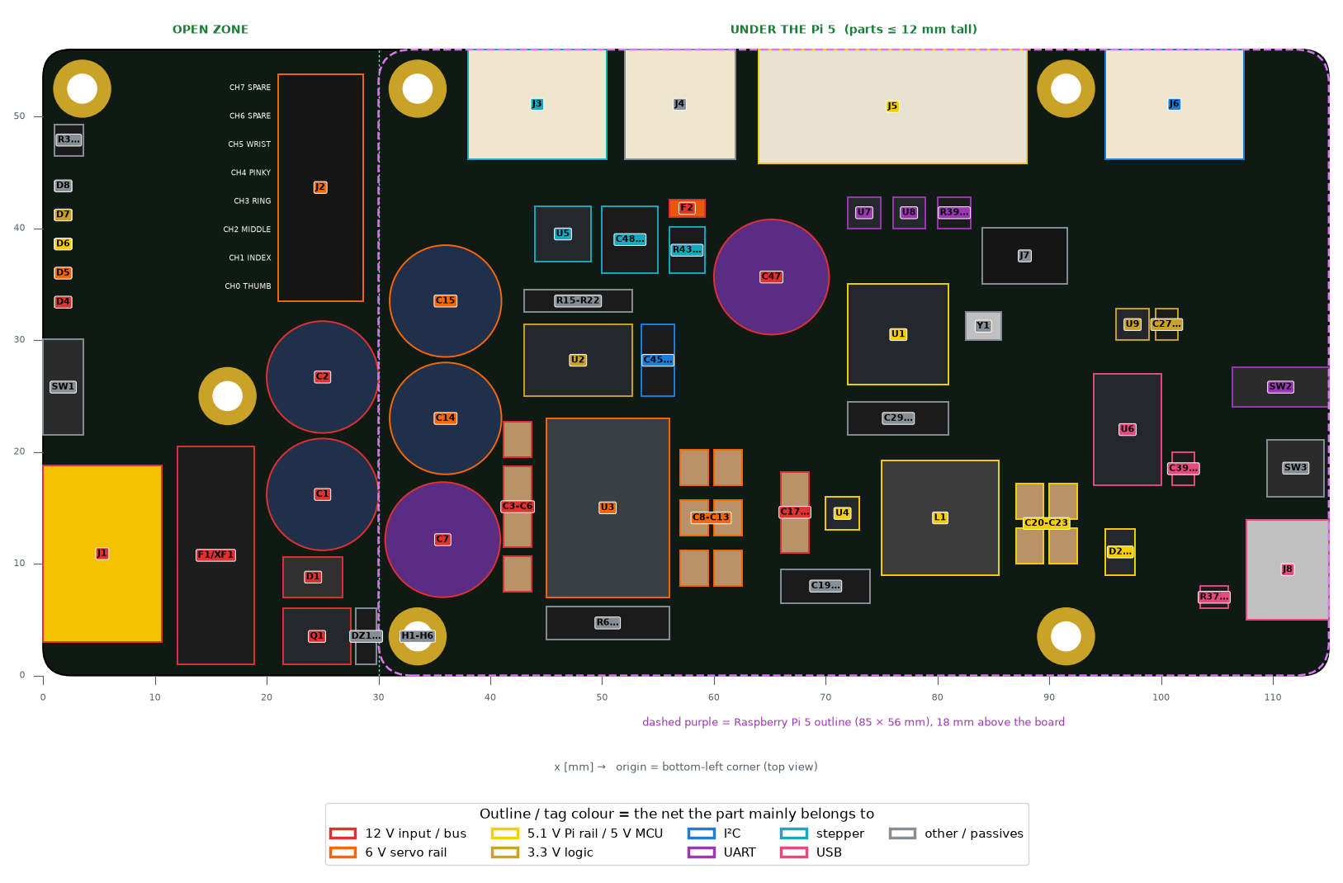
Figure 5. Top layout — real package sizes, Pi outline, to scale (concept placement) · full image with part tables: GitHub electronics/renders/layout_top.png
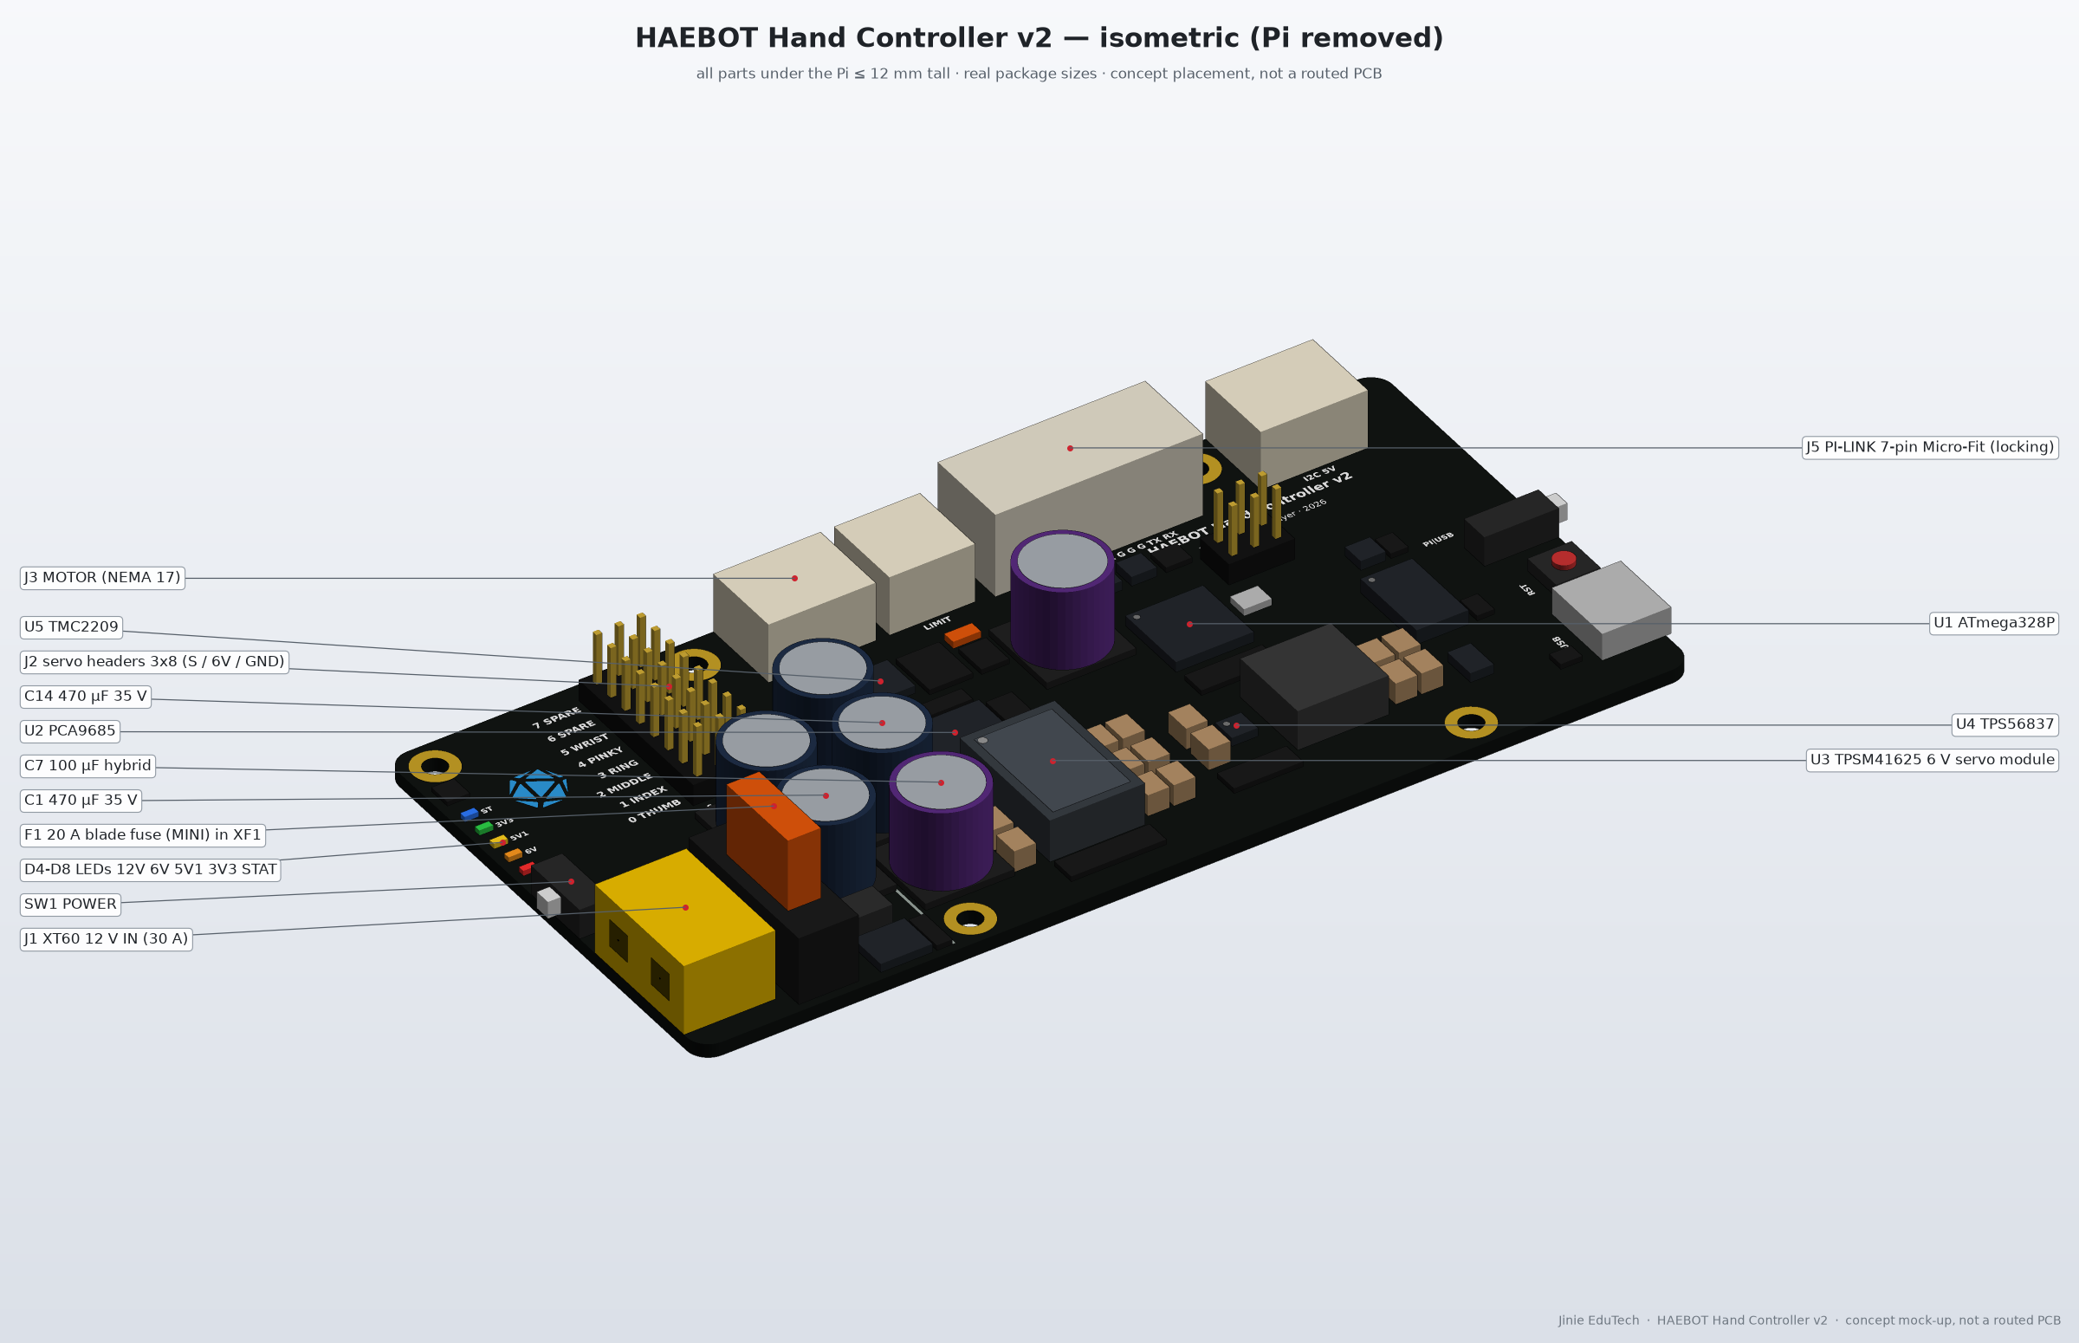
Figure 6. Isometric (no Pi) — conceptual generated 3D image, not a real 3D model · parts under the Pi ≤ 12 mm
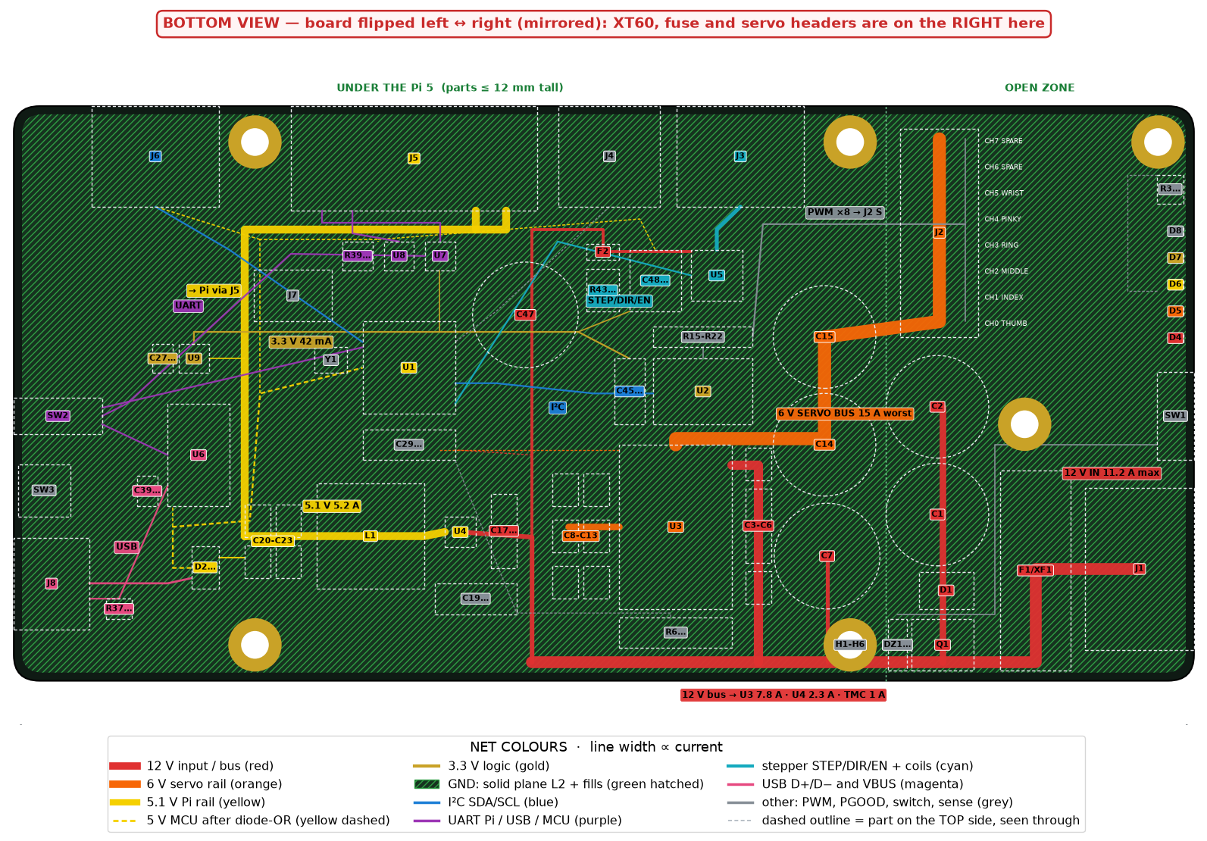
Figure 7. Wiring — bottom view (mirrored), colour-coded nets · full image with part tables: GitHub electronics/renders/wiring_back_colorcoded.png
Net colours: 12 V red · 6 V orange · 5.1 V yellow · 3.3 V gold · GND green hatched · I²C blue · UART purple · stepper cyan · USB magenta · other grey
Figure 8. Isometric, Pi 5 stacked (18 mm standoffs) — conceptual generated 3D image, not a real 3D model

8. Board developer checklist
Table 10. Deliverables
 | Deliverable | Content
☐ | Schematic | KiCad, based on this document and bom_controller_v2.csv
☐ | PCB | 4-layer ≈115 × 56 mm, zones / stack-up / copper widths, DRC clean
☐ | 3D check (KiCad) | KiCad 3D with Pi 5: ≤ 12 mm under Pi, 2.6 mm keep-out at M2.5 holes, connector access
☐ | Fab files | JLCPCB Gerber, BOM, CPL (LCSC part numbers)
☐ | Final BOM · silk | TBD / out-of-stock parts resolved; label every connector, switch, LED

Design rules
• Parts are fixed (incl. PSU: Mean Well 12 V 20 A+, LRS-350-12). Ask us before changing any.
• TPSM41625: ≥ 30 thermal vias to L2/L3/L4, TI layout guide · TPS56837: TI Table 7-2 (500 kHz, 5 V)
• TMC2209: thermal pad to planes, keep standalone (MS1 = H, MS2 = L, VREF 1.41 V → 1.0 A RMS)
• Keep /OE, ENN pull-ups, PGOOD/PG, sense dividers · TVS + bulk caps at the input connector
Table 11. Open items (※ no parts purchased yet · LCSC status from the BOM)
 | To be resolved (TBD) | Details
☐ | LCSC part number not confirmed yet | R4, R6–R10, R12, R15–R22, R23, R25–R27, R30, R37/R38, R46, C25/C26, J2, D6
☐ | LCSC out of stock → substitute | C1/C2/C14/C15 (470 µF 35 V), J5 Molex 43650-0713, R43/R44 (0.11 Ω)
☐ | Buy separately | F1 20 A fuse (not at LCSC)
☐ | Validate before order | Regulator heat, TMC2209 current, 6 V drop < 0.3 V at servo peak, J5 5 A 30 min, 12 V spike < 16 V

2 decisions to make together
• Pi link 7-pin vs 8-pin: for Pi firmware upload, 8-pin Micro-Fit (43650-0813) + GPIO4 → 2N7002 → RESET
• Servo signal buffer: add a 74AHCT125 depending on the 3.3 V PWM test (not fitted now)

Details (GitHub electronics/): power_budget.md (math, validation) · bom_controller_v2.csv · README.md (pin map, Pi setup) · STEP (concept)

