HAEBOT Robot Hand
Study guide: electronics to software, just enough to finish the project
Prepared 2026-11-14. Browse the tables, open a link only when you reach that step. Links point to official docs where one exists.
MUST | Learn before you build. The project fails without it.
GOOD | Learn when you reach that part. Makes work faster or safer.
LATER | Skip for now. Only for the 5-finger upgrade or extras.

1. Project map (read this first)
Everything else in this guide hangs off this picture.
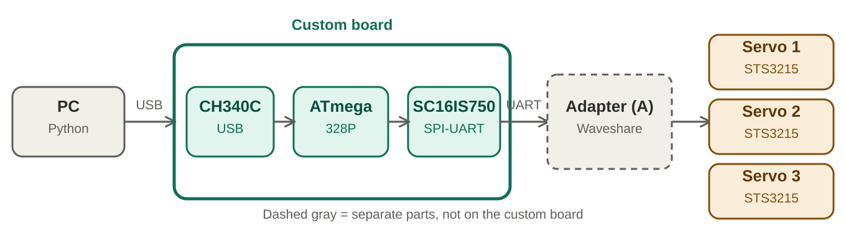
Data path: PC to servos
Level | Topic | Just enough to know
MUST | Data path | PC (Python, OpenCV, MediaPipe) to USB cable to CH340C to ATmega328P to SPI to SC16IS750 to UART to Waveshare Adapter (A) to the STS3215 servos. Only a few numbers per frame cross the USB cable.
MUST | On the custom board | USB-C, CH340C, ATmega328P, 16 MHz crystal, level shifter, SC16IS750 with its own crystal, 3.3V regulator.
MUST | Not on the board | Waveshare adapter, 12V servo supply, the three servos. Servo power goes to the adapter, never through the board.
MUST | Two modes | Follow PC (mirror your hand, rock-paper-scissors) and idle (stored gestures when no PC data arrives). Same hardware, the firmware decides.
GOOD | 3-servo hand | Thumb on one servo, index and middle together on one, ring and pinky together on one. Scissors works. Pointing with a single finger does not.

2. Electronics basics
Power mistakes destroy parts. Learn these before anything else.
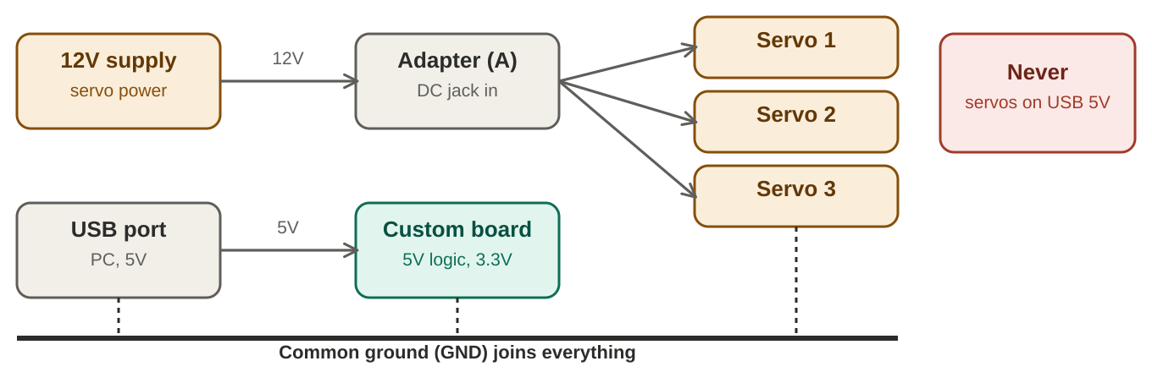
Power and ground
Level | Topic | Just enough to know
MUST | Power = volts x amps | Three STS3215 stalled can pull about 8 A (2.7 A each). At 12V that is about 97 W worst case (my arithmetic). Size supply, wires and connectors for stall. Normal motion is far lower.
MUST | Common ground | USB, custom board, adapter and servos share one ground. Without it the signals are unreliable.
MUST | USB cannot power servos | Servos run from their own supply into the adapter's DC jack or screw terminal.
MUST | Match the voltage | Waveshare: adapter input 9 to 12.6V and it must match the servo voltage. Your box says 12V (code ST-3215-C018). A 7.4V servo on 12V can be damaged, so check every servo.
MUST | Decoupling and pull-ups | 100 nF capacitor on every IC power pin, close to the pin. 10k pull-up on RESET. General practice, copy the datasheet reference circuits.
GOOD | Logic levels | ATmega328P runs at 5V here. SC16IS750 supply is 3.0 to 3.6V. NXP rates its inputs to 5.5V only while the chip is powered (datasheet Table 35 note), so a level shifter adds margin, especially if the chip could be unpowered.
GOOD | Fuse and cutoff | Fuse the servo supply and keep a switch within reach. Stalled servos heat quickly.
GOOD | Trace width | IPC-2221 sizes copper from current and allowed temperature rise. 8A needs wide pours. In our plan servo power does not cross the board, which avoids this.

Source (click) | Use it for
DigiKey PCB trace width calculator  https://www.digikey.ca/en/resources/conversion-calculators/conversion-calculator-pcb-trace-width | IPC-2221 width for a given current
Farnell PCB trace width calculator  https://uk.farnell.com/pcb-trace-width | Same calculation with voltage drop and power loss
Proto Express IPC-2152 note  https://protoexpress.com/?p=12833 | IPC-2152 is the newer standard that improves on IPC-2221

3. Communication: UART, servo bus, SPI, USB
Four links carry the project: PC to board, board to bridge, bridge to adapter, adapter to servos.
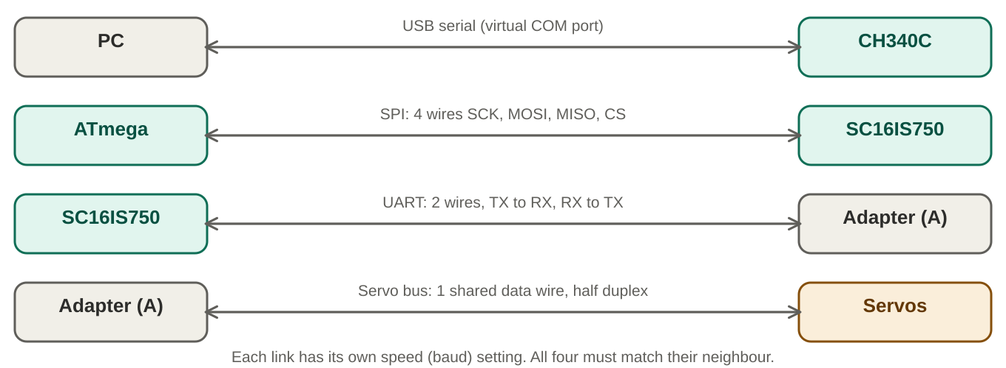
The four communication links
Level | Topic | Just enough to know
MUST | UART (TX/RX) | Asynchronous serial: baud rate plus 8N1 framing. Normally TX crosses to RX. The Waveshare adapter in UART mode is wired RX to RX and TX to TX per its wiki, so follow the wiki.
MUST | Half-duplex servo bus | STS servos share one Data wire, one talker at a time. The adapter turns TX/RX into that single wire for you. On a bare board a tri-state buffer does it (SN74LVC1G125: output off when OE is high).
MUST | SPI | Four wires: SCK, MOSI, MISO, CS. On the ATmega328P: D13 SCK, D11 MOSI, D12 MISO, D10 CS. Keep the hardware SS pin set as an output or the chip can drop into slave mode.
MUST | USB to serial | CH340C turns USB into UART. DTR through 100 nF to RESET restarts the ATmega when the PC opens the port. That is how Arduino uploads work.
GOOD | Baud and crystal | NXP: the baud generator outputs 16x the baud rate and divides by 1 to 65535, with a prescaler of 1 or 4. So baud = crystal / (prescaler x 16 x divisor). A 16 MHz crystal with divisor 1 gives exactly 1,000,000. My derivation from the datasheet, confirm the allowed clock range.
GOOD | FIFO buffers | SC16IS750 has 64-byte transmit and receive FIFOs. A 3-servo sync-write packet is about 31 bytes (my estimate from the Feetech layout), so it fits.

Source (click) | Use it for
Arduino SPI library reference  https://docs.arduino.cc/language-reference/en/functions/communication/SPI | Pins, SPISettings, transfer functions
Arduino SPI guide  https://docs.arduino.cc/learn/communication/spi | How SPI works, modes, transactions
CH340 datasheet (WCH, v2G)  https://mikrocontroller.net/attachment/528524/CH340DS1.PDF | USB lines connect directly, built-in clock, modem pins
TI SN74LVC1G125B datasheet  https://www.ti.com/lit/gpn/sn74lvc1g125b | Tri-state buffer, OE pull-up advice
pySerial short introduction  https://pyserial.readthedocs.io/en/latest/shortintro.html | Open a port, write bytes, timeouts

4. The chips on the board
One line each. Open the datasheet when you reach that chip.
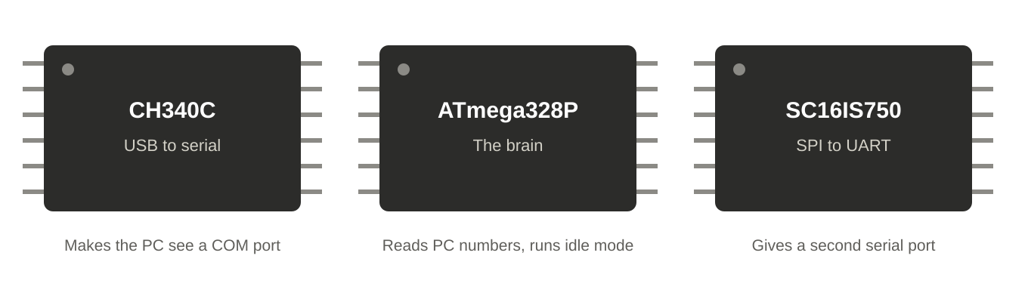
The three chips
Level | Topic | Just enough to know
MUST | ATmega328P | 8-bit AVR, 32 KB flash, 2 KB SRAM, 1 KB EEPROM, up to 20 MHz, 1.8 to 5.5V. Same family as Arduino Uno and Nano. Needs a bootloader to accept USB uploads (Optiboot, about 512 bytes).
MUST | CH340C | USB to UART in a SOP-16. Built-in clock (no crystal), 5V or 3.3V supply. D+ and D- go straight to the connector with no series resistors. DTR pin drives auto-reset.
MUST | SC16IS750 | SPI or I2C to UART bridge. 64-byte FIFOs, SPI up to 4 Mbit/s, UART up to 5 Mbit/s in 16x mode, supply 3.0 to 3.6V. Needs its own crystal. SparkFun's SPI test wires the I2C/SPI select pin to GND.
GOOD | SN74LVC1G125 | Only for a single-board design without the Waveshare adapter. One tri-state buffer, 1.65 to 5.5V. Pull OE up so the output stays off during power-up.
MUST | Bootloader (no ICSP for us) | A bare ATmega328P arrives without a bootloader. Buy pre-bootloaded chips, flash once with another Arduino (ArduinoISP) or a USBasp, or use a Nano module. After that every upload goes over USB.

Source (click) | Use it for
ATmega328P datasheet (Atmel, 2016)  https://fab.cba.mit.edu/classes/863.17/EECS/people/akaspar/project/atmega328p-datasheet.pdf | Pinout, electrical limits, registers
Microchip ATmega328P product page  https://www.microchip.com/en-us/product/atmega328p | Current official datasheet
NXP SC16IS740/750/760 datasheet  https://www.nxp.com/docs/en/data-sheet/SC16IS740_750_760.pdf | Baud generator, FIFO, registers, voltage limits
SparkFun SC16IS750 breakout  https://sparkfun.com/products/9981 | Wiring example and test sketch for SPI mode
Appnostic SC16IS7XX Arduino library  https://github.com/appnostic-io/Appnostic_SC16IS7XX_Arduino_Library | Ready library for SC16IS750 over SPI or I2C
Optiboot bootloader  https://github.com/Optiboot/optiboot | The Uno/Nano bootloader and how to burn it
Arduino forum: bootloader on a custom board  https://forum.arduino.cc/t/programming-the-bootloader-on-a-custom-board/1245848 | Real troubleshooting, including the reset capacitor tip
Arduino forum: custom PCB with ATmega328P and CH340C  https://forum.arduino.cc/t/issue-uploading-custom-pcb-with-atmega328p-ch340c/1352431 | Same chip pair as ours, board setting Arduino Nano

5. STS3215 servos and the Waveshare adapter
The actuators. Most of your debugging time will be here.
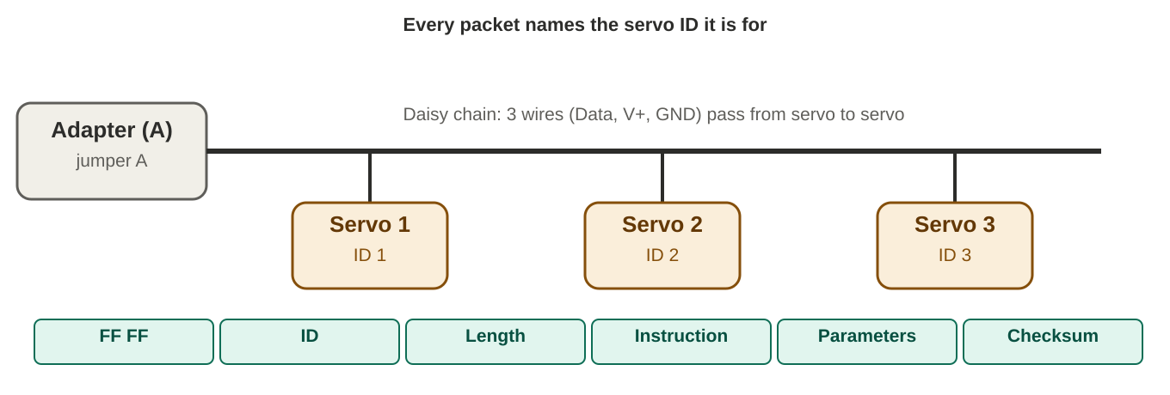
Servo bus and packet layout
Level | Topic | Just enough to know
MUST | Your servo | STS3215, 12V version: 30 kg.cm at 12V, 0.222 s per 60 degrees. Range 360 degrees as 0 to 4095. ID 0 to 253. Baud 38400 to 1 Mbps, 1 Mbps default. Locked-rotor about 2.7 A. Box code ST-3215-C018.
MUST | Unique IDs | New servos ship as ID 1. Connect one at a time and set IDs 1, 2, 3 using the Waveshare or Feetech software, or the SDK.
MUST | Feedback | Position, speed, load, voltage and temperature can be read back. Use temperature and load to protect the hand.
MUST | Sync write | One packet moves several servos together. Python SDK: GroupSyncWrite. Arduino library: SyncWritePosEx.
MUST | Adapter (A) jumper | Jumper A is UART control for hosts without USB (Arduino, ESP32). Jumper B is USB control for a PC. Input 9 to 12.6V through a 5.5 x 2.1 mm jack or the screw terminal. Up to 253 servos in theory with adequate power.
GOOD | Bench test first | Use jumper B and a USB cable to drive the servos from the PC before the custom board exists. This proves servos, IDs, power and Python.
GOOD | Servo vs motor mode | The STS3215 can run as a position servo or a continuous motor. The hand uses position mode.

Source (click) | Use it for
Waveshare ST3215 servo wiki  https://www.waveshare.com/wiki/ST3215_Servo | Specs, default ID and baud, resources
Waveshare ST3215 product page  https://www.waveshare.com/product/st3215-servo.htm | 12V and 7.4V variants side by side
Waveshare Bus Servo Adapter (A) wiki  https://www.waveshare.com/wiki/Bus_Servo_Adapter_(A) | Jumper A/B, wiring, power input, demo software
FTServo_Python (Feetech SDK)  https://github.com/StarCycle/FTServo_Python | scservo_sdk with ping, read, write and sync examples
ftservo-python-sdk on PyPI  https://pypi.org/project/ftservo-python-sdk | pip install for the same SDK
FTServo_Arduino (Feetech)  https://gitee.com/ftservo/FTServo_Arduino | Arduino library with SyncWritePosEx
workloads/scservo  https://github.com/workloads/scservo | Another Feetech/SC servo library
LeRobot SO-101 docs  https://huggingface.co/docs/lerobot/so101 | Real STS3215 setup: install, set motor IDs, calibrate
Hackster STS3215 setup guide  https://www.hackster.io/ian-hong/feetech-serial-bus-servo-sts3215-setup-guide-fd16aa | Walkthrough with Python and feedback values
Hugging Face forum STS3215 tutorial  https://discuss.huggingface.co/t/feetech-sts3215-servo-hardware-tutorial/173674 | Python wrapper for beginners, daisy chaining

6. PC software: Python, OpenCV, MediaPipe
This is where hand movement becomes numbers. It runs entirely on the PC.
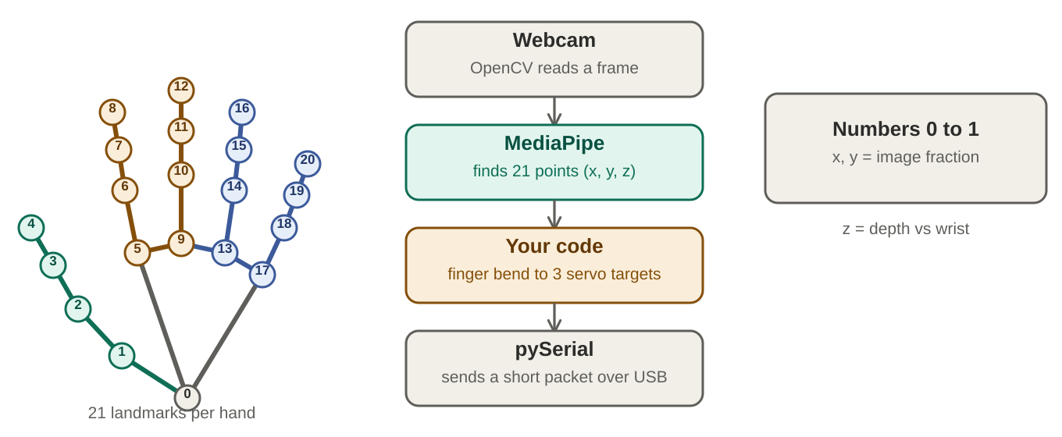
From camera to servo numbers
Level | Topic | Just enough to know
MUST | Setup | Use a virtual environment with opencv-python, mediapipe, numpy, pyserial and the Feetech SDK. If pip has no mediapipe build for your newest Python, use 3.11 or 3.12 (user reports, check with pip).
MUST | OpenCV camera loop | cv2.VideoCapture(0) opens the webcam. Read frames in a loop, show them with cv2.imshow while debugging.
MUST | MediaPipe Hand Landmarker | Finds 21 landmarks per hand. x and y run 0 to 1 across the image, z is depth relative to the wrist. Use VIDEO or LIVE_STREAM mode for a camera. LIVE_STREAM skips frames while busy.
MUST | Landmarks to finger values | My suggestion: curl = joint angle, or fingertip-to-wrist distance divided by palm size. Average index with middle and ring with pinky to get 3 values. Map 0 (open) to 1 (closed) onto each servo's safe range.
MUST | Smoothing and limits | My suggestion: exponential moving average against jitter, clamp positions to the mechanical limits, send about 30 times per second.
GOOD | Rock-paper-scissors | Gesture Recognizer outputs None, Closed_Fist, Open_Palm, Pointing_Up, Thumb_Down, Thumb_Up, Victory, ILoveYou. Map rock to Closed_Fist, paper to Open_Palm, scissors to Victory. The robot answers with a stored pose.
GOOD | Link to the board | Option 1: send 3 numbers plus a checksum per frame and let the board build servo packets. Option 2: the board passes bytes through and Python speaks the servo protocol itself, which is the simplest firmware.

Source (click) | Use it for
MediaPipe Hand Landmarker for Python  https://developers.google.com/edge/mediapipe/solutions/vision/hand_landmarker/python | Setup, model file, options, result object
MediaPipe Hand Landmarker overview  https://developers.google.com/edge/mediapipe/solutions/vision/hand_landmarker | 21 landmarks, models, configuration
MediaPipe Gesture Recognizer  https://developers.google.com/edge/mediapipe/solutions/vision/gesture_recognizer | Built-in gesture list for rock-paper-scissors
Google Research: on-device hand tracking  https://research.google/blog/on-device-real-time-hand-tracking-with-mediapipe/ | How palm detection and landmarks work
OpenCV: getting started with videos  https://docs.opencv.org/4.x/dd/d43/tutorial_py_video_display.html | VideoCapture, reading and showing frames
pySerial documentation  https://pyserial.readthedocs.io/en/stable/ | Serial ports from Python, port listing, miniterm
Finger counting with OpenCV and MediaPipe  https://medium.com/@oetalmage16/a-tutorial-on-finger-counting-in-real-time-video-in-python-with-opencv-and-mediapipe-114a988df46a | Worked example turning landmarks into finger states

7. Firmware: Arduino C++ on the ATmega328P
A small program: read PC data, talk SPI, build servo packets, fall back to idle.
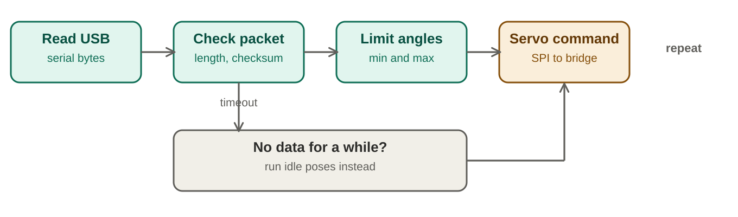
Firmware loop
Level | Topic | Just enough to know
MUST | Arduino C++ basics | setup() and loop(), Serial.begin and Serial.read, millis() for timing instead of delay(), arrays and structs for poses.
MUST | Board setting | Choose Arduino Nano, ATmega328P in the IDE. A forum build with ATmega328P-AU and CH340C used exactly that.
MUST | SPI driver for SC16IS750 | Start SPI, set the baud divisor, enable the FIFO, write to the transmit register, read the receive register. Use an existing library or the SparkFun sample rather than writing registers from scratch.
MUST | Servo packets | A frame has header bytes, ID, length, instruction, parameters and checksum. The Feetech Arduino library builds them. It is written for a normal serial port, so you will wrap the SC16IS750 to look like one (not tested yet).
MUST | Watchdog and idle mode | If no valid PC packet arrives for a set time, stop following, play an idle gesture, optionally relax torque. When packets return, resume following.
GOOD | Stored poses | Keep rock, paper, scissors, wave and idle poses in flash (PROGMEM) or the 1 KB EEPROM.
GOOD | Debugging | Print status over USB serial. Add a logic analyzer later if SPI misbehaves.

Source (click) | Use it for
Arduino SPI guide  https://docs.arduino.cc/learn/communication/spi | SPI.begin, SPISettings, beginTransaction
Appnostic SC16IS7XX library  https://github.com/appnostic-io/Appnostic_SC16IS7XX_Arduino_Library | Starting point for the bridge driver
SparkFun SC16IS750 breakout and test sketch  https://sparkfun.com/products/9981 | Minimal SPI send and receive example
FTServo_Arduino  https://gitee.com/ftservo/FTServo_Arduino | Servo packet building and sync write
Amazing Hand Arduino demos  https://github.com/pollen-robotics/AmazingHand | Working servo control sketches to read

8. PCB design with KiCad
The board developer owns this. You only need enough to review the work.
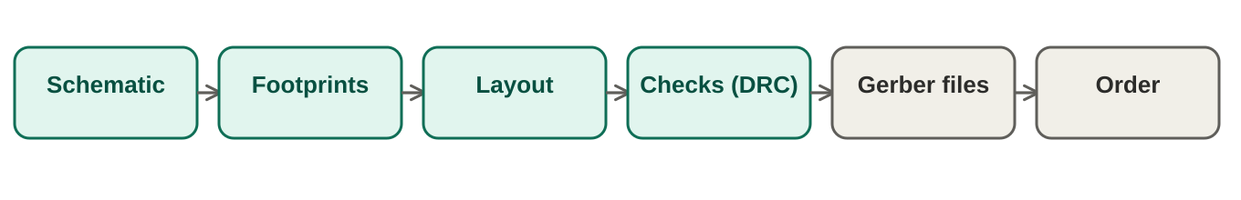
From schematic to ordered board
Level | Topic | Just enough to know
MUST | Workflow | Schematic, electrical rules check, footprints, PCB layout, design rules check, Gerbers and parts list, order. KiCad's Getting Started covers each step.
MUST | KiCad | Free and open source. Docs exist for 9.0 and 10.0, so follow the one matching your install.
MUST | Layout rules that matter | Decoupling caps at the pins. Crystals close with short traces. USB D+ and D- straight to the connector. Ground plane. Keep servo power away from logic.
GOOD | Parts | CH340C is SOP-16, ATmega328P-AU is TQFP-32. Pick sizes someone can solder, or use an assembly service.
GOOD | Test pads | Add pads for 5V, 3.3V, GND, TX and RX so bring-up is easy.

Source (click) | Use it for
KiCad 9.0 Getting Started  https://docs.kicad.org/9.0/en/getting_started_in_kicad/ | Builds a complete board step by step
KiCad 9.0 reference manual  https://docs.kicad.org/9.0/en/kicad/kicad.html | Details for every tool
DigiKey KiCad 9 series (video)  https://www.digikey.ca/en/videos/d/digi-key-electronics/kicad-9-0-getting-started-part-1-intro-download-digikey | Seven-part beginner series from install to Gerbers
KiCad documentation home  https://docs.kicad.org/ | All versions and PDFs

9. Mechanics: fingers, tendons, printing
Software can be fixed in minutes. A wrong hand design costs weeks.
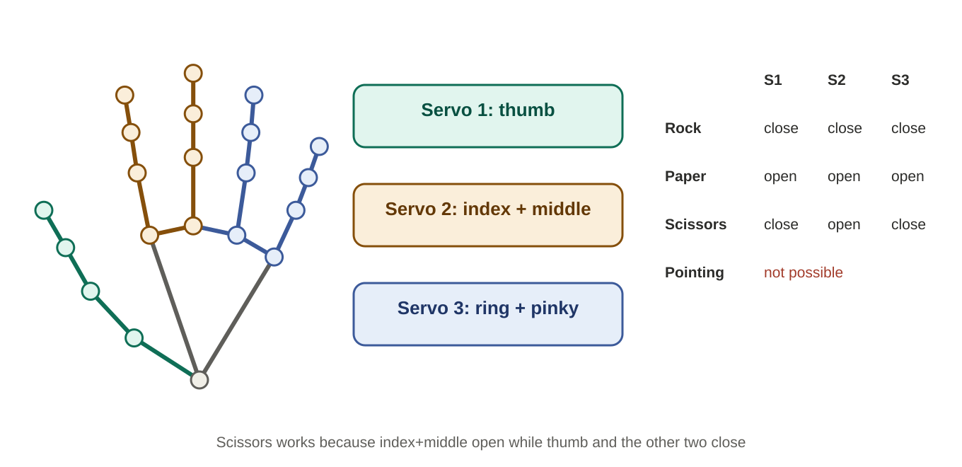
Three servos and the poses they make
Level | Topic | Just enough to know
MUST | Why 3 servos | STS3215 measures 45.22 x 24.7 x 35 mm (box). Three side by side are about 75 mm wide (my arithmetic), five do not fit a palm. Check against your hand CAD.
MUST | Coupled fingers | One servo pulls index and middle together. A balance bar (whiffletree) between two tendons lets each finger stop on contact. It needs space and careful tendon tension.
MUST | Tendon basics | A tendon is a cable pulled by the servo horn. Return comes from a spring or a second tendon. Tension, friction and routing decide how it feels.
GOOD | Learn from Amazing Hand | Open source: 8 servos, 4 fingers, about 400 g, under 200 euro. CAD, parts list, assembly guide, Arduino and Python demos on GitHub. Its servos are the small SCS0009 type, much smaller than STS3215.
GOOD | Printing | Rigid internal frames with flexible TPU shells is the approach used by Amazing Hand kits.
GOOD | Scale | If servos must sit in the palm, make the hand about 1.2 to 1.3 times human size (my suggestion).
LATER | 5 independent fingers | Move servos to the forearm with long tendons and tension adjusters. The board only needs IDs 4 and 5 and a stronger supply.

Source (click) | Use it for
Amazing Hand GitHub  https://github.com/pollen-robotics/AmazingHand | CAD, BOM, assembly guide, Arduino and Python demos
Amazing Hand announcement (Hugging Face)  https://huggingface.co/blog/pollen-robotics/amazing-hand | Design goals, hand tracking demo
Seeed Studio Amazing Hand wiki  https://wiki.seeedstudio.com/hand_amazinghand/ | Build and demo steps, power warning
CNX Software: Amazing Hand kit  https://www.cnx-software.com/2025/12/02/amazing-hand-a-8-dof-3d-printable-open-source-robotic-hand-for-prototyping-and-research/ | Rigid frames with TPU shells, dimensions
Differential mechanisms for underactuated hands  https://www.ncbi.nlm.nih.gov/pmc/articles/PMC8558225/ | Whiffletree and other ways one motor drives many fingers
Underactuated tendon-driven hands (arXiv)  https://arxiv.org/pdf/2011.01483.pdf | Tendons versus springs, design matrix

10. Bring-up order and pass checks
Prove each step before the next. Steps 1 to 6 need no custom board.
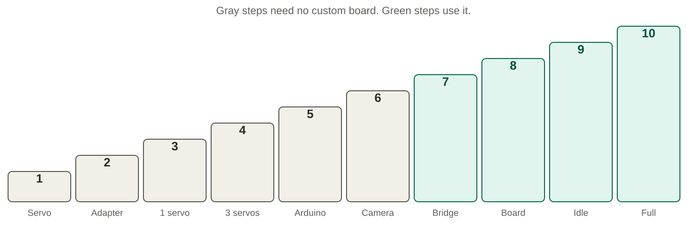
Bring-up ladder
# | Step | Do | Pass when
1 | Servos alone | Adapter jumper B, USB to PC, 12V supply. Set IDs 1, 2, 3 one servo at a time. | Ping returns IDs 1, 2, 3.
2 | Move from Python | Sweep each servo with the Feetech SDK. Read position, voltage, temperature. | Smooth motion, readings sane.
3 | Camera | OpenCV window with MediaPipe landmarks. | 21 points track your hand at a steady frame rate.
4 | Finger values | Compute 3 curl values with smoothing. | Numbers steady with your hand still.
5 | Mirror | Send the values to the servos through the adapter. | Hand copies yours, no stall against the mechanics.
6 | Gestures | Gesture Recognizer to stored poses. | Rock, paper, scissors played reliably.
7 | Board power and USB | Check 5V and 3.3V rails, plug in USB. | Board appears as a COM port, blink sketch uploads.
8 | Bridge test | SPI to SC16IS750, TX to RX loopback at the servo baud rate. | Bytes sent equal bytes received.
9 | Board to servos | Board UART to adapter jumper A. Ping one servo, then three. | All three respond through the board.
10 | Idle mode | Stop PC data, wait for the timeout, reconnect. | Idle gesture plays, then following resumes.

11. Cheat sheet: numbers worth remembering
Item | Value | Source
STS3215 voltage and stall | 6 to 12.6V, 12V recommended; locked-rotor about 2.7 A | Waveshare ST3215 wiki and product page
STS3215 torque and speed (12V) | 30 kg.cm, 0.222 s per 60 degrees | Waveshare product page, your box
STS3215 resolution, IDs, baud | 4096 steps per 360 degrees; ID 0 to 253; 38400 to 1 Mbps (1 Mbps default) | Waveshare product sheet
Adapter (A) input | 9 to 12.6V, must match servo; up to 253 servos in theory | Waveshare adapter wiki
SC16IS750 | 64-byte FIFOs; SPI 4 Mbit/s; UART up to 5 Mbit/s; supply 3.0 to 3.6V; inputs 5.5V while powered | NXP datasheet
ATmega328P | 20 MHz max; 1.8 to 5.5V; 32 KB flash, 2 KB SRAM, 1 KB EEPROM | Atmel datasheet
SN74LVC1G125 | 1.65 to 5.5V; output off when OE is high | TI datasheet
MediaPipe hand | 21 landmarks; x,y normalized 0 to 1; confidence defaults 0.5 | Google MediaPipe docs
Trace width (IPC-2221) | External layer k = 0.048, b = 0.44, c = 0.725 | DigiKey calculator

12. Glossary
UART | Two-wire serial link (TX, RX) at an agreed baud rate.
Half-duplex | One wire, one talker at a time. The servo bus works this way.
Tri-state buffer | A gate whose output can switch off, letting several devices share a wire.
SPI | Fast four-wire link between a controller and chips.
DTR / auto-reset | A USB-serial pin that resets the ATmega so uploads start by themselves.
Bootloader | Small program in the chip that accepts uploads over serial.
FIFO | Hardware buffer holding bytes in order until they are read or sent.
Stall | Motor pushing against a block. Highest current, fastest heating.
Sync write | One servo packet that sets several servos at once.
Landmark | One tracked point on the hand, such as a fingertip or knuckle.
Underactuated | Fewer motors than joints. Mechanics share motion between fingers.
Whiffletree | Pivoting bar that splits one pull evenly between two tendons.

13. Not verified yet
Treat these as open until you or the board developer confirm them.
- SC16IS750 allowed clock range for a 16 MHz crystal (derived 1 Mbps, not read from the datasheet).
- Whether the Feetech Arduino library can run through a wrapper on the SC16IS750.
- Current rating of the adapter's DC jack and screw terminal (Waveshare publishes none).
- Palm width versus three STS3215 side by side (check against your CAD).
- Python version that has a mediapipe build on your PC.

