HAEBOT robot hand controller board: wiring diagram
The Waveshare adapter, the servo supply and the servos are separate from the custom board (shown outside the green frame).
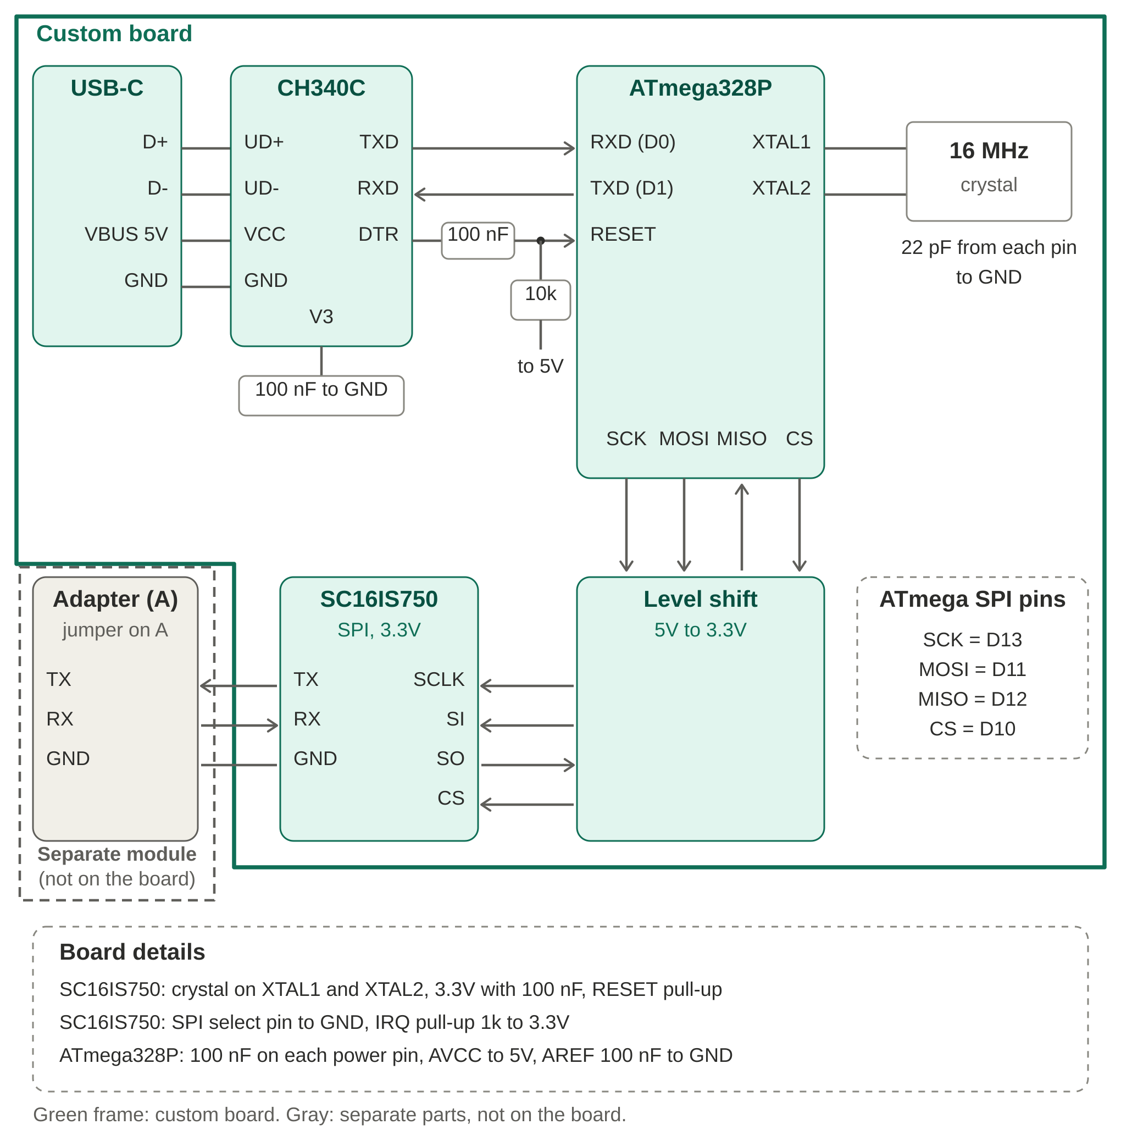

Block diagram and power diagram

Block diagram
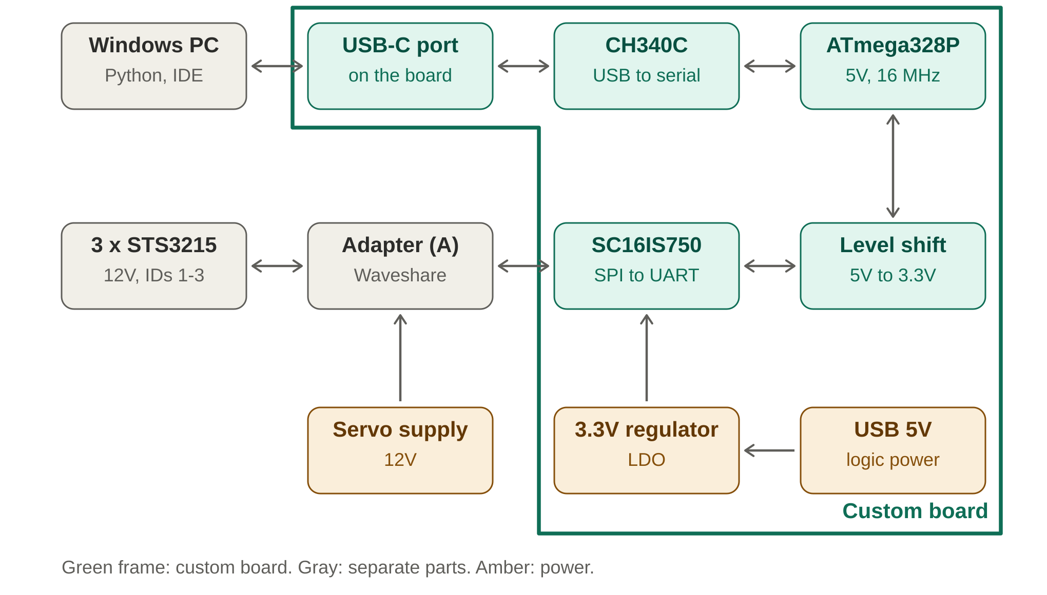

Power diagram
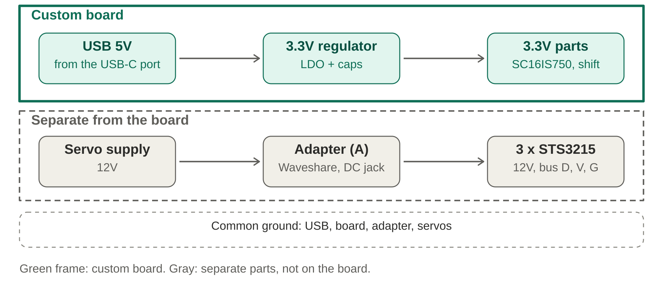

Why this design
Python, OpenCV and MediaPipe run on the PC. Only a few finger values travel over one USB cable to the board, which turns them into servo commands.

Data path
Step | What it does
1. PC | Python, OpenCV and MediaPipe find the hand and compute finger values
2. USB cable | Carries the values, firmware uploads and logic power
3. CH340C | Converts USB to serial for the ATmega328P
4. ATmega328P | Reads the values, applies limits, sends servo commands
5. SC16IS750 (SPI) | Adds a second UART so servo traffic does not share the USB serial port
6. Adapter (A), separate module | Not on the custom board. Converts UART to the servo bus and feeds the 12V to the servos
7. 3 x STS3215 (12V) | Move the fingers (IDs 1, 2, 3)

Why we chose it
Choice | Reason
USB cable only | One cable for firmware upload, data and logic power. No pairing and no dropped packets. Wi-Fi and Bluetooth were considered and are not needed, because tracking runs on the PC and only a few numbers are sent.
ATmega328P (Nano style) | Same chip family as the Arduino Nano, so tools and code are familiar. Enough for a bridge with safety limits, because vision stays on the PC.
SC16IS750 over SPI | The ATmega328P has one hardware serial port and USB uses it. The SC16IS750 gives the servo bus its own UART.
Level shifter | The ATmega328P runs at 5V and the SC16IS750 at 3.3V.
Waveshare Adapter (A) | A separate module, not part of the custom board. It already converts to the servo bus and has its own power jack. Jumper on A, wiring RX to RX and TX to TX.
Separate 12V servo supply | Plugs into the adapter, never into the custom board. Three STS3215 servos can draw about 8 A when stalled (2.5 to 2.7 A each), which USB cannot supply.
Room for more servos | One bus carries many servos (Waveshare lists up to 253). Going to 5 servos needs no change on the board, only a unique ID per servo and a stronger supply.

