OpenDocument Text Template for ICSC 2022
AuthorA1 and AuthorB2,

1 InstituteA
2 InstituteB
Icsc2022.music@gmail.com
Abstract. The abstract should summarize the contents of the paper and should contain at least 150 and at most 350 words. It should be written using the abstract style provided in this template. It should be set in 9-point font size and should be inset 1.0 cm from the right and left margins. There should be two blank (10-point) lines before and after the abstract. This document is in the required format.
Keywords: We would like to encourage you to list your keywords in this section.
- Introduction
This is an Open Document Text template for (Libre|Open)Office or Word users for the preparation of manuscripts for the 6th International Csound Conference — ICSC2022. This template is provided as a second choice to the preferred LaTeX template, also available.
The maximum paper length is six pages including abstract, figures, tables and eventual references. An additional seventh page is accepted provided it only includes references.
To guarantee the double blind review process, manuscripts should not include the author names nor affiliations. Please keep the generic names included in the template.
- Paper Preparation
Please do not modify the page format (paper size, margins) or any of the styles included in this template. To ensure consistency in the layout, the use of direct formatting is discouraged in favor of the use of the available styles.
This document is designed to use the Computer Modern Roman font. The required fonts are included in this package in TrueType and Open Type Font formats; refer to the documentation of your operating system to see how to install fonts and make them available to your word processor. A version of this document in PDF is provided, to verify that the right fonts are being used.
Italic type may be used to emphasize words in running text. Bold type and underlining should be avoided.
  - Sections and Headings
Only two levels of structure should be used throughout the document, corresponding to the heading1 and heading2 styles in this template. The font sizes and styles are given in Table 1.
Headings should be capitalized, i.e., nouns, verbs, and all other words except articles, prepositions, and conjunctions should be set with an initial capital. Words joined by a hyphen are subject to a special rule: if the first word can stand alone, the second word should be capitalized. Here are some examples of headings: “Developing a User-Friendly Interface”, “Processing Multi-track Audio Files with Granular Techniques”.
The first paragraph in each section should use the pa1 style; subsequent paragraphs should use the Default Style.
Table 1. Font sizes of headings. Table captions should always be positioned above the tables.
Heading level | Example | Font size and style
Title (centered) | Lecture Notes … | 14 point, bold
1st-level heading | 1 Introduction | 12 point, bold
2nd-level heading | 2.1 Printing Area | 10.5 point, bold
3rd-level heading | Remark. Text follows … | 10 point, italic

  - Page Numbering and Running Heads
Pages are numbered automatically. If your paper title is too long to serve as a running head, use a shortened version in the page header.
  - Footnotes
The superscript numeral used to refer to a footnote appears in the text either directly after the word to be discussed or – in relation to a phrase or a sentence – following the punctuation mark (comma, semicolon, or period). Please insert footnotes using the appropriate function in your word processor.
  - Figures
Figures should be centered and sequentially numbered; copying and pasting the captions in this template should number the figures automatically.
All figures should have a caption positioned under the figures, in contrast to the caption belonging to a table, which should always appear above the table. Please use the figure legend (9-point type) style for captions. Short captions fitting in one line should be centered, multi-line captions should be justified. Fig. 1 shows an example.
Fig. 1. Spectrogram of a piano note A3 in vector graphics (SVG).
For line drawings, vector graphics file formats like SVG are preferred when available. When including figures in raster graphics file formats like JPG or PNG, please try to generate an image of the appropriate size and quality. (See Figs. 1 and 2)
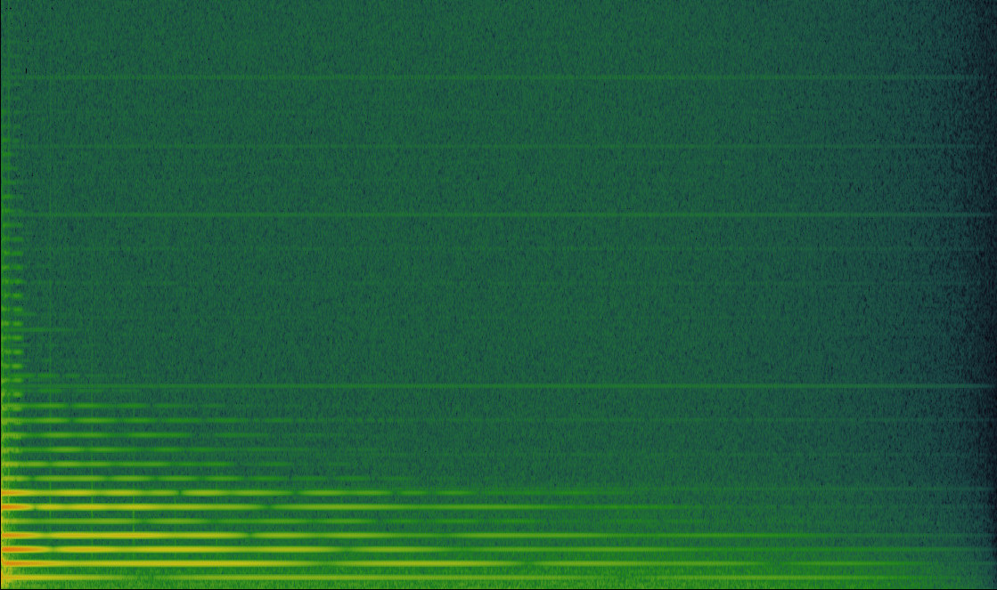
Fig. 2. Spectrogram of the same sound file in raster image (JPG, 1119×663 pixels).
Remark. The proceedings will be distributed only in electronic format, and colored images are welcome. It would be convenient, however, to make sure that all the images remain clear and legible when printed in black and white.
  - Program Code
Program commands in the text should use the code style: csound -o dac foo.csd; program listings should use the programcode style.
Example of Program Code
<CsoundSynthesizer>
<CsInstruments>

sr = 48000
ksmps = 8
0dbfs = 1

instr 1

idur = p
iamp = ampdbfs(p4)
ifreq = cpspch(p5)
kamp linen iamp, 0.1, idur, 0.3
a1 poscil kamp, ifreq
out a1

endin

</CsInstruments>
<CsScore>

i1 0 1 -3 8.00
i1 + . -6 8.01
i1 + . -4.5 8.07

</CsScore>
</CsoundSynthesizer>
  - Citations
For citations in the text please use square brackets and consecutive numbers: [1], [2], [3], etc.
- The References Section
Only references written using the Latin alphabet are accepted. If the title of the reference uses a different alphabet, please use the transcript or translation of the title, followed by the original language in parenthesis, e. g. (in Russian) or (in Chinese).
The following section shows a sample reference list with entries for journal articles [1], books [2], [3], book chapter [4], proceedings without editors [5], as well as a URL [6].
References
1. Lorrain, D.: A panoply of stochastic ‘cannons’. Computer Music Journal 4(1), 53–81 (1980)
2. Dodge, C., Jerse, C.: Computer Music: Synthesis, Composition and Performance, 2nd edn. Schirmer, New York (1997)
3. Lazzarini, V. et al.: Csound: A Sound and Music Computing System. Springer (2016)
4. ffitch, J.: Introduction to program design. In: R. Boulanger, V. Lazzarini (eds.) The Audio Programming Book, pp. 383–430. MIT Press, Cambridge (2010)
5. Vercoe, B.: Real-Time Csound, Software Synthesis with Sensing and Control. In: Proceedings of the International Computer Music Conference, pp. 209–211. Glasgow (1990)
6. Csound Github site, http://csound.github.io

Example of a footnote

