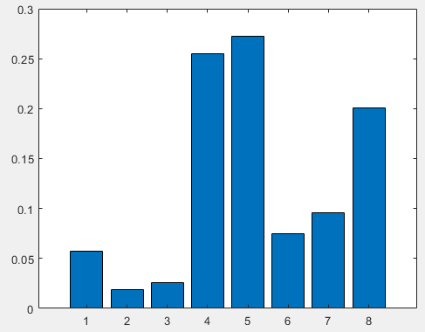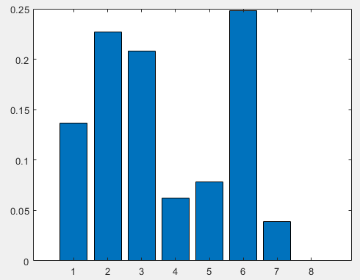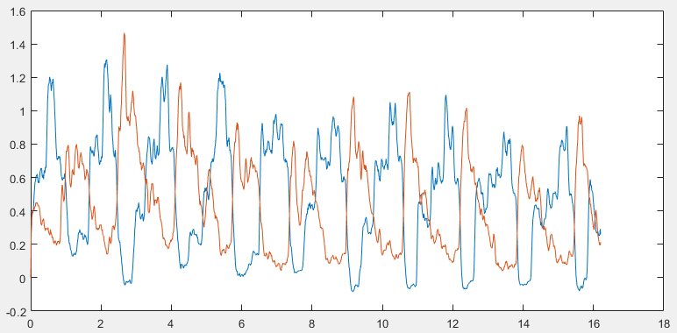

% EMG import

EMG=importdata('subj65_iVC_s01.txt');

EMG=EMG.data(27232:189228,1:8);

% synergy extraction

EMG_ma=muscle_activation(EMG);

[W, H] = NMF_E(EMG_ma',2,5000);

W=W./repmat(sum(W),[size(W,1),1]); % size(8x2)

H=W\EMG_ma'; % size(2x162007)