Name: Ritika Rane Email id: [raner@oregonstate.edu](mailto:raner@oregonstate.edu)

**Project 1**

**OpenMP: Monte Carlo Simulation**

* **Probability**

After checking the probability between the trials 10000 to 1000000, the probability ranges from **29% to 31%**

* **Code Snippet**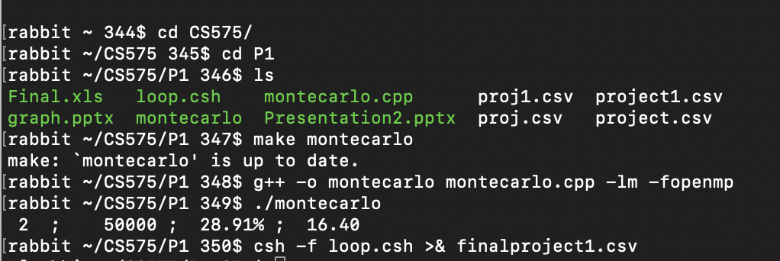
* **Graphs**

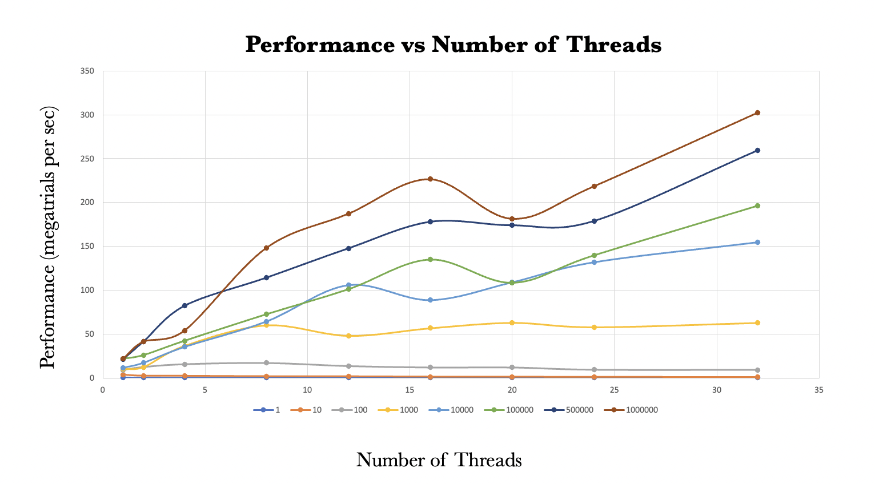

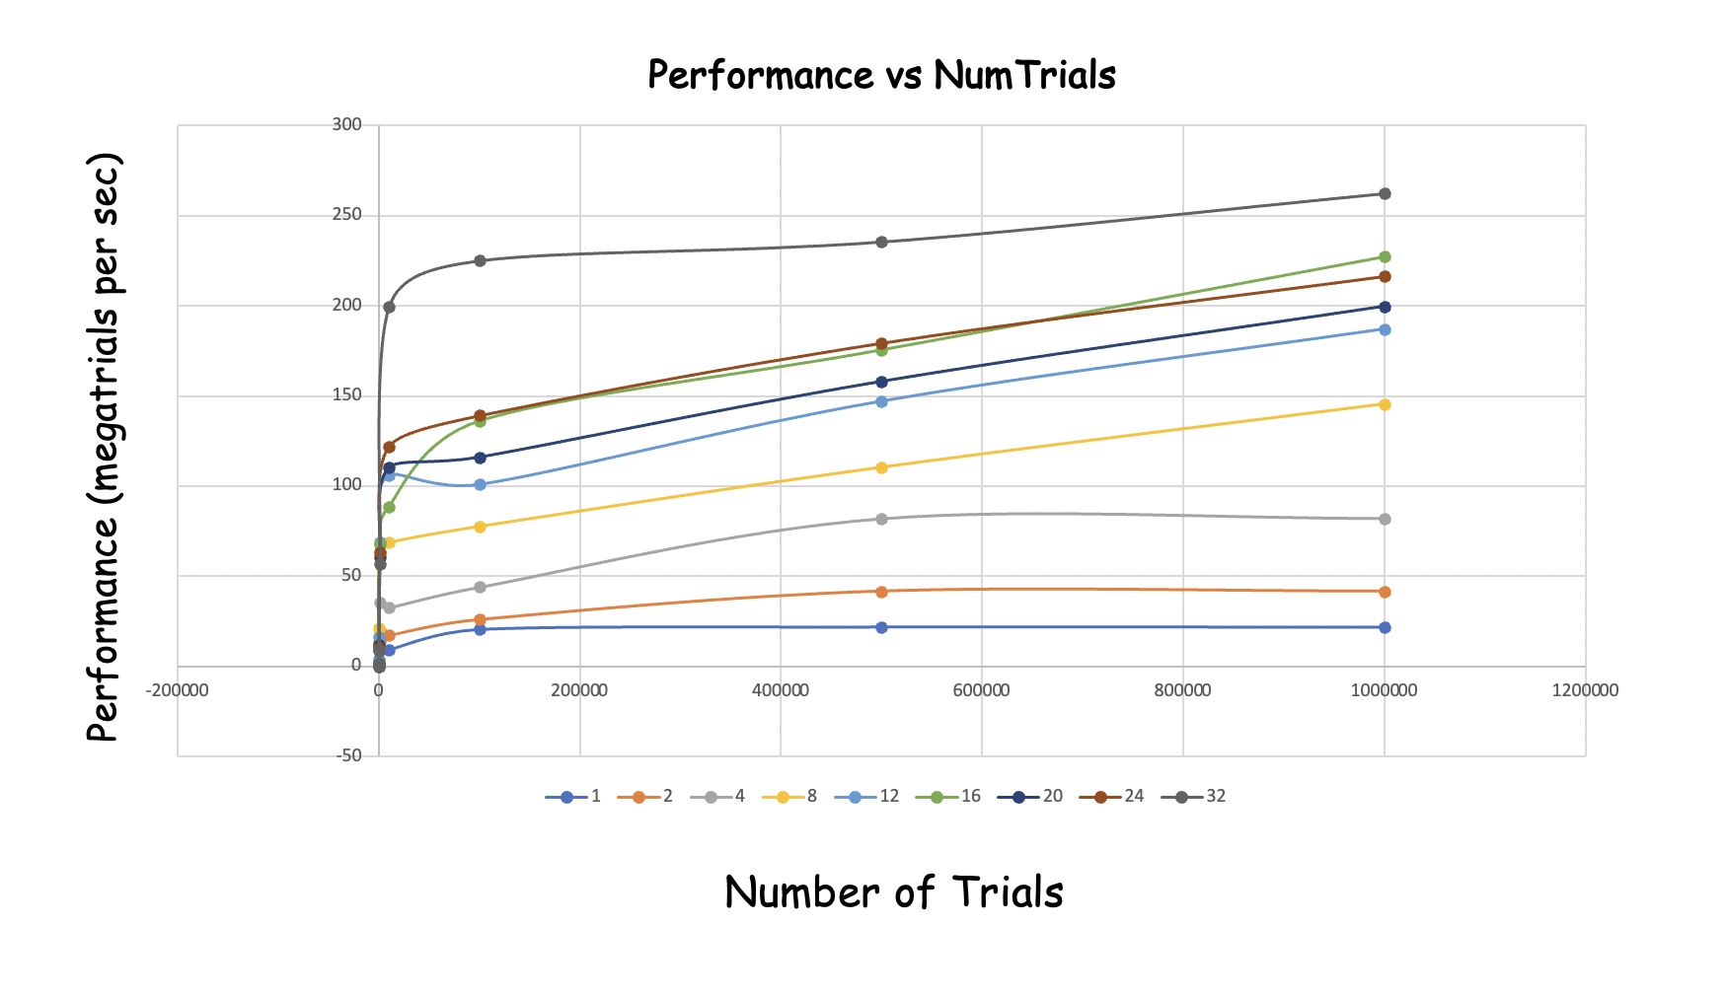

* **Parallel Fraction, Fp:**

float Fp = (4./3.)*( 1. - (1./S))

S = (Performance with four threads) / (Performance with one thread)

= 82.19/ 21.31

= 3.8569

Fp = (4./3.)*( 1. - (1./3.8569)) = 0.9876