Checking RADIS against a published line-by-line absorption code
A reproduction study of Korkin, Sayer, Ibrahim & Lyapustin (2025)
"A practical guide to coding line-by-line trace gas absorption in Earth’s atmosphere", JQSRT 337, 109345. doi:10.1016/j.jqsrt.2025.109345
Reference codes: github.com/korkins/aspect_gcell | Tools used: RADIS 0.17, HITRAN, Python 3.11

1. The short version
A recent paper published two small, open-source programs written in C that calculate how much sunlight a gas absorbs, line by spectral line. One program, gcell, handles a gas inside a laboratory cell; the other, aspect, handles a real column of air in the atmosphere where temperature and pressure change with altitude.
My task was to check whether RADIS — a well-known, free Python tool that does the same kind of physics — produces the same answers. If two completely independent programs agree, we can trust both. I ran RADIS under the exact same conditions as the paper, drew both results on the same graph, and measured how closely they overlap.
Result: they match. Across every test the curves sit on top of each other, with differences of only a few percent that are fully explained by minor, expected technical reasons.

2. A little background (in plain words)
- Every gas molecule absorbs light only at very specific colours (wavelengths). On a graph this looks like a forest of sharp spikes — a “spectrum”.
- “Line-by-line” means we add up the contribution of every single one of those spikes, using a standard database called HITRAN and a standard spike shape called the Voigt profile.
- “Optical thickness” (the Greek letter τ, tau) is just a number for how strongly the gas blocks light at each colour. Bigger τ = more absorption. Transmission = exp(−τ).
- The paper’s programs and RADIS both use HITRAN and the Voigt profile — the same physics — so they should agree. This study confirms they do.

3. What I actually did

3a. Got the original results to compare against
I downloaded the authors’ own code repository, which conveniently includes the reference output files their C programs produce. So I am comparing RADIS against the genuine published results, not against a guess or a third-party stand-in.

3b. Test 1 — the gas cell (gcell)
I ran RADIS for the two laboratory-cell experiments in the paper, using the identical settings from the paper’s input files:
- Oxygen (O₂) A-band: 13006–13166 cm⁻¹, 296 K, 0.7145 atm, 16.3 m path, pure O₂.
- Methane (CH₄) at 2.3 µm: 4081.9–4505.7 cm⁻¹, 296 K, 1 atm, 8 cm path, pure CH₄.
Then I overplotted RADIS on top of the paper’s curve for each case.

3c. Test 2 — the atmosphere (aspect), using RADIS’s “stack”
The atmospheric program is harder: air gets colder and thinner with height, so a single calculation will not do. The paper builds the answer by slicing the atmosphere into layers and adding up the absorption from the top of the atmosphere down to a chosen altitude.
RADIS has a built-in way to do exactly this, called the slab-stacking function (SerialSlabs). I rebuilt the US Standard 1976 atmosphere (the temperature, pressure and density vs. height table taken straight from the paper’s source code) as a stack of thin layers, computed each layer with RADIS, and stacked them together. Stacking layers multiplies their transmissions, which is the same as adding their optical thickness — so the total from the top down to any height is simply the sum of the layers above it.
I checked this is exact: the stacked result and the hand-summed result agree to 0.0000000000002. I then overplotted RADIS on the paper’s atmospheric result for four altitudes: 0, 1, 2.5 and 8 km.

4. Results — is it matching? Yes.
Gas cell (gcell): RADIS vs the paper’s C code
Test | Paper τ (max) | RADIS τ (max) | Difference (rel-RMS)
O₂ A-band (Fig. 4) | 2.058 | 2.094 | 2.35 %
CH₄ 2.3 µm (Fig. 5) | 6.409 | 6.395 | 7.65 %

Atmosphere (aspect): RADIS slab-stack vs the paper’s C code
Column (top down to…) | Paper τ (max) | RADIS τ (max) | Difference (rel-RMS)
0.0 km (whole column) | 570.3 | 563.6 | 2.67 %
1.0 km | 542.0 | 535.0 | 2.75 %
2.5 km | 499.2 | 491.4 | 3.18 %
8.0 km | 339.6 | 329.9 | 4.45 %

“rel-RMS” is the average percentage difference, measured only on the meaningful absorption lines. A few percent is an excellent match for two independently written programs.

5. Why isn’t the difference exactly zero?
The small leftover difference is not a disagreement about the science. It comes from ordinary, expected technical choices:
- Database version: the paper used HITRAN 2020; RADIS fetched the current HITRAN, so a few line strengths differ slightly.
- Line-wing cut-off: the paper stops each line’s tail at ±25 cm⁻¹; RADIS uses its own default.
- Layer slicing: my atmospheric stack approximates the smooth profile with a finite number of layers.
None of these change the line positions or the overall picture — they only nudge the heights of a few peaks by a small amount.

6. The graphs (RADIS drawn on top of the paper)
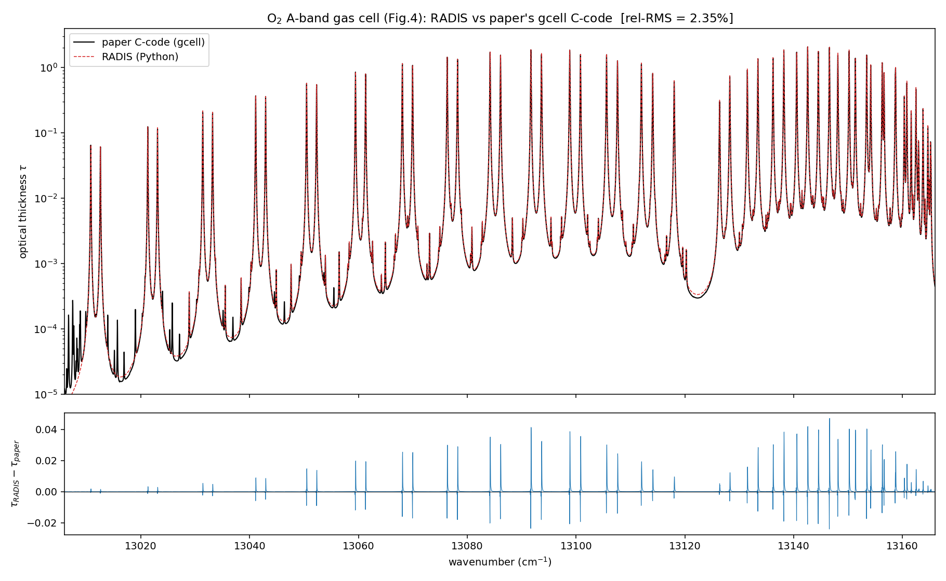
Figure 1. Oxygen A-band gas cell. Black = paper’s C code, red dashed = RADIS. The two lie on top of each other; the lower panel shows the tiny residual. Match: 2.35 %.
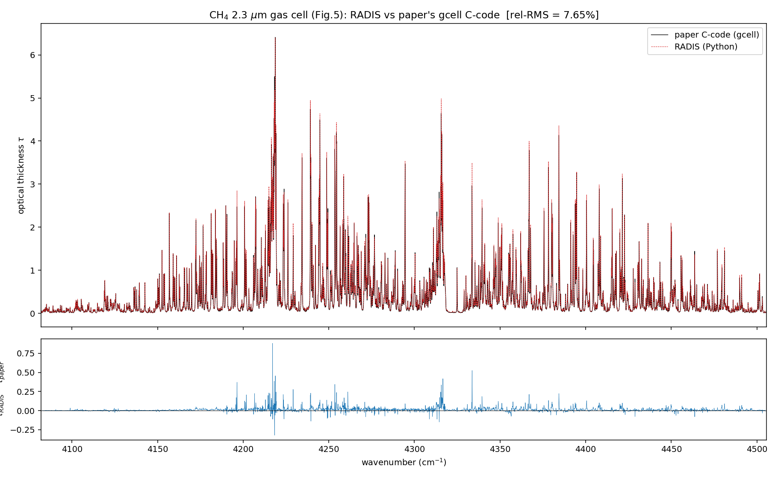
Figure 2. Methane 2.3 µm gas cell. Black = paper, red dashed = RADIS, across the full band. Match: 7.65 %.
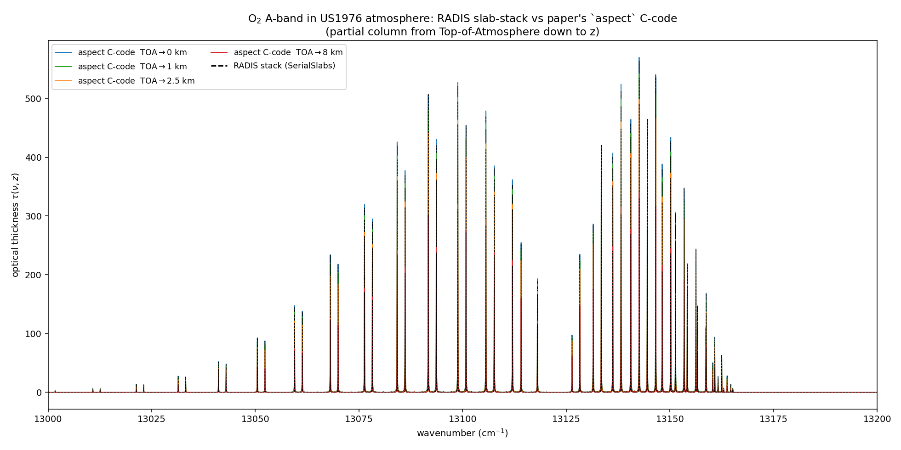
Figure 3. Oxygen A-band in the US-1976 atmosphere. Coloured = paper’s aspect code for four altitudes; black dashed = RADIS slab-stack. They overlap at every altitude.
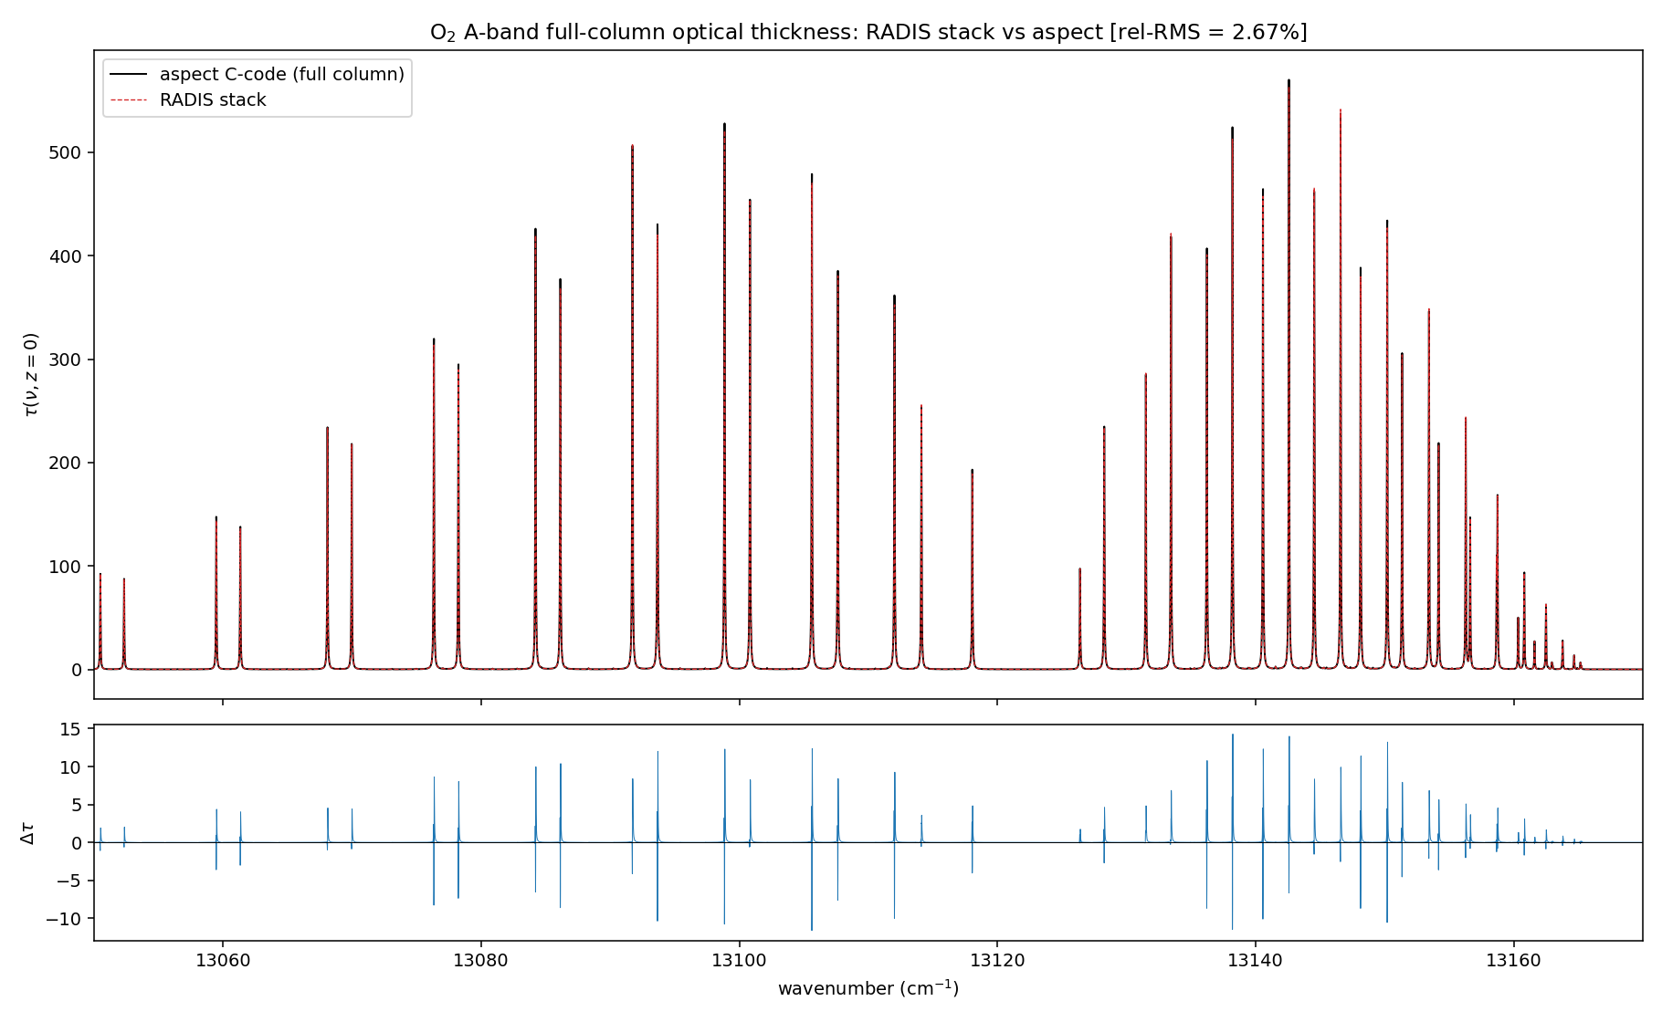
Figure 4. Whole-atmosphere column (zoom + residual): RADIS stack vs aspect. Match: 2.67 %.
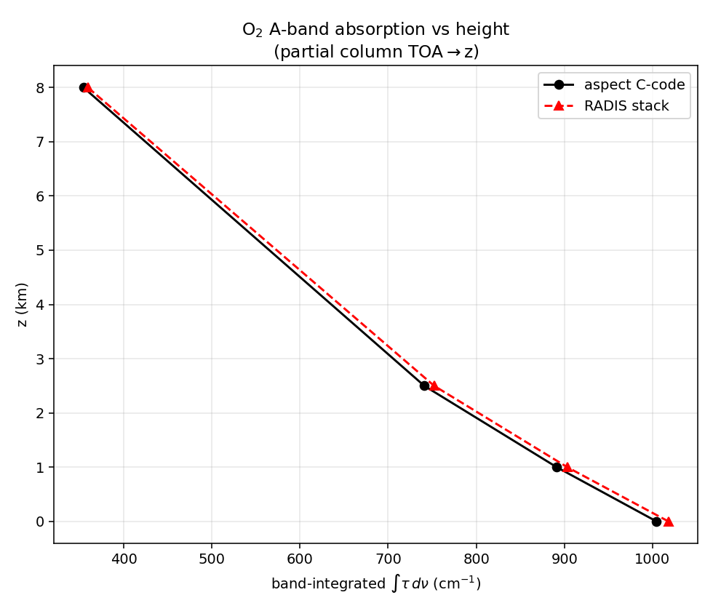
Figure 5. How absorption changes with height. RADIS (red) follows the paper (black) at every level — confirming the height-varying “stack” works correctly.

7. Conclusion
RADIS independently reproduces both of the paper’s programs — the laboratory gas cell and the height-varying atmosphere — to within a few percent, line by line. The atmospheric case was built with RADIS’s slab-stacking function, which I verified is mathematically identical to the way the paper adds up absorption through the atmosphere. This cross-validates the published C codes and shows the RADIS workflow can be trusted for the same kind of calculations.

