**Larvel changes**

**I created the software using Neonlms template for laravel and i made many changes of it. The goal of it is make a checkup for company, so there are some checkups, argument and questionnaire. When the user finish the questionnaire the software show an automatic report based on answers.**

**Now all web work but have many small orrors to solve regard the page questions (by admin) and the questions that are visble in user page.**

**I attach a list of errors but after solved these list it is necessary make a meeting togheter to test al sofwìtware and see if there are otehr erros that now it is impossible see or explain.**

**I attach in details the features to solve**

1. **Question page, configuration an dvisualizzation in user page.**

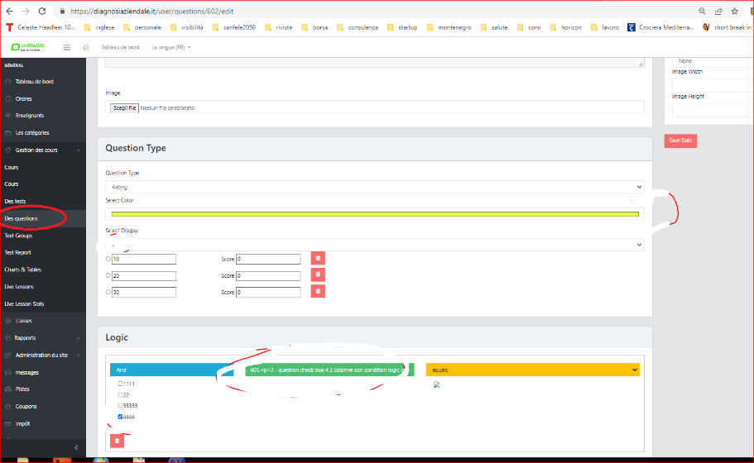

**Pratically now the software have some few error regard the creation of question by administartor. They are design and other erors of configuration. I attach these changes.**

**List of question page change (point 1)**

**1.1 add in “add file” type the options of type of file and dimention that the software must acept**

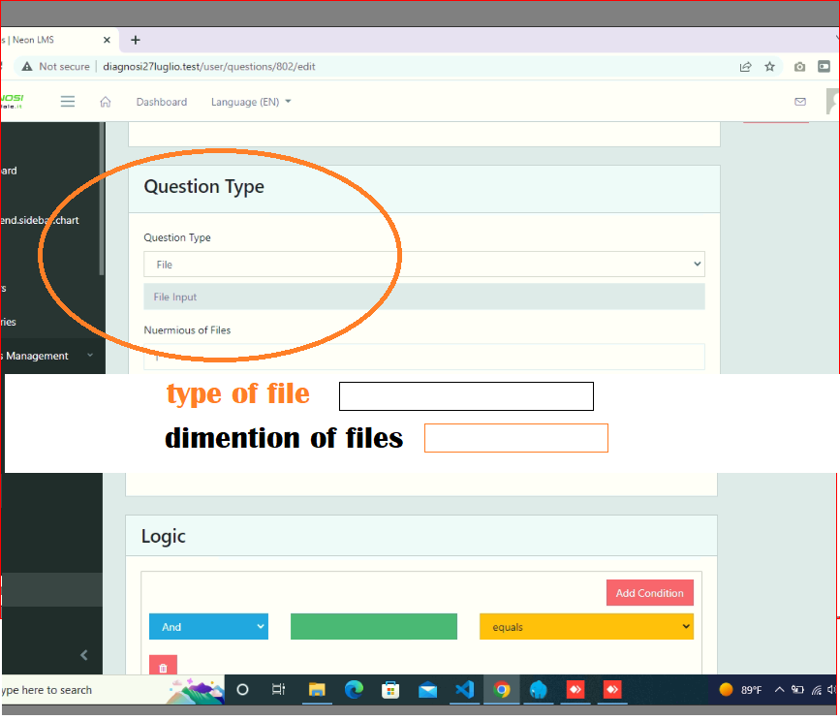

* 1. **It is also necessary that the administartor cna see the file add by users. Now in page “order” there is buton with the downlaos, but don’t work. So it is necessary that in order page the software show the list of file add by user to do the downlaod. make how the following image**

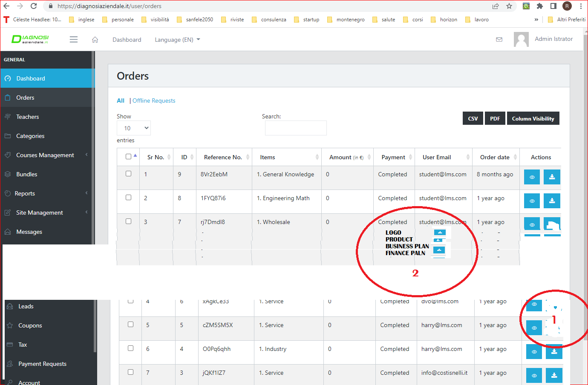

**1.3 Position of image of answer, dimention of text of answer and other options. Now the software have many options regard the description of questions. see the following images.** 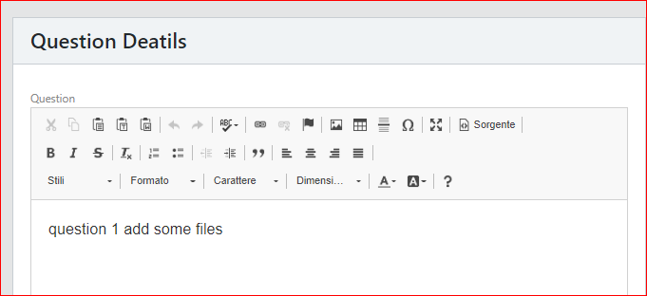

**But now the software don’t have the same options regard the answers. This is a problem. So it is neecessary solve to have the options to change the dimentions of text, position of images, etc. Now there is only some options on the right (see the following image) but give errors if the administartor make some changes of these options.**

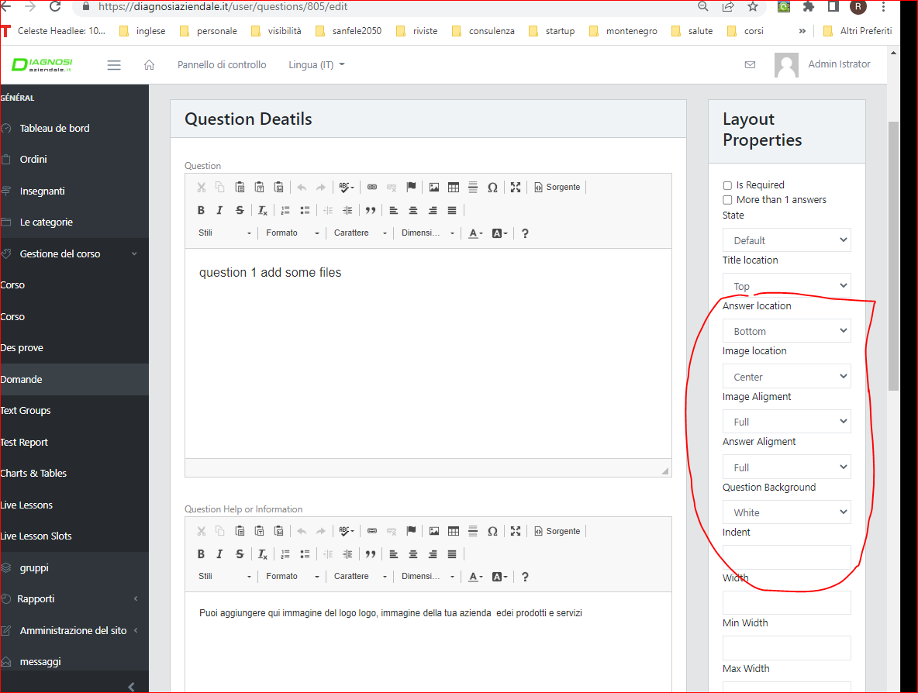

**I attach some errors: for example don’t show the description**

**when make the change here**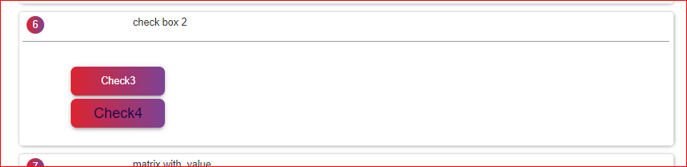

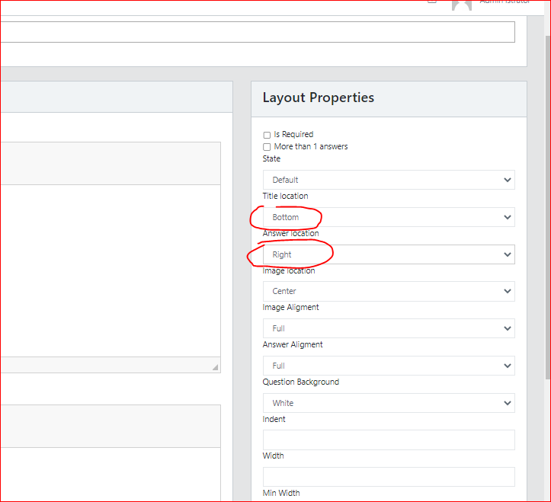

**or and don’t show the buttons** 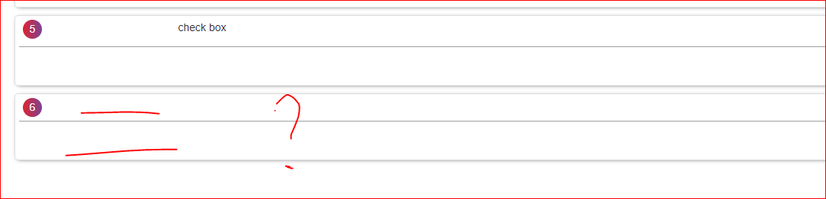

**Regard the image I want that the images cna be positioned where i want, for exaplample on the light an don the right description and answers. now it isn’t possible**

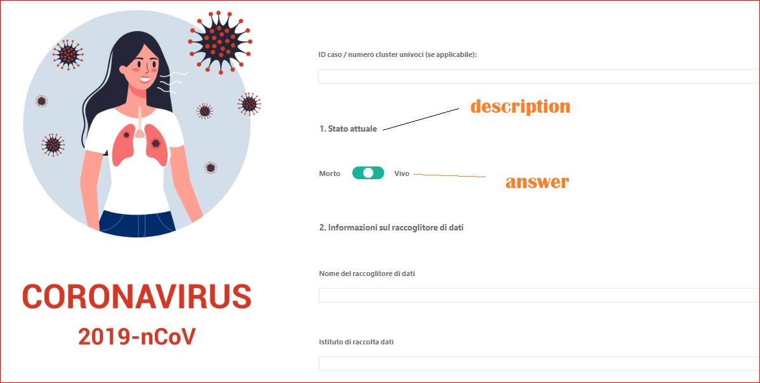

**1.4 question single input and value in euro. In admin, type of questioni t is necessray add th eimpostation of dimention of box**

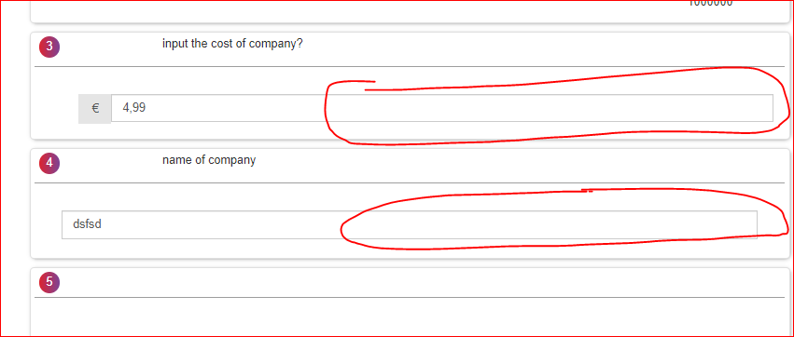

**1.5 button template and button of questionnaire. we must use a unique design of buttons, so we must ahave a button type for check boox and a different button for all button. this concept regard also the color (but this we can see toghether)**

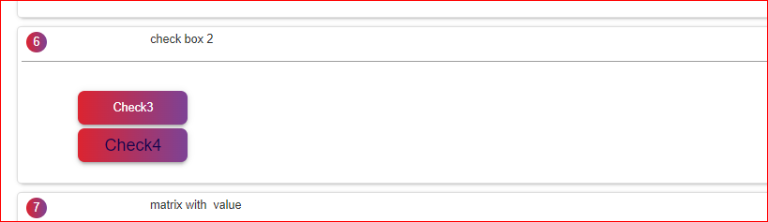

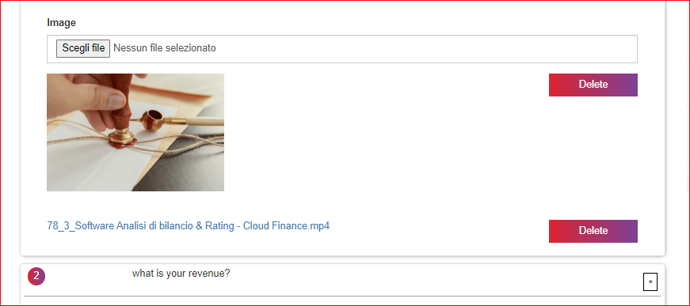

**1.6 table of question (in use rate showed bed)**

**Now in user the table have this orrible design and colors. we must use a better design and a color based on template style or personalized. And must be the impostation regard the font how template, alignement. Finally it is necessary delaite the text**

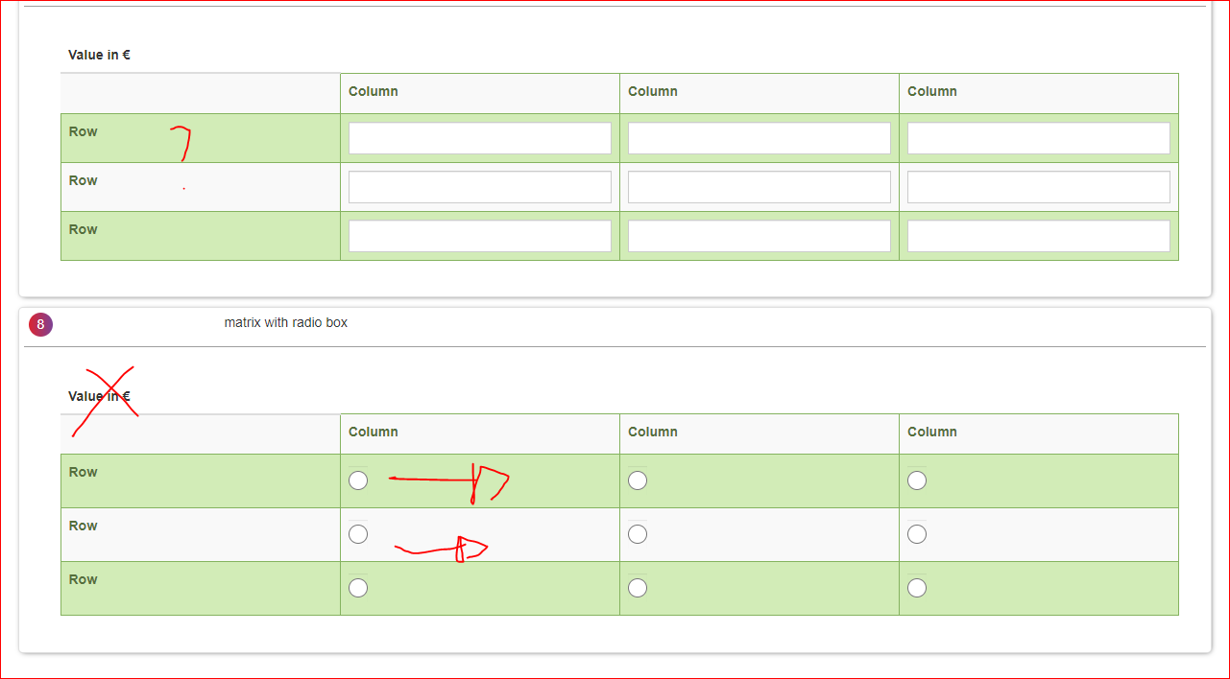

**1.7 value in €. regard value in € question, range and table with value in € it is necessray that the software use the “.” and the decimal automatically how i show yesterday, so for example 10.000,00 (not 10000)**

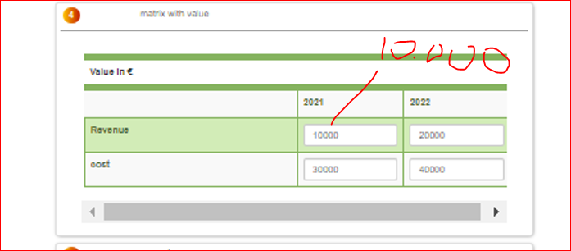

**all value of web must have the € logic, so (10.000,00), so point and decimal**

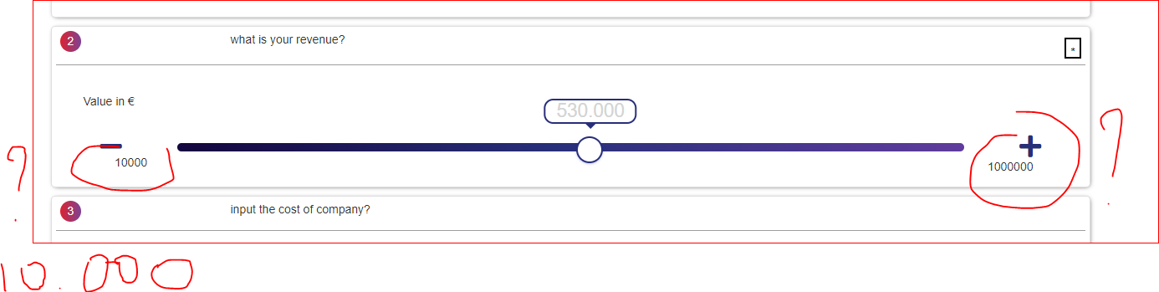

**1.8 problem regard the position of text. Now when there is an image th e software don’t make the correct position of text. by image see tha tth eadministartor put central alignment down the image but the software show the text near the image.**



**1.9 requestion question: now there is the option obbligatory. to have obbligatory answer it is neecssary click”is request”. I want how default the option “is request”**

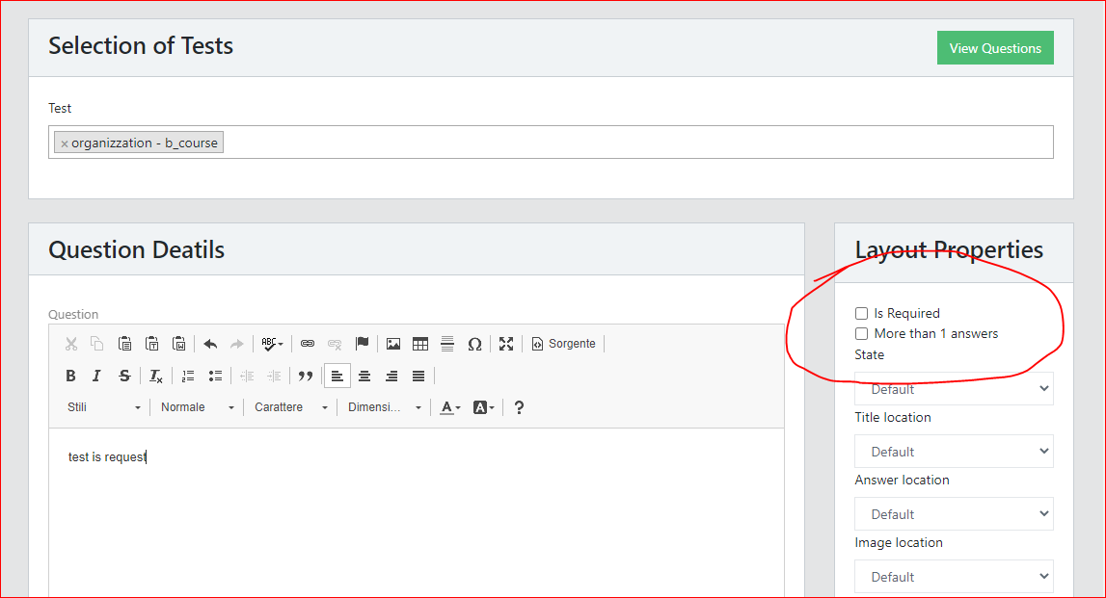

**1.10 make a button of checkbox different by button of template, and must have many different color regard seelcted, not selcted. now the difference is minimal**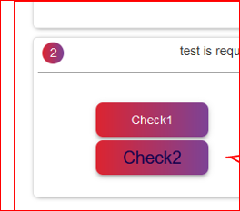

**1.11 other colors of all type of answers. Now some question have the possibility to change the colors, other have the color of tempate, other have a fixed color (for example matrix green). it is necessary for al type of answer have a dedault color based on template, and the option to make personalizzation. this must be identical for all type of answers**

**Very Important conditions:**

1. max budget 30$ .
2. job deadline: 2 days

3. it is necessary verify before all code, all document and all web by login because only in this way the developer can value if have the competence to solve the errors

4 I open the milestone only if the developer demostrate me that understand the job and make a proof regard code and design style.

So i can also open the milestone but you don’t acept because i want see the first changes to verify your competence. If the proof is ok for me you can acept. So we don’t waste time and ater delate the milestoone an dpay both the fee to Freelancer

5. after acept no apolagies and the job must be perfect in every thing, so enougth errors.