SHELL SORT

Shellsort is one of the oldest sorting algorithms, named after its inventor D.L. Shell (1959) [She 59]. It is fast, easy to understand and easy to implement. However, its complexity analysis is a little more sophisticated.

Shellsort is a generalization of insertion sort that allows the exchange of items that are far apart. The idea is to arrange the list of elements so that, starting anywhere, considering every hth element gives a sorted list. Such a list is said to be h-sorted. Equivalently, it can be thought of as h interleaved lists, each individually sorted.^{[6]} Beginning with large values of h, this rearrangement allows elements to move long distances in the original list, reducing large amounts of disorder quickly, and leaving less work for smaller h-sort steps to do.^{[7]} If the file is then k-sorted for some smaller integer k, then the file remains h-sorted. Following this idea for a decreasing sequence of h values ending in 1 is guaranteed to leave a sorted list in the end.

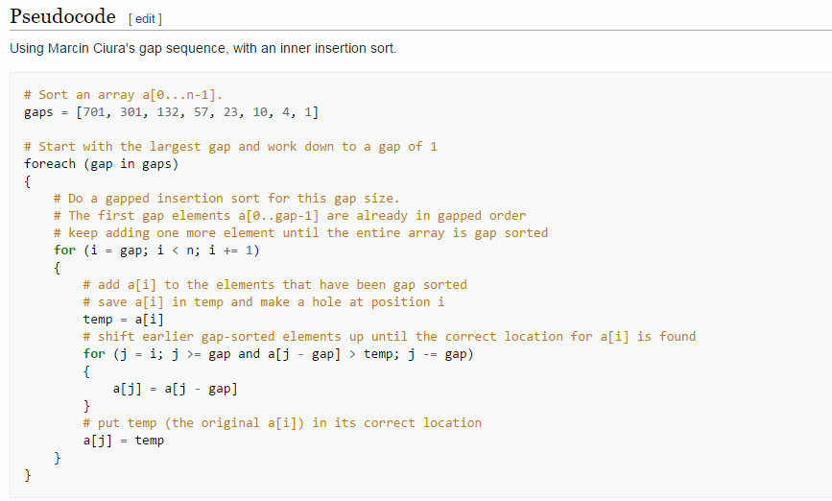

Shell Sort with Threads

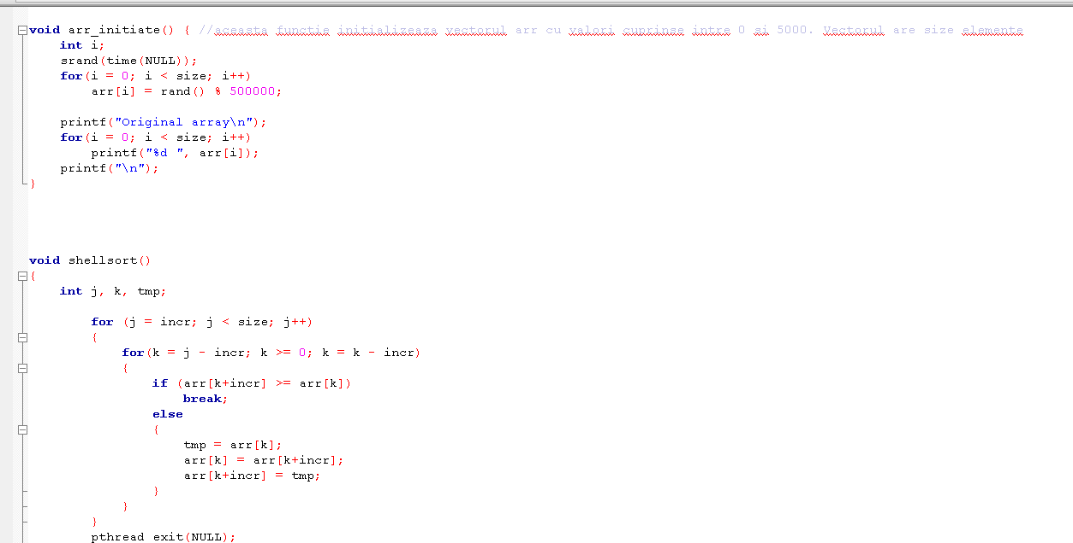
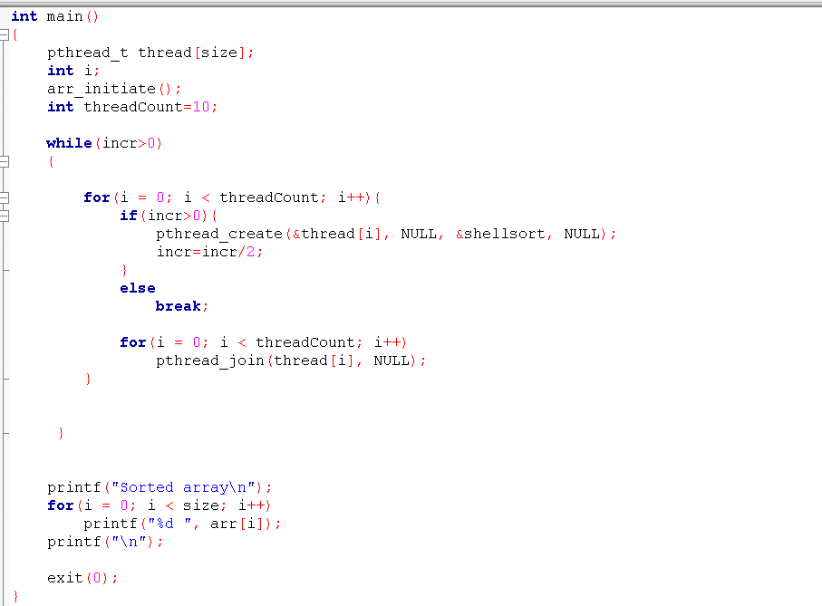

Shell Sort with Cuda

Sorting is a classic algorithmic problem and its importance has led to the design and implementation of various sorting algorithms on many-core graphics processing units GPUs. CUDA shellsort, is proposed for many-core GPUs with CUDA. CUDA shellsort is also robust over various data distributions and could be suitable for other many-core architectures.

