Assignment 4

Ryan Dill
CS 432
February 27, 2018

1. Determine if the friendship paradox holds for my Facebook
account.* Compute the mean, standard deviation, and median of the
number of friends that my friends have. Create a graph of the
number of friends (y-axis) and the friends themselves, sorted by
number of friends (y-axis). (The friends don't need to be labeled
on the x-axis: just f1, f2, f3, ... fn.) Do include me in the graph
and label me accordingly.

* = This used to be more interesting when you could more easily download
your friend's friends data from Facebook. Facebook now requires each
friend to approve this operation, effectively making it impossible.

I will upload a csv file of my 2014 friends list on the #assignment-4 slack channel

For this problem I used assignment4_1.py to graph the data I had extracted from the .csv file provided by Prof Anwala since I don’t use Facebook.
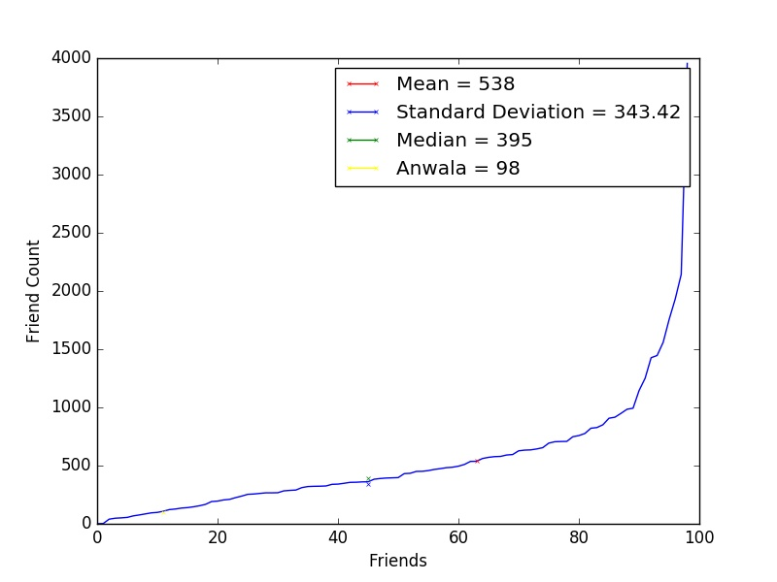

2. Determine if the friendship paradox holds for your Twitter account.
Since Twitter is a directed graph, use "followers" as value you measure
(i.e., "do your followers have more followers than you?").

Generate the same graph as in question #1, and calcuate the same
mean, standard deviation, and median values.

For the Twitter 1.1 API to help gather this data, see:

https://developer.twitter.com/en/docs/accounts-and-users/follow-search-get-users/api-reference/get-followers-list

If you do not have followers on Twitter (or don't have more than 50),
then use my twitter account "acnwala".

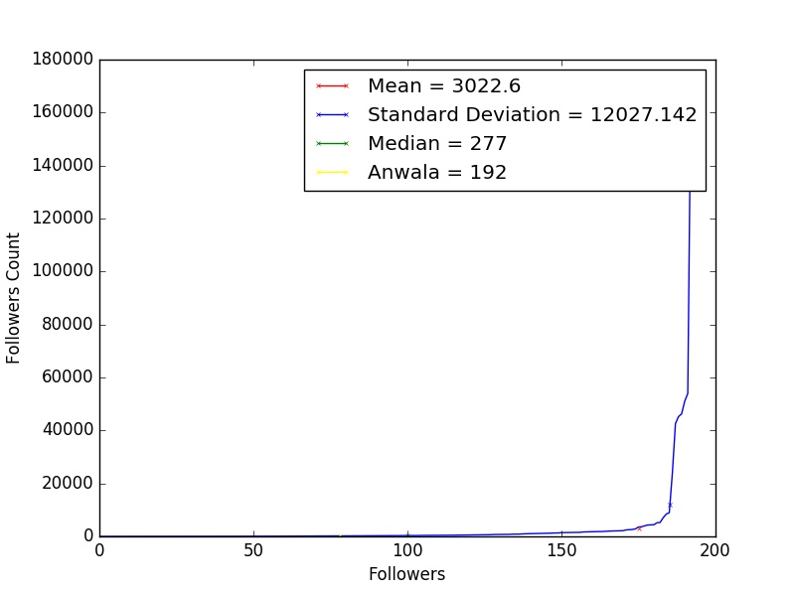
For this problem I did approximately the same thing as previously, however I used assignment4_3.py to extract the necessary data from Prof Anwala’s twitter account since I also do not use twitter. I tend to avoid social media in most all forms. I used assignment4_2.py to create the graph.

