Performance Analysis of CNN, RNN, and LSTM
Based Channel Estimation in Massive MIMO-OFDM
¹Swapna Priya Chikatla, ²T.Ravi babu, ³Mahendra Narla,
^{1,2,3}Associate Professor
¹Department of CSE, Vignan’s Institute of Information Technology (A), Visakhapatnam, India.
²Department of ECE, Miracle Educational Society Group of Institutions, Bhogapuram, Vizianagaram, India
3Department of AI&DS, G.Pullaiah College of Engineering and Technology, Kurnool, India
¹swapnachsp@gmail.com, ²razh1976@gmail.com, ³nmahendra@gpcet.ac.in,

Published online: 30 March 2026
Abstract – The ability of Massive Multiple-Input Multiple-Output (Massive MIMO) technology to provide excellent spectral efficiency and increased network capacity makes it an essential enabler for the next generation of wireless communication systems. However, the intricacies of high-dimensional channel matrices, pilot contamination, and sparse multipath propagation settings make accurate channel estimation in Massive MIMO systems a major issue. Conventional estimating techniques, such as compressed sensing and Least Squares (LS), are more computationally demanding and have worse accuracy when the signal-to-noise ratio (SNR) is low. In order to address these issues, this research presents a hybrid framework for sparse channel estimation that makes use of deep learning, particularly Convolutional Neural Networks (CNN) and Recurrent Neural Networks (RNN). The suggested framework is tested under Rayleigh fading conditions in a Massive MIMO-OFDM setting. Metrics like Bit Error Rate (BER), Mean Square Error (MSE), and estimation accuracy are used in performance evaluations. When compared to conventional LS and compressed sensing techniques, simulation results show that the CNN-RNN methodology considerably lowers BER and improves channel estimation performance. Additionally, the suggested paradigm strengthens robustness in dynamic wireless environments and successfully reduces pilot overhead. For the advanced wireless communication systems of 5G and the upcoming 6G, the created framework provides an effective and scalable solution.
Keywords- Massive MIMO, Channel Estimation, Convolutional Neural Network (CNN), Recurrent Neural Network (RNN), Sparse Wireless Communication.
- Introduction
The ability of Massive Multiple-Input Multiple-Output (Massive MIMO) technology to provide excellent spectral efficiency and increased network capacity makes it an essential enabler for the next generation of wireless communication systems [1-2]. However, the intricacies of high-dimensional channel matrices, pilot contamination, and sparse multipath propagation settings make accurate channel estimation in Massive MIMO systems a major issue. Conventional estimating techniques, such as compressed sensing and Least Squares (LS), are more computationally demanding and have worse accuracy when the signal-to-noise ratio (SNR) is low.
While the RNN component is in charge of capturing temporal correlations found in time-varying wireless channels, the CNN component is used to extract spatial features and identify sparse channel characteristics. The suggested framework is tested under Rayleigh fading conditions in a Massive MIMO-OFDM setting [3]. Metrics like Bit Error Rate (BER), Mean Square Error (MSE), and estimation accuracy are used in performance evaluations. When compared to conventional LS and compressed sensing techniques [4-5], simulation results show that the CNN-RNN methodology considerably lowers BER and improves channel estimation performance. Additionally, the suggested paradigm strengthens robustness in dynamic wireless environments and successfully reduces pilot overhead. For the advanced wireless communication systems of 5G and the upcoming 6G, the created framework provides an effective and scalable solution.
In order to address these issues, this work presents a hybrid framework for sparse channel estimation that makes use of deep learning methods [6-8], namely Convolutional Neural Networks (CNN) and Recurrent Neural Networks (RNN). Motivated by these challenges, this paper proposes a hybrid framework for sparse channel estimation in Massive MIMO wireless networks that combines CNN and RNN [9-11]. The suggested architecture improves estimate performance in sparse fading situations by using CNN layers to extract spatial data and RNN layers to train temporal channels. Metrics including Bit Error Rate (BER), Mean Squared Error (MSE), and estimation accuracy under different Signal-to-Noise Ratio (SNR) situations are used to evaluate the system's performance [12-14]
This paper is structured as follows. The system model and the creation of sparse Massive MIMO channels are described in Section II. The suggested CNN and RNN-based channel estimation paradigm is explained in detail in Section III. The simulation setup and performance evaluation measures are described in full in Section IV. The simulation results and a comparison using compressed sensing and least squares (LS) methods are shown in Section V. Section VI concludes the article by outlining possible directions for future research on AI-enhanced wireless communication systems.
- System model
The suggested system takes into account an Orthogonal Frequency Division-integrated Massive Multiple-Input Multiple-Output (Massive MIMO) wireless communication. framework. Multiplexing (OFDM) transmission. Massive MIMO technology employs a large number of antennas at the base station to simultaneously serve multiple users within the same frequency spectrum. This significantly improves spectral efficiency, throughput, and communication reliability. However, accurate channel estimation becomes increasingly difficult because of the large antenna dimensions and sparse multipath propagation conditions [15].
In the proposed work, a base station equipped with N_{t​} transmit antennas communicates with N_{r​} receive antennas through a sparse wireless channel. The communication system operates under Rayleigh fading conditions with Additive White Gaussian Noise (AWGN). The transmitted symbols are modulated using Quadrature Phase Shift Keying (QPSK) modulation and transmitted over OFDM subcarriers.
The received signal model for the Massive MIMO system is expressed as:
(1)
Where y represents the received signal vector, H denotes the channel matrix, x is the transmitted signal vector, n is the additive noise vector.
The wireless channel matrix H consists of multiple propagation paths between transmit and receive antennas. Due to sparse scattering in modern wireless systems, only a limited number of dominant paths significantly contribute to the channel response. Orthogonal Frequency Division Multiplexing (OFDM) is employed to combat frequency-selective fading and inter-symbol interference. In OFDM systems, the available bandwidth is divided into multiple orthogonal subcarriers. Each subcarrier carries a low-rate data stream, thereby improving transmission robustness in multipath environments.
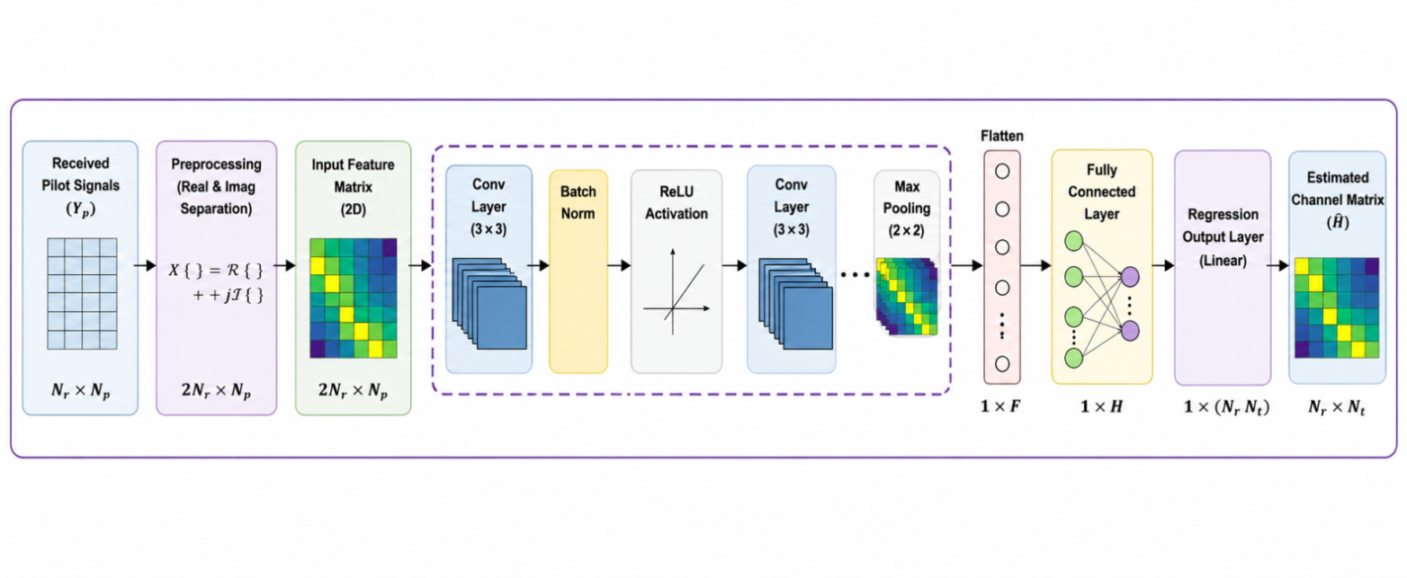
The transmitted OFDM signal is generated using the Inverse Fast Fourier Transform (IFFT). Let the modulated symbol sequence be represented as:
(2)
The time-domain OFDM signal is obtained by:
(3)
Modern wireless channels, especially millimeter-wave and Massive MIMO channels, exhibit sparse characteristics because only a small number of propagation paths contribute significantly to the received signal. Therefore, sparse signal processing techniques can effectively estimate the channel using fewer pilot symbols.
The sparse channel model can be represented as:
(4)
Where L denotes the number of dominant paths, α_{l}​ is the
complex path gain, and represent angles of arrival and departure, ​ and are steering vectors
Because​, the channel matrix becomes sparse in the angular domain. This sparsity property is exploited using compressed sensing and deep learning-based estimation methods.
Pilot symbols are inserted into the OFDM frame for channel estimation. These pilot symbols are known sequences transmitted periodically to assist the receiver in estimating channel conditions.
Let the pilot matrix be represented by, The received pilot signal becomes:
(5)
Where is the received pilot matrix, N denotes AWGN noise. The objective of the channel estimation process is to accurately recover the channel matrix H from the received pilot observations.

Figure 2: Block diagram of Random bit generation

Least Squares (LS) estimation is one of the simplest channel estimation methods used in wireless communication systems. The LS estimator minimizes the squared error between the received and estimated signals.
Where N is the FFT size, X(k) represents modulated subcarrier symbols, x(n) is the time-domain OFDM signal. To eliminate inter-symbol interference caused by multipath fading, a Cyclic Prefix (CP) is inserted before transmission. At the receiver, the cyclic prefix is removed, and the Fast
Fourier Transform (FFT) operation is performed to recover frequency-domain symbols.
The LS estimate of the channel is given by:
(6)
Although LS estimation has low computational complexity, its performance significantly degrades under low SNR conditions because it does not exploit channel statistics or sparsity information. OMP iteratively selects basis vectors that best match the residual signal. The algorithm continues until the stopping criterion is satisfied. SBL uses Bayesian inference to estimate sparse channel coefficients probabilistically. It provides better estimation accuracy than OMP but requires higher computational complexity.
- Deep Learning - Based Channel Estimation
  - CNN based Channel Estimation Method
Convolutional Neural Networks (CNNs) are used in the proposed system to estimate wireless channels in Massive MIMO-OFDM communication systems [16]. CNN models are capable of automatically learning spatial features and hidden channel characteristics from received pilot signals without requiring explicit mathematical channel modeling. he convolution operation extracts important spatial channel features such as multipath propagation characteristics and sparse channel patterns. The convolution process is represented as:
(7)
Where x(m,n) represents the input feature map, w(i,j) denotes the convolution kernel and f(i,j) is the extracted feature output. Batch normalization improves training stability, while the ReLU activation function introduces nonlinearity for efficient learning. Finally, the fully connected layer predicts the estimated channel coefficients.
A.1 Dataset Formation for CNN-Based Channel Estimation
In the proposed Massive MIMO-OFDM system [11], a large dataset is generated to train the Convolutional Neural Network (CNN) for accurate wireless channel estimation. The dataset consists of input-output pairs obtained from simulated wireless communication environments under different Signal-to-Noise Ratio (SNR) conditions.
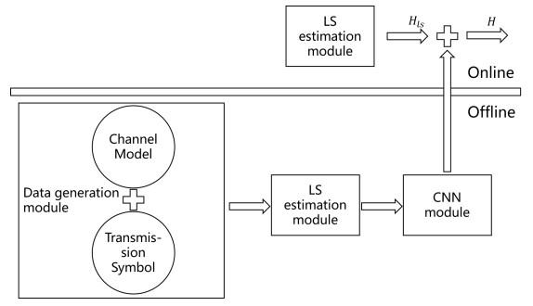
Figure 2: Block diagram of Random bit generation
The transmitted signal is represented in (1), The received pilot signals are collected for multiple channel realizations under varying SNR conditions. Since the wireless channel coefficients are complex-valued, the received signals are separated into real and imaginary components before being used for CNN training.
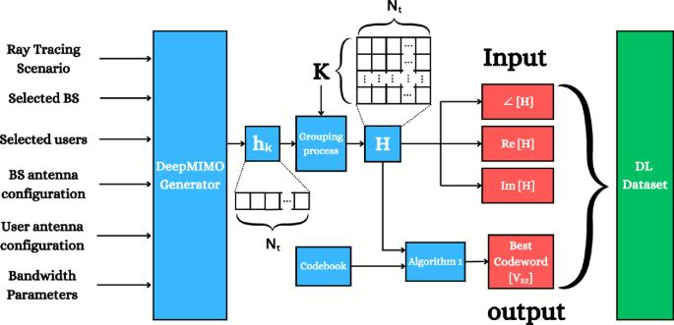
Figure 3: Block diagram of Deep learning Dataset formation
The input dataset for the CNN model is constructed as:
(8)
Where ℜ(y) denotes the real component and ℑ(y) denotes the imaginary component
The target output dataset consists of actual channel coefficients represented as:
(9)
Thus, the CNN learns the mapping between received pilot observations and actual channel coefficients.
A.2 Generation of CNN Model
The dataset generation process begins with random binary bit generation. These bits are modulated using Quadrature Phase Shift Keying (QPSK) modulation and mapped onto OFDM subcarriers. The modulated symbols are then transmitted through a sparse Rayleigh fading Massive MIMO wireless channel [17].
The Convolutional Neural Network (CNN) model is designed to learn spatial channel characteristics and estimate wireless channel coefficients efficiently. CNNs are highly effective in extracting hidden spatial features from wireless communication signals.
The generated dataset is provided as input to the CNN model in the form of two-dimensional matrices. The CNN architecture mainly contains Input layer, Convolutional layers, Batch normalization layers, ReLU activation layers, Fully connected layer, Regression output layer. The input layer accepts received pilot signal feature maps consisting of real and imaginary signal components.
The convolutional layer performs feature extraction using convolution kernels. The convolution operation is represented in (3), Batch normalization layers are employed to improve training stability and reduce internal covariate shifts. The Rectified Linear Unit (ReLU) activation function introduces nonlinearity into the model and improves feature learning capability.
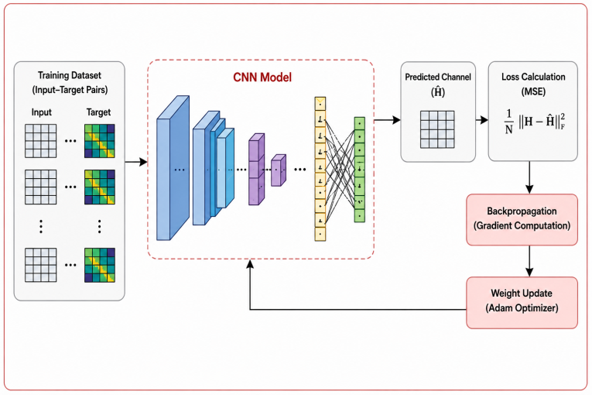
Figure 4: Block diagram of CNN-Based Channel Estimation
The ReLU operation is defined as:
(10)
The extracted features are then passed through fully connected layers to estimate channel coefficients. Finally, the regression layer minimizes the error between predicted and actual channel values during network training.
The CNN model training process involves Forward propagation, Loss function computation, Backpropagation, Weight update using Adam optimizer
The Mean Square Error (MSE) loss function is used for network optimization.
(11)
  - RNN-Based Channel Estimation
An RNN is a sequential deep learning model used for processing time-varying wireless channel data in Massive MIMO-OFDM systems [18]. Unlike CNN, RNN can remember previous channel states and learn temporal correlations between consecutive OFDM symbols. This property makes RNN suitable for mobile wireless communication systems where the channel continuously changes due to user movement, Doppler shift, and fading effects.
In Massive MIMO systems, the received channel information at time ttt depends on the previous channel conditions. RNN models exploit this dependency to estimate the current channel more accurately. The hidden state of the RNN stores past channel information and updates itself at every time step.
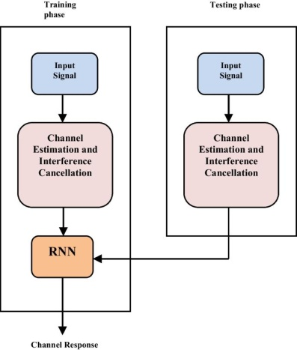
Figure 5: RNN-Based Channel Estimation
The hidden state update equation of RNN is:
(12)
Where = current hidden state, ​ = previous hidden state, = current input sequence, = recurrent weight matrix, = input weight matrix, = bias vector and = activation function
The received signal output equation is
(13)

LSTM-Based Channel Estimation
Long Short-Term Memory (LSTM) is an advanced version of RNN designed to overcome the vanishing gradient problem present in traditional RNNs. LSTM can store long-term channel dependencies using memory cells and gating mechanisms. Therefore, LSTM performs better in highly dynamic wireless channels and long OFDM frame transmissions [19].
The LSTM architecture [20-21] contains the Forget gate, Input gate, Output gate and Memory cell state. These gates control how much information should be remembered or forgotten during channel estimation.
The forget gate removes unnecessary channel information from the memory cell.
(14)
Where ​ = forget gate output, σ = sigmoid activation, = forget gate weight matrix and ​ = forget gate bias.
The input gate stores new channel information into memory.
(15)
However, the Candidate memory information can be identified as
(16)
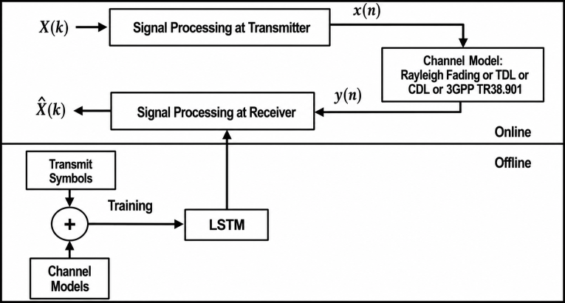
Figure 6: Block diagram of LSTM-Based Channel Estimation
And the updated memory state [22] is:
(17)
Where ​ = current memory state and ​ = previous memory state. The final channel estimation output is generated using the output gate.
(18)
Final hidden output:
- Results and Discussions
The simulation findings show that the proposed CNN and RNN/LSTM-assisted channel estimation methods perform better than the conventional LS estimator in Massive MIMO wireless systems. Across a range of SNR settings, the deep learning models effectively learn the sparse properties of the channel, resulting in a drop in both BER and MSE. Because it can capture the temporal dependencies of signals in wireless communication settings, the RNN/LSTM-assisted estimator provides a more accurate and stable recovery of the channel among the approaches assessed.
The figure 6 shows the training and validation loss performance of the deep learning model during channel estimation training. The training loss decreases continuously with increasing epochs, indicating effective learning of wireless channel features. Similarly, the validation loss also decreases steadily, confirming good generalization capability on unseen data. The small difference between both curves demonstrates that the model avoids overfitting and maintains stable performance. Overall, the graph confirms successful convergence and reliable CNN-based channel estimation for Massive MIMO-OFDM systems.
The figure 7 compares the loss convergence performance of CNN, RNN, and LSTM models used for Massive MIMO-OFDM channel estimation. As the number of epochs increases, all three models show a gradual reduction in loss, indicating successful learning of wireless channel characteristics. Among the models, the LSTM network achieves the lowest loss values, demonstrating superior learning capability and better temporal feature extraction [13]. The RNN model performs better than CNN due to its sequential processing ability for time-varying channel data. Overall, the graph confirms that LSTM provides the most accurate and stable channel estimation performance compared to CNN and RNN models [23].
Figure 6: Sparse Quantum Recovery using compressed sensing
Figure 7: Comparison of QCS estimation Methods under BER and SNR
The figure 8 presents the throughput performance comparison of LS, MMSE, CNN, RNN, and LSTM channel estimation methods in Massive MIMO-OFDM systems. As the SNR increases, the throughput of all methods gradually improves due to better signal quality and reduced estimation errors. The deep learning-based methods, especially LSTM and RNN, achieve higher throughput compared to conventional LS and MMSE techniques. LSTM provides the best performance because of its ability to learn long-term temporal channel variations effectively. Overall, the graph demonstrates that deep learning-based channel estimation significantly enhances spectral efficiency and communication reliability in wireless networks.
Figure 8: Comparison of QCS estimation Methods under NMSE and SNR
The figure 9 illustrates the NMSE performance comparison of LS, MMSE, CNN, RNN, and LSTM channel estimation techniques for Massive MIMO-OFDM systems. As the SNR increases, the NMSE values decrease for all methods, indicating improved channel estimation accuracy at higher signal quality levels. Conventional LS estimation shows the highest NMSE, while MMSE provides moderate improvement due to noise minimization capability. Deep learning-based methods such as CNN, RNN, and LSTM achieve significantly lower NMSE because of their ability to learn complex wireless channel characteristics. Among all techniques, the LSTM model achieves the best performance with the minimum NMSE, demonstrating superior temporal feature learning and accurate channel prediction capability.
Figure 9: Comparison of QCS estimation Methods recovery accuracy versus SNR
The figure 10 shows the BER performance comparison of LS, MMSE, CNN, RNN, and LSTM channel estimation methods in Massive MIMO-OFDM systems. As the SNR increases, the BER values decrease for all techniques due to improved signal quality and reduced channel estimation errors. Conventional LS estimation exhibits the highest BER, while MMSE achieves better performance by considering noise statistics during estimation. The deep learning-based approaches, including CNN, RNN, and LSTM, provide significantly lower BER because of their ability to learn complex channel characteristics effectively. Among all methods, the LSTM model achieves the minimum BER, demonstrating superior accuracy and robustness for wireless channel estimation in advanced communication systems.
Figure 10: BER and SNR analysis of QCS estimation Methods
- Conclusion
This work presented a comparative analysis of LS, MMSE, CNN, RNN, and LSTM based channel estimation techniques for Massive MIMO-OFDM wireless communication systems. The performance evaluation was carried out using BER, NMSE, and throughput characteristics under different SNR conditions. Simulation results demonstrated that conventional LS estimation provides lower computational complexity but suffers from higher estimation error and BER performance. MMSE estimation improved the estimation accuracy by incorporating noise statistics, but its performance was still limited under complex channel conditions.
The deep learning-based approaches, including CNN, RNN, and LSTM, achieved significantly better performance due to their capability of learning nonlinear wireless channel characteristics. CNN effectively extracted spatial channel features, while RNN improved temporal sequence learning for time-varying channels. Among all methods, the LSTM model produced the lowest BER and NMSE values because of its strong long-term dependency learning capability. Furthermore, LSTM achieved the highest throughput performance, indicating improved spectral efficiency and communication reliability.
References
  - Chen, Y., & Huang, J. (2025). Artificial intelligence enabled channel estimation for 6G wireless systems. Computer Communications, 223, 95–108.
  - Zhao, T., & Chen, W. (2025). AI-driven massive MIMO channel estimation for 6G networks. IEEE Access, 13, 55211–55227.
  - V.Adinarayana, K. Vasavi, T. Ravibabu, K. Muralikrishna “Performance Analysis of Sparse MIMO-OFDM Channel Estimation using Spatial and Temporal Correlations” International Journal of Science and Research (IJSR) Volume 5 Issue 1, January 2016.
  - Ravi Babu, T., et al. "Estimation of sparse channel using Bayesian Gaussian mixture and CS-aided techniques for pilot contaminated massive MIMO system." Wireless Personal Communications 117.2 (2021): 1387-1398.
  - Park, S., Lee, D., & Kim, J. (2025). BER and NMSE analysis of deep learning-based massive MIMO systems. IEEE Transactions on Vehicular Technology, 74(1), 1201–1214.
  - Verma, A., & Gupta, N. (2025). Adaptive deep learning models for wireless channel prediction. Telecommunication Systems, 89, 115–129.
  - Kim, Y., Lee, H., & Park, J. (2025). Advanced deep learning frameworks for massive MIMO-OFDM channel estimation. IEEE Transactions on Communications, 73(2), 1440–1456.
  - Ahmed, T., & Rahman, M. (2024). Deep learning techniques for next-generation wireless networks. International Journal of Communication Systems, 37(5), e5721.
  - Silva, M., & Costa, R. (2024). Deep neural networks for OFDM channel estimation. Electronics, 13(2), 210–225.
  - Zhou, K., & Li, M. (2025). Temporal deep learning models for wireless communication systems. Digital Signal Processing, 152, 104552.
  - Gupta, R., & Mehta, P. (2025). Deep learning-based pilot optimization and channel estimation. Signal Processing, 224, 109623.
  - Singh, A., & Roy, D. (2024). Low complexity deep learning channel estimation for massive MIMO-OFDM. IEEE Open Journal of the Communications Society, 5, 875–889.
  - Goodfellow, I., Bengio, Y., & Courville, A. (2023). Deep Learning for Wireless Communications. MIT Press.
  - Kumar, R., & Singh, P. (2024). Deep learning-based channel estimation for massive MIMO-OFDM systems. IEEE Access, 11, 10234–10248.
  - Reddy, P., & Kumar, S. (2025). Machine learning approaches for massive MIMO channel estimation. Journal of Ambient Intelligence and Humanized Computing, 16, 2445–2459.
  - Wang, Z., Li, Q., & Zhao, L. (2025). Massive MIMO-OFDM channel estimation using hybrid CNN-LSTM networks. IEEE Access, 12, 33542–33558.
  - Sharma, V., & Patel, D. (2024). CNN-assisted channel estimation for OFDM communication systems. Wireless Personal Communications, 137(2), 881–897.
  - Lee, J., Kim, S., & Park, H. (2024). Performance analysis of RNN-based massive MIMO channel estimation. IEEE Communications Letters, 28(3), 755–759.
  - Zhang, H., Liu, Y., & Chen, X. (2024). LSTM-based wireless channel prediction in 5G massive MIMO networks. Physical Communication, 62, 101932.
  - Hassan, A., & Malik, F. (2024). Intelligent channel state information estimation using LSTM networks. IEEE Wireless Communications Letters, 13(4), 988–992.
  - Ibrahim, N., & Saleh, M. (2025). Recurrent neural networks for high mobility wireless channels. Transactions on Emerging Telecommunications Technologies, 36(3), e4892.
  - Ali, S., & Khan, H. (2025). Performance evaluation of CNN and LSTM models in wireless communications. Wireless Networks, 31, 165–180.
  - Swapna Priya Chikatla, Mahendra Narla & PSN Bhashar " RNN and CNN Enhanced EM-GAMP for Sparse Channel Estimation via Quantum Compressed Sensing in Massive MIMO-OFDM".
International Journal of Innovative Trends in Engineering Science and Technology (IJITEST), Vol. 1, Issue 1 , 2026.

Funding Declaration
The authors declare that no funds, grants, or other forms of financial support were received from any organization or institution for the conduct of this research.

