Digital Revolution: The Role of Informatics in Industry 4.0 and 5.0

Gulshan Sribabu Thorlapati¹, Chekatla Swapna Priya², Suseela Kocho³
¹Department of CIVIL, Vignan’s Institute of Information Technology (A), Visakhapatnam, India.
²Department of CSE, Vignan’s Institute of Information Technology (A), Visakhapatnam, India.
³SGT, Department of school education, India
¹gulshansribabu@gmail.com, ²swapnachsp@gmail.com, (Orcid ID: 0000-0002-1567-7896 ³jackbenison12@gmail.com

Abstract— The emergence of Industry 5.0 predicts a paradigm shift in industrial development, as cutting-edge devices—such as AI-enhanced robots—collaborate harmoniously with human labourers to maximize productivity. This phase emphasizes the significance of human engagement while emphasizing sustainability and resilience. This development based on innovations has led to industry 4.0, the fourth industrial revolution has changed production and production techniques. Changes are motivated by the strong progress of automation, robots, Big data, Internet of Things, Machine learning, artificial intelligence and virtualization. In addition to the successful automation and technological integration of its predecessor, largely related to production and efficiency stimulation, industry 5.0 to create both sustainable innovations and focus on people. Looking for a long -term balance between technology development and environmental protection and the happiness of our society is the main goal. This requires intentional approach to innovation, ensuring that our progress increases the living standards of people while benefiting our natural systems to support us.
Index Terms—Industry 4.0, Industry 5.0

1. INTRODUCTION
In the modern landscape of smart connectivity, automation has transitioned from the idea of independent robots to complex solutions that tap into big data, the industrial Internet of Things (IIoT), and data analytics. By integrating software with hardware, manufacturers can maintain full command over their operations. Industry 4.0 represents a leap forward from Industry 3.0, where the integration of computers into manufacturing was fraught with challenges. Now, in Industry 4.0, computers are networked and function independently, significantly reducing the need for human involvement. Industry 3.0 focused on the measurement and analysis of processes to pinpoint areas for improvement, which facilitated the use of powerful statistical tools like Statistical Process Control (SPC) and the seven Quality Management tools [1]. This emphasis on data collection allowed for the application

of strategies like plan–do–check–act (PDCA) and Six Sigma (Define, Measure, Analyze, Improve, Control), enabling manufacturing industries to refine their processes and enhance efficiency through the capabilities of Industry 4.0.
At the heart of Industry 4.0 is the powerful combination of cyber-physical systems and the Industrial Internet of Things (IIoT) [2], which transforms the idea of smart manufacturing into a tangible reality. Exploring further, cyber-physical solutions [3] enhance industries through wireless connectivity, facilitating remote oversight and the ability to make independent decisions, thus adding a new dimension to production. This integration creates a networked ecosystem where machines, personnel, processes, and systems work together, leading to improved reliability and greater operational efficiency. The advent of Industry 4.0 enables cross-functional teams (CFTs) in organizations to exchange improved, timely, and relevant perspectives on manufacturing and business processes, backed by more dynamic analytics [4-5].
This transformation is set to take hold across the manufacturing landscape. By comprehending and applying contemporary technologies, the manufacturing sector can progress towards digital transformation. Even though it marks the height of technological innovation in manufacturing, it can give the impression that machines are seizing control of the sector. This state-of-the-art manufacturing technology provides manufacturers with a new standard of optimization and efficiency [6-7].
From straightforward pressure driven and pneumatic frameworks to complex mechanical autonomy, computerization within the mechanical segment has advanced over time. Programmed control frameworks can streamline the commerce exercises of workshops by utilizing IoT and IIOT in generation. This handle computerization moved the center from diminishing human intelligent to evacuating carcinogenicity and moving forward viability and effectiveness. Agreeing to Industry 4.0, after the advance of past innovation has been effectively coordinates, remote mechanization frameworks are as of now being utilized in a assortment of applications.
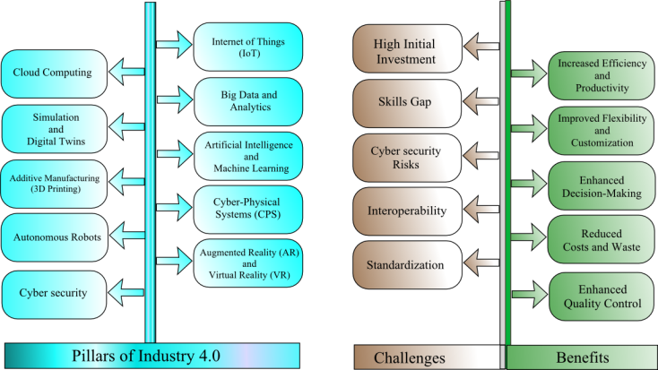
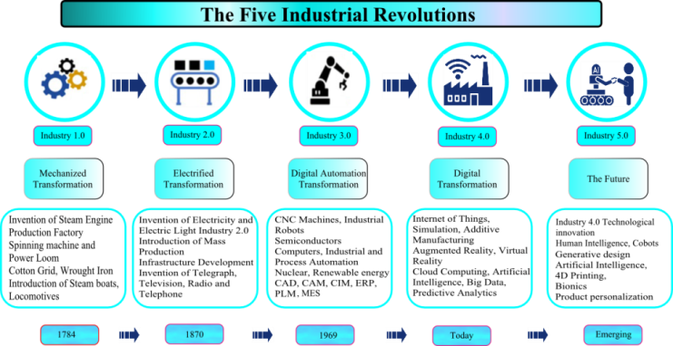

Fig. 1. Industry Evolution.
Based on the success of Industry 4.0, we enter the era of Industry 5.0, a revolutionary stage of industrial development, when automation, robotics and artificial intelligence revolutionize the manufacturing industry. Industry 5.0 introduces a more individual approach to production processes as an industry 4.0 with a high priority for cooperation between humans and machines and focuses on the digitalization and automation of processes. Each industrial revolution has brought about major changes in society that have influenced working conditions and economic structure. Industry 5.0 promotes the state of the ART production paradigm, prioritizing sustainability, adaptation and teamwork [8].
By enabling sustainable and customized solutions through biotechnology and bioengineering, biology plays a crucial role in Industry 5.0. Precision medicine, bio-based manufacturing, and environmentally friendly materials are all developed with its help. Biological efficiency and innovation are improved through integration with robotics and AI. This change encourages industrial systems that are resilient, human-centered, and ecologically conscious.

2. LITERATURE SURVEY
It must be stressed that the rise of Industry 5.0 does not mean that Industry 4.0 will be entirely supplanted. Rather, it seeks to amplify the advantages of Industry 4.0, enabling businesses to become more agile and prepared for the future [2].
A significant aim is to enhance networking and collaboration across the entire value chain, thereby strengthening the relationships between customers, suppliers, and partners. Moreover, the importance of data security cannot be overstated, as it must be more robustly ensured in this new technological era. Overall, Industry 5.0 opens up tremendous possibilities for companies in every sector to maintain their success in a rapidly digitizing world and venture into new markets [9].
Fig. 2. Challenges and benefits of Industry 4.0.

A. Challenges of Industry 5.0
To increase productivity and surpass performance, manufacturers will consider new ways to include state-ART technology. Many manufacturers around the world have already taken over the key principles of Industry 4.0, the next phase of industrial development. As more industries become more automated, current organizational structure and business plans need to be changed to meet industry 5.0 requirements. This movement has made client-centric processes more important in the direction of mass adjustment. Changing organizational structure and business practices can be a challenging task as customer distortions change over time [10].
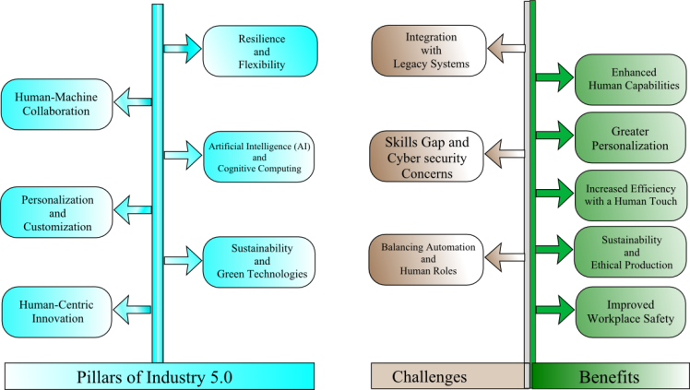
Fig. 3. Challenges and benefits of Industry 5.0.
Employees need to learn how to work well with these intelligent machines, but using robots offers exciting opportunities. In addition to essential soft skills, technical know-how is extremely important. The flexibility of existing systems, especially in integrated decision-making skills, is a major cause of the considerable challenges facing the transition to industry 5.0 [11].

B. Benefits of Industry 5.0
A key factor in placing products in the market is customer satisfaction, or the pillar of industrial growth. Customer preferences can be communicated during the design stage and can be included smoothly in the production process without increasing the final cost.
Traditional production has been transformed into an intelligent ecosystem with seamless internet-based device communications with the rise of Industry 5.0. The data is currently collected, archived and analyzed by manufacturing companies in the entire supply chain to find ways to improve quality, rationalize operations, reduce costs and ensure compliance. Industry 5.0 combines critical thinking with industrial automation speed and accuracy. Promoting interference processes, improving organizational effectiveness while protecting the environment, and developing sustainable practices where even small waste production matters are some of its goals [12-13].

3. KEY ELEMENTS OF INDUSTRY 5.0

A. Human-Centric Approach
The foundation of industry 5.0 is the development of human technology partnership. Machinery is considered to be a partner to increase human capacity rather than replacement. Efficiency, creativity and innovation are strengthened by this cooperation, leading to more specialized, long -term and successful trade activities. The goal is to integrate robots and artificial intelligence with human creativity and intelligence. This shows that the transition from the level of automation is high to a contracting strategy in which machines and people work together to increase productivity and stimulate innovation.

Cobots, also known as cooperative robots, is specially designed to work next to each other with human operators in a common workspace, performing tasks in contrast to alone or isolated. They are equipped with advanced sensors, artificial intelligence and safety features that allow human safety interaction in a dynamic and adaptable environment. They are essential for the principles of the industry 5.0 and in the future of the cooperation interaction of the machine and the machine, because their main goal is to improve human performance instead of replacing it. Cobots are done to complete them, increase work satisfaction, safety and productivity. Cobots pave the way for more orientation automation solutions with sophisticated safety protocols, user adaptation and adaptability in their industry. This will help create a future of the industry 5.0 in which the efficiency of the machine and the creativity of the people in harmony with each other.

B. Personalization and Customization
The increasing demand for goods and services to meet the specific needs of each customer makes the concepts of personalization and personalization necessary in industry 5.0. Companies from traditional mass production to production products are highly personalized and personalized at a larger scale when consumers' preferences become more complicated and diverse. To allow mass customization without sacrificing productivity or profit rate of beneficiaries, industry 5.0 using advanced technologies such as artificial intelligence (AI), 3D printing and flexible production system. The future of customer interaction depends on this emphasis on personalization, allowing companies to provide unique goods and services to meet the needs of each individual. Companies can now achieve high levels of personalization, improve customer satisfaction and performance, thanks to AI's development, IoT and flexible production processes.

C. Artificial Intelligence (AI) and Cognitive Computing
`The main technologies such as artificial intelligence (AI) and IT perceive networks of industries by imitating and improving the skills of human theory, deciding and solving problems. They are important for creating industry 5.0, combining human creativity and intelligence through the development of sophisticated systems designed to operate with people. Despite their frequent replacement ability, these terms serve separate goals [14].
In industry 5.0, artificial intelligence will play a more important role because it not only supports human work but also improves business decisions. Self -study algorithms, for example, can improve product quality and accelerate production processes. Early detection of the machine can be performed through data analysis and automatic learning techniques, allowing quick remedy. In industry 5.0, who complete human judgment instead of completely replaced. Artificial intelligence tools (AI) can evaluate complex data to help people make better decisions, improve concepts and improve production methods. Real -time analysis: AI collects and analyzes data in real time in collaboration with IoT to provide information and prediction to help people constantly improve their activities.

D. Sustainability and Green Technologies
Circulating economy: The insidescent industry 5.0 on sustainability, in order to reduce waste and improve the use of resources, is an important component. To reduce carbon footprints, technologies such as artificial intelligence (AI), Internet of objects (IoT) and Block chain are very important to monitor materials and energy consumption as well as product lifecycle management.
Energy saving system: to ensure energy saving processes in supply and production chains, frames combining smart networks and renewable energy sources, such as solar, wind and battery technology.

E. Hyper-Connectivity via 5G and IoT
An important step in the development of industry 5.0 is the introduction of 5G connectivity, promoting improving the cooperation of machines, allowing data processing in real time and can make personalized production techniques. To create a dynamic, flexible and sustainable industrial frame, where the interactions and machines of people are transparent and effective, this technology is essential. The speed, reliability and bandwidth of 5G will be important to allow the entire potential of industry 5.0, because the industries are increasingly applying advanced technologies.
IoT is the main catalyst in industry 5.0, aiming to establish a smart, connected and concentrated production ecosystem. IoT promotes sustainability, performance and personalization by allowing the real time cooperation between people, machines and systems. The role of IoT will develop when industry 5.0 is developing, not only changing production processes, but also interacting between humans and machines in the industrial environment.

F. Cyber Security and Data Privacy
It is impossible to appreciate the importance of cybersecurity and data security in the context of industrial 5.0, in which human cooperation with smart systems such as IoT devices, artificial intelligence, robots and cloud technology is popular. The strong and secure network security measures in the state must be done because this new industrial model creates huge holes that cyber criminals may have beneficial during extraordinary connections [15].

G. Digital Twins and Virtual Simulation
Industry 5.0 is based on digital twins and virtual simulation to create smarter, durable and personalized industrial parameters. These technologies help manufacturers increase their operational efficiency, improve human cooperation and allow real -time decision to make procedures and products in the real world. However, obstacles such as interactive possibilities, threats of cyber security and significant financial investments must be treated so that these innovations can be applied successfully. Digital twins and virtual simulation will play an important role in determining the future of production and industrial activities when industry 5.0 is developing.
The industry increases productivity, allows mass personalization, improves safety and modifies the way employees interact with equipment and workflow by merging practical applications to enhance reality with virtual reality parameters [16].

H. Resilient and Agile Supply Chains
The autonomous supply chains are distinguished in industry 5.0 because of the ability to recover and increase the efficiency as well as their voice is placed in the principles focusing on people to promote sustainability and personalization. Companies can effectively predict demand, improve logistics and produce personalized goods on a large scale while reducing their costs and environmental impacts using AI technologies, Automatic, IoT and Blockchain. However, problems such as cyber security threats, the integration of genetic systems and the need for eligible labor force must be resolved if the autonomous supply chain must benefit from this change environment [17].
By encouraging confidence, cooperation and responsibility between supply chains and industrial processes, block-chain technology helps significantly improve transparency in industry 5.0. The block improves the ability to pursue, quality assurance and comply with the regulations by providing a safe, unmistakable transaction and easy access, resulting in a more effective industrial framework focusing on people.

I. Ethical Use of Technology
An industrial, comprehensive and sustainable industrial ecosystem depends on the ethical application of technology in industry 5.0. A series of moral concerns, including data security, algorithm bias, labor consequences and environmental sustainability, because industries apply new technologies.

4. STRATEGIES OF INDUSTRY 5.0

A. Human-Centric
Industry 5.0 is a change in the model of re -explaining the role of people in organizations, staying away from considering them as a simple resource and considering them as valuable assets. This strategy emphasizes that companies should surpass their employees' needs first, not another way. Therefore, the emphasis is put in the use of talent only to gain competitive advantage and increase customer value to improve the experience and value for employees, by creating a atmosphere that attracts and maintains the best talent.

B. Resilience
The important effects of global issues such as pandemic and CIVID-19 supply chain attacks have become more evident as the world becomes more linked. While many companies are aimed at increasing productivity and profit, recovery capacity is not always improved by these initiatives. In fact, some people maintain that recovery can be violated if agility and flexibility are overestimated. Shift their attention to expanding and effectively to the prevention and reaction of the crisis will help more resilient organizations maintain stability in situations.

C. Sustainability
By focusing on positive efforts to create positive impacts instead of minimizing or reducing climate damage, industry 5.0 redefines sustainability. Known as "positive", this initiative motivates companies to make more than simply respect the rules or make notification promises sometimes called "greenwashing". Organizations are encouraged to apply strategies to promote economy, improve society's health and restore ecosystems instead of simply reduce negative impacts or communities.
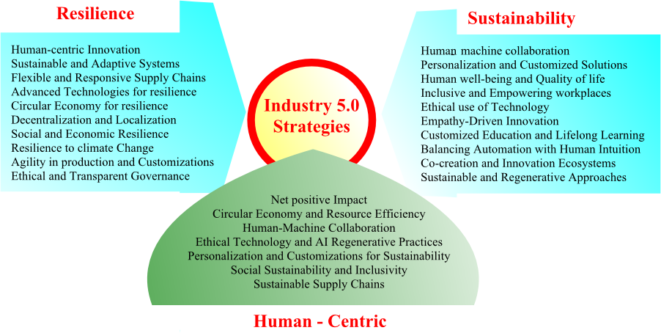

Fig. 4. Strategies of Industry 5.0.

5. ADVANTAGES OF TRANSITIONING FROM INDUSTRY 4.0 TO INDUSTRY 5.0
Companies approach all industries with great opportunities to develop in new markets and maintain their success level in an increasingly digital world thanks to the industry 5.0. Because robots and network systems will allow the automation of manual labor force to increase, automation will play the main role. This helps them improve the quality of goods they sell in addition to saving their time and money. Examples of automation can optimize the entire production process including stock management automation and reduced production disorders through predictable maintenance. Another essential element of production is the test of the future is artificial intelligence (AI). The development of self -study algorithms is revolutionizing the optimization of production processes and improving product quality. Companies can have a significant competitive advantage by actively investing in these technological developments, including sophisticated sensors, network capacity and smart production throughout their activities.

A. Improved efficiency and productivity
One of the most important aspects of this is the enhancement of efficient and productive practices. Robots and other networked systems have made it possible to automate more and more of the manual labor that was previously done. This not only helps to reduce the amount of time and money spent, but it also helps to improve the overall quality of the goods Furthermore, across the entirety of the value chain, improvements may be accomplished through the utilization of sophisticated sensors and intelligent manufacturing technologies. For instance, data may be centrally gathered and analyzed to discover issues early and take action. Industry 5.0 organizations may further automate and improve company operations with the use of artificial intelligence and machine learning approaches. This will provide them a competitive advantage.

B. Higher quality of products and services
There will be massive opportunity for businesses to automate processes and make better use of linked technologies in the soon-to-be-revealed Industry 5.0. All the way down the value chain, sensors and intelligent manufacturing technologies make it possible to gather and use data centrally, which in turn makes it simpler to help suppliers and customers work together and prevents production delays. A notable benefit of Industry 5.0 lies in its ability to elevate the standards of both products and services. With robotics and interconnected systems, manual tasks can be increasingly automated, contributing to higher product quality. Companies that are already preparing for and investing in these developments can not only gain a decisive competitive advantage, but also create the basis for a future-oriented production.

C. Better accessibility and connectivity
The automation and digitization of production systems provide great potential companies to maintain competitiveness and future testing in the context of industrial 5.0. One of the most important advantages that can be taken into account is improving productivity and efficiency. Time and money can be saved by automation of manual tasks by using robots and smartly connected systems. Companies can collect and analyze data concentrated in a combination with sophisticated sensors and techniques to identify possible problems early and start taking remedial measures. In addition, industry 5.0 significantly contributes to the increase in the product size. Product reminders can be reduced by using advanced robots and production techniques, helping to improve customer satisfaction.

6. THE FIFTH INDUSTRIAL REVOLUTION
Many small and medium -sized businesses have a part of or completely industrial 3.0 and 4.0, which are partially applied or completely, showing strong wishes for technological innovations. AI conversion and technological progress such as quantum computer science, will promote the interaction between people, machines, processes and the environment, will be the main goal of this step. The urgent need to increase productivity without eliminating human labor forces in production poses new difficulties in the context of global industry. To better exploit the creativity and improve the performance of processes through intelligent and industrial systems 5.0 will focus on the combination of human capacity and machines.
Manufacturers are primarily focused on linking the virtual and physical environments to analyze data, oversee manufacturing processes, mitigate risks, and reduce downtime, all facilitated by simulations through digital twins. Recent advancements in large-scale data processing and AI technology have made it possible to create more intelligent models that illustrate different operational conditions and process features. By accounting for process unpredictability, digital twins provide significant opportunities to minimize waste through system collaboration. Due to the intimate integration of robots into everyday human activities, Industry 5.0 will provide special problems for human-machine interaction. This new phase builds on the technological progress of Industry 4.0, emphasizing the importance of human roles in industrial production, where machines will work alongside cobots. Industry 5.0 aims not only to meet consumer needs but also to undertake tasks that reach new levels of significance, far beyond what has been achieved in the last century.

A. Collaborative Robots
Cooperative robots, or Cobots, is a contemporary development of manufacturing robots to operate with human operators rather than alone. The use of COBOTS rapidly grows in the field of industrial automation. These robots are different from conventional industrial machines that can create threats to their environment because they are forced to work in harmony with human workers. Modern sensors and notable optical systems allow cooperative robots, or cobots, recognize people and modify their activities accordingly. Many industrial processes, such as quality control, testing, CNC processing, casting, packaging and manufacturing, can use COBOTS. Cobots will help workers in their work instead of replacing them, managing repetitive tasks so that workers can focus on other activities.
Because they think the robot will be the machine of the future, manufacturers begin to integrate advanced sensors and basic industrial vision in the early 80s. This helped to boost industrial growth and increase production competitiveness. This development allowed robots to learn, improve, and make quick decisions to avoid issues while keeping production running smoothly without human intervention. Universal Robots launched the first collaborative robot in 2008, which could safely work alongside people without needing safety barriers.

B. Artificial Intelligence
The cutting-edge technology effectively handles various business and personal tasks that require decision-making and complex reasoning. As a key development in the future industrial economy, AI mimics human intelligence in machines designed to learn and replicate human behavior. The nerve networks are formed through automatic learning and learning in today's AI systems, requiring initial data input as text, images or other data. Training data has been tweaked digital is essential. The main application suppliers have developed automation improvement software in intelligence and trade analysis due to AI's growth. Digital twins of equipment and parts used in production are very important to suit different product configurations and adapt to the personal preferences of customers. To improve their AI capacity, industrial robots focus on their performance and accuracy in training sessions.
Cobots with computer vision capacity will definitely work with human colleagues. Google optimizes energy efficiency in its data centers by integrating AI. In fact, it is now used by chatbots, a popular AI function on many online commercial websites. They analyze text in studies using natural language treatment (PNL), creating information that increases the efficiency and customer satisfaction.
In the process of product development, combining this innovation creates new opportunities to rethink the components in different industrial fields. "CAD tools can create independence of a number of design alternatives in the final constraints that provide products for free products that choose the design they want to explore more, allowing them to focus on other important tasks," said a product design engineer.

C. Four Dimensional (4D) Printing
The combination of advanced science, technology and software innovation with 3D printing techniques, D printing has become a technology that changes the situation. The use of materials such as hydrogel, memory polymers and liquid elasticity allow changes to be programmed in mechanical and body properties, allowing them to react to external environmental effects or control users. This technology is still being studied.
Basically, 4D printing is an improvement in 3D printing because it allows print objects to change the form after production. It is strongly affected by the principle of self -assembly, basically for nanotechnology. The main difference is that the 4D printing creates capable of changing their shape and properties over time, while 3D printing creations maintain permanent structure. Print 4D encourages the development of products that are more personalized and unique by shifting focusing on the design of products under the influence of industry 5.0.

7. CONCLUSION
Industry 5.0 inaugurated a new era of human computer cooperation to produce creative, sustainable and personalized goods. This change represents a gap with only technology voice and towards a more complete and focused human strategy. It gives priority to creating long -term values ​​of short -term efficiency and allows high priority for the sustainability and happiness of workers and the environment. Unlike the voice of the industry 5.0 n automation, industry 5.0 emphasizes the cooperation of human machines and promotes the creativity of people outside AI and robots. It emphasizes sustainability through eco-friendly practices and products that reduce carbon footprints. Mass customization allows for tailored products while maintaining mass production efficiency. Additionally, it promotes flexible manufacturing systems that can adapt to global challenges, improving industry resilience.

8. REFERENCES
- P Zheng et al., "Smart manufacturing systems for Industry 4.0: Conceptual framework scenarios and future perspectives", Front Mech Eng, vol. 13, pp. 137-50, 2018.
- T. M. Fernández-Caramés and P. Fraga-Lamas, "A review on the application of blockchain to the next generation of cybersecure Industry 4.0 smart factories", IEEE Access, vol. 7, pp. 45201-45218, 2019.
- X. Li, D. Li, J. Wan, A. V. Vasilakos, C.-F. Lai and S. Wang, "A review of industrial wireless networks in the context of Industry 4.0", Wireless Netw., vol. 23, no. 1, pp. 23-41, Jan. 2015.
- V. C. Gungor and G. P. Hancke, "Industrial wireless sensor networks: Challenges design principles and technical approaches", IEEE Trans. Ind. Electron., vol. 56, no. 10, pp. 4258-4265, Oct. 2009.
- J. C. Cano, V. Berrios, B. Garcia and C. K. Toh, "Evolution of IoT: An industry perspective", IEEE Internet Things Mag., vol. 1, no. 2, pp. 12-17, Dec. 2018.
- A. Zalozhnev and L. Zalozhneva, "Information technologies and economic-technological concepts Industry 4.0 concept", Proceedings of scientific papers of the IX International School-Symposium Analysis modeling management development of socio-economic systems (AMUR-2015), pp. 128-132, 2015.
- X. Xu, Y. Lu, B. Vogel-Heuser and L. Wang, "Industry 4.0 and Industry 5.0 – Inception conception and perception", Journal of Manufacturing Systems, vol. 61, 2021.
- C A. Bernal‐Torres, U Thoene, et.al, "The Role of Human Values in the Relationship Between Industry 4.0 and Job Insecurity in an Emerging Economy", International Social Science Journal, 2024.
- M C Marica, N Bizon, et.al, "A Brief Review of Industry 5.0: Key Technologies, Applications, and Future Perspectives", 2024 16th International Conference on Electronics, Computers and Artificial Intelligence (ECAI), pp.1-6, 2024.
- S. Bartoloni, E. Calo, L. Marinelli, F. Pascucci, L. Dezi, E. Carayannis et al., "2021. Towards Designing Society 5.0 Solutions: the New Quintuple Helix-Design Thinking Approach to Technology", Technovation, pp. 102413.
- M. Javaid and A. Haleem, "Critical components of Industry 5.0 towards a successful adoption in the field of manufacturing", Journal of Industrial Integration and Management, 2020.
- Al Mubarak and M, "2022. Sustainably Developing in a Digital World: harnessing artificial intelligence to meet the imperatives of work-based learning in Industry 5.0", Dev. Learn. Org. Int. J. (ahead-of-print).
- G. Aceto, V. Persico and A. Pescapé, "A survey on information and communication technologies for Industry 4.0: State-of-the-art taxonomies perspectives and challenges", IEEE Commun. Surveys Tuts., vol. 21, no. 4, pp. 3467-3501, 4th Quart. 2019.
- H. Xu, W. Yu, D. Griffith and N. Golmie, "A survey on industrial Internet of Things: A cyber-physical systems perspective", IEEE Access, vol. 6, pp. 78238-78259, 2018.
- J. Lee, B. Bagheri and H-A. Kao, "A Cyber-Physical Systems architecture for Industry 4.0-based manufacturing systems", Manufacturing Letters, no. 3, pp. 18-23, 2015.
- P. Fraga-Lamas, T. M. Fernández-Caramés, O. Blanco-Novoa and M. A. Vilar-Montesinos, "A review on industrial augmented reality systems for the Industry 4.0 shipyard", IEEE Access, vol. 6, pp. 13358-13375, 2018.
- A. Sofic, S. Rakic, et.aljanovic, "Smart and Resilient Transformation of Manufacturing Firms", Processes, 2022.

Funding Declaration
The authors declare that no funds, grants, or other forms of financial support were received from any organization or institution for the conduct of this research.

