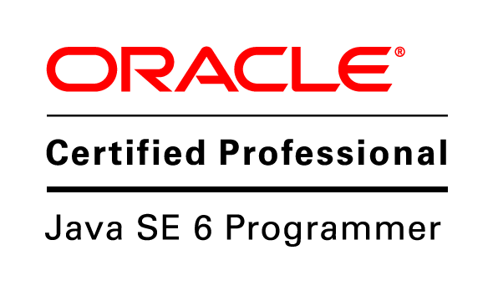
AYUSH INDANI
Assistant System Engineer, at Tata Consultancy Services
Mob: (+91) 7887570803 | E-mail: ayush.indani@yahoo.in
Website: ayush-indani.blogspot.com

Career Objective:

To steadily groom into an individual who can Learn, unlearn and relearn at a fast pace.

Work Experience:

- Dec ’15 – Present Tata Consultancy Services Limited, Pune

Client : The Home Depot, USA
Project Name : Stores and Customer Relations
Role : Developer
Skills : J2EE, Spring, RESTful WebService, SQL, HTML5, CSS3,
GIT, JavaScript, Ajax, JSON

Job Responsibility:
- Implementing codes, services for gifting and managing gift card balance for customers.
- Resolving issues with rebate order
- Writing script for restoring and maintaining sales data
- Application maintenance and other on demand featured enhancements

- Jan ’15 – Dec. ’15 Tata Consultancy Services Limited, Chennai

Client : Target Corporation, USA
Project Name : Target (Business Intelligence)
Role : Backend Developer
Skills : J2EE, UNIX, Oracle PL/SQL, ETL, Datastage

Job Responsibility:
- Creating production summaries and other featured enhancements.
- Optimizing complex production queries.
- Creating Unix Shell Scripts for efforts reduction and performance monitoring.
- Supporting Business Intelligence by preparing monthly statistical reports.
- Performing code changes as per production requirements.

Career Overview:

- A seasoned Java developer with nearly 2 years of experience in Java Spring, RESTful WebServices, Database, HTML, CSS, AJAX, JSON, Unix. Also, an Oracle Certified Java Programmer SE6. (Conti...)

Career Overview: (Conti…)

- Accolade Silver - Honored with this title of excellence for going an extra mile and being proactive during client visit (Client: Target, Inc.)
- Brainbench Certified Unix Administrator
- Oracle Certified Java Programmer SE6 (Oracle Testing ID: OC1565515 )
- Harbinger : Honored with this certificate of Excellence for proactive and outstanding performance during TCS training period
- Owner of Penaway.blogspot.com and Supportive content writer for ShoutMeLoud.com since 2015

Technical Skills:

- Programming Tools: J2EE, Java Spring, REST WS, Unix, Subversion, GIT, SQL Databases
- Web Tools: HTML, CSS, JavaScript, Ajax
- Platforms: Windows, Linux

Qualification:

B.E. (Hons.) in Information Technology Engineering from Medicaps Institute of Science and Technology, Indore with C.G.P.A 7.67

Notable Attainments:

- AIR of 679 (state rank 20) over 45000 applicants in International Mathematics Olympiad, 2010
- AIR of 23956 (state rank 1196) over 11 Lakh applicants, in AIEEE 2010

Extra Curricular Activities:

- Represented Indore in various Yoga championships (open as well as school)
- Winner of various school level debates, extempore and chess competitions

Personal Details:

Father’s Name : Mr. Ashok Indani
Mother’s Name : Mrs. Vijaya Indani
Date of Birth : 14-03-1993
Passport Number : L4396796
Permanent Address : 10/11-E Bakhtawar Ram Nagar, near Ajit Club,
Indore (M.P.), Pin-452018

I hereby declare that the information given above is true to the best of my knowledge and belief.

Date: 22-Jul-2016 (Ayush Indani)
Place: Pune

