Exercise 4
1.How are inline and block elements different from each other?
Answer:A block-level element always starts on a new line and takes up the full width available i.e; it stretches out to the left and right as far as it can. For example: anchor <a> tag ,emphasis <em> tag,image <img> tag,span tag, etc.
Whereas an inline element does not start on a new line and only takes up as much width as necessary . For example: heading tag, list tag , div tag, etc
2.Explain the difference between visibility:hidden and display:none
Answer: Display:none means that the tag in question will not appear on the page at all (although you can still interact with it through the dom). There will be no space allocated for it between the other tags.
Visibility hidden means that unlike display:none, the tag is not visible, but space is allocated for it on the page. The tag is rendered, it just isn't seen on the page.

3. Explain the clear and float properties.
Answer:The float property is used for positioning and formatting content e.g. let an image float left to the text in a container.
The float property can have one of the following values:
- left - The element floats to the left of its container
- right- The element floats to the right of its container
- none - The element does not float (will be displayed just where it occurs in the text). This is default
- inherit - The element inherits the float value of its parent
In its simplest use, the float property can be used to wrap text around images.

The clear property specifies what elements can float beside the cleared element and on which side.
The clear property can have one of the following values:
- none - Allows floating elements on both sides. This is default
- left - No floating elements allowed on the left side
- right- No floating elements allowed on the right side
- both - No floating elements allowed on either the left or the right side
- inherit - The element inherits the clear value of its parent

4. Explain difference between absolute, relative,fixed and static.
Answer: Absolute is a very powerful type of positioning that allows to place any page element exactly where we want it. We use the positioning attributes top, left, bottom. and right to set the location. Remember that these values will be relative to the next parent element with relative (or absolute) positioning. If there is no such parent, it will default all the way back up to the <html> element itself meaning it will be placed relatively to the page itself.
An element with position: relative; is positioned relative to its normal position.
Setting the top, right, bottom, and left properties of a relatively-positioned element will cause it to be adjusted away from its normal position. Other content will not be adjusted to fit into any gap left by the element.

An element with position: fixed; is positioned relative to the viewport, which means it always stays in the same place even if the page is scrolled. The top, right, bottom, and left properties are used to position the element.
A fixed element does not leave a gap in the page where it would normally have been located.

Static is the default for every single page element. Different elements don't have different default values for positioning, they all start out as static. Static doesn't mean much; it just means that the element will flow into the page as it normally would. The only reason you would ever set an element to position: static; is to forcefully remove some positioning that got applied to an element outside of your control. This is fairly rare, as positioning doesn't cascade.

5. Write the HTML code to create a table in which there are 4 columns( ID , Employee Name, Designation, Department) and at least 6 rows. Also do some styling to it.
Answer:
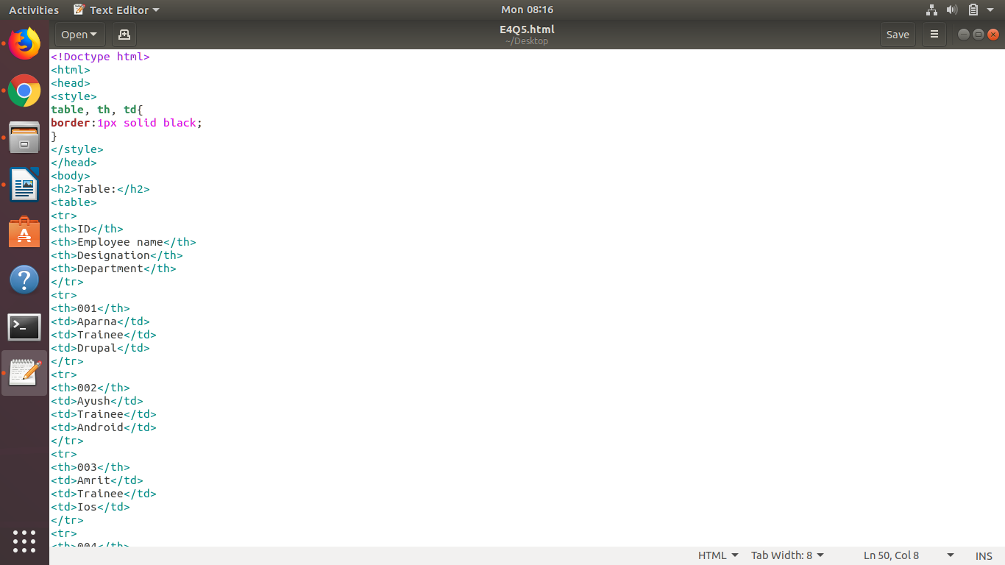

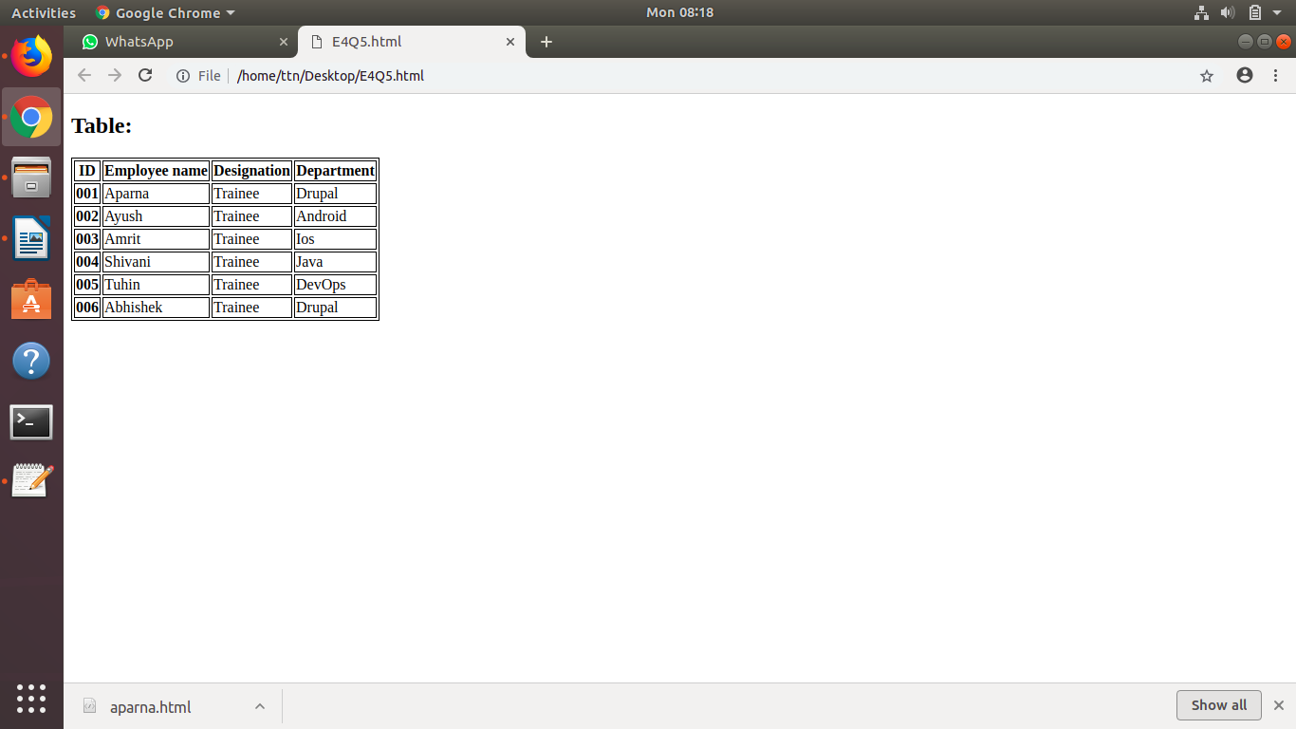

6. Why do we use meta tags?
Answer: The <meta> tag provides metadata about the HTML document. Metadata will not be displayed on the page, but will be machine parsable.
Meta elements are typically used to specify page description, keywords, author of the document, last modified, and other metadata. Also, it helps to improve the SEO( Search Engine Optimization) of a web page by using certain keywords related to the web page.
<meta> tags always go inside the <head> element.

7. Explain box model.
Answer: All HTML elements can be considered as boxes. In CSS, the term "box model" is used when talking about design and layout.
The CSS box model is essentially a box that wraps around every HTML element. It consists of: margins, borders, padding, and the actual content.

Explanation of the different parts:
- Content - The content of the box, where text and images appear
- Padding - Clears an area around the content. The padding is transparent
- Border - A border that goes around the padding and content
- Margin - Clears an area outside the border. The margin is transparent

8. What are the different types of CSS Selectors?
Answer: A CSS selector is the part of a CSS rule set that actually selects the content you want to style.
The universal selector works like a wild card character, selecting all elements on a page. Every HTML page is built on content placed within HTML tags. Each set of tags represents an element on the page. Look at the following CSS example, which uses the universal selector:
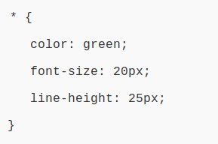

Element type selector:
Also referred to simply as a “type selector,” this selector must match one or more HTML elements of the same name. Thus, a selector of nav would match all HTML nav elements, and a selector of <ul> would match all HTML unordered lists, or <ul> elements.

The following example uses an element type selector to match all <ul> elements:
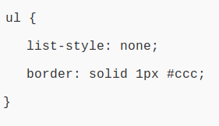

An ID selector is declared using a hash, or pound symbol (#) preceding a string of characters. The string of characters is defined by the developer. This selector matches any HTML element that has an ID attribute with the same value as that of the selector, but minus the hash symbol.

Here’s an example:
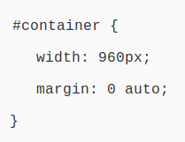

The class selector is the most useful of all CSS selectors. It’s declared with a dot preceding a string of one or more characters. Just as is the case with an ID selector, this string of characters is defined by the developer. The class selector also matches all elements on the page that have their class attribute set to the same value as the class, minus the dot.

Take the following rule set:
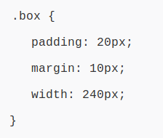

9. Define Doctype.
Answer: The <!DOCTYPE> declaration must be the very first thing in your HTML document, before the <html> tag.
The <!DOCTYPE> declaration is not an HTML tag; it is an instruction to the web browser about what version of HTML the page is written in.
In HTML 4.01, the <!DOCTYPE> declaration refers to a DTD, because HTML 4.01 was based on SGML. The DTD specifies the rules for the markup language, so that the browsers render the content correctly.
HTML5 is not based on SGML, and therefore does not require a reference to a DTD.

10. Explain 5 HTML5 semantic tags.
Answer: The <section> element defines a section in a document.

According to W3C's HTML5 documentation: "A section is a thematic grouping of content, typically with a heading."

A home page could normally be split into sections for introduction, content, and contact information.
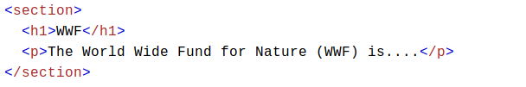

The <article> element specifies independent, self-contained content.

An article should make sense on its own, and it should be possible to read it independently from the rest of the web site.

Examples of where an <article> element can be used:

Forum post
Blog post
Newspaper article
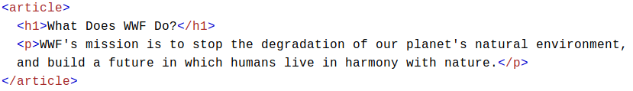

The <header> element specifies a header for a document or section.

The <header> element should be used as a container for introductory content.

You can have several <header> elements in one document.

The following example defines a header for an article:
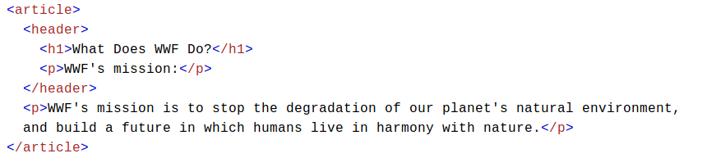

The <footer> element specifies a footer for a document or section.

A <footer> element should contain information about its containing element.

A footer typically contains the author of the document, copyright information, links to terms of use, contact information, etc.

You may have several <footer> elements in one document.

The <nav> element defines a set of navigation links.

The <aside> element defines some content aside from the content it is placed in (like a sidebar).

The <aside> content should be related to the surrounding content.
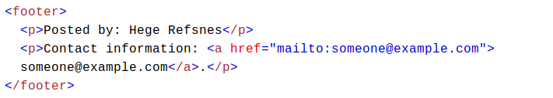
11. Create HTML for web-page.jpg (check resources, highest weightage for answers)
Answer:
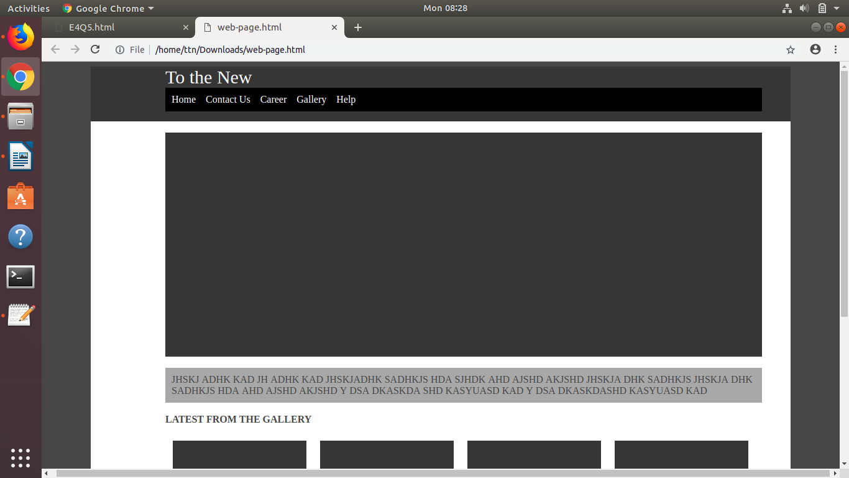

12. Create HTML for form.png (check resources, highest weightage for answers)
Answer:
