Exercise

MySQL:
1. Fetch employee's Name, address, Phone, Dob, Department, salary whose salary is greater than the average salary.
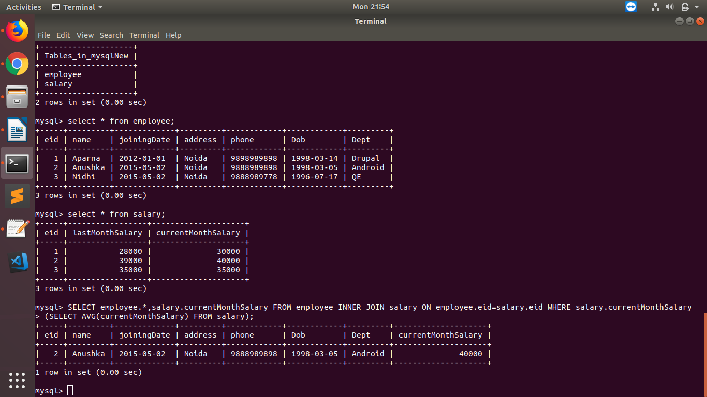
Answer :

2. Fetch Paid average salary for the current month.
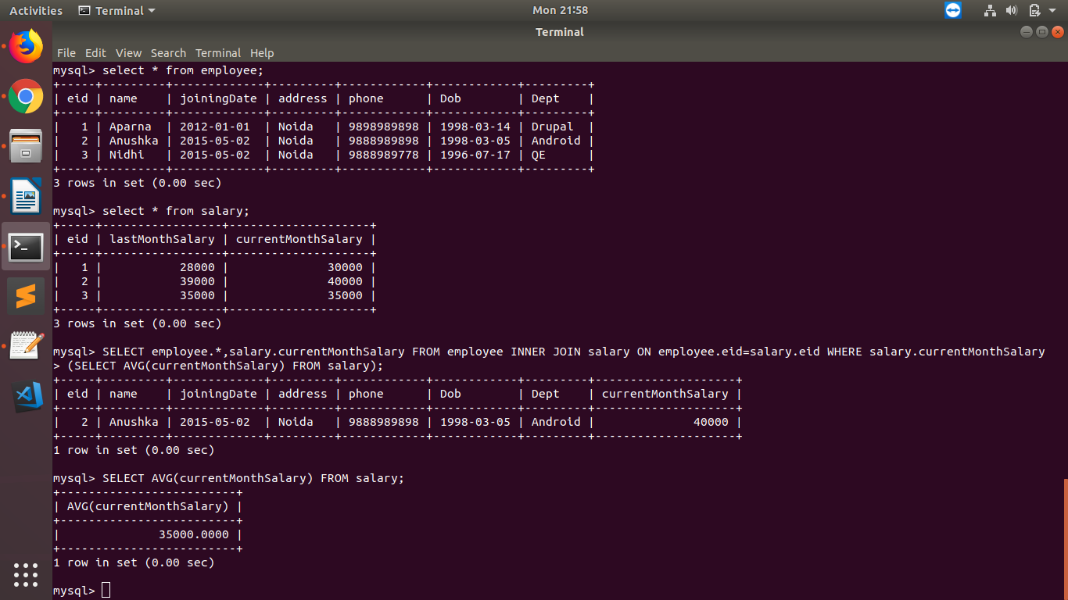
Answer :
3. Fetch the top 5 Employee's Name, Phone, Salary month, Paid salary for the current month.
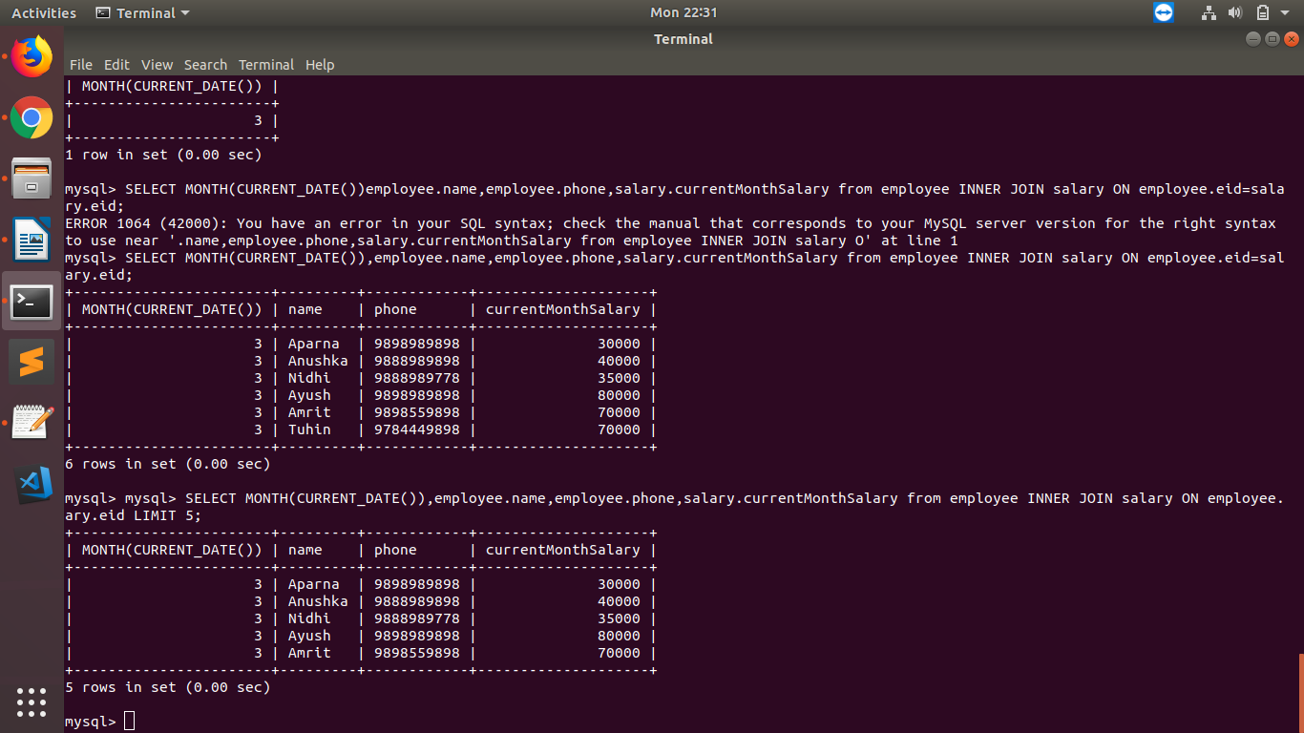
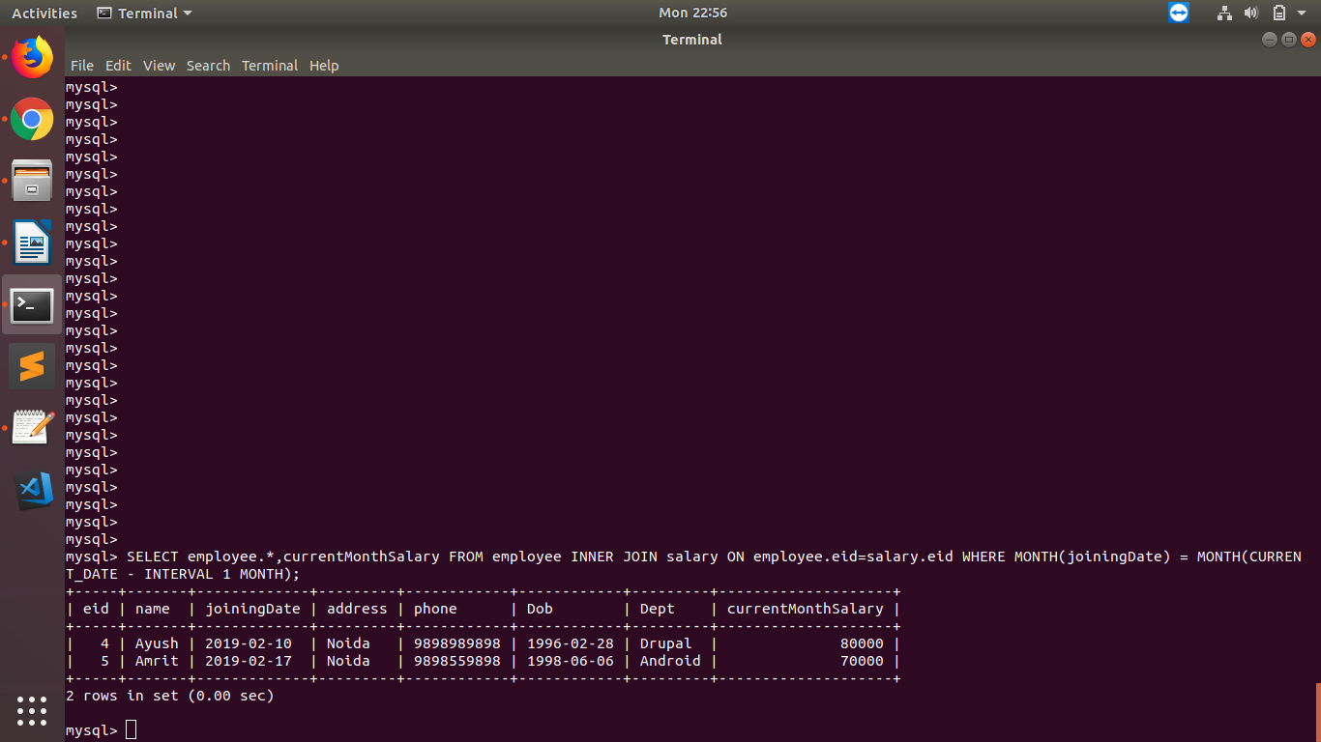
Answer :

4. Fetch the employee's name, phone, dob, department name, salary who join last month.
Answer :

5. Create a Program in PHP that will fetch and show employee details whose DOB is today?
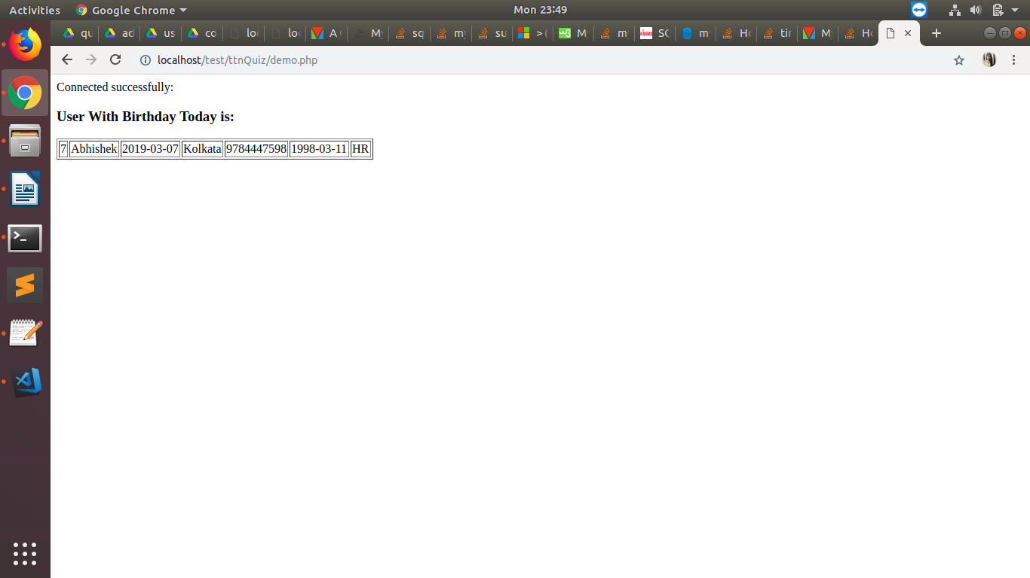
Answer :

6. What is a composite key?
Answer :
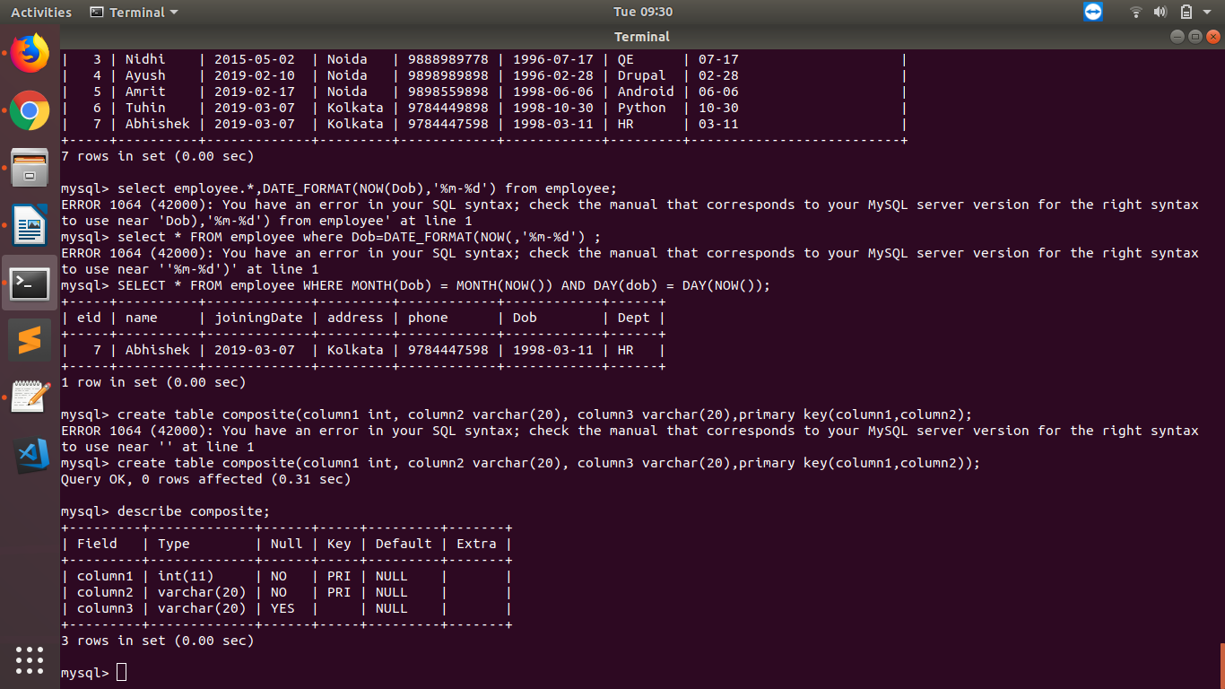

Composite key is made when more than one column of a table is used to make primary key in that table. The rows used in making the composite key could be of different data types.
It may be a candidate key or primary key. It is used to make the primary key even more uniquely identifiable.

7. What are the advantage & disadvantage of Index?
Answer : Indexes are used to find rows with specific column values quickly. Without the Index, MySQL would need to begin with first row and then read entire table every time to find relevant rows which would make it more and more difficult and tedious as the size of the table grows.
With indexes, MySQL can quickly determine the position it seeks in the middle of the data file without having to look at the entire table.
Example :
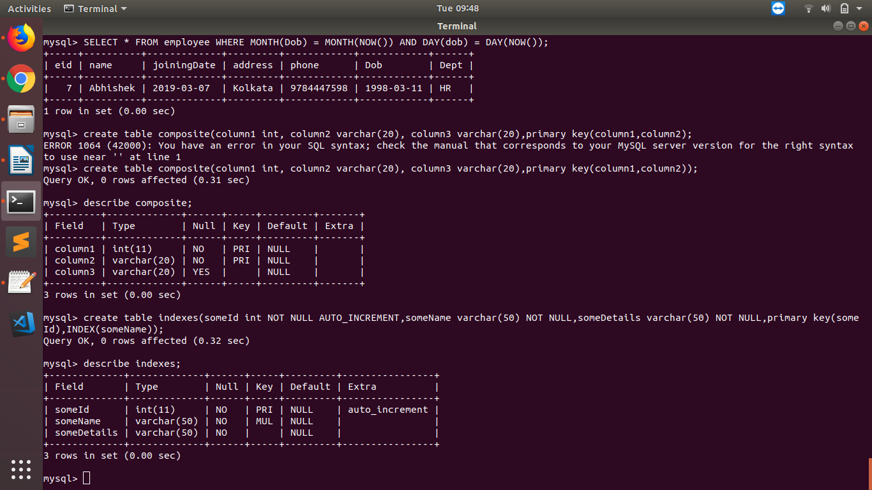
Advantages:
- Indexes make search queries much faster.
- Indexes like primary key index and unique index help to avoid duplicate row data.
- Full-text indexes in MySQL, users have the opportunity to optimize searching against even large amounts of text located in any field indexed as such.

Disadvantages:
- A separate file created when a new index created on the table column. that file stored only the field you’re interested in sorting on. So when we create index, it takes up disk space.
- The index also slow down the speed of writing queries, such as INSERT, UPDATE and DELETE. AS MySQL has to internally maintain the pointers to the inserted rows in the actual data file

8. Create two tables in MYSQL that shows working of INNER, OUTER, LEFT, RIGHT, CROSS JOINS.
Answer : Inner Join : The Inner Join selects all rows from both participating tables as long as there is a match between the columns.

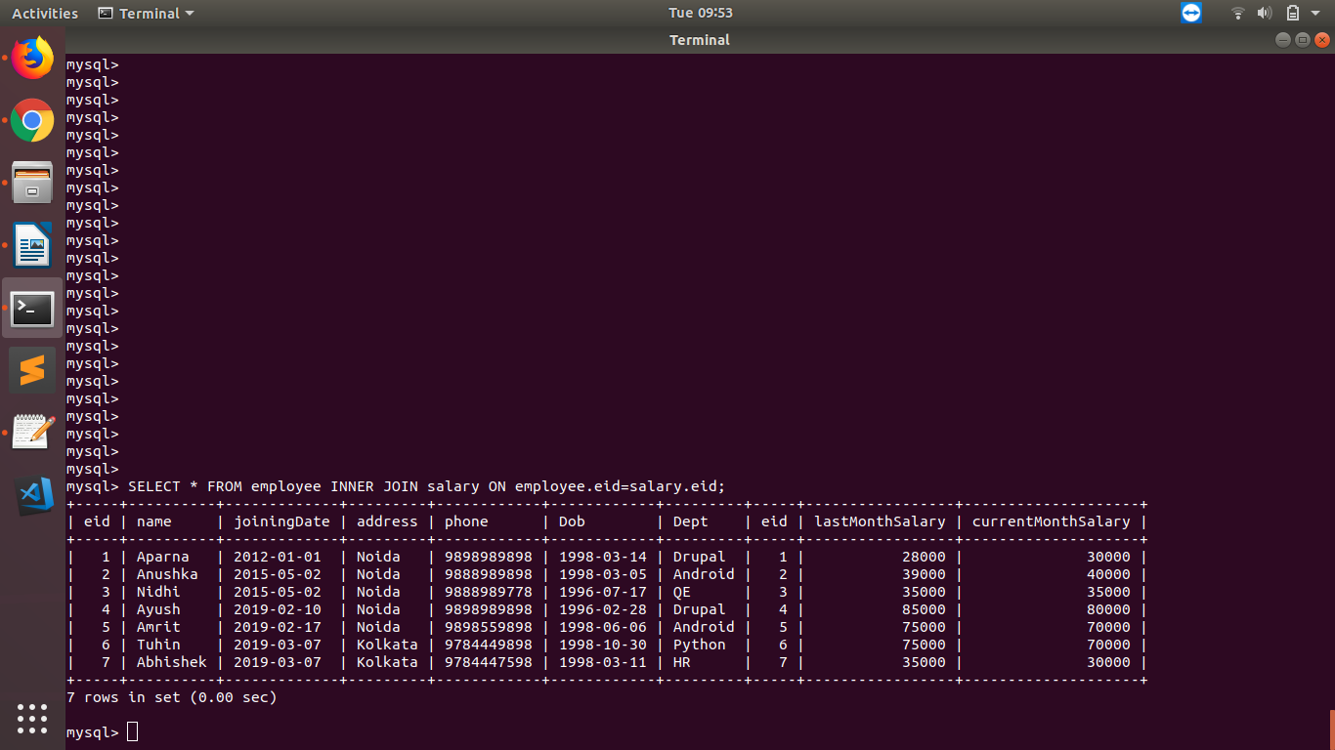

Outer Join :Outer Joins return all records matching from both tables .
It can detect records having no match in joined table. It returns null values for records of joined table if no match is found.

Left Outer Join : The Left Join returns all the rows from the table on the left even if no matching rows have been found in the table on the right. Where no matches have been found in the table on the right, NULL is returned.
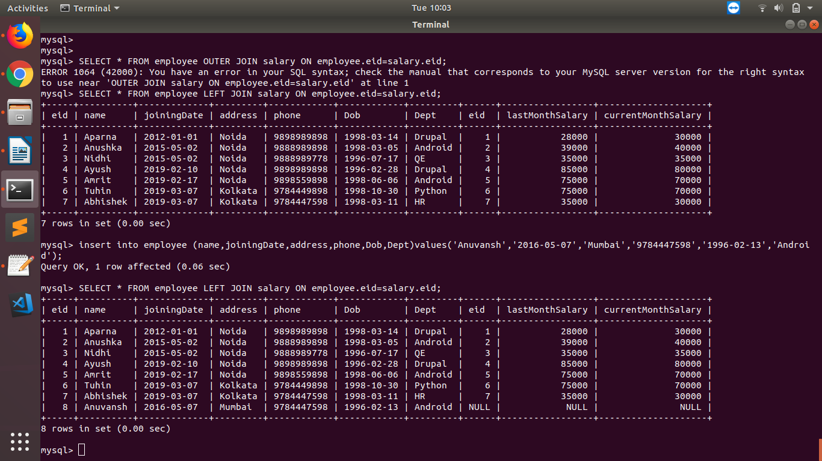

Right Outer Join : The Right Join returns all the rows from the table on the right even if no matching rows have been found in the table on the left. Where no matches have been found in the table on the left, NULL is returned.

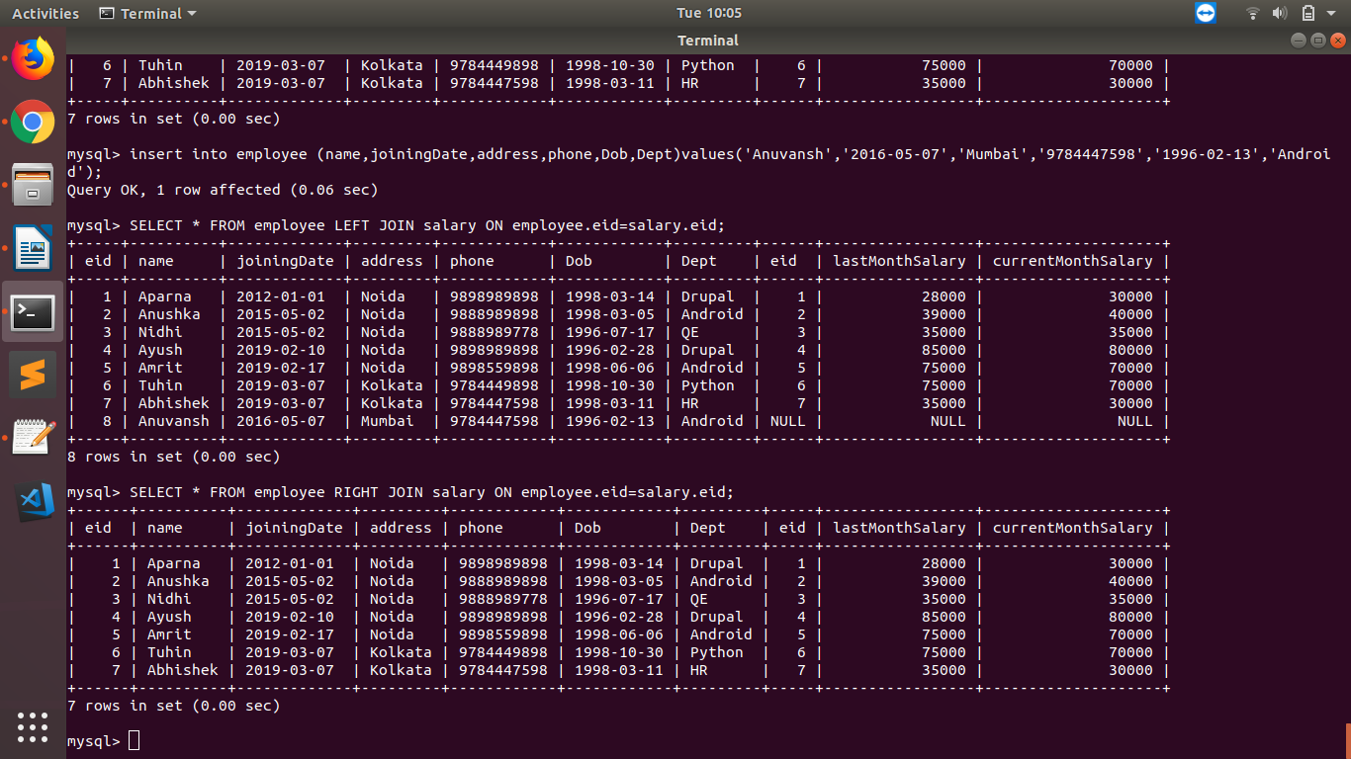

Cross Join: It gives us combinations of each row of first table with all records in second table.

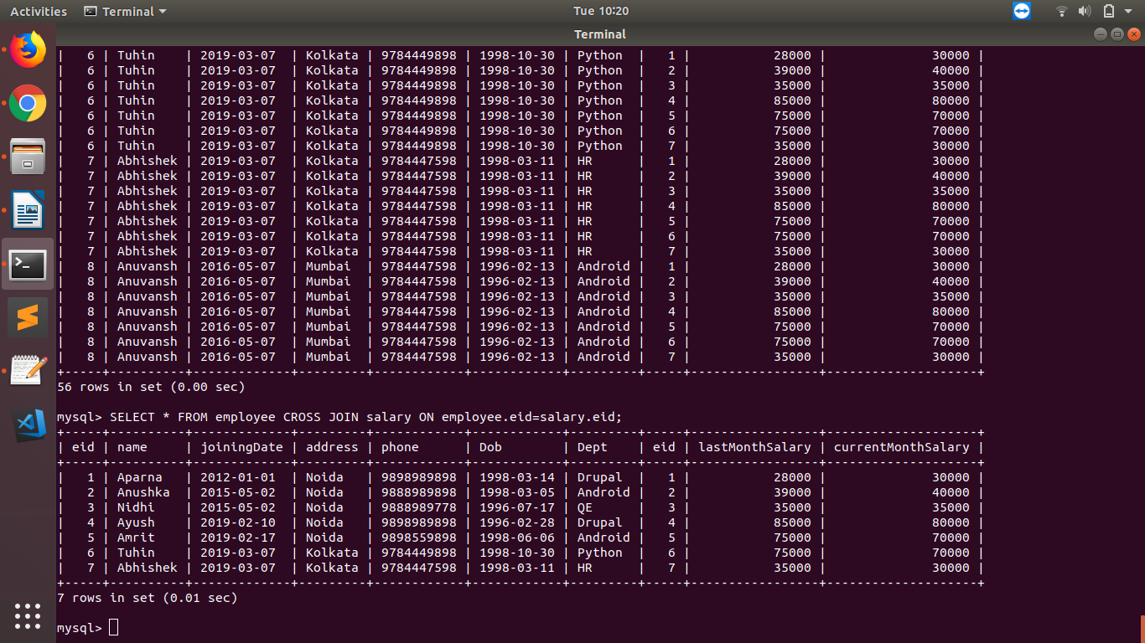

MONGO:

9. Write a program in PHP that will create a database "Bootcamp" with table "mongo".
10. Write a PHP program to perform Create, Read, Update and Delete Operations.
11. Write a PHP program to create a "single field" and "compound" indexes on the MongoDB collection and retrieve data using them.
12. Create two users one with "userAdminAnyDatabase" role and another with "readWrite" role and try to access mongo using both of them.

