Assessment of Ksoll classification in individual highly extincted regions

Clump72

(note these are the 3xbinned images – full res is higher)

Ksoll PMS candidates are in green with their mean probability

Contours are fitted dust column from Galliano out to PACS160

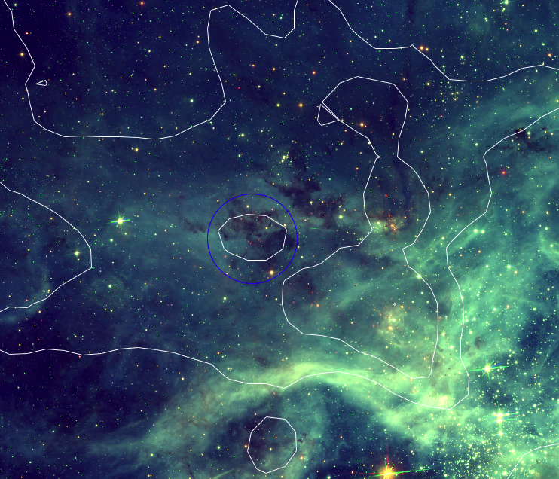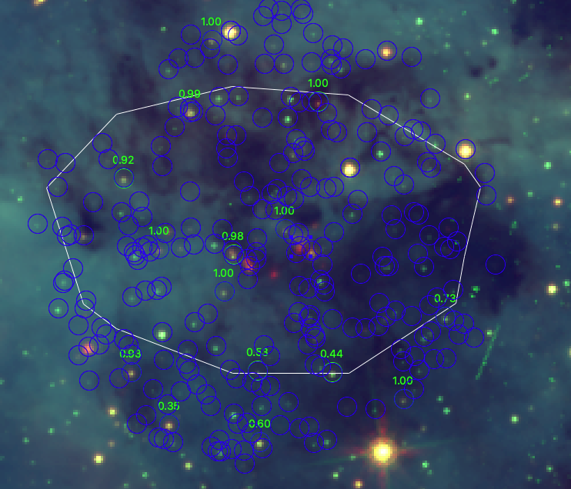

Observed and deredenned, for R136 in black dots, and for this region in green.

The single UMS star that is being used to deredden the entire region is shown.

457593: not detected at 555, so can’t be classified with 555-755

452716: not detected at 555

452717: close to MS in V-I so not distinguished there

452705: quite red – not sure why it isn’t classified as PMS – possibly due to the zero-prob. FG sources in training set?

452699: quite red – not sure why it isn’t classified as PMS

The marked points stand out in the NIR, showing the benefit of including those bands in the classification:

