heyer12, heyer13:

<https://ui.adsabs.harvard.edu/abs/2009ApJ...699.1092H/abstract>

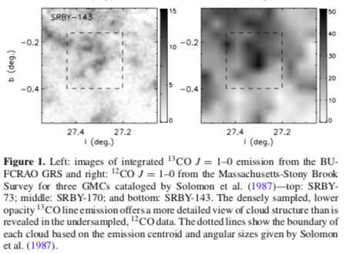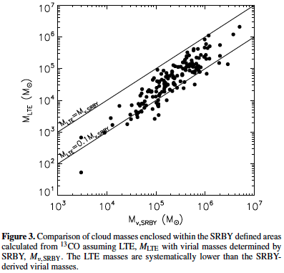

[12C/13C] = 6.2Rgal + 18.7.

H2/12CO abundance ratio of 1.1x104 (Freking et al. 1982)

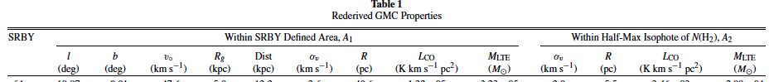

i l b v rg d sigv r lco mlte sig2 r2 lco2 mlte2

so sigv,r,MLTE are w/in the SRBY boundaries, similar to a 12CO-derived clumpfind segmentation.

R is not explained in Heyer09 – going back to SRBY:

<https://ui.adsabs.harvard.edu/abs/1987ApJ...319..730S/abstract>



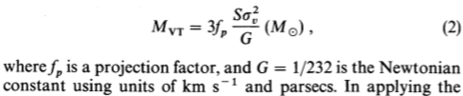

…

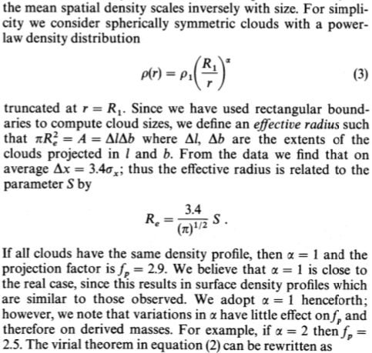

This is where the 1.92 comes from:

R = 3.4/sqrt(pi) S = 1.92 sqrt(sigl*sigb)

Sigl, sigb are the second moments in the spatial directions

I reproduced this figure in Heyer09:  
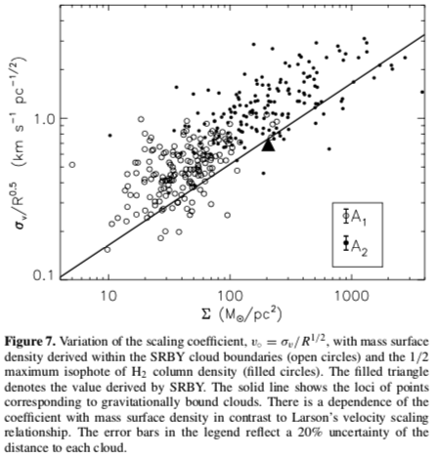

Oka01 galactic center

Figure reproduced: (with S=sigx)

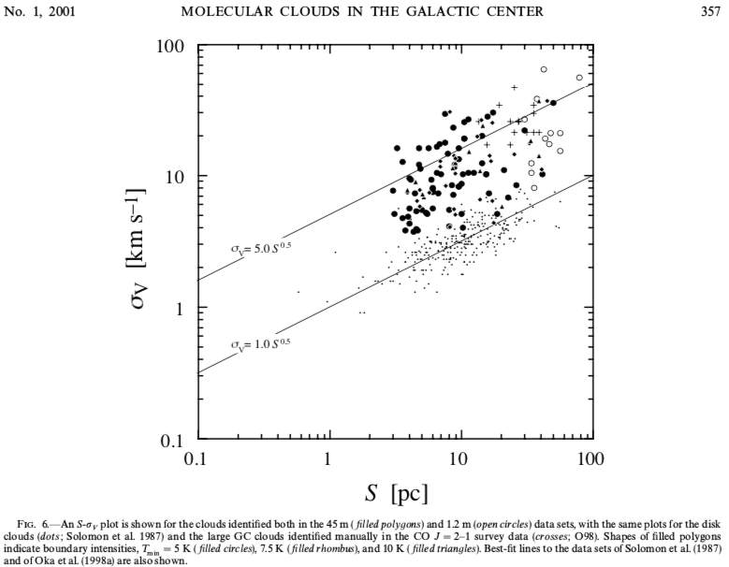

COMPLETE

https://www.cfa.harvard.edu/COMPLETE/data.html

[FCRAO Perseus 12CO cubes and map](https://dataverse.harvard.edu/dataset.xhtml?persistentId=doi:10.7910/DVN/B1G6QP)

[PerA_12coFCRAO_F_xyv.fits.gz](https://dataverse.harvard.edu/file.xhtml?persistentId=doi:10.7910/DVN/B1G6QP/RQVJZJ&version=2.0)

imsubimage "PerA_12coFCRAO_F_xyv.image",outfile="PerA_12coFCRAO_F_xyv.trim.image",chans="100~350"

exportfits "PerA_12coFCRAO_F_xyv.trim.image","PerA_12coFCRAO_F_xyv.trim.fits",velocity=True,dropdeg=True