Design

Use Case Diagram:

A use case diagram is a type of UML diagram that shows the interactions between a system and its users or actors, summarizing the relationships between use cases, actors, and the system.

Class Diagram:

A class diagram is a type of UML diagram that describes the structure of a system by showing the system's classes, their attributes, operations, and the relationships among objects. It is used for general conceptual modeling of the structure of the application and is the main building block of object-oriented modeling.Diagram

Sequence Diagram:

A sequence diagram is a type of UML diagram that depicts the interactions between objects in a sequential order, showing what messages are sent and when. It is used by software developers and business professionals to understand the requirements for a new system or to document an existing process.

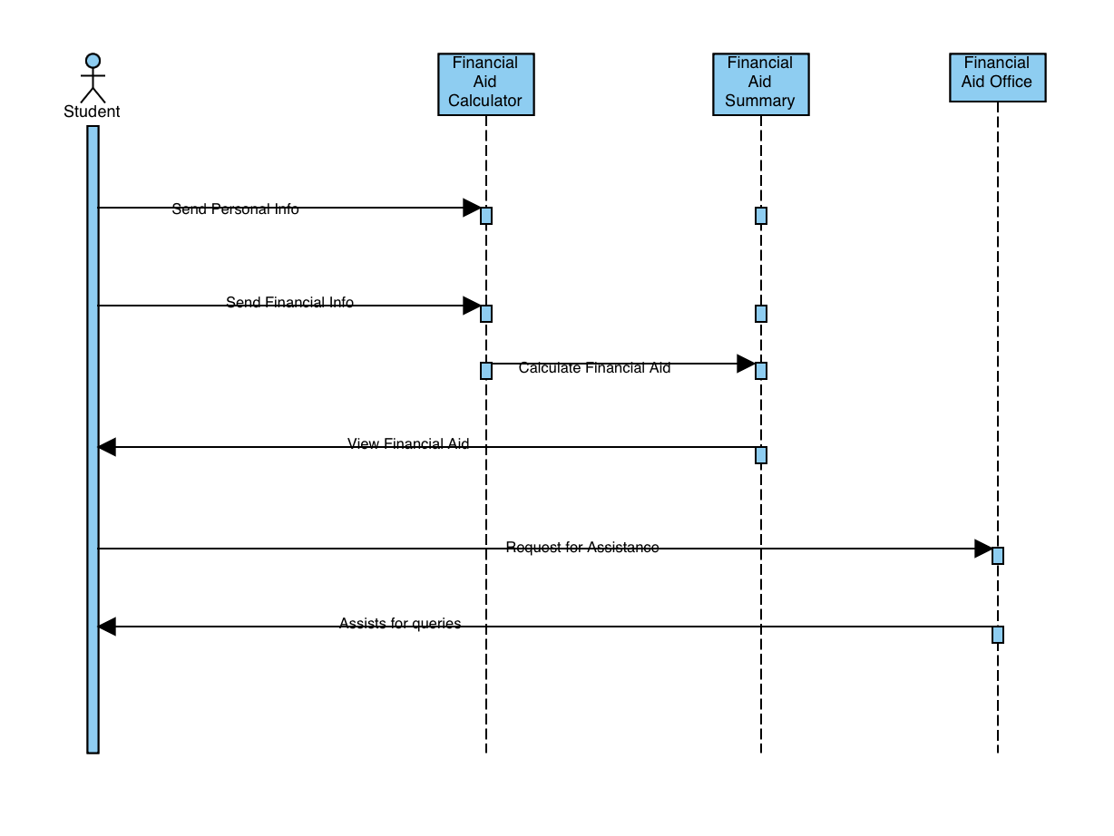

Activity Diagram:

An activity diagram is a type of UML diagram that represents workflows of stepwise activities and actions with support for choice, iteration, and concurrency. It is used to model both computational and organizational processes, as well as the data flows intersecting with the related activities. Activity diagrams can be regarded as a form of a structured flowchart combined with a traditional data flow diagram.

