**Autonomous Navigation and Perception via Deep Learning**

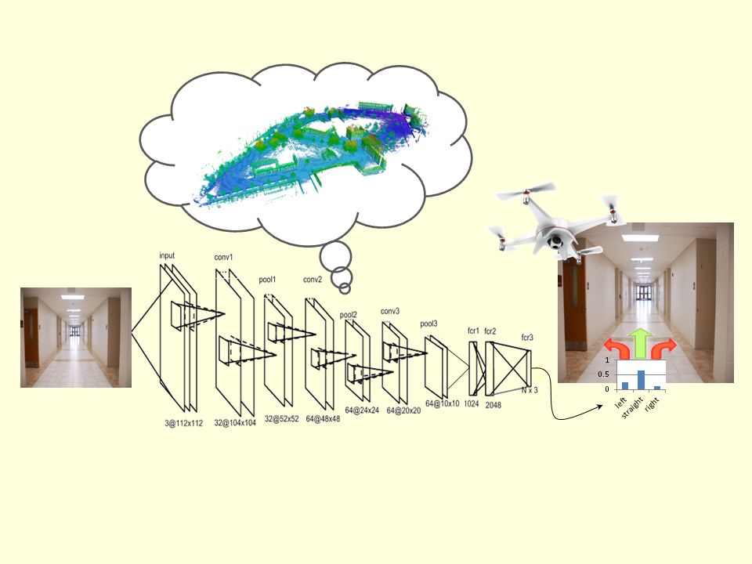

**In this project we shall investigate approaches to address autonomous navigation and perception in unknown environments via deep learning. Specific project objectives will be determined together with the student(s).**

**Contact details:**

Asst. Prof. Vadim Indelman: [vadim.indelman@technion.ac.il](mailto:vadim.indelman@technion.ac.il)

**Prerequisites:** programing skills (preferably Python or C++). Background in machine (deep) learning is an advantage.