**Autonomous Navigation and Perception via Deep Learning**

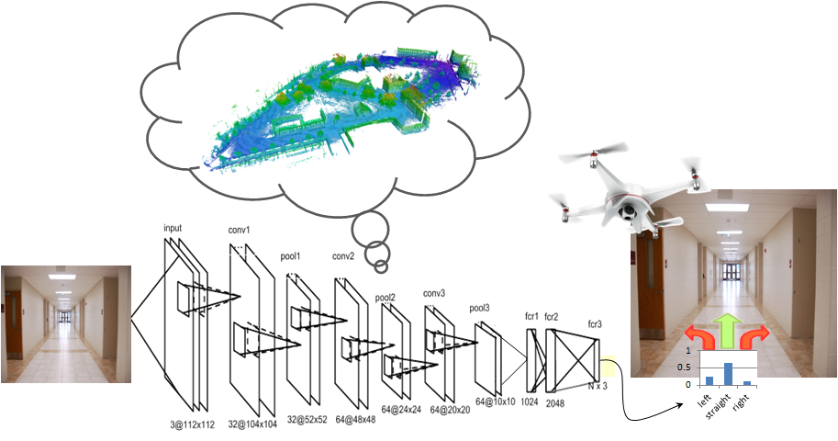

In this project we will reproduce recent results in the field, in an Unreal Engine - based environment. Time permitting, we will investigate modifications to the agent, in varying environments.

https://www.unrealengine.com/en-US/what-is-unreal-engine-4

Project steps:   
1. Set up infrastructure for reinforcement learning with Unreal Engine  
2. Train agent to navigate the simulation environment  
3. Investigate behavior in a set of navigation tasks, modifying the agent and the environment.

**Prerequisites:** strong programming skills, python (or willingness to learn). Background in machine (deep) learning, computer vision, robotics is an advantage.

**Supervisor:** Yuri Feldman, yurif@cs.technion.ac.il

**Academic supervisor**: Asst. Prof. Vadim Indelman, [vadim.indelman@technion.ac.il](mailto:vadim.indelman@technion.ac.il)

**Duration:** 1 or 2 semesters