**Autonomous Control of a Quadrotor**

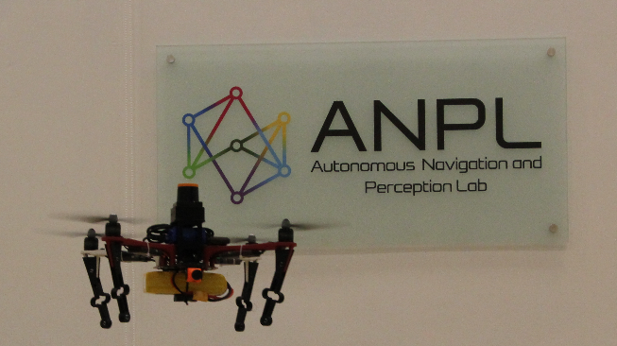

The goal of this project is to develop a position controller for a quadrotor equipped with a Pixhawk autopilot. The controller will get as input an estimated position of the quadrotor and a designated target location that the quadrotor has to reach. The quadrotor starts on the ground, has to take-off and navigate to the target location. The controller will be implemented on an onboard computer, such as Nvidia Jeston X1, which, upon need, will communicate with a central computer (e.g. using MAVROS protocol). The project will include conducting experiments with real quadrotors and evaluating performance using a motion capture system. A possible extension is to consider tight coupling with visual single/multi-robot SLAM.

**Prerequisites:** C++ or python

**Supervisor:** Asaf Feniger, asafeniger@gmail.com

**Academic supervisor:** Asst. Prof. Vadim Indelman: [vadim.indelman@technion.ac.il](mailto:vadim.indelman@technion.ac.il)

**Duration:** 1 or 2 semesters