**Autonomous Navigation and Perception via Deep Learning**

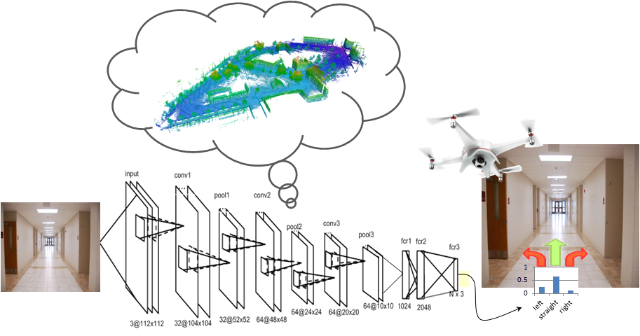

In this project we shall use deep learning for autonomous navigation and perception. Specific project objectives will be determined together with the student(s).

**Prerequisites:** Strong programming skills (preferably Python or C++). Background in machine (deep) learning, computer vision, robotics is an advantage.

**Academic supervisor**: Asst. Prof. Vadim Indelman, [vadim.indelman@technion.ac.il](mailto:vadim.indelman@technion.ac.il)

**Duration:** 1 or 2 semesters