BarBellix — Complete Project Documentation

A multi-tenant gym management platform: member mobile app, staff web dashboard, and one shared API.

Field | Value
Document version | 1.0
Date | 2026-09-11
Repository | barbellix — npm workspaces monorepo
Branch documented | master
Commits covered | 43 — 0c4a936 (2026-07-19) through f38ca23 (2026-08-30), plus the uncommitted payments work
Scale | 365 source files, ~31,400 lines across 4 workspaces

> How to read this document. Sections 1–5 describe what was built and how it fits together. Sections 6–13 are the reference tables: every data model, every API route, every service function, every screen. Section 14 covers testing, section 15 covers deployment. Section 16 is the pending-functionality analysis — what is still missing, ordered by how much it matters.

1. Executive summary

BarBellix is a gym-management product built as three deliverables sharing one backend:

- Member mobile app — Expo / React Native. Training plans, live workout logging, AI coaching, progress tracking, nutrition, habits, QR gym check-in, class booking, and membership payment.
- Staff web dashboard — React / Vite. Gym-owner and trainer consoles for member management, trainer management, attendance analytics, payments, class scheduling, and workout-plan oversight.
- API server — Fastify / MongoDB. One multi-tenant API serving both clients, with role-based access control enforced at both the route layer and the data-query layer.

The platform supports four roles — member, trainer, admin (gym owner), and superadmin (platform operator) — over a tenant-scoped, branch-scoped data model, so one deployment can host multiple gyms.

Where the project stands. The core product is functionally complete and runs end to end: authentication, workout and diet planning with AI generation, attendance, progress tracking, class booking, messaging, trainer management, and payments. Payments were migrated from Stripe to Cashfree — India-first, covering UPI, cards, net banking and wallets — and verified against a live Cashfree sandbox account up to and including the real hosted checkout UI. A cash-payment flow with SMS OTP confirmation was added for members who pay at the front desk.

What is not finished is covered in full in section 16. The headline items: password reset is non-functional end to end because no email capability exists anywhere in the product; four notification toggles are inert because the server has no job scheduler; iOS is not buildable because eas.json has no ios profile and app.json has no camera usage-description string; and the legal pages still carry [PLACEHOLDER] markers.

2. Development timeline

The project began as a mock-only mobile prototype with AI API keys embedded in the client. The entire backend, web dashboard, and multi-tenancy model were built afterwards. The commit history reads as eight distinct phases.

Phase 1 — Monorepo and backend foundation (2026-07-19)

Commit | Change
0c4a936 | Baseline commit before backend monorepo restructuring
aabd718 | Scaffold npm workspace monorepo, move app into apps/mobile
6a610d8 | Extract packages/shared — domain types and auth Zod schemas
5da3bc0 | Scaffold apps/server — Fastify + Mongoose + MongoDB skeleton
1c7fa85 | Auth module — register, login, refresh, logout, forgot-password
d284b85 | Users, exercises, workouts modules
bf48a10 | Attendance, workout sessions, progress, nutrition, habits modules
feafce0 | Trainer and admin modules
2a386e0 | Messaging and notification preferences
052e57e | The AI proxy — the security fix that motivated the whole backend. AI provider keys moved server-side.
a1f2387 | Wire the mobile app to the real backend; mocks and client-side AI keys removed

Phase 2 — Web dashboard (2026-07-19)

Commit | Change
a12d064 | M0 — backend extensions for the web management dashboard
9c5d71d | M1 — Stripe billing backend: membership plans, checkout, webhooks
ef309c9 | M2 — scaffold apps/web: Vite + React 19 + TypeScript + Tailwind v4 + shadcn/ui
c036e50 | M3 — web auth and routing shell: MobX session, role-gated routes
5130ff3 | M4 — owner/admin dashboard: KPIs, roster management, billing UI
ddace70 | M5 — trainer dashboard: roster, plan builder, assignment, messaging

Phase 3 — Deployment and client-PRD gap closure (2026-07-20 to 2026-07-26)

Commit | Change
164b648, 593c808, d4ede3f | GitHub repo init, README rewrite, history merge
ce79a49 | Containerize the stack; Render Blueprint for hosted deployment
83035da | Wire the last 3 mock mobile screens to the real backend
e3f10fa | Account and payment fields, admin analytics, real AI-generated workout plans
55b68eb | Grace period, QR device-pairing login, sponsorships, AI diet plans, payment history, photo upload
5bc2df1 | Fix the N+1 query storm on the trainer and admin member roster

Phase 4 — Shared UI, classes, push (2026-07-26 to 2026-07-27)

Commit | Change
82f76f3 | M0 — shared UI component library on both clients
bd33a63 | M1 backend — group class scheduling and booking
50019c5 | M1 frontend — class scheduling and booking on mobile and web
e0eb496 | M2 — real push notifications
40537dd | M3 — shared mapper helper, web code-splitting, working lint on every app

Phase 5 — Rebrand (2026-07-29 to 2026-07-30)

Commit | Change
1e600a5 | Rename project: FitPulse to BarBellix
681ea8a | Theme: Tech-Forward Powerhouse — Obsidian Black, Titanium Silver, Electric Volt
7ed0d33 | BarBellix brand mark — bolt-monogram icon, favicon, app icon assets

Phase 6 — Production hardening (2026-08-09)

Commit | Change
2542cb3 | Vercel migration, Sentry, rate limiting, first tests
6b6dbc9 | Fix seeded members missing assignedTrainerId; extend seed data
3bbfee5 | Replace emoji icons with Ionicons on the member home screen
c539d39 | Google sign-in, QR check-out, trainer sign-in QR; seed script removed

Phase 7 — Production bug fixes (2026-08-22 to 2026-08-30)

Commit | Change
108304f | Explore card text-wrap bug, profile-setup prompt, richer AI exercise selection
8e3c1d9 | Production crash fix — replaced argon2 with bcryptjs; the native addon could not be bundled for serverless
cb2d068 | Security fix — passwordHash was leaking in every API response returning a User, through a Mongoose subdocument spread
04e014f | Real favicon.ico and vector logo assets
f38ca23 | Gym-owner admin management: trainers, attendance, payments, workout oversight

Phase 8 — Cashfree payments and go-live prep (uncommitted at time of writing)

Area | Change
Payments | Stripe removed entirely. Cashfree Payment Gateway integrated — orders API, hosted checkout through their client JS SDK, signed webhooks with replay protection
Cash payments | New SMS-OTP flow, so a front-desk cash payment is confirmed by the member rather than asserted by staff
Membership extension | Atomic MongoDB aggregation-pipeline update, so concurrent payments cannot double-extend or lose time
Legal | Public /privacy and /terms pages on the web app, linked from mobile registration
Tooling | bootstrap-admin.ts — creates the very first admin account, which no in-product path can do
Tests | 46 passing server tests across attendance, auth, billing, trainer, Cashfree, and cash-OTP
Docs | docs/DEPLOYMENT.md go-live checklist

3. System architecture

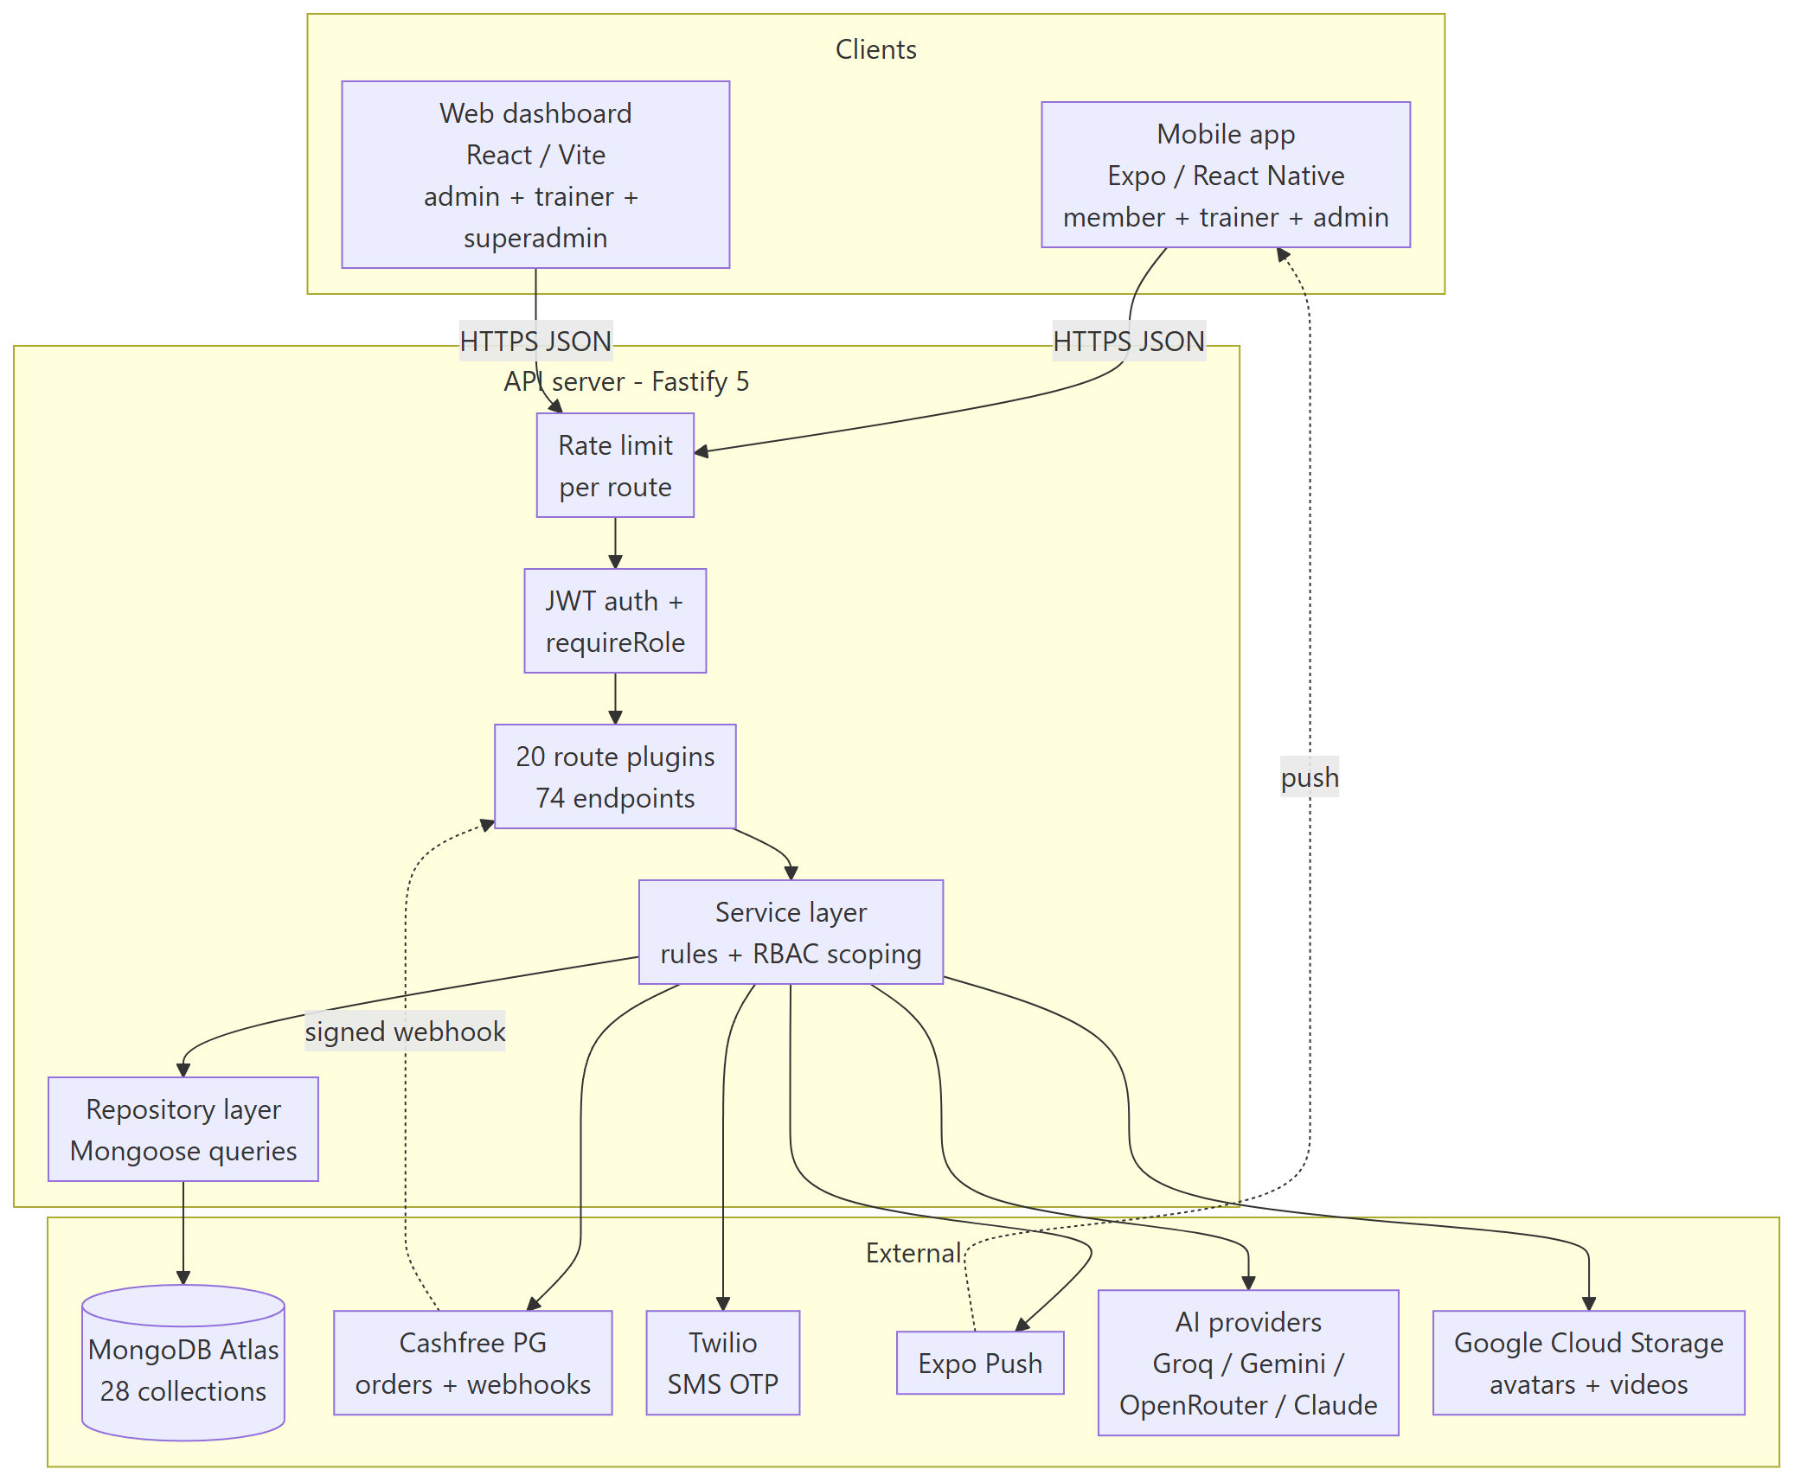

The layering rule. Routes own HTTP concerns and Zod validation. Services own business rules and role scoping — a trainer's request resolves a member through findAssignedMemberByIdInTenant, an admin's through findMemberByIdInTenant, so authorization is enforced by the query itself rather than by a separate check that can be forgotten. Repositories own Mongoose. Nothing skips a layer.

Request lifecycle

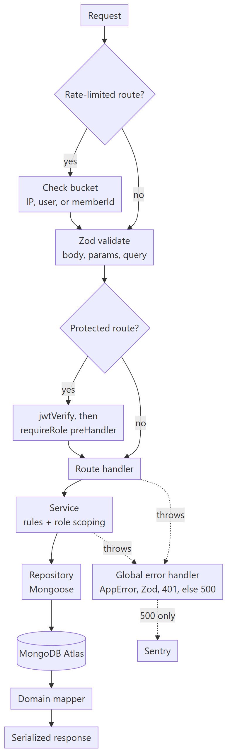

4. Technology stack

Layer | Choice | Why it is here
Monorepo | npm workspaces | apps/* and packages/*; shared types compiled once, consumed by all three apps
API framework | Fastify 5 | Schema-first, fast, first-class TypeScript plugin model
Validation | Zod 3 + fastify-type-provider-zod | One schema validates the request and types the handler
Database | MongoDB + Mongoose 8 | The document model fits nested workout plans and profile subdocuments naturally
Auth | @fastify/jwt + rotating refresh tokens | Short-lived access token; hashed refresh token with reuse detection
Password hashing | bcryptjs, 12 rounds | Pure JS — argon2's native addon could not be bundled for serverless
Payments | Cashfree Payment Gateway, orders API | UPI, cards, net banking, wallets — the India-first requirement
SMS | Twilio, behind a provider seam | SMS_PROVIDER env var, the same swappable pattern as storage
Push | Expo Push | Works with the existing Expo client without a native module
Object storage | Local disk or Google Cloud Storage | STORAGE_BACKEND env var selects the backend
Monitoring | Sentry | Server, web and mobile; no-ops when the DSN is unset
Web UI | React 19 + Vite 8 + Tailwind v4 + Radix / shadcn | Code-split routes, dark-first theme
Web client state | MobX | A single observable authStore; pages are observers
Web server state | TanStack Query v5 | 2-minute stale time, refetch on window focus
Mobile | Expo SDK 54 + React Native 0.81 + React 19 | One codebase, OTA-updatable, no ejection needed
Mobile client state | Zustand + MMKV | A small auth store with fast native-backed persistence
Mobile navigation | React Navigation 6 | Bottom tabs for members, flat stacks for staff
Charts | Recharts on web, Victory Native on mobile | Different rendering models per platform
Testing | Vitest | 46 server tests, mocked at the repository boundary

5. Repository layout

barbellix/
├── apps/
│ ├── server/ Fastify API — 145 files, ~8,979 lines
│ │ ├── src/
│ │ │ ├── app.ts builds Fastify, registers 20 route plugins
│ │ │ ├── server.ts boots Sentry, listens
│ │ │ ├── config/env.ts the single env-var schema
│ │ │ ├── plugins/ config, database, auth, error-handler
│ │ │ ├── db/models/ 28 Mongoose models
│ │ │ ├── db/bootstrap-admin.ts creates the first admin account
│ │ │ ├── lib/ 16 cross-cutting libraries
│ │ │ └── modules/ 19 feature modules
│ │ └── test/ 46 Vitest tests
│ ├── web/ Admin + trainer dashboard — 72 files, ~7,772 lines
│ │ └── src/ pages, layouts, routes, components, api, store, lib
│ ├── mobile/ Expo app — 144 files, ~13,675 lines
│ │ └── src/ screens, navigation, components, hooks, api, store, lib, theme
├── packages/
│ └── shared/ Types, Zod schemas, constants — 4 files, ~989 lines
└── docs/ This document, deployment guide, PRD set, client status

Module shape. Every server module follows the same four files, and the convention is worth stating because it is what makes the codebase navigable:

modules/<name>/
├── routes.ts HTTP surface, Zod schemas attached, role guards in preHandler
├── schemas.ts Zod request and response definitions
├── service.ts business rules, role scoping, cross-module orchestration
└── repository.ts Mongoose queries — the only file that touches a model

Root npm scripts

Command | What it does
npm run shared | Build packages/shared — required before the server or web typechecks
npm run shared:watch | Rebuild shared on change
npm run server | Start the API in watch mode
npm run web | Start the web dashboard dev server
npm run mobile | Start Expo
npm run mobile:tunnel | Start Expo through a tunnel, for testing on a device off the LAN
npm run mobile:typecheck | Typecheck the mobile app
npm run build | Build shared, then server, then web
npm run test | Run the server test suite
npm run lint | Lint every workspace that defines a lint script

6. Roles and permissions

Four roles, in a strict capability hierarchy. Each role's surface is deliberately different on mobile and web, because the jobs are different: members live in the app, staff live in the dashboard.

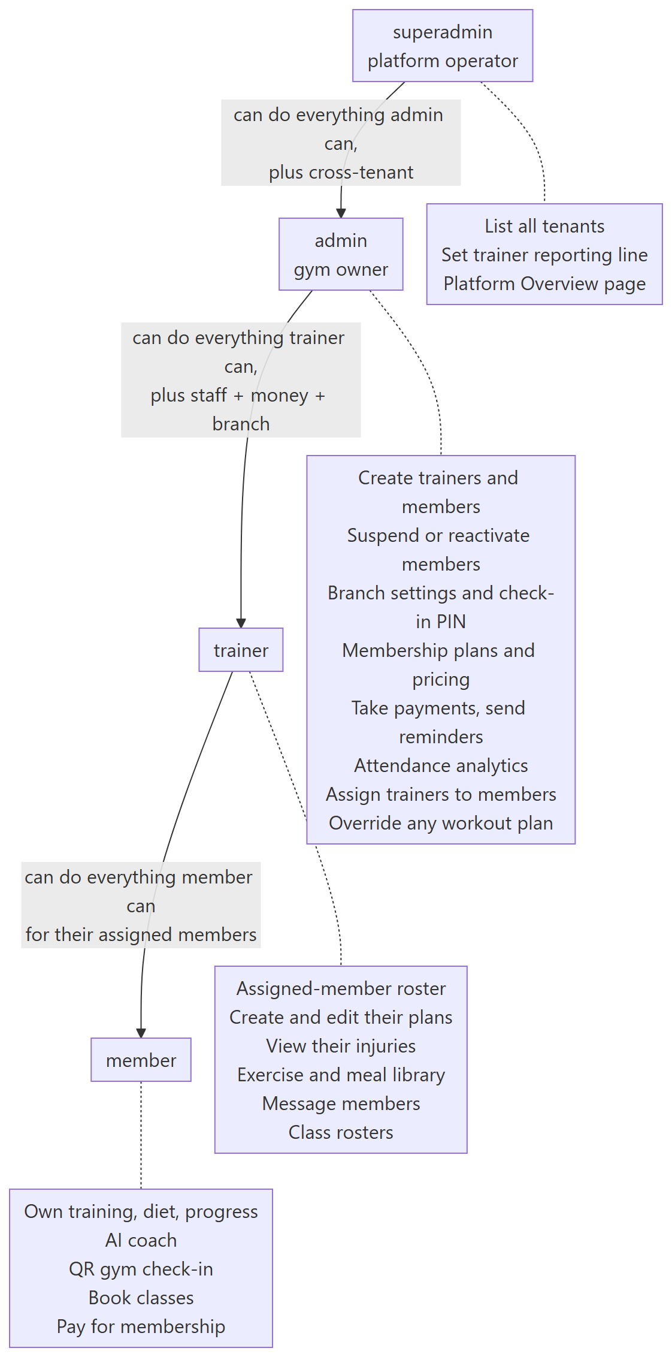

Where each role is enforced

Enforcement point | Mechanism | Example
Route level | fastify.requireRole(...) in preHandler | PATCH /trainer/members/:id/status is admin-only
Service level | Requester-scoped repository call | A trainer resolves members via findAssignedMemberByIdInTenant; an admin via findMemberByIdInTenant
Service level, finer | Per-trainer permission flags | assertTrainerCanManage() checks trainerPermissions.canManageExerciseLibrary before library writes
Service level, reporting line | reportsToRole on the trainer | A trainer who reports to superadmin can only be edited by a superadmin, not by a gym admin
Web route level | RequireAuth then RequireRole | /admin/platform carries a second, nested superadmin-only guard
Mobile navigation | RootNavigator branch on role | Role decides which navigator mounts at all; there is no shared shell to escape from

Capability matrix

Capability | member | trainer | admin | superadmin
Log workouts, meals, habits, body metrics | yes | own | own | own
AI coach and AI plan generation | yes | yes | yes | yes
QR or PIN gym check-in | yes | yes | yes | yes
Book and cancel classes | yes | yes | yes | yes
Pay for own membership | yes | — | — | —
View assigned members' data | — | yes | all members | all members
Create and edit member workout plans | own only | assigned only | any member | any member
Manage exercise and meal library | — | if permitted | yes | yes
Message members | — | yes | yes | yes
Create trainer and member accounts | — | — | yes | yes
Suspend or reactivate a member | — | — | yes | —
Assign a trainer to a member | — | — | yes | yes
Set trainer library permissions | — | — | yes | yes
Branch settings, check-in PIN, capacity | — | — | yes | yes
Membership plans and pricing | — | — | yes | yes
Take payment, mark paid, cash OTP | — | — | yes | yes
Send payment-due reminders | — | — | yes | yes
Attendance analytics and feed | — | — | yes | yes
Class templates and rosters | — | yes | yes | yes
Sponsors management | — | — | yes | yes
List all tenants on the platform | — | — | — | yes
Set a trainer's reporting line | — | — | — | yes

7. Data model

28 Mongoose models. Everything hangs off Tenant, and almost every collection carries a tenantId so a query can never accidentally cross gyms.

Core — identity, tenancy, billing

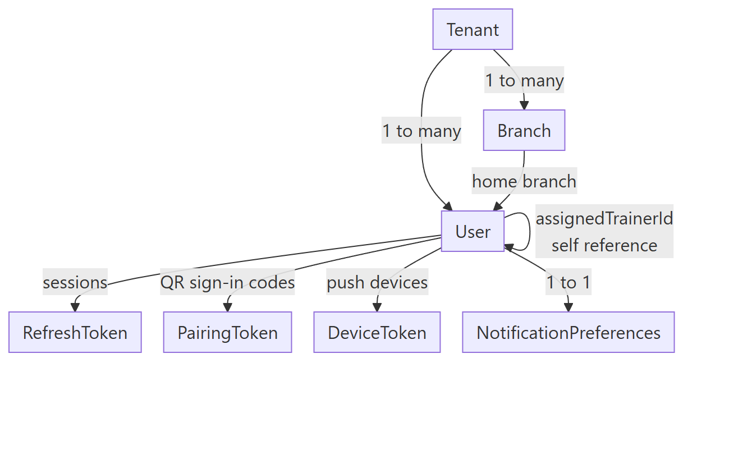

Billing and payments

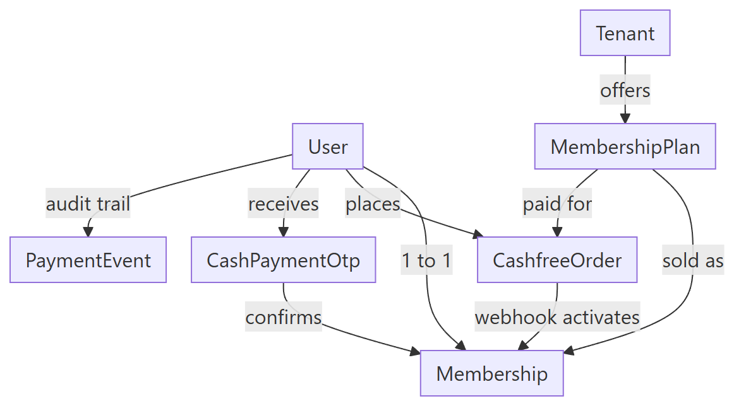

Training and activity

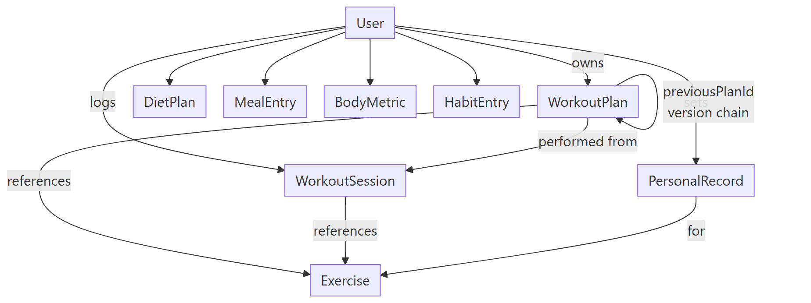

Gym floor and classes

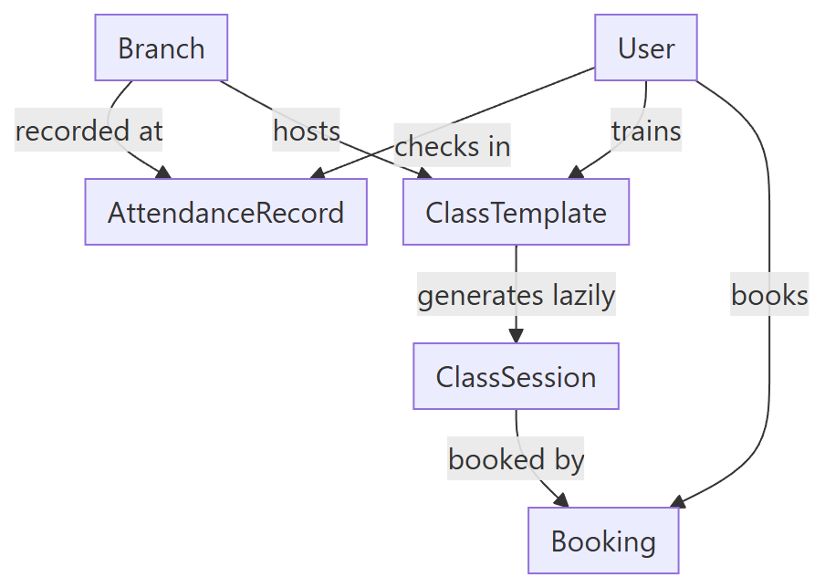

Model reference

Model | Purpose | Key fields | Notable constraints
Tenant | One gym business | name, planTier, themeConfig | Root of the tenancy tree
Branch | One physical location | qrCodeToken unique, checkInPin, capacity, checkInMethods, autoCheckoutAfterMins, gracePeriodDays, checkInIntervalDays | QR token is the check-in credential
User | Every human, all four roles | role, status, email unique, passwordHash select false, profile subdocument, assignedTrainerId, trainerPermissions, reportsToRole | passwordHash is never selected by default
Exercise | Exercise catalog | name, muscleGroups, equipment, instructions, mediaUrl, isCustom, tenantId sparse | Null tenantId means a global catalog entry
Meal | Reusable meal library | name, mealType, macros, isCustom, tenantId sparse | Same global-vs-tenant split as Exercise
WorkoutPlan | A member's training plan | days with nested exercises, goal, generatedBy, active, version, previousPlanId, changeSummary | Versioned: edits supersede rather than mutate
WorkoutSession | One logged workout | sets subdocuments, durationMins, perceivedEffort | Drives streaks, volume, PRs
DietPlan | AI or trainer diet plan | daily calorie and macro targets, meals | Meals are inline copies, not refs
MealEntry | One logged meal | loggedAt, mealType, macros | The member's own food log
BodyMetric | One body measurement | weightKg, bodyFatPct, measurements | Powers the weight and body-fat charts
PersonalRecord | A best lift | exerciseId, value, unit | —
HabitEntry | One habit, one day | habitId, date, completed | Unique on user plus habit plus date
AttendanceRecord | One gym visit | checkedInAt, checkOutAt, method | An open record means still inside
ClassTemplate | A recurring class | occurrences, trainerId, capacity | Sessions are generated from this lazily
ClassSession | One dated instance | date, startTime, bookedCount, waitlistCount, status | Unique on template plus date
Booking | A member's seat | status booked, waitlisted or cancelled | Partial-unique so a cancelled booking can be rebooked
MembershipPlan | A purchasable plan | priceCents, currency default inr, billingInterval | Prices stored in the minor unit
Membership | One member's subscription | status, paymentStatus, paymentMethod, gatewayOrderId, startDate, endDate, lastPaymentReminderAt | Unique per user; extended atomically
CashfreeOrder | An online payment attempt | cashfreeOrderId unique, paymentSessionId, amountCents, status | Unique order id gives webhook idempotency
CashPaymentOtp | A front-desk cash OTP | codeHash, amountCents, attempts, expiresAt, usedAt | Hashed, single-use, 10-minute TTL, 5-attempt cap
PaymentEvent | Payment audit trail | type, amountCents, planName, occurredAt | Backs the payment-history view
Message | 1:1 message | senderId, recipientId, text, read | Trainer and member threads
Sponsor | Gym partner brand | name, logoUrl, websiteUrl, active | Member-facing sponsor list
DeviceToken | Expo push token | expoPushToken unique, platform, lastSeenAt | One row per device
NotificationPreferences | Per-user toggles | 9 boolean preferences plus reminder time | _id is the userId — a true 1:1
RefreshToken | A session | tokenHash unique, expiresAt TTL, revokedAt, replacedByTokenId | Rotation chain; reuse revokes every session
PairingToken | A QR sign-in code | tokenHash unique, 10-minute TTL, usedAt | Single-use, redeemed atomically
AIRecommendationAcceptance | Accepted AI advice | recommendationId, acceptedAt | Unique per user and recommendation

Two data-model decisions worth calling out.

Membership.endDate is never computed in application code. Extension runs as a MongoDB aggregation-pipeline update using $$NOW, $dateAdd, $max and $ifNull, so two simultaneous payments cannot read the same start date and both extend from it. The pipeline also handles the three real cases correctly in one expression: a fresh purchase starts now, a renewal on an active membership stacks onto the existing end date, and a renewal after expiry restarts from now rather than back-dating.

WorkoutPlan edits supersede rather than mutate. Editing a member's plan deactivates the old row and inserts a new one with version + 1, a previousPlanId pointer, and a changeSummary. A member can therefore see what changed and when, and a trainer's edit can never silently rewrite the history a member trained against.

8. API reference

74 endpoints across 20 route plugins. Only the auth module uses a route prefix; every other plugin registers absolute paths. The "Access" column is the role guard applied in preHandler; where a service applies further scoping, that is noted.

8.1 Public — no authentication

Method | Path | Description
GET | /health | Liveness plus MongoDB connection state
GET | /uploads/* | Serves locally-stored uploads, with MIME sniffing, a path-traversal guard, and HTTP Range support
POST | /webhooks/cashfree | Cashfree payment webhook. Signature and timestamp verified against a raw body before anything is trusted

8.2 Authentication

Method | Path | Access | Description
POST | /auth/register | public | Self-registration. Always creates a member — staff can never be created this way
POST | /auth/login | public | Email and password sign-in
POST | /auth/google | public | Google ID-token sign-in, verified against GOOGLE_CLIENT_ID
POST | /auth/pair | public | Redeem a single-use QR pairing token for a session
POST | /auth/refresh | refresh token is the credential | Rotate the refresh token and issue a new access token
POST | /auth/logout | authenticated | Revoke the presented refresh token
POST | /auth/forgot-password | public | Accepts the request. See section 16 — no email is actually sent

8.3 Self-service account

Method | Path | Access | Description
GET | /me | authenticated | Current user
PUT | /me | authenticated | Update own name and contact details
PUT | /me/password | authenticated | Change own password, current password required
PUT | /me/profile | authenticated | Update fitness profile: goals, body stats, diet preference, gym access
POST | /me/injuries | authenticated | Add an injury entry
DELETE | /me/injuries/:id | authenticated | Remove an injury entry
GET | /me/notification-preferences | authenticated | Read notification preferences
PUT | /me/notification-preferences | authenticated | Update notification preferences
POST | /me/device-tokens | authenticated | Register an Expo push token
DELETE | /me/device-tokens/:token | authenticated | Unregister a push token

8.4 Training

Method | Path | Access | Description
GET | /workout-plans | authenticated | List own plans
POST | /workout-plans | authenticated | Create a plan
GET | /workout-plans/:id | authenticated | One plan, ownership checked
GET | /workout-sessions | authenticated | List own logged sessions
POST | /workout-sessions | authenticated | Log a completed session
GET | /exercises | authenticated | Search the tenant plus global exercise catalog
POST | /exercises | trainer, admin, superadmin | Create a custom exercise
PATCH | /exercises/:id | trainer, admin, superadmin | Update a custom exercise
DELETE | /exercises/:id | trainer, admin, superadmin | Delete a custom exercise
POST | /exercises/:id/video | trainer, admin, superadmin | Upload a demo video, 100 MB cap

Trainers are further gated by trainerPermissions.canManageExerciseLibrary inside the service.

8.5 Attendance and progress

Method | Path | Access | Description
POST | /attendance/check-in | authenticated | Check in, or check out if a record is already open. Accepts QR, PIN, NFC or manual
GET | /attendance/history | authenticated | Own check-in history
GET | /attendance/summary | authenticated | Streak and frequency summary
GET | /progress/metrics | authenticated | Body-metric history
POST | /progress/metrics | authenticated | Log a body metric
GET | /progress/prs | authenticated | Personal records
GET | /progress/check-in-status | authenticated | Whether a periodic progress check-in is due, from the branch interval and grace period

8.6 Nutrition and habits

Method | Path | Access | Description
GET | /nutrition/meals/today | authenticated | Today's logged meals
POST | /nutrition/meals | authenticated | Log a meal
DELETE | /nutrition/meals/:id | authenticated | Delete own meal log
GET | /nutrition/diet-plans | authenticated | Own diet plans
GET | /meals | authenticated | Search the reusable meal library
POST | /meals | trainer, admin, superadmin | Create a library meal
PATCH | /meals/:id | trainer, admin, superadmin | Update a library meal
DELETE | /meals/:id | trainer, admin, superadmin | Delete a library meal
GET | /habits/today | authenticated | Today's habit entries
POST | /habits/:habitId/toggle | authenticated | Toggle one habit

Trainers are further gated by trainerPermissions.canManageMealLibrary.

8.7 AI coach

All authenticated; all rate-limited per user rather than per IP, because the cost is per account.

Method | Path | Description
GET | /ai/recommendations | Rule-engine recommendations, no LLM call
POST | /ai/recommendations/:id/accept | Record that the member accepted a recommendation
POST | /ai/coach/complete | Chat completion with the member's real training context attached
POST | /ai/coach/generate-plan | Generate a structured workout plan
POST | /ai/coach/generate-diet-plan | Generate a diet plan
POST | /ai/coach/generate-full-plan | Workout plus diet in one request, two LLM calls
POST | /ai/coach/regenerate-plan | Deterministic regeneration from recent session data, no LLM

8.8 Trainer and member management

Method | Path | Access | Description
GET | /trainer/members | trainer, admin, superadmin | Member roster, scoped to the caller's assignment
GET | /trainer/stats | trainer, admin, superadmin | Roster KPIs
POST | /trainer/members/:memberId/assign-plan | trainer, admin, superadmin | Assign a plan to a member
PUT | /trainer/members/:memberId/plans/:planId | trainer, admin, superadmin | Edit a member's plan — supersedes, does not mutate
GET | /trainer/members/:memberId/injuries | trainer, admin, superadmin | Read a member's injuries
GET | /trainer/available-trainers | admin, superadmin | Trainers available for assignment
PATCH | /trainer/members/:memberId/assign-trainer | admin, superadmin | Set a member's trainer
PATCH | /trainer/members/:memberId/status | admin | Suspend or reactivate a member
PATCH | /trainer/members/:memberId/info | admin | Edit a member's contact details
POST | /trainer/members/:memberId/login-pairing | admin | Generate a QR sign-in code for a member
POST | /admin/trainers | admin, superadmin | Create a trainer account, returns a pairing token
POST | /admin/members | admin, superadmin | Create a member account, returns a pairing token
POST | /admin/trainers/:trainerId/login-pairing | admin, superadmin | Generate a QR sign-in code for a trainer
PATCH | /admin/trainers/:trainerId/permissions | admin, superadmin | Toggle a trainer's library permissions

For the two trainer-targeting endpoints, the service further restricts trainers whose reportsToRole is superadmin so a gym admin cannot edit them.

8.9 Gym owner dashboard

All admin and superadmin.

Method | Path | Description
GET | /admin/dashboard-stats | Owner KPI tiles
GET | /admin/analytics/attendance | Tenant-wide attendance analytics
GET | /admin/attendance/recent | Recent check-in feed
GET | /admin/branch | Read branch settings
PUT | /admin/branch | Update branch settings
GET | /admin/members/:memberId/progress | One member's progress data
GET | /admin/members/:memberId/attendance | One member's attendance history

8.10 Billing and payments

Admin surface — admin and superadmin:

Method | Path | Description
GET | /admin/membership-plans | List plans
POST | /admin/membership-plans | Create a plan
PUT | /admin/membership-plans/:planId | Update a plan
GET | /admin/payment-gateway-status | Whether Cashfree credentials are configured
POST | /admin/members/:memberId/membership/checkout-session | Create a Cashfree checkout session on a member's behalf
POST | /admin/members/:memberId/membership/mark-paid | Manually mark a membership paid, including comp
PUT | /admin/members/:memberId/membership/dates | Edit membership dates
GET | /admin/members/:memberId/payment-history | Payment event history
POST | /admin/members/:memberId/cash-payment/initiate | Send the member a 6-digit cash-payment OTP by SMS
POST | /admin/members/:memberId/cash-payment/confirm | Verify the OTP and record the cash payment
POST | /admin/members/:memberId/payment-reminder | Push a payment-due reminder to the member

Member surface — authenticated:

Method | Path | Description
POST | /me/membership/checkout-session | Pay for own membership
GET | /me/membership | Own membership status
GET | /me/membership-plans | Plans available to buy

8.11 Classes

Method | Path | Access | Description
GET | /classes/schedule | authenticated | Schedule for a date range, with the caller's booking state. Generates sessions lazily from templates
POST | /classes/sessions/:sessionId/book | authenticated | Book, or join the waitlist if full
POST | /classes/bookings/:bookingId/cancel | authenticated | Cancel own booking
GET | /classes/my-bookings | authenticated | Own upcoming bookings
GET | /admin/class-templates | trainer, admin, superadmin | List recurring class templates
POST | /admin/class-templates | trainer, admin, superadmin | Create a template
PUT | /admin/class-templates/:templateId | trainer, admin, superadmin | Update a template
GET | /admin/class-sessions/:sessionId/roster | trainer, admin, superadmin | Booked and waitlisted roster
GET | /admin/trainers | trainer, admin, superadmin | Trainers selectable for a class

8.12 Messaging, sponsors, superadmin

Method | Path | Access | Description
GET | /messages/:otherUserId | authenticated | Fetch a 1:1 thread
POST | /messages | authenticated | Send a message
PUT | /messages/:id/read | authenticated | Mark a message read
GET | /sponsors | authenticated | Active sponsors, member-facing
GET | /admin/sponsors | admin, superadmin | All sponsors including inactive
POST | /admin/sponsors | admin, superadmin | Create a sponsor
PUT | /admin/sponsors/:sponsorId | admin, superadmin | Update a sponsor
GET | /superadmin/tenants | superadmin | Every tenant on the platform
PATCH | /superadmin/trainers/:trainerId/reports-to | superadmin | Set whether a trainer reports to admin or superadmin

8.13 Rate limits

Rate limiting is registered with global: false, so only these routes are limited. The key is deliberately different per group.

Route | Limit | Keyed by
POST /auth/register | 5 per hour | IP
POST /auth/login | 10 per 15 minutes | IP
POST /auth/google | 10 per 15 minutes | IP
POST /auth/pair | 20 per hour | IP
POST /auth/forgot-password | 3 per hour | IP
POST /ai/coach/complete | 20 per hour | user
POST /ai/coach/generate-plan | 8 per hour | user
POST /ai/coach/generate-diet-plan | 8 per hour | user
POST /ai/coach/generate-full-plan | 5 per hour | user
POST /ai/coach/regenerate-plan | 8 per hour | user
POST /admin/members/:memberId/cash-payment/initiate | 3 per hour | the member, not the admin
POST /admin/members/:memberId/cash-payment/confirm | 10 per hour | the member
POST /admin/members/:memberId/payment-reminder | 1 per 6 hours | the member

The last three are keyed by the member being acted on rather than the staff member acting. That is what bounds how many SMS messages or push notifications a single member can receive, no matter how many admins are clicking.

9. Server modules and functions

19 feature modules. The table lists every exported service function — these are the business-logic entry points, one layer below the HTTP routes.

Module | Responsibility | Exported service functions
admin | Gym-owner dashboard: analytics, KPIs, branch settings, per-member drill-downs | getAttendanceAnalytics, getBranch, updateBranch, getDashboardStats, getMemberProgress, getMemberAttendanceHistory, getRecentAttendance
ai-coach | AI coaching: chat, structured plan generation, rule-based recommendations | generateWorkoutPlan, generateDietPlan, generateFullPlan, regenerateWorkoutPlan, acceptRecommendation, completeChat
attendance | Gym check-in and check-out, streaks, frequency | computeSummary, computeSummariesForUsers, getHistory, getHistoryForMember, checkIn
auth | Registration, password and Google sign-in, QR pairing, token rotation | register, login, loginWithGoogle, pairDevice, refresh, logout, forgotPassword
billing | Plans, online checkout, cash OTP, manual payment, reminders, webhook | deriveSubscriptionStatus, isAccessBlocked, listPlans, listActivePlans, getMembershipSummary, getMembershipSummariesForUsers, getMembershipCounts, updateMembershipDates, createPlan, updatePlan, createCheckoutSessionForMember, markPaid, getPaymentGatewayStatus, getPaymentHistory, getMembershipForSelf, initiateCashPayment, confirmCashPayment, sendPaymentReminder, handleCashfreeWebhook
classes | Recurring templates, lazy session generation, booking and waitlist | listTemplates, createTemplate, updateTemplate, listTrainers, getSchedule, bookSession, cancelMyBooking, getMyBookings, getRoster
exercises | Exercise catalog search and CRUD, demo-video upload | searchExercises, getExercisesByIds, createExercise, updateExercise, uploadExerciseVideo, deleteExercise
habits | Daily habit tracking | listToday, toggleHabit
meals | Trainer-curated reusable meal library | searchMeals, createMeal, updateMeal, deleteMeal
messaging | 1:1 member and trainer threads with read receipts | getThread, sendMessage, markMessageRead
notifications | Expo push device-token lifecycle | registerDeviceToken, unregisterDeviceToken
nutrition | A member's own food log and diet plans | listToday, logMeal, deleteMeal, listDietPlans
progress | Body metrics, personal records, periodic check-in status | listMetrics, logMetric, computeCheckInStatus, getCheckInStatus, listPRs, recordIfPR
sponsors | Gym partner listings, member-facing read plus admin CRUD | listActiveSponsors, listAllSponsors, createSponsor, updateSponsor
superadmin | Platform-level capabilities | listTenants, setTrainerReportsTo
trainer | Trainer and member relationship management, staff account creation | listMembers, getStats, updateMemberStatus, updateMemberInfo, generateLoginPairingToken, assignPlan, updateMemberPlan, getMemberInjuries, setTrainerPermissions, generateTrainerLoginPairingToken, listAvailableTrainers, createTrainer, createMember, assignTrainer
uploads | Static file serving for the local storage backend, with Range support | routes only
users | Self-service account and preferences | getMe, updateMyProfile, addMyInjury, removeMyInjury, updateMyInfo, changeMyPassword, getNotificationPreferences, updateNotificationPreferences
workouts | Workout plan CRUD and session logging | listPlans, getPlan, createPlan, listSessions, findRecentSessions, logSession

9.1 Cross-cutting libraries

Library | Exported functions | Purpose
cashfree.ts | isConfigured, createOrder, getOrderStatus, verifyWebhookSignature | Cashfree client. Converts the stored minor-unit amount to decimal rupees at the API boundary only. Webhook verification adds a 300-second timestamp-freshness check the SDK does not do, closing a replay window
cashPaymentOtp.ts | issueCashPaymentOtp, verifyCashPaymentOtp | SHA-256-hashed 6-digit OTP, bound to member and amount, 10-minute TTL, single-use, voided after 5 failed attempts
sms.ts | isConfigured, sendSms | Twilio behind a provider seam. Unlike push, it throws on failure, because a cash-payment OTP that silently vanishes is worse than a visible error
push.ts | registerDeviceToken, unregisterDeviceToken, sendPushToUser | Expo push, best-effort — swallows errors so a failed notification never fails the request that triggered it
refreshToken.ts | issueRefreshToken, rotateRefreshToken, revokeRefreshToken, revokeAllRefreshTokens | Rotation with reuse detection. A replayed token revokes every session for that user
pairingToken.ts | issuePairingToken, redeemPairingToken | 24 random bytes, hashed, 10-minute TTL, redeemed atomically so a QR code cannot be used twice
password.ts | hashPassword, verifyPassword | bcrypt at 12 rounds
googleAuth.ts | verifyGoogleIdToken | Verifies a Google Identity Services ID token server-side
phone.ts | toE164 | Phone normalization, defaulting to India, applied at the point of use
storage.ts | UPLOADS_DIR, isBase64ImageDataUri, putBase64Image, isSupportedVideoMimeType, putVideoStream | Object storage with a local and a GCS backend behind one interface
trainerPermissions.ts | assertTrainerCanManage | Gates library writes on a trainer's permission flags; admin and superadmin always pass
mappers.ts | toDomainUser | Explicit field-by-field User mapping. It deliberately does not spread the Mongoose profile subdocument — that spread was the cause of the passwordHash leak fixed in cb2d068
mappers-base.ts | idStr, isoStr | Shared primitives used by every module's mapper
errors.ts | AppError and subclasses | ValidationError 400, UnauthorizedError 401, ForbiddenError 403, NotFoundError 404, ConflictError 409, BadGatewayError
objectId.ts | isValidObjectId | Rejects malformed ids before they reach Mongoose
sentry.ts | initSentry | No-ops when SENTRY_DSN is unset

9.2 Plugins

Plugin | What it does
config.ts | Parses and validates every environment variable once, decorates fastify.config. Registered first, so a misconfigured deployment fails at boot rather than at first request
database.ts | Connects Mongoose, logs connection errors, disconnects on close
auth.ts | Registers JWT, decorates fastify.authenticate and fastify.requireRole(...roles)
error-handler.ts | AppError keeps its own status and message; Zod and Fastify validation errors become 400; JWT errors become 401; anything else is captured to Sentry and returned as a generic 500

9.3 AI coach internals

The AI coach is the one module with real internal structure beyond the standard four files.

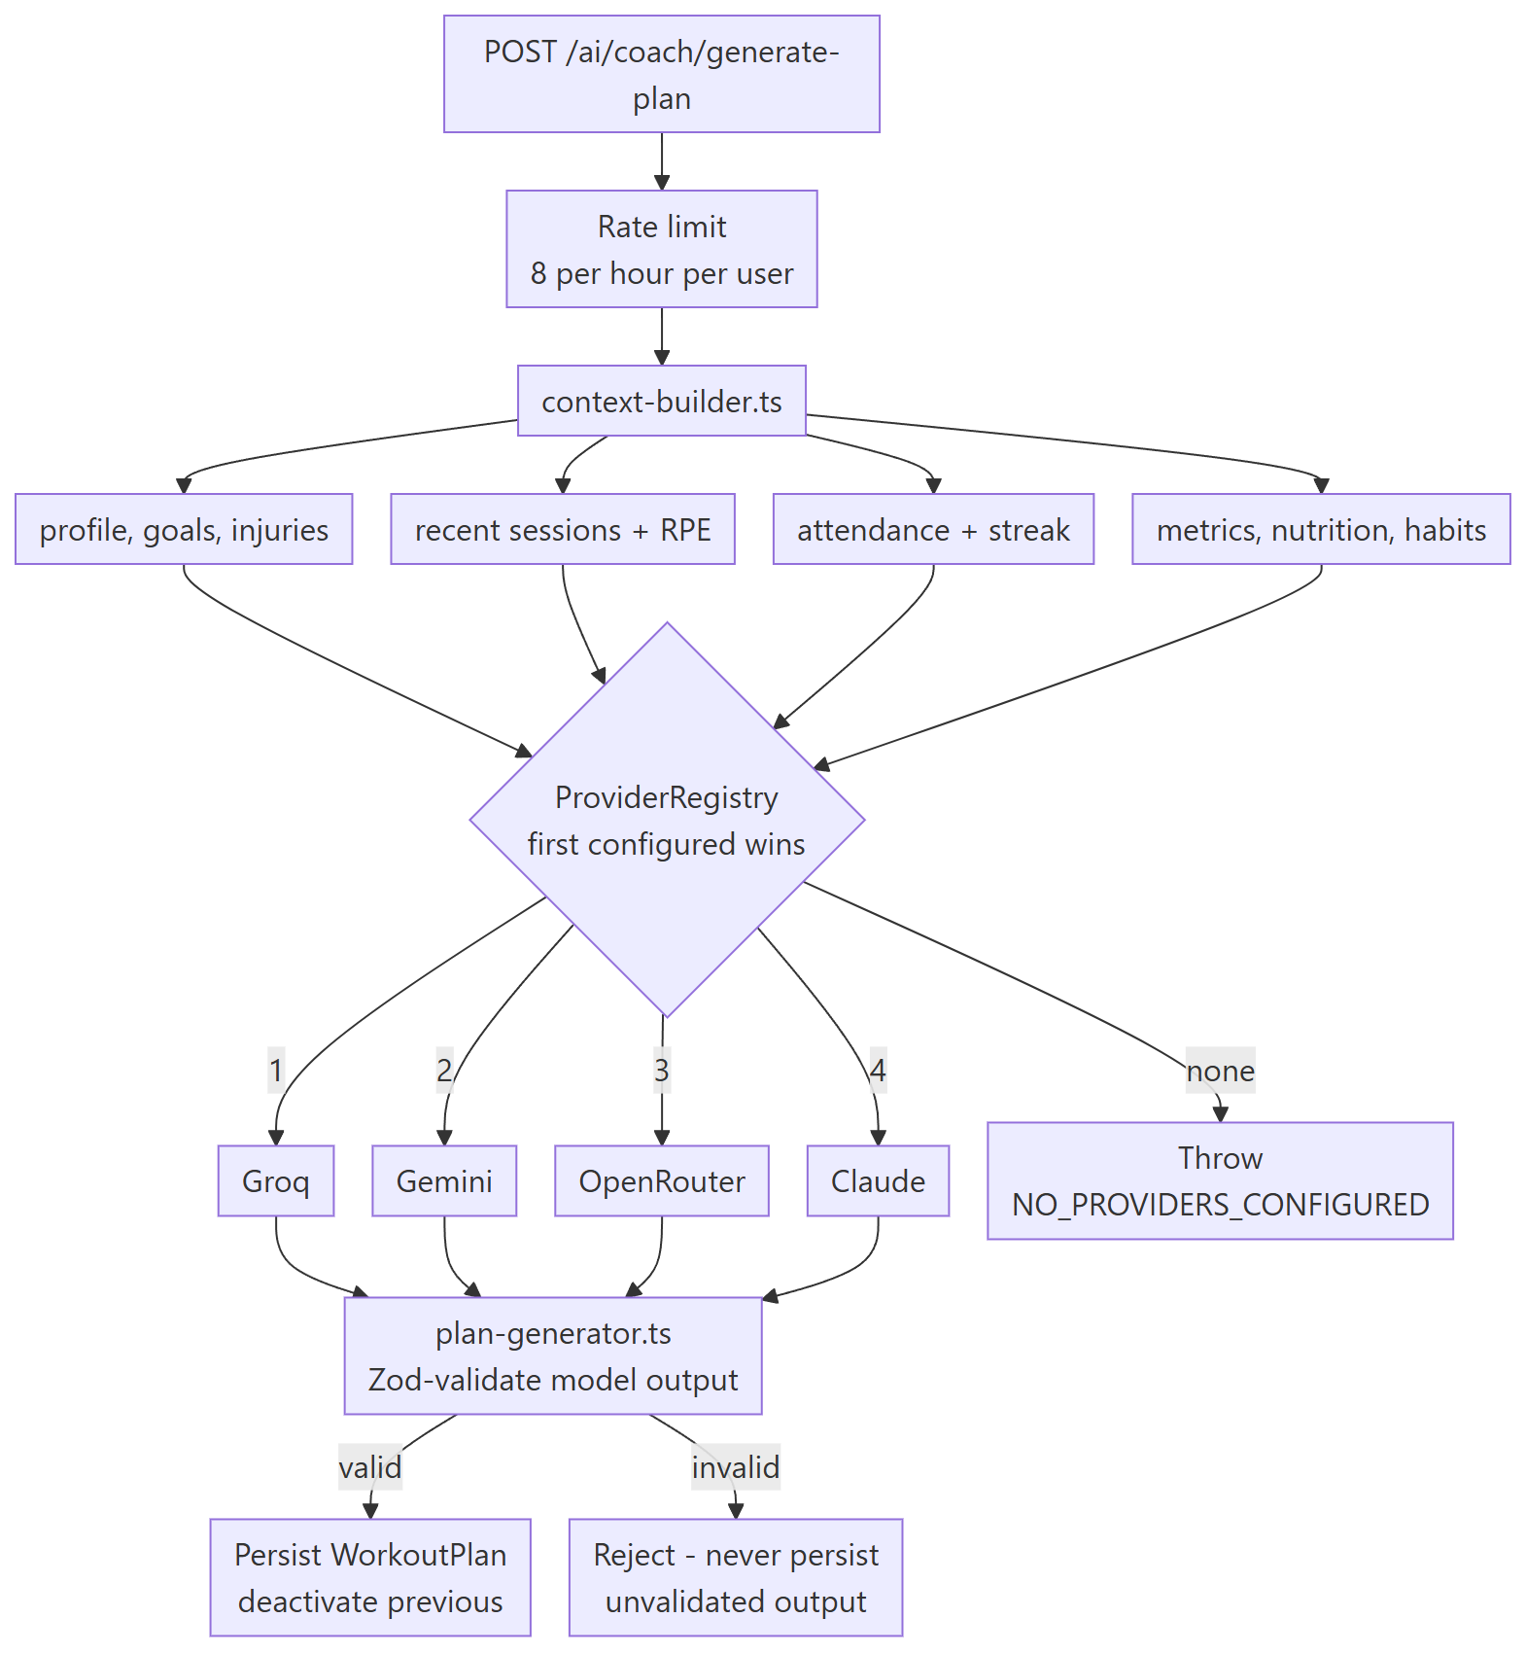

File | Role
context-builder.ts | Assembles the member's real training context from users, workouts, progress, nutrition, habits and attendance, so the model answers from logged numbers rather than generalities
plan-generator.ts | Structured generation plus Zod validation of the model's output before anything is written to the database
recommendations.ts | A non-LLM rule engine — RPE averaging, frequency and streak checks. Costs nothing and always works
providers/ | GroqProvider, GeminiProvider, OpenRouterProvider, ClaudeProvider, all behind BaseProvider, selected in that order by ProviderRegistry

10. Key flows

10.1 Authentication and token rotation

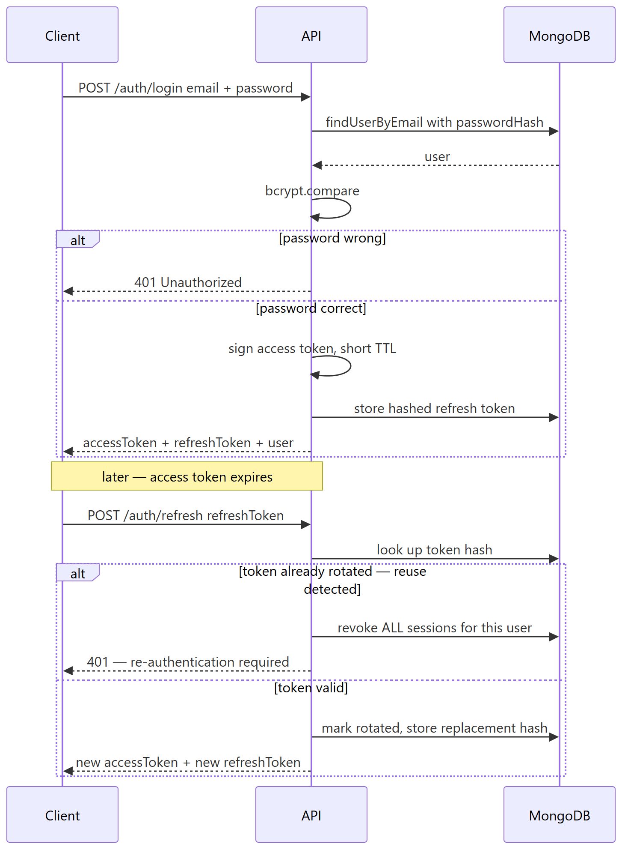

Reuse detection is the part worth noting: presenting an already-rotated refresh token is treated as a stolen-token signal, and every session for that user is revoked rather than just the one.

10.2 QR device pairing — how staff and members sign in without a password

Accounts created by an admin never get a password. They sign in by scanning a QR code shown on the dashboard.

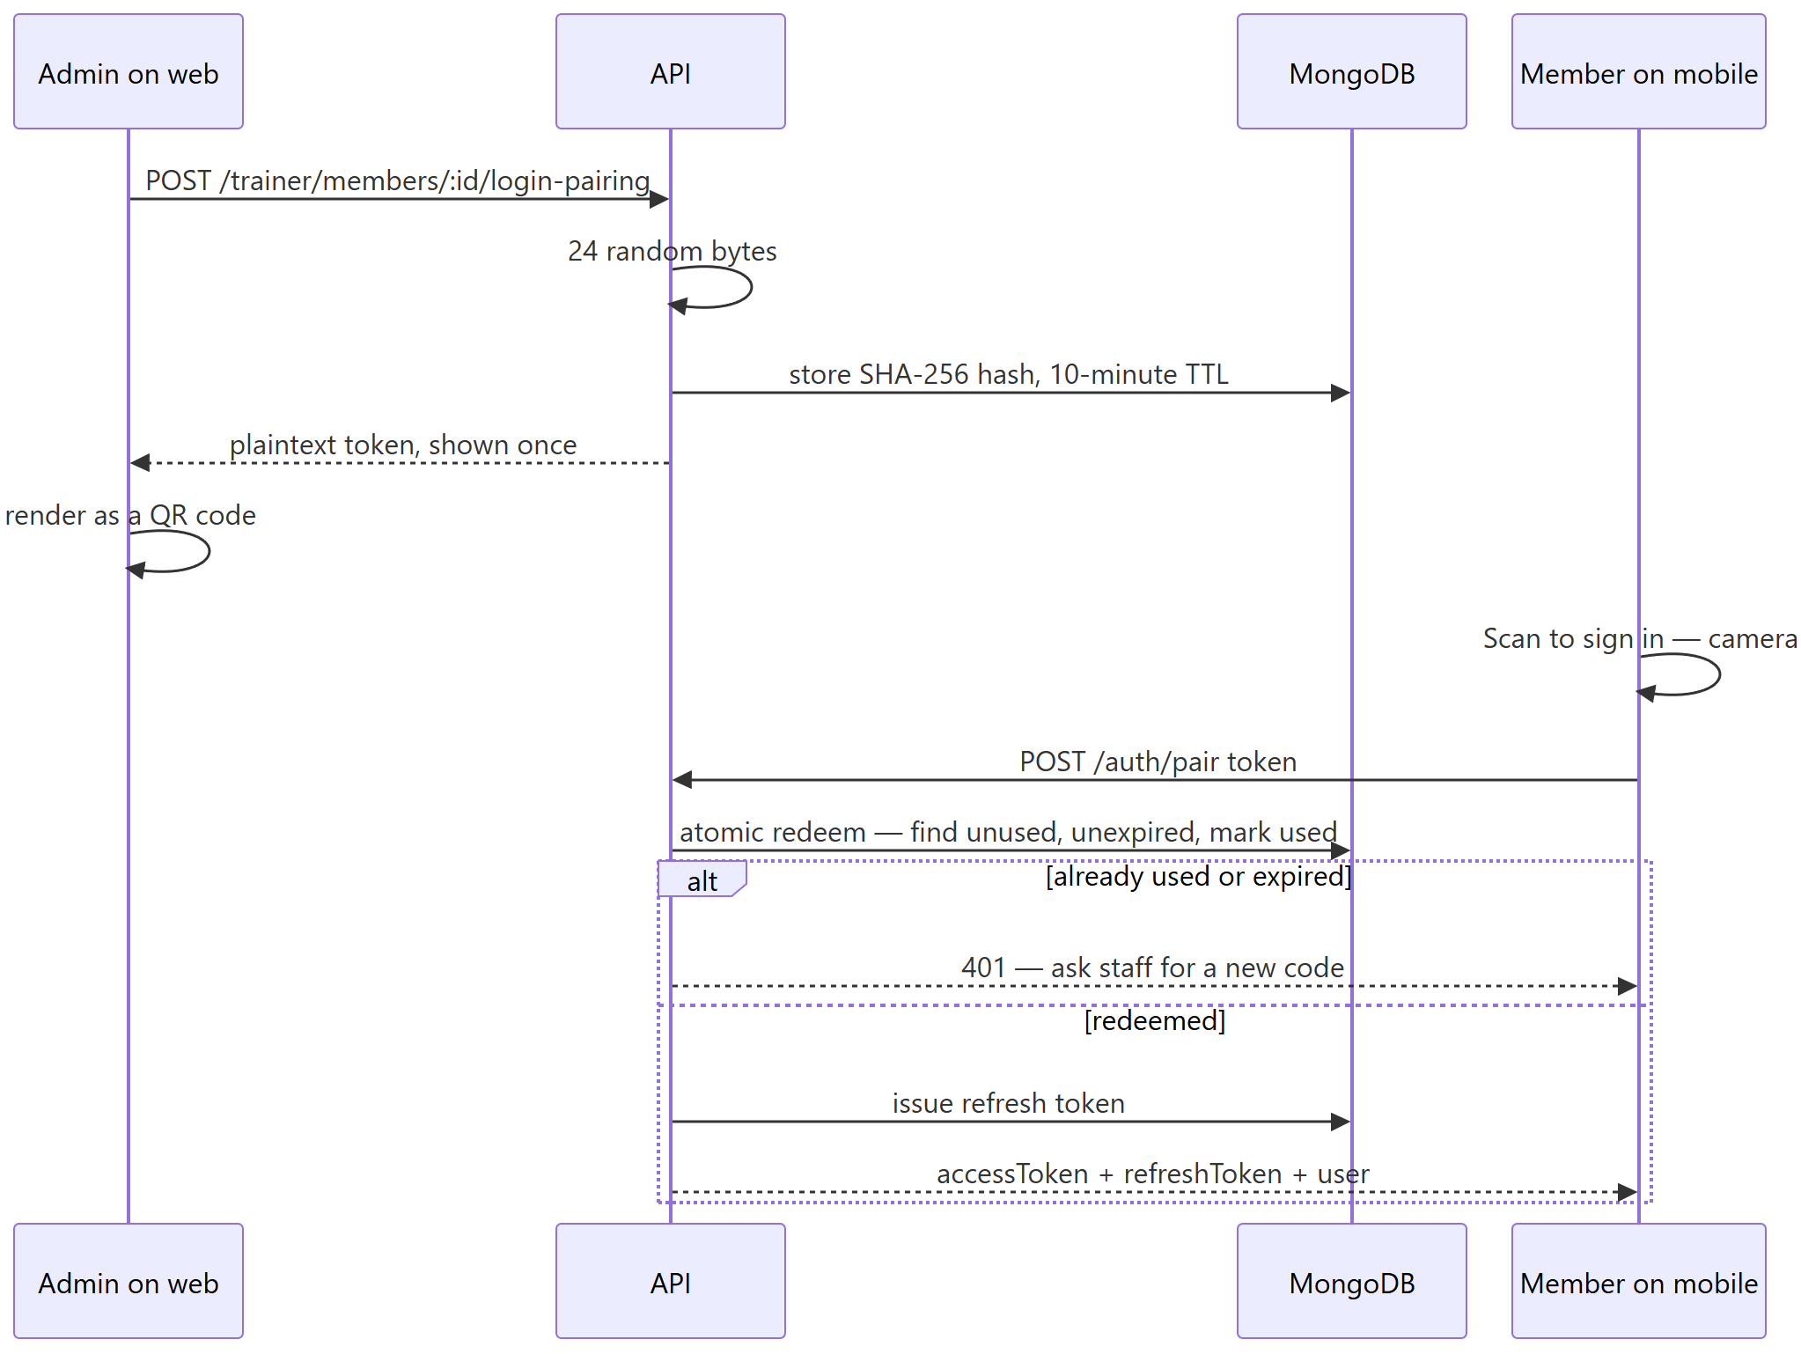

10.3 Gym check-in and check-out

One endpoint handles both directions, so the member taps the same button either way.

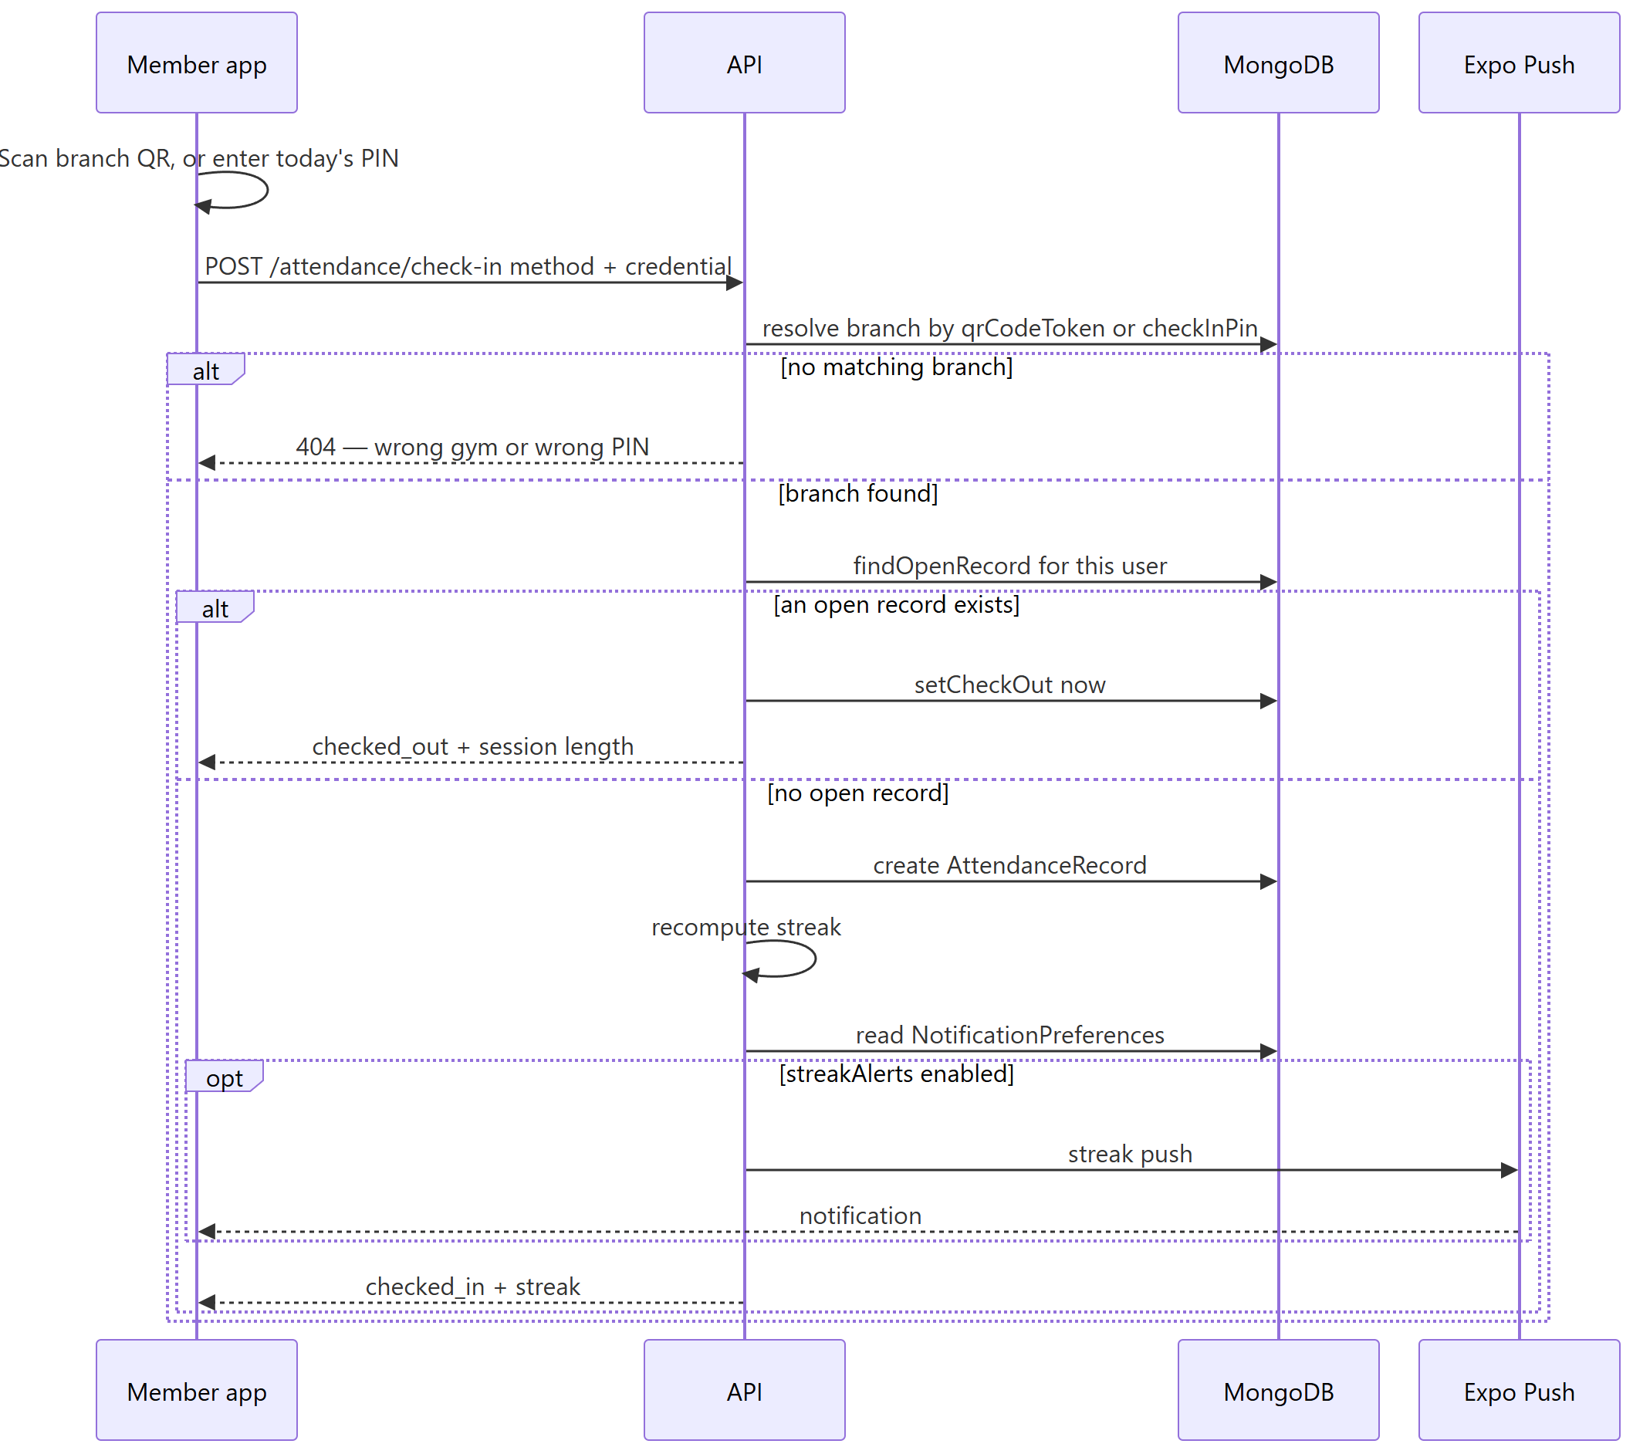

10.4 Online membership payment — Cashfree

The important architectural fact: Cashfree's hosted checkout has no plain-URL redirect. It requires loading their client-side JavaScript SDK from a real web page. That is why the server hands back a URL pointing at the app's own /billing/checkout page rather than at Cashfree directly, and why both the web dashboard and the mobile app open that same page.

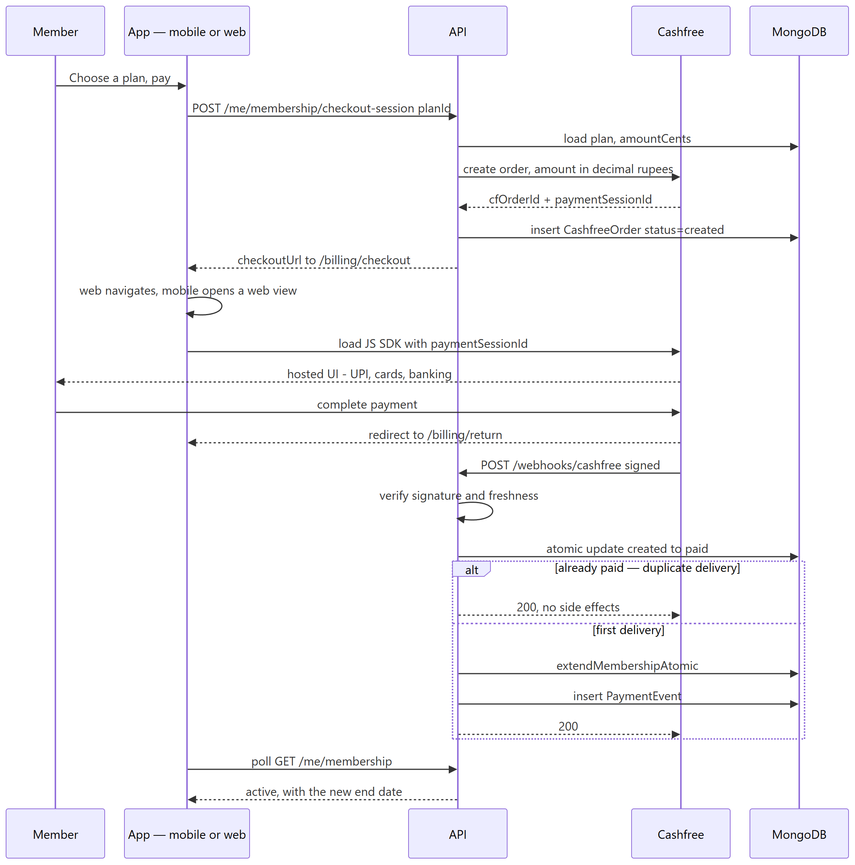

Three deliberate choices in that flow:

- The webhook is the source of truth, not the redirect. The return page says thank you; it does not grant access. A member who closes the browser mid-redirect still gets their membership.
- Idempotency is a database constraint, not a code check. The created → paid transition is a single atomic findOneAndUpdate; a duplicate webhook delivery matches nothing and returns null, so extension can never run twice.
- The client polls. Mobile refetches membership status after the browser closes rather than trusting what the redirect said.

10.5 Cash payment with OTP confirmation

The requirement was that a member paying cash at the front desk confirms it themselves, so a payment cannot be recorded purely on staff assertion.

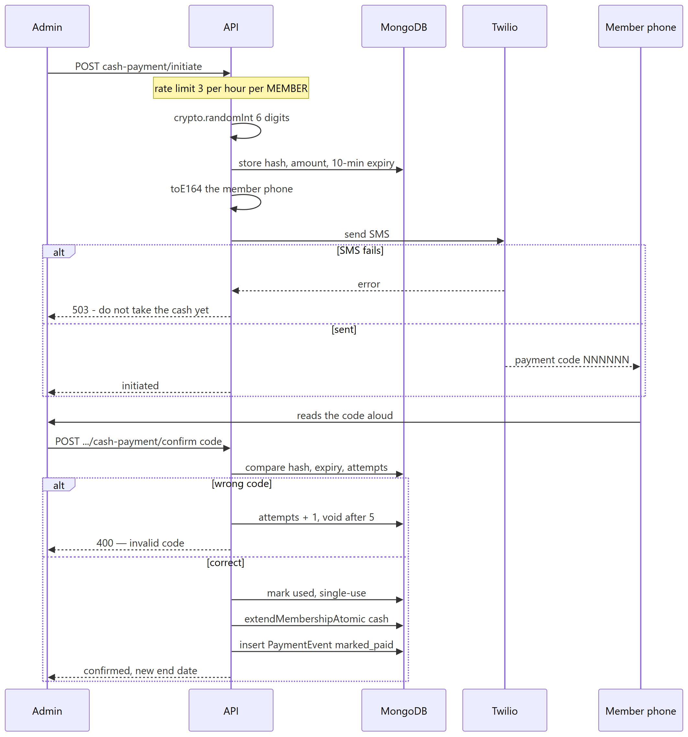

The OTP is bound to the amount as well as the member, so a code issued for one price cannot be replayed to confirm a different one.

10.6 Workout plan versioning

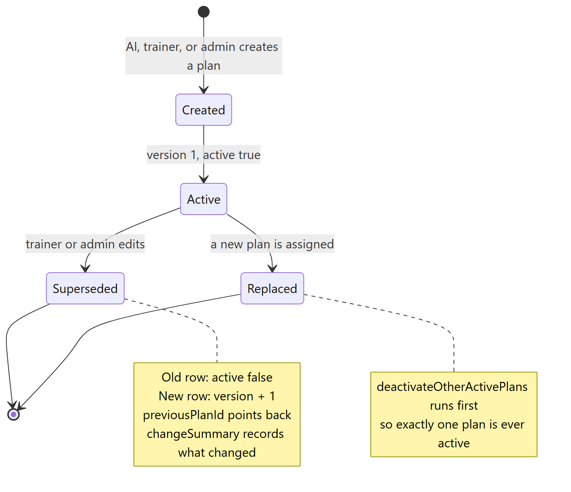

deactivateOtherActivePlans exists because of a real bug: assigning a second plan used to leave both marked active, and the member's app would show whichever came back first. The fix is now covered by a regression test.

11. Web dashboard

React 19 on Vite, createBrowserRouter, every page lazy-loaded except the login screen. Session state is a single MobX store; server state is TanStack Query.

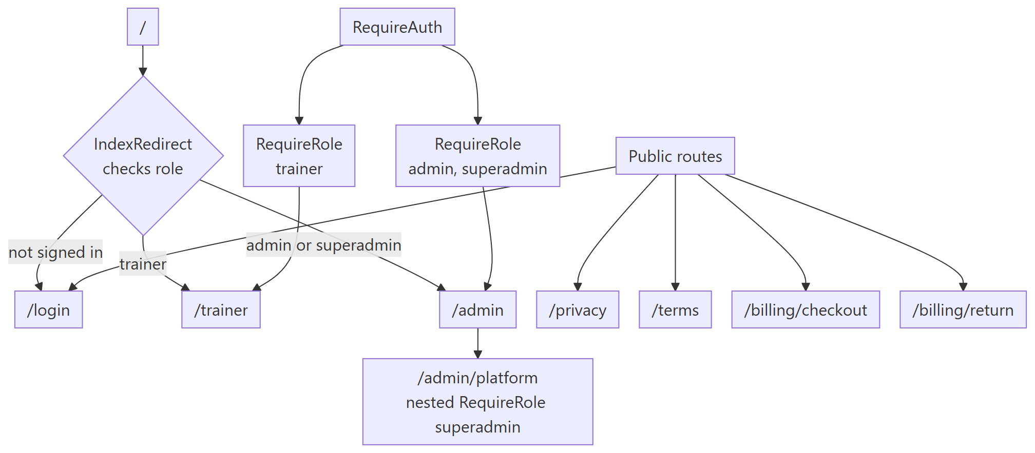

RequireRole redirects a wrong-role user to their own home rather than to a dead end, so a trainer who follows an admin link lands somewhere useful. /admin/platform carries a second nested guard, so an admin who types the URL is bounced even though they already passed the outer admin check.

11.1 Admin pages

Route | Page | What it does
/admin | AdminHomePage | Owner dashboard: 8 KPI tiles — total clients, sessions today, attendance rate, 30-day check-ins, new enrollments, pending payments, expired subscriptions, online versus cash — plus a recent-activity feed
/admin/members | MembersPage | Full roster with search, status filter and sort. Actions: new member, edit details, edit membership dates, assign trainer, collect cash payment, send checkout link, QR pairing
/admin/members/:memberId | MemberDetailPage | One member in full: streak, sessions, weight, workout plans with superseded markers, recent sessions, check-in history, payment history, personal records, weight chart, injuries
/admin/trainers | TrainersPage | Trainer roster and creation. The reporting-line control is superadmin-only
/admin/workout-plans/new | CreateWorkoutPlanPage | Build a plan template
/admin/members/:memberId/assign-plan | AssignPlanPage | Assign a template to a member
/admin/members/:memberId/plans/:planId/edit | EditMemberPlanPage | Edit an assigned plan, with a required change note
/admin/analytics | AnalyticsPage | 30-day check-in volume, chart or table view
/admin/attendance | AttendanceFeedPage | The 50 most recent check-ins, tagged by method
/admin/plans | MembershipPlansPage | Membership plan and pricing CRUD
/admin/sponsors | SponsorsPage | Sponsor and brand-deal CRUD
/admin/classes | ClassesPage | Recurring class definitions
/admin/classes/roster | ClassRosterPage | Next 14 days of sessions, with per-session booking rosters
/admin/branch | BranchSettingsPage | Branch info and membership enforcement rules
/admin/settings | SettingsPage | Profile, security, payment gateway, notifications
/admin/platform | PlatformOverviewPage | superadmin only — cross-tenant gym list and platform totals

11.2 Trainer pages

Route | Page | What it does
/trainer | TrainerHomePage | Roster at a glance: active members, sessions today, attendance rate, recent joiners
/trainer/members | MembersPage | Assigned-member roster with search
/trainer/members/:memberId | MemberDetailPage | Membership status, profile and injuries
/trainer/members/:memberId/assign-plan | AssignPlanPage | Assign a plan template
/trainer/plans/new | CreatePlanPage | Build a new plan
/trainer/exercises | ExerciseLibraryPage | Exercise and meal library browser and editor
/trainer/classes/roster | ClassRosterPage | Shared with admin
/trainer/messages/:otherUserId? | MessagesPage | Two-pane member messaging

11.3 Public pages

Route | Page | Why it exists
/login | LoginPage | Email and password plus Google sign-in
/privacy | PrivacyPolicyPage | Required for app-store submission and for handling health data. Still contains placeholders
/terms | TermsOfServicePage | Same. Still contains placeholders
/billing/checkout | CheckoutRedirectPage | Loads the Cashfree JS SDK and starts checkout. Used by both web and mobile, because Cashfree has no plain-URL redirect
/billing/return | BillingReturnPage | Post-checkout confirmation. Explicitly not the source of truth — the webhook is

11.4 Shared web components

Component | Purpose
DataTable | Generic table over the shadcn primitives; the caller owns filtering and sorting
StatCard | KPI tile used across both dashboards
WorkoutPlanEditor | The day-and-exercise plan builder, shared by admin create, admin edit and trainer create
LoginPairingDialog | The QR sign-in flow, shared by the member and trainer rosters
QRCodeImage | Client-side QR rendering — no external QR service, so no member id leaves the browser
InjuriesCard | Read-only member injuries, shared by the admin and trainer detail pages. Staff can view, never edit
BrandMark, EmptyState, ErrorState | Shell and state components
statusBadges | UserStatusBadge, PaymentStatusBadge, MembershipStatusBadge, SubscriptionStatusBadge

12. Mobile app

Expo SDK 54, React Native 0.81, React 19. The role decides which navigator mounts at the root — there is no shared shell to escape from, so a member build and an admin build are structurally different apps at runtime.

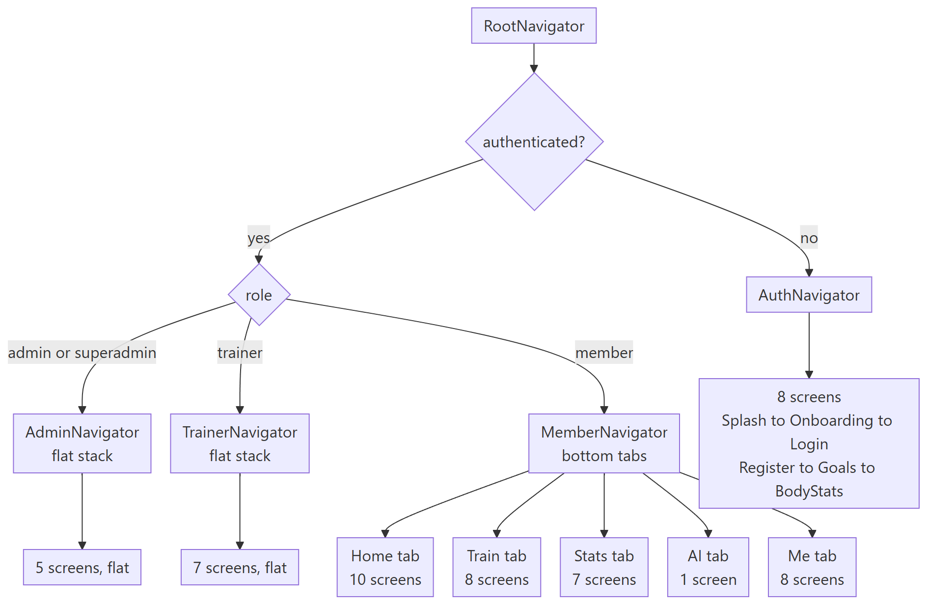

An onboarding subtlety worth recording, because it is not obvious from the code: beginRegistration() activates real tokens without flipping isAuthenticated. If it flipped the flag, RootNavigator would immediately swap to the member app and skip goal selection and body stats. completeOnboarding() flips it at the true end.

12.1 Auth screens

Screen | Purpose
SplashScreen | Branded launch, auto-advances
OnboardingScreen | Swipeable intro with a log-in escape hatch
LoginScreen | Email and password plus Google, links to sign-up and scan-to-sign-in
RegisterScreen | Create account, with working links to the hosted Terms and Privacy pages
GoalSelectionScreen | Multi-select fitness goals, skippable
BodyStatsScreen | Starting measurements and training experience
ForgotPasswordScreen | Reset request. See section 16 — no email is sent
ScanToSignInScreen | Camera QR scanner that redeems an admin-issued pairing token

12.2 Member screens — 33 total

Area | Screens
Home and classes | HomeScreen, ClassesHomeScreen, ClassDetailScreen, MyBookingsScreen
AI plan wizard | AIWizardBasicsScreen, AIWizardGoalScreen, AIWizardDietScreen, AIWizardGymAccessScreen, AIWizardInjuriesScreen, AIWizardReviewScreen
Training | WorkoutHomeScreen, ActiveWorkoutScreen, WorkoutSummaryScreen, WorkoutHistoryScreen, WorkoutDetailScreen, ExerciseLibraryScreen, ExerciseDetailScreen, ExercisePickerScreen
Progress | ProgressHomeScreen, BodyMetricsScreen, PersonalRecordsScreen, OneRMCalculatorScreen
Nutrition and habits | NutritionScreen, DietPlanScreen, HabitTrackerScreen
AI coach | AICoachScreen — server AI, with an on-device fallback that answers from the member's own logged numbers when the API is unavailable
Profile and membership | ProfileHomeScreen, MembershipCardScreen, PaymentCheckoutScreen, QRCheckInScreen, EditProfileScreen, NotificationsScreen, SettingsScreen, SponsorshipScreen

12.3 Trainer and admin screens

Role | Screens
Trainer | TrainerHomeScreen, MemberListScreen, MemberDetailScreen, AssignPlanScreen, MessageMemberScreen, ClassRosterListScreen, ClassRosterDetailScreen
Admin | AdminHomeScreen, AttendanceFeedScreen — live, refreshes every 15 seconds, AnalyticsScreen, MemberManagementScreen, BranchSettingsScreen

12.4 Mobile hooks

Hook | Purpose
useActiveWorkout | The entire live-workout state machine — sets, exercises, completion. Pure state, no UI, no API
useRestTimer | Rest countdown, deliberately split out from the workout state
useStopwatch | Elapsed session time
useCheckIn | Owns the check-in mutation lifecycle and invalidates attendance queries on success
useProgressData | Derives chart-ready series from raw API responses
useAICoach | Deterministic rule-based recommendations, structured so a model can replace the internals later
useLocalCoach | On-device coach fallback — answers always cite the member's own numbers
useTrainerData | The single source of trainer-dashboard data, so trainer screens make no direct query calls
usePushRegistration | Requests permission and registers the push token once per session; silently no-ops in Expo Go, which no longer supports remote push

13. Shared package

packages/shared is the contract between the three apps. It is built once and imported by all of them, which is what prevents the classic drift where a mobile enum and a server enum disagree by one value.

Export group | Count | Contents
Types | 71 | User, UserRole, WorkoutPlan, WorkoutDay, FitnessGoal, ClassSession, MuscleGroup, InjuryCondition, InjurySeverity, DietPreference, GymAccess, CheckInMethod, membership and payment status unions, and the rest of the domain
Zod schemas | 22 | Request and response schemas shared between server validation and client forms
Constants | 17 | Enum value lists and their display-label maps

The constants file is the single place enum lists and label maps live. Copying a label map into a component is the mistake this package exists to prevent.

14. Testing status

46 server tests, all passing. Mocked at the repository and model boundary, so the tests exercise real business logic without a database.

Suite | Tests | Covers
test/billing/service.test.ts | 16 | Payment-event branching for online versus cash, the full deriveSubscriptionStatus truth table, isAccessBlocked grace-period boundaries
test/attendance/service.test.ts | 7 | Streak computation, check-in and the check-out toggle
test/lib/cashfree.test.ts | 7 | The minor-unit to decimal-rupee conversion in both directions, and isConfigured branching
test/auth/service.test.ts | 6 | Registration, login, token handling
test/lib/cashPaymentOtp.test.ts | 5 | OTP issue and verify, expiry, attempt cap, single use
test/trainer/service.test.ts | 5 | Requester scoping for trainer versus admin, and supersede-not-mutate plan editing

Verified manually against real infrastructure, beyond the unit tests:

What | Result
extendMembershipAtomic against a real MongoDB Atlas database | Fresh insert, stacking onto an active membership, restart after expiry, and yearly interval — all correct
Cashfree sandbox, end to end in a real browser | Real order created, real payment session, real hosted checkout UI rendered showing the correct amount and the member's phone number, with UPI QR, cards, net banking, wallets and pay-later all present
Double plan assignment against the real database | Exactly one active plan, one superseded — the bug fix holds
bootstrap-admin.ts | Creates an admin; duplicate-email and short-password guards both fire

Not covered. This is stated plainly because it matters more than the coverage that exists:

Gap | Detail
15 of 19 server modules have no tests | admin, ai-coach, classes, exercises, habits, meals, messaging, notifications, nutrition, progress, sponsors, superadmin, uploads, users, workouts
Security-sensitive libraries untested | pairingToken.ts — QR sign-in, trainerPermissions.ts — authorization, refreshToken.ts, password.ts, googleAuth.ts
Web has no test tooling at all | No test script, no Vitest, no Testing Library, no end-to-end runner
Mobile has no test tooling at all | No test script, no jest-expo, no Detox or Maestro
Cashfree webhook never received a real delivery | Verification requires the server to be reachable from the public internet
Twilio SMS never sent a real message | No account credentials exist yet

15. Deployment and configuration

Full detail is in docs/DEPLOYMENT.md. The summary:

Tier | Variables | Consequence if unset
Required | MONGODB_URI, JWT_ACCESS_SECRET, JWT_REFRESH_SECRET | The server does not boot
Silently wrong if unset | CORS_ORIGIN, STORAGE_BACKEND, PUBLIC_URL, WEB_APP_BASE_URL, CASHFREE_RETURN_URL | Boots and appears to work, but: CORS defaults to any origin; local storage loses every upload on a serverless redeploy; checkout URLs point at localhost
Feature gates | CASHFREE_APP_ID, CASHFREE_SECRET_KEY, CASHFREE_WEBHOOK_SECRET, TWILIO_ACCOUNT_SID, TWILIO_AUTH_TOKEN, TWILIO_FROM_NUMBER | Online checkout and cash OTP return a clear 503 instead of failing strangely
Genuinely optional | SENTRY_DSN, GROQ_API_KEY, GEMINI_API_KEY, OPENROUTER_API_KEY, ANTHROPIC_API_KEY, GOOGLE_CLIENT_ID | One feature each is disabled, cleanly

Bootstrapping the first admin. Every account-creation path needs an existing admin, and self-registration always creates a member. There is no in-product way to create the first admin account. Run once against the production database after deploying:

cd apps/server
npx tsx src/db/bootstrap-admin.ts <email> <password> <firstName> <lastName>

16. Pending functionality

This section is deliberately blunt. Items are ordered by how much they matter to a real user or a real launch, not by how hard they are.

16.1 Release blockers

These stop a launch. Each one is a thing a user or a reviewer will hit immediately.

# | Gap | What actually happens today | What it needs
1 | Password reset does not work, end to end | A user taps "Forgot password", gets "If an account with that email exists, a reset link has been sent", and no email is ever sent. There is no email capability anywhere in the product — no email.ts, no mail provider, no reset-token model, no /auth/reset-password endpoint, and no reset screen. A member who forgets their password is permanently locked out. | An email provider, a reset-token model mirroring PairingToken, a reset endpoint, and a reset screen on both clients
2 | The web dashboard has no password-reset route at all | An admin or trainer who forgets their web password has no self-service path whatsoever. The only public web routes are login, privacy, terms and the two billing pages | A /forgot-password and /reset-password route pair on web, once item 1 exists
3 | Legal pages ship with `[PLACEHOLDER]` markers | /privacy and /terms render with [PLACEHOLDER: legal entity name], [PLACEHOLDER: registered address] and [PLACEHOLDER: support email] visible on the page. This blocks public launch and app-store review for an app that collects health data | Real legal entity name, registered address and support email
4 | iOS cannot be built or submitted | eas.json has three build profiles, all Android-only — there is no ios key in the file. An iOS build would fall back to http://localhost:4000 for its API base URL and be silently non-functional. app.json has no ios.infoPlist, so no NSCameraUsageDescription — Apple rejects any build that opens the camera without one, and this app has two camera screens | An ios profile in eas.json with the API and web base URLs, ios.infoPlist with camera and photo usage strings, ios.buildNumber, and expo.extra.eas.projectId
5 | File uploads do not survive a redeploy | STORAGE_BACKEND defaults to local, which writes avatars and exercise videos to apps/server/uploads/ — an ephemeral filesystem on the documented serverless host. Uploads can disappear on the next request | A Google Cloud project and bucket, STORAGE_BACKEND=gcs, GCS_BUCKET_NAME, GCS_CREDENTIALS_JSON. The GCS code path is written and typechecked but has never run against a live bucket
6 | `CORS_ORIGIN` defaults to any origin | Left unset, the API accepts requests from any website, indefinitely, for an app handling health data and payments | Set it to the real web dashboard origin before going live
7 | The payments work is uncommitted | The entire Cashfree migration, the legal pages, the billing pages, the new tests and the deployment guide exist only in one working tree — no branch, no remote, no backup | Commit and push

16.2 Features that look finished but are inert

These are worse than missing features, because the UI promises them.

Gap | The promise shown to the user | The reality
Personal Record Alerts toggle | "Celebrate when you hit a new PR" | The preference saves to the database. No code ever reads it. No notification is ever sent
Weekly Report toggle | "Sunday summary of volume, sessions, and streak" | Same — and it cannot work at all, because the server has no job scheduler. Every push in the product is triggered by an inbound request
AI Tips and Insights toggle | "Smart nudges based on your training patterns" | Same. Additionally, the settings screen has a second, duplicate AI-tips toggle held in local component state that is never persisted anywhere
Check-in confirmations toggle | Implied confirmation on check-in | Never consulted

Three of the nine notification preferences are genuinely honored — streakAlerts, trainerMessages and classBookings. workoutReminders works, but only as a device-local scheduled notification, so it stops if the app is uninstalled and never reflects server-side state.

The root cause is one missing piece: there is no scheduled-job infrastructure in the server. Anything periodic — weekly reports, membership-expiry reminders, auto-checkout of members who forgot to tap out — cannot exist until that is added.

Also inert | Detail
checkInIntervalDays on a branch | The field exists, the API accepts it, and the progress service consumes it — but no UI anywhere exposes it. A gym owner cannot change the check-in interval without a raw API call
Mobile class-template API client | fetchClassTemplates, createClassTemplate and updateClassTemplate are written and exported in the mobile API layer with zero call sites. A complete admin class-template client was built and no screen was ever made for it
PlaceholderScreen component | Defined and exported, never imported. Dead code — good news in that no "coming soon" screen ships, but it should go
fetchAttendanceHistory, fetchWorkoutPlan on mobile | Defined, never called

16.3 Integrations that are coded but unverified

Both fail cleanly with a 503 when unconfigured, which is the right behavior. Neither has been proven against a live account.

Integration | Verified | Not verified
Cashfree | Order creation, the amount conversion, and the real hosted checkout UI — confirmed in a browser against a live sandbox account | A completed payment and the resulting webhook delivery. This matters more than it sounds: membership activation, renewal, expiry extension and access restoration are all webhook-driven. The untested half is the half that keeps memberships accurate. Verification needs the server reachable from the public internet — a deployment or a tunnel
Twilio SMS | Nothing | Everything. No real code has ever been sent. This gates the entire cash-payment OTP flow — the front-desk payment path does not work until Twilio is configured and tested
Google Cloud Storage | Typechecks | Never run against a live bucket

16.4 Feature parity gaps between web and mobile

These read as inconsistency to a client, and both directions have holes.

Capability | Web | Mobile
Member photo on the roster | missing — avatarUrl is not rendered on the web roster or detail page | upload works
Progress photo timeline | missing | missing — a separate feature from the profile avatar; needs a storage and gallery design
Class template management | yes | missing — the API client exists, the screen does not
Branch settings depth | full — methods, PIN, grace period, capacity | thin — name and capacity only
Muscle-gain progress | not surfaced on the admin drill-in | yes
Sponsors administration | yes | read-only
Membership plans and pricing | yes | missing
Trainer management | yes | missing
Payment history on a member | yes | missing
Superadmin platform overview | yes | missing — admin and superadmin share one mobile navigator
Password reset | no route at all | screen exists but is non-functional
Registration | no route — staff are created by an admin | yes
Habit tracker, nutrition, 1RM, PRs, QR check-in, diet plan | missing by design — member features | yes

16.5 Testing gaps

Gap | Detail
Server module coverage | 4 of 19 modules tested. Untested includes admin — the entire owner dashboard, ai-coach — the headline feature with four providers, and users — profile, password change and preferences
Security-sensitive libraries | pairingToken.ts — the QR sign-in credential — and trainerPermissions.ts — authorization — have no tests
Web | No test tooling exists. Every payment, membership and QR-login UI path is untested
Mobile | No test tooling exists

16.6 Security and account hardening not built

Gap | Current state
Two-factor authentication | Not built
Session management UI | A user cannot see or revoke their active sessions. Reuse detection exists server-side, but there is no way to say "sign out my other devices"
Per-feature access blocking | Blocking is all-or-nothing at the login gate. A member whose payment lapses cannot authenticate at all, rather than losing specific features inside an active session
Rate-limit error message | A 429 returns a generic "Internal server error" body, because the global error handler does not special-case it. Low severity, but confusing
Audit logging | No audit-log model. There is no record of which admin suspended a member or changed a price

16.7 Originally scoped but never started

The PRD set in docs/prd/ describes a larger product than what was built, and says so itself: it is a future-state blueprint, not a description of the current build. These workstreams have no data models at all.

PRD area | What it called for | Status
Trainer assignment lifecycle | Request, admin-assigned, change requests | No model — assignment is a single assignedTrainerId field
AI review queue | A pending_review to approved or rejected state machine, described in the PRD as "the core trust mechanism the whole product is built on" | No model, no code
Workout templates | A reusable WorkoutTemplate entity | No model
Adaptive interval engine | IntervalRule-driven check-in prompts, a ProgressCheckIn submission flow, plan versioning with a version-diff UI — the PRD's own stated primary goal | Plan versioning exists. The interval engine and check-in submission flow do not. Needs the same missing job-scheduler infrastructure
Gamification | XP, levels, badges, challenges, leaderboards, referrals | Only streaks exist
Wearables | Five provider integrations | Nothing
Super admin portal | AI prompt library, feature flags, RBAC UI, audit logs, backup and restore | The whole superadmin surface is 2 endpoints and 1 page
Content feed | Health and fitness articles, a CMS | Nothing. Blocked on a content-source decision
Future roadmap | Posture analysis, form correction, calories from a photo, barcode scanner, grocery lists, injury-risk prediction, voice coach, community groups, corporate wellness | Explicitly out of scope for the core build

One process note that belongs here: the client-status document records that the original requirements message was cut off mid-sentence. There may be requirements that were never captured. Worth getting the rest of that message before planning the next phase.

16.8 Suggested order of work

Steps 1 to 3 — getting to a real launch.

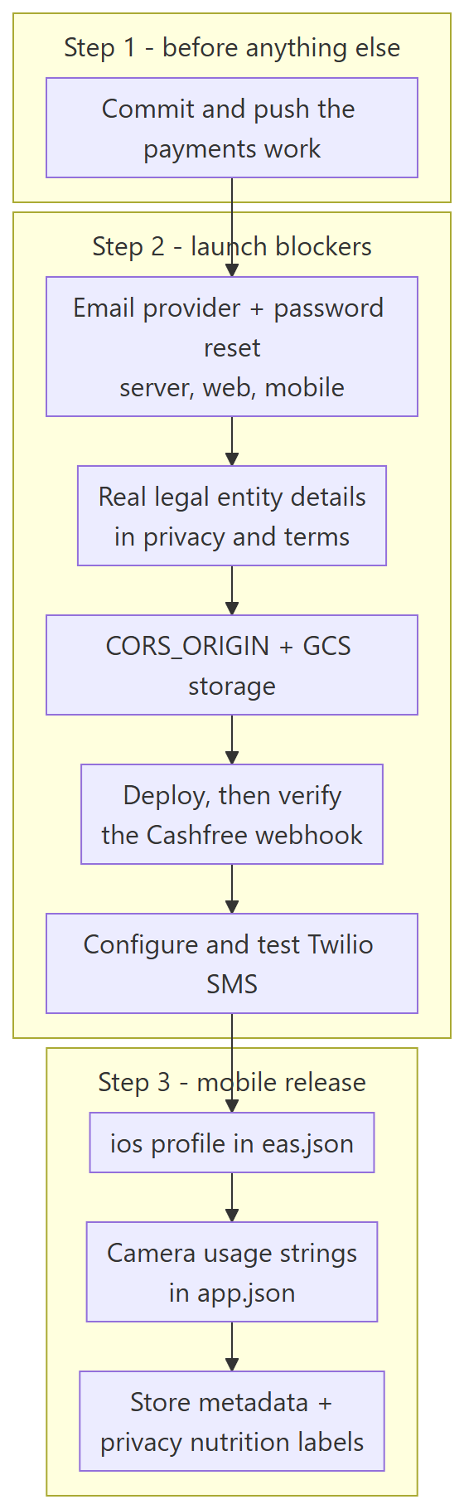

Steps 4 to 6 — after launch.

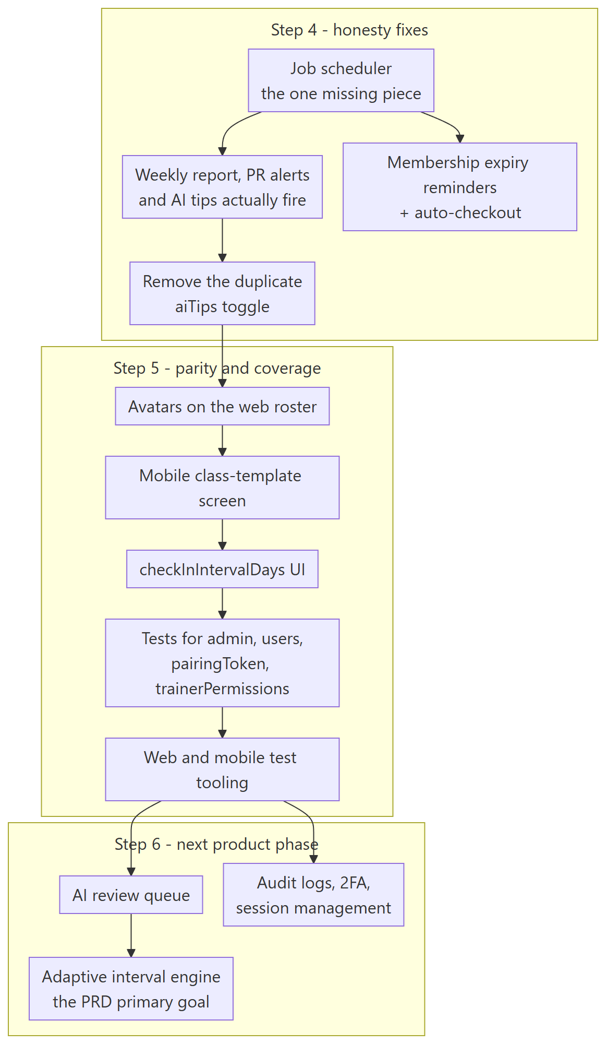

Step | Theme | Why this order
1 | Commit the work | Everything else is at risk until the payments migration exists somewhere other than one working tree
2 | Launch blockers | Password reset and the legal placeholders are the two things that make a public launch impossible. Storage and CORS are the two that make it unsafe. The webhook and SMS verifications need a deployment, so they come after it
3 | Mobile release | Depends on step 2 — the store listing needs real legal URLs, and the app needs a working password reset before real users install it
4 | Honesty fixes | The job scheduler is one piece of infrastructure that unlocks four promised-but-inert features at once, plus membership reminders and auto-checkout
5 | Parity and coverage | Nothing here blocks a launch, but each item is a visible inconsistency or an untested risk
6 | Next product phase | The AI review queue and the adaptive interval engine are the PRD's actual differentiators, and both are greenfield

17. Summary

What exists and works. A complete, multi-tenant gym platform with four roles, 74 API endpoints, 28 data models, 21 web pages, 53 mobile screens, and a shared type contract that keeps all three apps honest with each other. Authentication with rotating refresh tokens and reuse detection. QR-based passwordless sign-in for staff-created accounts. Gym check-in and check-out with streaks. AI coaching with a four-provider fallback chain and Zod-validated model output. Workout plan versioning that supersedes rather than mutates. Class scheduling with waitlists. Cashfree online payments with atomic, concurrency-safe membership extension and idempotent webhook handling. Cash payments confirmed by SMS OTP. Three real production bugs found and fixed — a password-hash leak in every user response, a serverless crash from a native addon, and a double-active-plan bug.

What does not. Password reset is a dead end in both apps. Four notification toggles save state and do nothing, because the server has no scheduler. iOS cannot be built. The legal pages say [PLACEHOLDER]. Uploads do not survive a redeploy on the intended host. The payment webhook — the half that keeps memberships accurate — and the SMS layer that the entire cash-payment flow depends on have never run against real accounts.

The distance between those two paragraphs is section 16, and most of it is a few days of focused work rather than new architecture. The two exceptions are the job scheduler, which is genuinely new infrastructure, and the adaptive interval engine, which is a product phase in its own right.

