Case WhatsApp Alerts — Workflow
PSRI CRM · 9 October 2026

Overview
When an agent saves a new case, the CRM checks four conditions and sends a WhatsApp alert to the right department for each one that matches. One case can match several conditions, and each match sends its own alert.
- Fires on: a new case being saved, or an Incomplete draft being completed. Ordinary edits to an existing case do not fire it.
- Runs once per case: a repeated save never sends the same alerts twice.
- Where it lives: Admin → Workflows → + Case WhatsApp Alerts. It runs alongside the existing New Case Onboarding workflow and does not change it.

Workflow graph
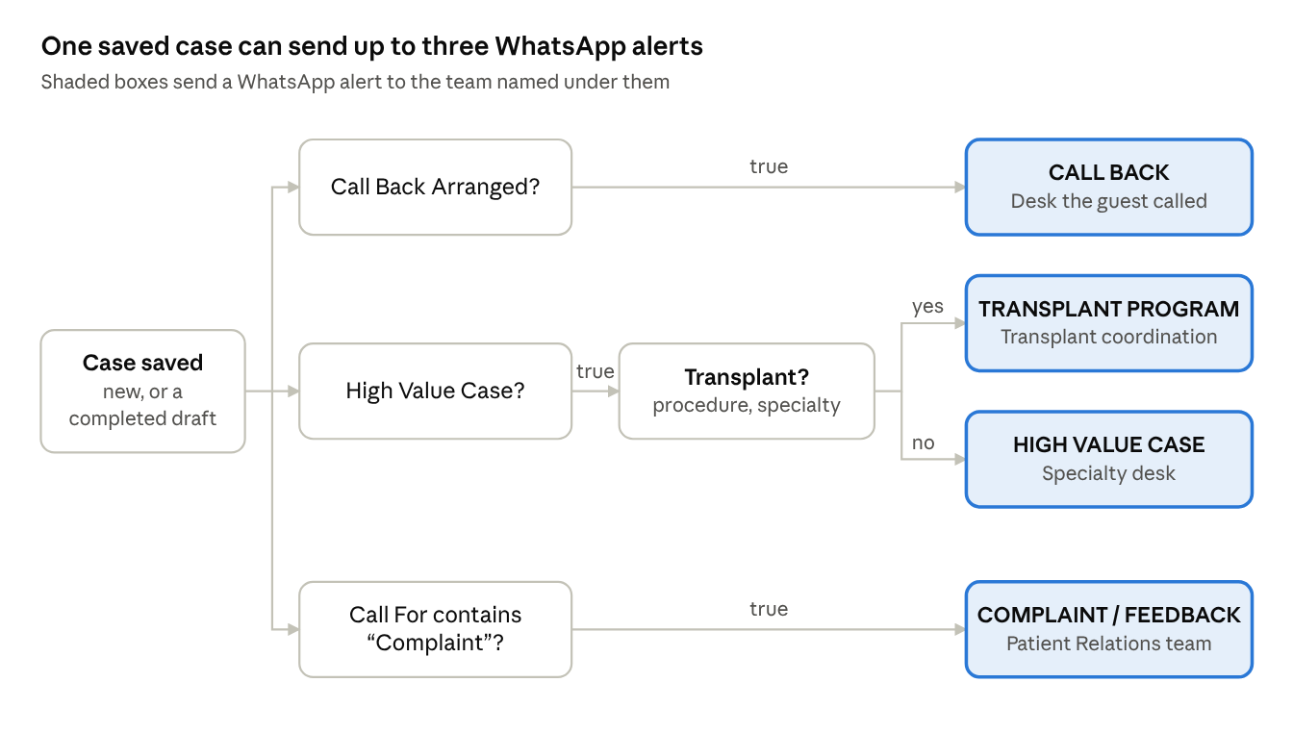
The three checks run independently, so a case can match more than one, up to three alerts. A case that fails every check sends nothing.

Nodes
Each alert is a Send Notification node on the WhatsApp channel. Concern is the case summary the agent typed.
Alert | Sent when | Recipient | Message fields
CALL BACK | Call Back Arranged = true | Desk the guest was trying to reach (e.g. Report Desk, Billing Desk) | Name, Number, Concern
HIGH VALUE CASE | High Value Case = true, not Transplant | Specialty desk for the procedure | Name, Number, Concern
TRANSPLANT PROGRAM | High Value Case = true and Procedure / Specialty Enquired contains "Transplant" | Transplant coordination team | Name, Number, Location (city, state), Concern
COMPLAINT / FEEDBACK | Call For contains "Complaint" | Patient Relations / Quality, plus the department named | Name, Number, Concern
Transplant check: the case counts as Transplant if Type of Procedure, Name of Procedure or Specialty Enquired For contains "Transplant". A Transplant case gets the Transplant alert instead of the High Value alert, never both.

Messages
CALL BACK
Name- {{contact.name}}
Number- {{contact.mobile}}
Concern- {{case.summary}}
Please arrange a call back from concerned department.
HIGH VALUE CASE
Name - {{contact.name}}
Number - {{contact.mobile}}
Concern- {{case.summary}}
Please arrange a call back from concerned department
Transplant Program
Name- {{contact.name}}
Number- {{contact.mobile}}
Location - {{contact.city}}, {{contact.state}}
Concern- {{case.summary}}
Please arrange a call back from concerned department.
Complaint/Feedback
Name- {{contact.name}}
Number- {{contact.mobile}}
Concern- {{case.summary}}
Please look into this matter.

Before go-live
The workflow is built and the routing has been tested, but no real WhatsApp message has been sent yet.
- Enter each department's WhatsApp number in the "To" field of its alert node. The workflow cannot be saved while any of the four is blank.
- Choose the WhatsApp provider and enter its URL, token and request format in the server settings. Until then every alert is logged as failed.
- Check whether the provider requires these four messages to be pre-approved as templates.
- Confirm the exact "Complaint / Feedback" value in the Call For list. The check matches any value containing "Complaint".
- Decide whether High Value alerts should go to a different desk per specialty. That needs extra condition nodes.

