

WEB TECHNOLOGIES
CSD_1113

TRAVELOCITY

Submitted by:
Sandeep Singh sodhi | C0738793
Simardeep Kaur | C0739292
Amandeep Singh | C0740035
Puneet Kaur | C0736043
Kulwinder Kaur | C0739273

TRAVELOCITY

Home Page:

The picture shown below is the homepage of our website where the user can sign up and login to explore more about the tourist attractions in Toronto.
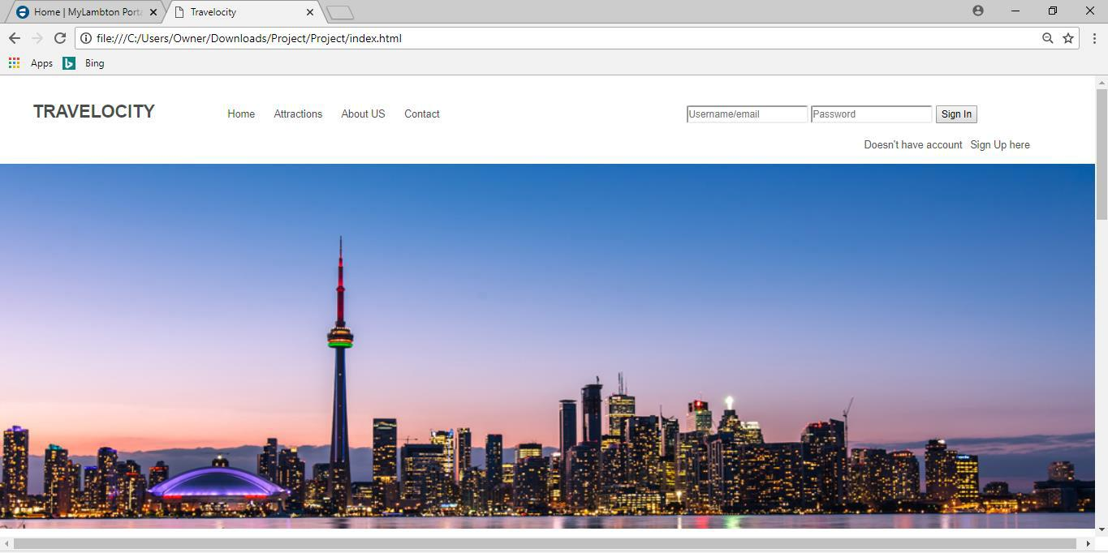

A user cannot access the given links of the tourist places if he/she is not an authenticated person, they must have an account to get more information, if anyone tries to do so the pop-up message will appear as shown in the image below.
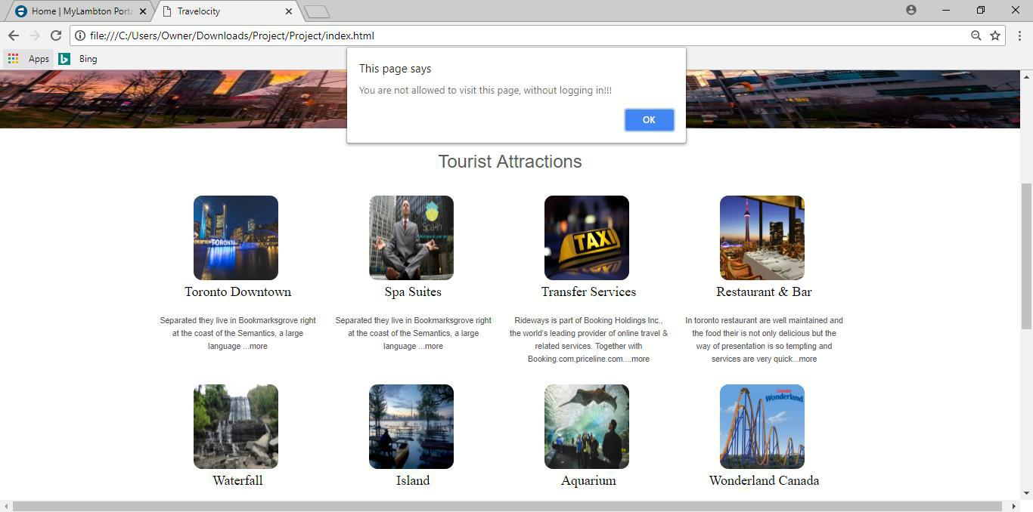
ATTRACTIONS:

At this page a user can get more information about the selected tourist place. Moreover, the user can also select more tourist places from the navigation bar which is located at the left-hand side of this page.
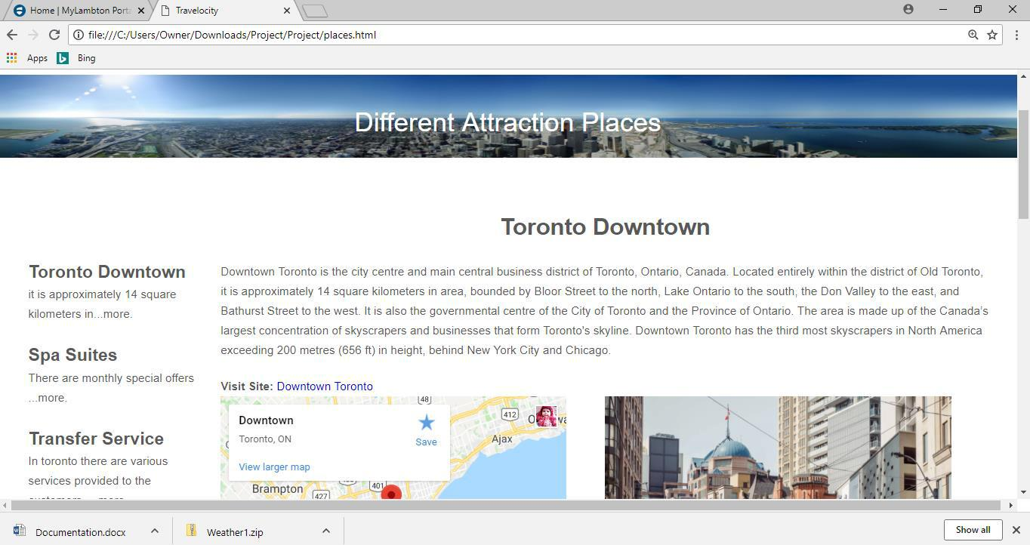

They can also access the location of the selected place on google map along with the images of that place.
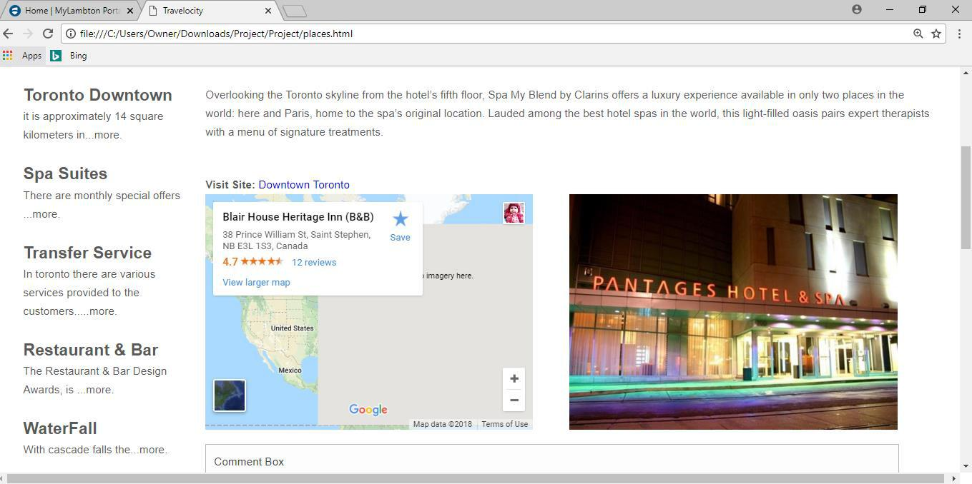
The registered users can also share their views by writing their travelling experience and about our services. They are free to let us know about all the possible improvements in order to serve them better.
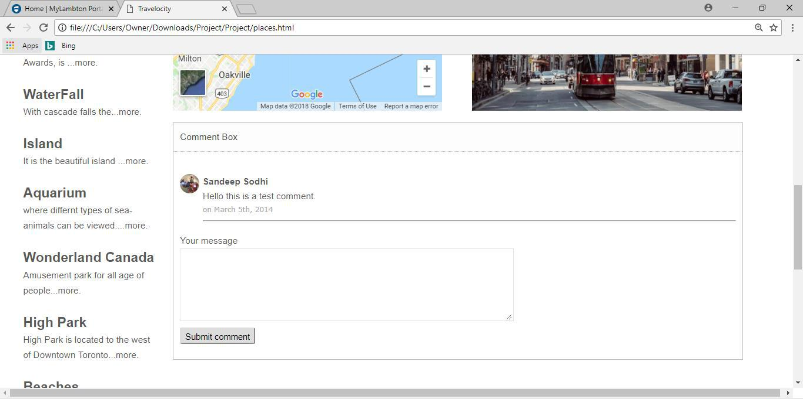

ABOUT US:

This page intimates the users about our history, including the services provided to them.
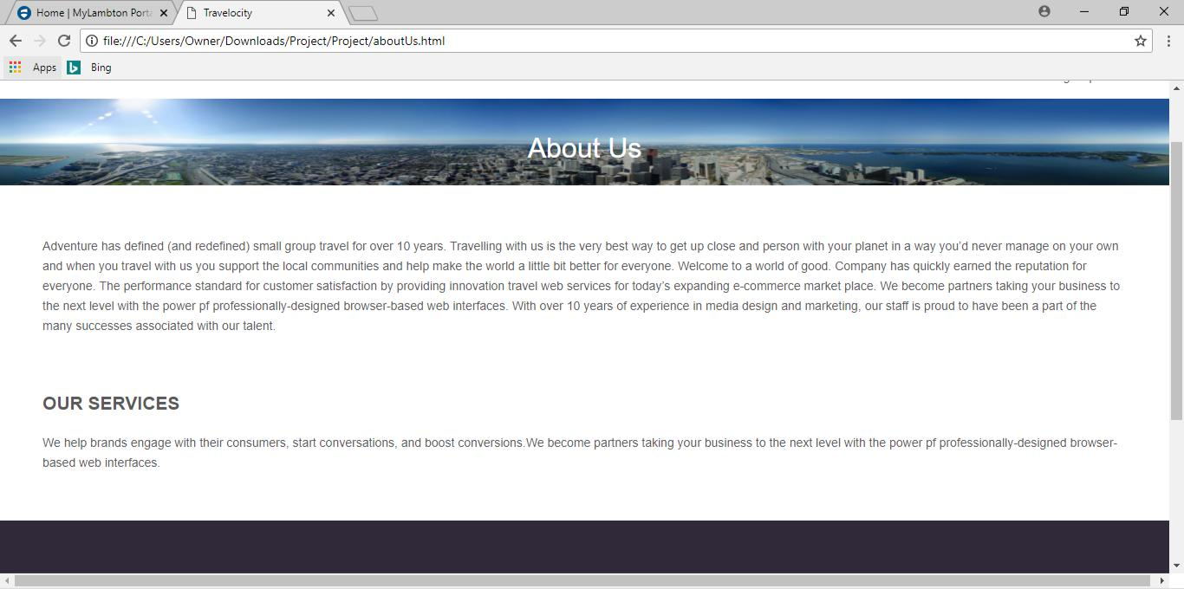

CONTACT US:

We are happy to serve our customers in all possible ways, they can reach us anytime as we are available 24/7 by our contact number, email address which are displayed on this page, through which we can hear from them. In case they
want to meet us in person the address is also provided. To make it more convenient they can access the google map to reach at the exact location.
