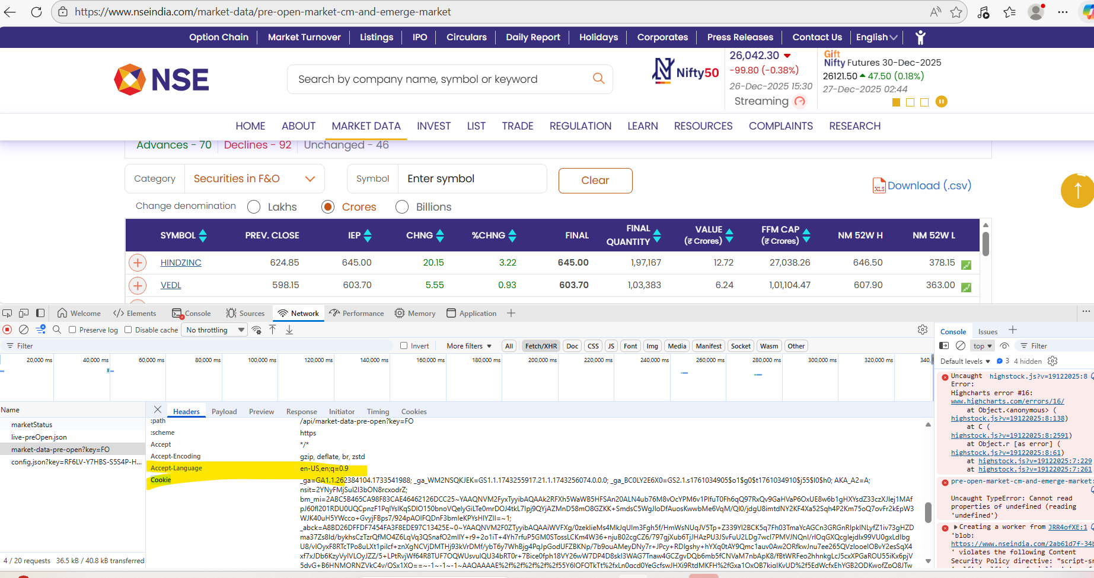
Inspect
Click network tab
Fetch/XHR tab
Refresh the website
Click on option u like to get data
Click on Name
U will get options like url, user-agent. Langayge. Cooky in right side. Use them

