Ff
1. Keywords
2. Literals
3. Dictionary with key with multiple values. Get keys and values
4. Class and object
5. Create a class with name Human, which would give out the name and age of the person
check answer here: /home/inder/my_data/educational_content/python_projects/interview_programs

6. __init__() with example
home/inder/my_data/educational_content/python_projects/interview_programs

7 Inheritence with example
home/inder/my_data/educational_content/python_projects/interview_programs

8 Numpy and how to create 1d, 2d and 3d array
home/inder/my_data/educational_content/python_projects/interview_programs

9 CREtae numpy 5*5 with all zeros

10 Lets numpy1_array= (1, 2,3)
numpy2_array= (4,5,6)
Output_numpy_array= (5,6,7)

11. How to get the n largest numbers from numpy array

12. Create dataframe from list 1d, 2d and dictionary and vice versa

13. Filter data frame wrto condition. Extract those records where sepal.lenth>5 and sepal.width>3
Eg sepal.length sepal.width petal.length petal.width species
5.1 3.5 1.4 0.2 setosa
4.9 3.0 1.4 0.2 setosa
4.7 3.2 1.3 0.2 setosa
4.6 3.1 1.5 0.2 setosa
5 3.6 1.4 0.2 setosa

14. How to introduce NaN values in the first n rows of the sepal.width and petal.length columns
eg If n=3
sepal.length sepal.width petal.length petal.width species
5.1 NaN NaN 0.2 setosa
4.9 NaN NaN 0.2 setosa
4.7 NaN NaN 0.2 setosa
4.6 3.1 1.5 0.2 setosa
5 3.6 1.4 0.2 setosa

15. How can I get number of NaN values present in each column of datframe
eg age bmi hyp ch1
1 NaN NaN NaN
2 22.7 1.0 187.0
1 NaN 1.0 187.0
3 NaN NaN NaN
1 20,4 1.0 113.0
16. How to open and read a file in python

17. What is lambda function. Use lambda to add 10 to a given number

18. Create a plot like below. Where x and y values ranges from 0-10. Title is “Y vs X”
x label is “x-axis” and y label is “y-axis”

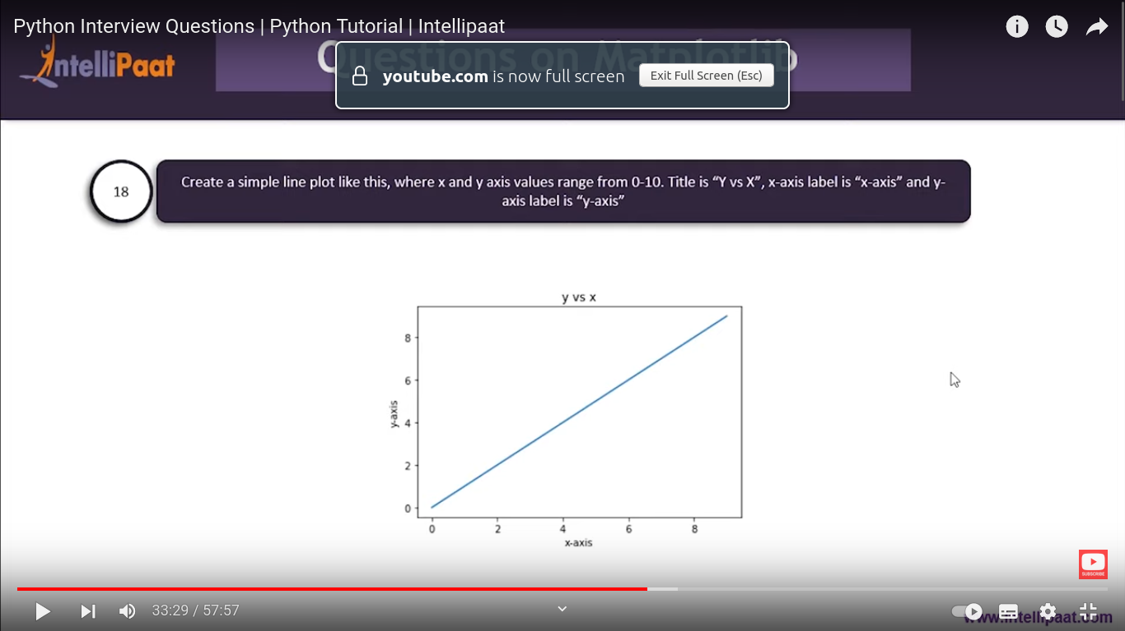

19. Create a simple bar plot like below, where x-axis has the name of fruits and y-axis is their cost

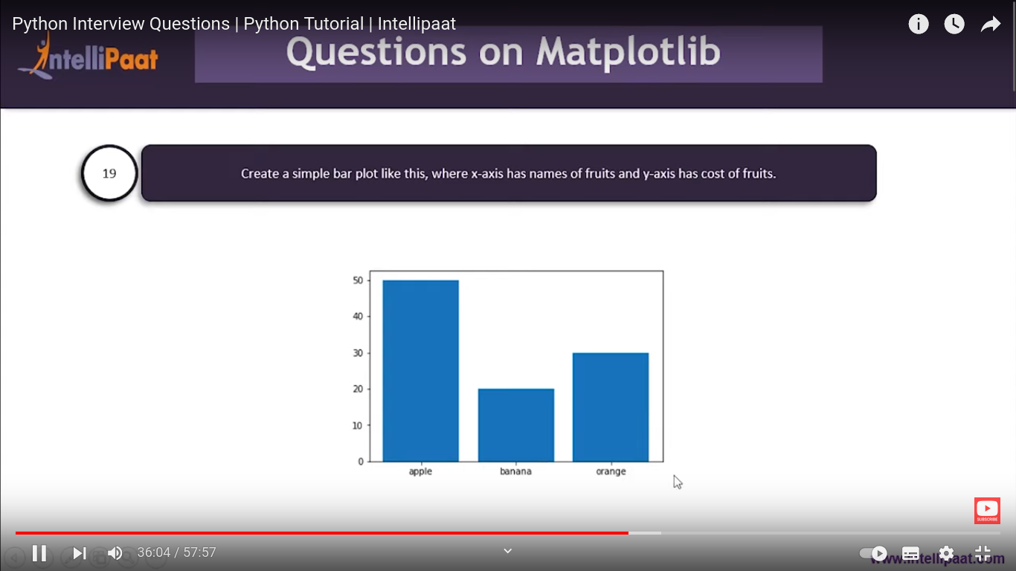

20, what is module in python?
Module helps in logically organizing our python code. For ex if u want make calculator which has features like add, sub, mul, div. If u like to perform add than just call add module instead of writing evry operation in a single program.

21. Randomize the items of a list in a place
eg
[marry, had, a, little, lamb] → [a, had, marray, little lamb]

22. Find length of a string without using len function
eg: Ophthalmology → 13

23. Replace all the odd numbers in numpy arry to -1

eg: array([0,1,2,3,4,5,6,7,8,9])→ array([0,-1,2,-1,4,-1,6,-1,8,-1])

24. How can u get common items in two numpy arrays

eg: ar1= array([0,1,2,3,2,3,4,4,5,6]) O/p: array([2,4])
ar2= array([7,2,10,2,7,4,9,4,9,8])

25. How can u convert the first charcater of each elememt to uppercasein a panda series

eg: marry had a little lamb → Marry Had A Little Lamb

26. How would u calculate the no. of characters of each word in panda series

eg: marry had a little lamb → 5 3 1 6 4

27. In the Iris datframe, change column name from sepal.length to s_length as below

