J

Devps cycle:
PLanning→ Coding→ Build→ Testing→ RElease→ Drploy→ Operate→ Monitor

Planning→ Tool used is JIRA
Code→ Tool used is git(In every project multiple developers are working at the same time and to make them calloborate, track the changes done by whom and when and why)
Build→ Build automation process is done like packaging, compliling, code review, code analysis. Tool used is maven
Testing→ WE write testcases and For automating testcases we genrally use selenium
Release→ Jenkin is used, and with help of pipelines, t can interact to all other tools. Ie why its called heart of ci/cd process.
Deploy→ Config management tool like ansible is used
MOnitor→ Grafana

Asnible used in Deployment

Ansible | saltstack | Chef | puppet
agentless or push based cm tool | agentless or push based cm tool | Agent based or pull based cm tool | Agent based or pull based cm tool
Follow master/slave architecture(One centeral VM is there and with that many slave nodes are connected) | Follow master/slave architectureOne centeral VM is there and with that many slave nodes are connected) | Follow master/slave architectureOne centeral VM is there and with that many slave nodes are connected) | Follow master/slave architectureOne centeral VM is there and with that many slave nodes are connected)
Agent is only in master VM ie Controller will take care of deploying anything to the nodes connnected to it) | Agent is only in master VM ie Controller will take care of deploying anything to the nodes connnected to it) | Agent is available in both in master VM and salave nodes connected to it. Its responsibilty of Slave node to start communication with master | Agent is available in both in master VM and salave nodes connected to it. Its responsibilty of Slave node to start communication with master
Making setup is easy, as we dont have to install agent in slave nodes | Making setup is not as easy as ansible, as we dont have to install agent in slave nodes | Making setup is difficult, as we have to install agent in slave nodes | Making setup is difficult, as we have to install agent in slave nodes
Uses ssh to login to hosts | It dont use ssh, it uses minions ie why its complicated

Jenkins
Its heart of entire Devops pipeline. It is a Open source CI plugin based Tool.

Maven→ Its a build automation tool

CI/CD Pipeline
Version control(DEvelopers write their code in VC eg git)
Build→ This code is pulled by Jenkin and do
unit testing
Deploying
auto testing
Deploy to production
And in every stage developer shout get notification if build has failed/sucees. So that devloper can take necessary action instantaously with less time ans less trouble.
Above everything is automatically in continous manner.

And than, once app is deployed we see, if our app is working as expected or not

In general,
CI/CD tool has
initial stage → code, commit, realted code
CI pipeline→ Build, Unit Test, Integration Test
CD Pipleline→ Review, Staging, Production

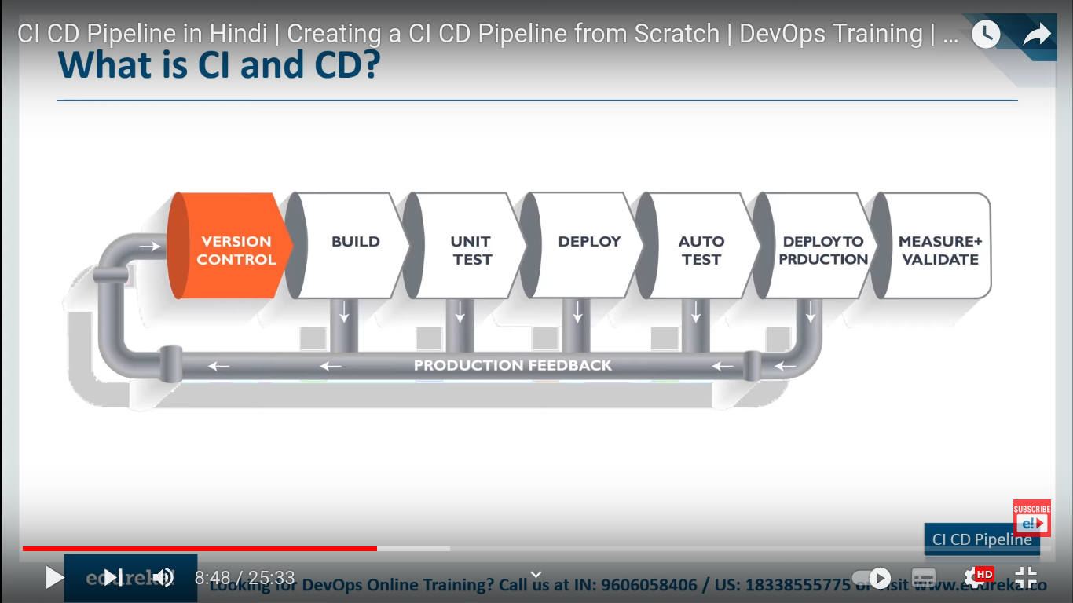

Docker
Its a container solution. WE create docker to make containers. We can not make container directly, we have to make image first and than by running image container is made. Image is made from docker file(Here only you define your code, OS u want u use, which library). Container is just a running instance of docker image.
Docker hub is repo where u can store your images.

It plays very imp role in ci/cd pipeline. When our app is build, packaged we use docker to containarize.

Agile Model

It is iterative and icremental model where requirements keeps on changing
Iterative means :
Requirement→ DEveleop→ test→ give the working picece of sw to the customer

Incremental Means
New features will be keep on adding

It is model that company should adopt/ follllow in order to give fast SW deleivery to the customer within short span of time. We should be flexible enough to handle any kind of requirement change, devlop those requirements, test thpose requirements.

Goul is customer satisfaction

Adavanatages:
Requirement changes is allowd at any stage of development
Releases will be very fast, may be weekly

Artifactory

Files that conatin both source code and the resources that are used to compile them are called artifacts.
It can be .tar.gz

Artifactory repository
Its a repository which can store multiple diff versions of artifacts.

Uses:→ Roll back can be done easily, as all artifacts are already present in Repo.

Lets say, artifact1 is stored inside the repo than it goes for deploymeent.
Artifact2 is also stored in repo and than it goes for deployment but somehow, artifact2 is having some major bugs and application got crash. And customer need them.
So instead of going to git or roll back for previous commit and check for root cause of error. We cab easily roll back by deploying artifact1 as it already present in repo

Sequence is:

Version control tool→ CI(Build Tool)→ JFROG Artifactory→ Container/deployment

JFROG Repository

Its used to store artifacts. Used to download and manage deopendencies for our build tool

