Devops
SW development approach which involves CI, C Testing, CD, and C monitoring.

Devops stage
Version control(Source Code Management ie. Maintains diff versions of code)→ CI(Continous build ie . Validate, review, unit testing, integration testing)→ Cdelivery(Continous tresting ie. Deploying the build application to test servers, UAT testing )→ Cdeploy(DEploying the tested app to PROD setrver for release) and C monitoring all

Version Control

1. what is puppet?
1st configuration tool
puppet→ salt deck→ chef → ansible(most used configuration tool) → Teraform(most useful in cloud automation)

2. Ansible
simple code to manage huge infrastructure. It came with more focused in linux machine than also windows automation, cloud automation, network tool automation, database automation and so many other integration also came with ansible now.

3. Use cases of automation
a. Any system automation(windows/linux)
setup webservices, database services, start the services, stop the services, retsrta the services.
b. Change management
c. WE can intergrate it with Jenkins

4. Why ansible is preffered?

Ansible is agentless
Target machines/services can accesed by using SSH for linux

In puppet/chef/salt deck→ they are having agent. In order to manage servers we have to install agent in all of them. For eg if we 100 servers than we have to install agent in all of them to manage, but in ansible no need to install, it uses existing connection for linnux it uses SSH, for window it used winrm and for cloud it will execute locally.

No Databases
no complicated storage or databases
It has yaml, ini and text files where we have playbooks, inventory,

Ansible has so many modules to do particular task
It can use bash script, shell command,

5. How Ansible connect to server?(LInux/windows/cloud server)
For LINUX→ SSH
For Windows→ winrm
for cloud(AWS, Azure)→ API

6. Architecure of ANSIBLE

we create inventory file→ it will have all target info like IP address, un, pw,
Ansible has lots of inbuilt module that suppose to do a particular task. For ex, for installing a package, restrating a servixce,
we write playbook and we mention this is the host from inv file and we want to execute this modules on this host→ this will be task in playbook
and when playbook is run
Than, ansible is going to create configuration, create python scripts/package and deliver to the destination lets say Linux server, execute there and returns the o/p.
Incase, the destination is not operating system ie. cloud than it will create python package and execute locally.

FYI: group of functiions→ module
group of modules→ package

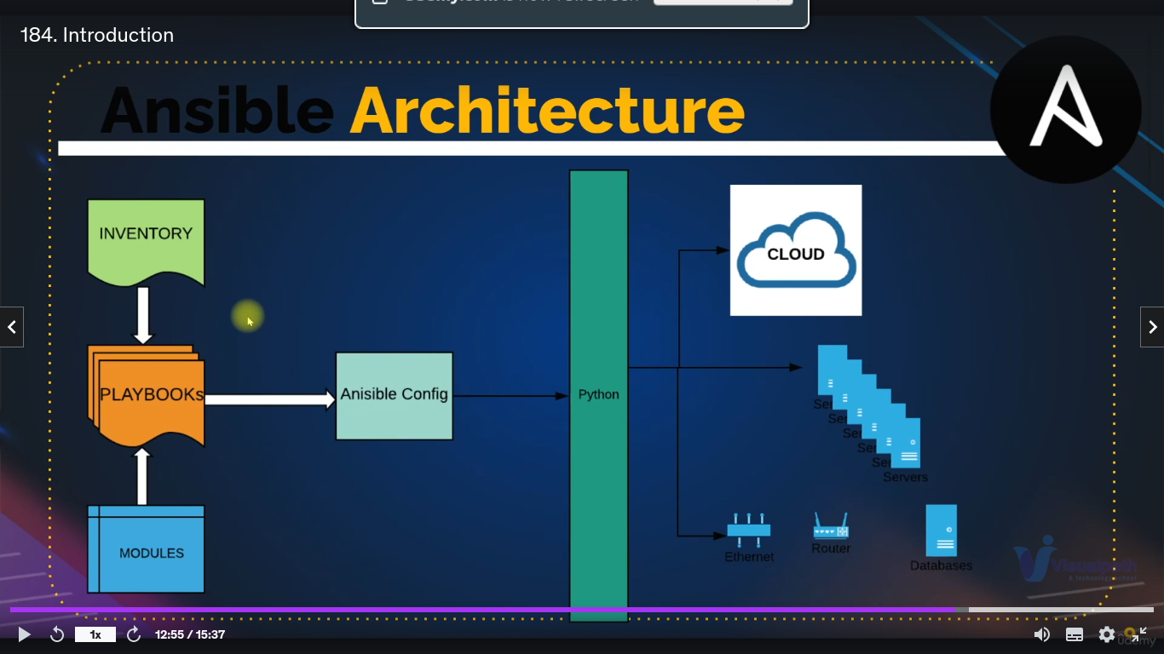

7. ansible ad-hoc?
We can execute a module on our target in single line command. It calls shell
ex. ansible -i path_of_inventory -m ping host_name
ansible -i path_of_inv -m service -a “name-httpd state-started enabled=yes” host_name --become

8. Inventory file, parent group, children group variable in inventory?

9. dictionray vs json vs yaml

/home/inder/my_data/educational_content/python_projects/interview_programs/ansible

10. Configuration management?
Its idempotent in nature→ If the sytsem is in same state its not going apply the change again. Ex
If u install any tool lets say httpd using ansible module than it will not re-install if both of them are in same state

11. Playbook, how to check syntax is correct or not?
ansible-playbook path_of_playbook –syntax-check

12 How to run playbooks
ansible-playbook ansible_playbook/playbook1.yml -i inventory_test_files/inventory2.txt

13. How and where to find ansible modules?
ansible-doc -l → Will get list of all modules
ansible-doc apt → will get documentation of apt module

14. CI/CD

CD stands for continuous delivery, and CI stands for Continous Integration both are software development practices.
CI
- is a development practice where the codes from each developers can be integrated into a shared repository.
- It triggers the build for the early detection of bugs present in the code.

CD
In CD, developers build software that can be released into production at any given time.

CI/CD pipeline is responsible for building codes, running tests, and deploying new software versions.

15. Ansible Tower
As we know ansible is good in managing huge infrastructure. Ansible tower helps in doing this
To utilise Ansible, different users and groups require varying levels of access. In addition, we must integrate these tools with other third-party tools such as integration with SCM tools for Ansible playbooks, integration with ticketing tools to create tickets if any tasks fail or notify the user via email or messaging apps, and so forth. Ansible Tower is the only way to get these features, which aren’t available in Ansible.
Ansible Dashboard: Ansible Dashboard displays job status in a graphical format, as well as information about recent job runs

