J

Devps cycle:
PLanning→ Coding→ Build→ Testing→ RElease→ Drploy→ Operate→ Monitor

Planning→ Tool used is JIRA
Code→ Tool used is git(In every project multiple developers are working at the same time and to make them calloborate, track the changes done by whom and when and why)
Build→ Build automation process is done like packaging, compliling, code review, code analysis. Tool used is maven
Testing→ WE write testcases and For automating testcases we genrally use selenium
Release→ Jenkin is used, and with help of pipelines, t can interact to all other tools. Ie why its called heart of ci/cd process.
Deploy→ Config management tool like ansible is used
MOnitor→ Grafana

Asnible used in Deployment

Ansible | saltstack | Chef | puppet
agentless or push based cm tool | agentless or push based cm tool | Agent based or pull based cm tool | Agent based or pull based cm tool
Follow master/slave architecture(One centeral VM is there and with that many slave nodes are connected) | Follow master/slave architectureOne centeral VM is there and with that many slave nodes are connected) | Follow master/slave architectureOne centeral VM is there and with that many slave nodes are connected) | Follow master/slave architectureOne centeral VM is there and with that many slave nodes are connected)
Agent is only in master VM ie Controller will take care of deploying anything to the nodes connnected to it) | Agent is only in master VM ie Controller will take care of deploying anything to the nodes connnected to it) | Agent is available in both in master VM and salave nodes connected to it. Its responsibilty of Slave node to start communication with master | Agent is available in both in master VM and salave nodes connected to it. Its responsibilty of Slave node to start communication with master
Making setup is easy, as we dont have to install agent in slave nodes | Making setup is not as easy as ansible, as we dont have to install agent in slave nodes | Making setup is difficult, as we have to install agent in slave nodes | Making setup is difficult, as we have to install agent in slave nodes
Uses ssh to login to hosts | It dont use ssh, it uses minions ie why its complicated

Jenkins
Its heart of entire Devops pipeline. It is a Open source CI plugin based Tool.

Maven→ Its a build automation tool

CI/CD Pipeline
Version control(DEvelopers write their code in VC eg git)
Build→ This code is pulled by Jenkin and do
unit testing
Deploying
auto testing
Deploy to production
And in every stage developer shout get notification if build has failed/sucees. So that devloper can take necessary action instantaously with less time ans less trouble.
Above everything is automatically in continous manner.

And than, once app is deployed we see, if our app is working as expected or not

In general,
CI/CD tool has
initial stage → code, commit, realted code
CI pipeline→ Build, Unit Test, Integration Test
CD Pipleline→ Review, Staging, Production

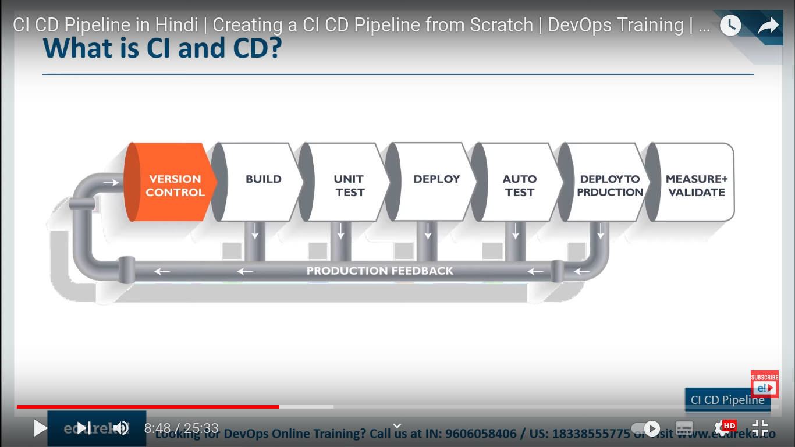

Docker
Its a container solution. WE create docker to make containers. We can make container directly, we have to make image first and than by running image container is made. Image is made from docker file(Here only you define your code, OS u want u use, which library). Container is just a running instance of docker image.
Docker hub is repo where u can store your images.

It plays very imp role in ci/cd pipeline. When our app is build, packaged we use docker to containarize.

