**Installation and Configuration**

**Step.1 - Installation of Grafana in Windows**

Download Grafana 🡪 <https://grafana.com/grafana/download?platform=windows>

Or Direct link 🡪 <https://dl.grafana.com/enterprise/release/grafana-enterprise-8.1.2.windows-amd64.msi>

**Step.2 - Installation of Prometheus in Windows**

1. Download Prometheus zip 🡪 <https://prometheus.io/download/>
2. Unzip and Move Prometheus in your working directory.
3. Edit prometheus.yml and add below attached line at the end.

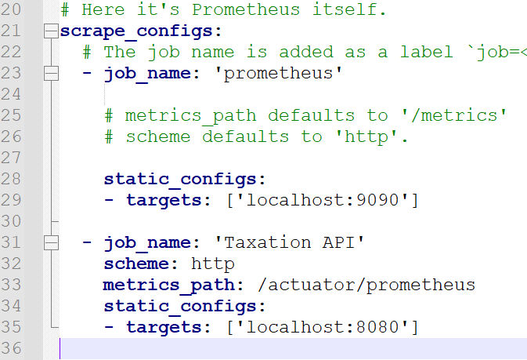

1. Add Actuator and Prometheus dependency in pom.xml

<dependency>

<groupId>org.springframework.boot</groupId>

<artifactId>spring-boot-starter-actuator</artifactId>

</dependency>

<dependency>

<groupId>io.micrometer</groupId>

<artifactId>micrometer-registry-prometheus</artifactId>

</dependency>

1. Add configuration in application.yml accordingly

Example:-

server:

compression:

enabled: true

spring:

management:

endpoint:

health:

show-details: always

endpoints:

web:

exposure:

include: health,prometheus,metrics

1. Run prometheus.exe present in Prometheus folder.
2. Check Prometheus on browser <http://localhost:8080/actuator/prometheus>

**Step.3 – Run Grafana on browser**

Run Grafana 🡪 <http://localhost:3000/login>

Default Username 🡪 admin

Default Password 🡪 admin

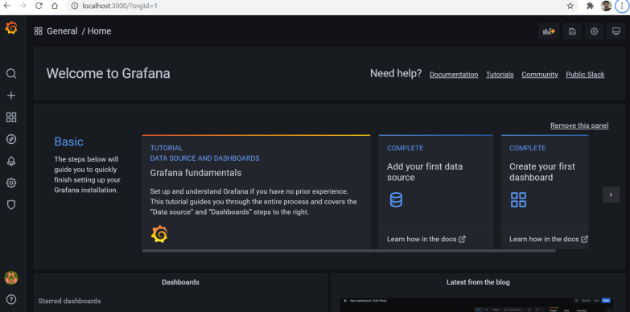

You can add your json file through import menu.

