A Research Assignment

**MRP CALCULATIONS WHEN LEAD TIME IS FUZZY**

Submitted By:

**Inderjeet Singh: 173190001**

**Saurav Adhikari: 173192001**

Industrial Engineering & Operations Research

IIT Bombay

Under the Guidance of:

**Prof. A. Subash Babu**

Department of Mechanical Engineering

IIT Bombay



**INDIAN INSTITUTE OF TECHNOLOGY BOMBAY**

**Mumbai 400076**

**July 2017 To Nov 2017**

**TABLE OF CONTENTS**

**TOPICS PAGE NO:**

1. **TABLE OF CONTENTS 2**
2. **LIST OF ABBREVIATIONS 3**
3. **INTRODUCTION 4** 
   1. **What is MRP? 4**
   2. **Primary functions of MRP 4**
   3. **Forms of uncertainties in MRP systems 4**
4. **METHOD USED 5**
5. **DISCUSSION 5** 
   1. **Multi-objective integer linear programming approach** 5
   2. **Solution methodology 7**
   3. **An example 9**
   4. **Method of Lead time estimation based on generating 13**

**fuzzy rules basis and some linguistic rules**

* 1. **Monte Carlo simulation 14**

1. **CONCLUSION 15**

***References* 16**

**LIST OF ABBREVIATIONS**

CP : Cost performance

CTO : Configure to order

DFA : Design for assembly

ECR : Efficient consumer response

ERP : Enterprise resource planning

FGP : Fuzzy goal programming

FP : Finite planning

HH : Hand held

HR : Human resources

LCA : Life cycle assessment.

LT : Lead time

M&S : Modellind and simulation.

MRP : Material Requirements Planning (MRP)

MRP-II : Manufacturing resource planning

NPI : New Product Introduction

WIP : Work in process

**1. INTRODUCTION**

**1.1 What is MRP (Material Requirements Planning)**

“Material requirements planning (MRP) is a production planning and inventory control system which integrates data from production schedules with that from inventory and the bill of materials (BOM) to calculate purchasing and shipping schedules for the parts or components required to build a product”.

MRP was developed by engineer **Joseph Orlicky** as a response to the **Toyota Production System**, the famous model for lean production. The first computerized MRP system was tested successfully by Black & Decker in 1964.

**1.2 Primary functions of MRP**

The primary functions of MRP are as follows:

1. To ensure the availability of the raw material for production and availability of the finished products to avoid shortage.
2. To reduce wastes by maintaining lowest possible materials and product levels in stock.
3. To help plan manufacturing functions, delivery schedules and purchasing.

**1.3 Forms of uncertainties affecting performance of MRP systems**:

They are as follows:

1. **Environmental uncertainties** – Includes uncertainty in demand and supply.
2. **System uncertainties** – Includes Fuzzy lead times, Quality uncertainty, Production system uncertainty and change of product structure.

When manufacturer wants to begin production, it is important to estimate lead time accurately. Also, estimated planned lead time will effect on the MRP and MPS respectively. After a proper estimation of lead time, the manufacturer is able to improve delivery performance into the customer.

So our objective is to Provide MRP calculations under fuzzy lead time conditions.

So here we will consider some approaches available to model a Material requirement planning problem with fuzzy lead times.

**2. METHOD USED**

1. Multi-objective integer linear programming approach.
2. Lead time estimation based on generating fuzzy rules basis and some linguistic rules.
3. Lead time estimation by Monte Carlo simulation (Less superior).

**3. DISCUSSIONS**

**3.1 Multi-objective integer linear programming approach**

Following are some assumptions which have followed during the formulation of given problem by above method:

1. A multi-level production system.
2. A multi-product manufacturing environment, Means multiple finished goods, raw material, sub-assemblies structure in bill material etc.
3. Backlog of the demand is defined as the non-negative difference between the cumulated demand and the volume of available product.
4. Constraints on production capacity and programmed reception.
5. Fuzzy lead times for finished goods and raw materials represented by using different values associated with different degree of possibility of each one.
6. Inventory of the each product is the available volume at the end of a given time period.
7. Lead time of the product is the number of consecutive and integer periods that are required for their finalization.
8. Master production schedule (MPS) and MRP are solved jointly.
9. Multi-period planning horizon
10. There are some overtime limits.

For the formulation of our model for MRP,

We will consider some notations that we will be using throughout our formulation, they are given by-

P*i,t*  = Production quantity for product ‘i’ at period ‘t’.

I*i,t* = Size of inventory for product ‘i’ at time ‘t’.

CP*i,t =* Production cost.

CI*i,t* = Inventory holding cost for product ‘i’ at period ‘t’ .

CTO*r,t* = Overtime cost at facility ‘r’ at time ‘t’.

CTU*r,t* = Under-time cost of facility ‘r’ at time ‘t’.

TO*r,t* = Overtime at facility ‘r’ at time ‘t’.

TU*r,t* = Under-time of facility ‘r’ at time ‘t’.

B*i,t* = Backorder quantity of product ‘i’ at time ‘t’.

P*i,t-LT* = Production before lead time.

Cr,t = Capacity of resource ‘r’ at time ‘t’.

We will take following objective functions:-

$Min. z1 ≅ \sum_{i=1}^{I}{\sum_{t=1}^{T}{\left(CPi,t Pi,t + CIi,t Ii,t \right)+ \sum_{r=1}^{R}{\sum_{t=1}^{T}{CTOr,t TOr,t }}}}$

This objective function represents total cost calculated for all products over entire time period.

$Min. z2 ≅ \sum_{i-1}^{I}{\sum_{t=1}^{T}{Bi,t }}$

This minimizes the backorder quantity over entire planning horizon.

$Min. z3 ≅ \sum_{r=1}^{P}{\sum_{t=1}^{T}{TUr,t}}$

This objective function minimizes the idle time of the productive resources.

Following constraints are imposed on this model

$I_{i,t-1}+P_{i,t-LT}+{SR}_{it}-I_{i,t}-B_{i,t-1}-\sum_{j=1}^{I}{α_{i,j}}\left(P_{j,t}+{SR}_{j,t}\right)+B_{i,t}=d_{i,t} ∀i,t$

This is the inventory balance equation for all the products.

$\sum_{i=1}^{I}{P_{i,t}{AR}_{i,r}+}{TU}_{ r,t}-{TO}_{r,t}=C_{r,t} ∀i,t$

This constraint establishes the available capacity for normal, overtime and subcontracted production.

$B_{i,j}=0 ∀i$

This finishes with delays in last period T of planning horizon.

$P_{i,t},I_{i,t},B_{i,t},{TU}_{i,t},{TO}_{i,t}≥0 ∀i,r,t$

It contemplates the non-negativity for the decision variables and constraint.

$P_{i,t},I_{i,t},B_{i,t}∈Z ∀i,t$

Establishes integrity condition for some of decision variables.

**3.2 Solution Methodology**

An approach to transform the fuzzy goal programming (FGP) into an equivalent auxiliary crisp mathematical programming model for MRP problems is provided. This approach considers non increasing linear membership functions for each fuzzy objective function as follows-

$M_{k}=\left\{\begin{aligned} \\ 1 z_{k}<z_{k}^{l} \\ \\ \frac{z_{k}^{4}-z_{k}}{\begin{aligned}z_{k}^{4}-z_{k}^{l} \\ \end{aligned}} z_{k}^{l}<z_{k}<z_{k}^{4} \\ 0 z_{k}>z_{k}^{4} \\ \end{aligned}\right.$

Where:

$M_{k}$ = Membership function of $z_{k}$.

Zkl & Zku = Lower and upper bound on objective function Zk.

FGP programming method proposes that a multi-objective model could be transformed in a single objective model as follows:

$\max_{x∈f(x)}{λ\left(x\right)=γλ_{0}+(1-γ)\sum_{k}{Q_{k}μ_{k}(x)}}$

Subjected to following constraints-

$λ_{0}≤M_{k}\left(x\right), k=1,..,n$

$x∈f(x)$

Where:

$M_{k}$ represents the satisfaction degree of kth objective function.

$λ_{0}=\min_{ }{ \left\{M_{k}(x)\right\}}$ is the minimum satisfaction degree of objectives.

$Q_{k}$ = Relative importance of kth objective.

$γ$ = coefficient of compensation.

So the equivalent auxiliary crisp mathematical programming model is formulated as follows:

$λ\left(x\right)=γλ_{0}+(1-γ)\left[θ_{1}\left(\frac{z_{1}^{4}-z_{1}}{z_{1}^{4}-z_{1}^{l}}\right)+θ_{2}\left(\frac{z_{2}^{4}-z_{2}}{z_{2}^{4}-z_{2}^{l}}\right)+θ_{1}\left(\frac{z_{3}^{4}-z_{3}}{z_{3}^{4}-z_{3}^{l}}\right)\right]$

Subjected to

$λ_{0}≤M_{1},M_{2},M_{3}$

$0≤λ_{0},M_{1},M_{2},M_{3}≤1$

Now all possible combinations of lead times are considered along with a possibility degree to the minimum possibility degree of all products in each combination.

Following solution procedure is adopted:-

1. Formulate original Fuzzy Goal Programming (FGP) model for the MRP problem.
2. Specify the corresponding linear membership functions (LMF) for all fuzzy objectives including upper and lower limits.
3. Determine corresponding relative importance of the objective functions (θk) and the coefficient of compensation (γ).
4. Transform the original FGP problem into an equivalent single-objective mixed-integer linear programming (MILP) form using the Torabi and Hassini (2008) fuzzy programming method.
5. Generate problem all possible instances of lead times.
6. Solve the proposed auxiliary crisp single-objective model by using a MILP solver for each problem instance and obtain a fuzzy set of solutions.
7. Defuzzify the obtained solution by applying **the center of gravity method**.
8. Determine the Manhattan and/or the Euclidean distance of each solution to crisp solution.
9. Select the solution with minimum distance to the defuzzified crisp solution.

For better understandings of this procedure, I am giving a numerical example as follows-

**3.3 Example**

**Source:** Díaz-Madroñero, M., Mula, J., & Jiménez, M. (2014). Fuzzy goal programming for material requirements planning under uncertainty and integrity conditions. International Journal of Production Research, 52(23), 6971-6988.

Now The proposed model we have to implement in the MPL language V4.2. The resolution is carried out with CPLEX 12.1.0 solver. The input data and the model solution values should be processed with the Microsoft Access database.

In this numerical example we are considering 21 instances.

Let we have a final product with following product structure:

**Product 1**

x1

**Product 2**

x3

**Product 3**

1. A 30 period planning horizon is considered.
2. Let finished goods have only external demands.
3. The decision variables Pi,t , Ii,t , Bi,t are considered integer.
4. Let firm orders can’t be rejected but backlog for finished product is allowed.
5. Fuzzy lead times of component are always higher than or equal to finished good lead times.

Now let we take possible values of lead times for all these three products as-

Product 1: {0/1, 1/0.5, 2/0.2}

Product 2: {1/1, 2/0.7, 3/0.3}

Product 3: {3/1, 4/0.8, 5/0.4}

Using these values following the instances were generated-

|  |  |  |
| --- | --- | --- |
| **Instance** | **Lead times** | **Possibility** |
| **I1** | {0,1,3} | 1 |
| **I2** | {0,1,4} | 0.8 |
| **I3** | {0,1,5} | 0.4 |
| **I4** | {0,2,3} | 0.7 |
| **I5** | {0,2,4} | 0.7 |
| **I6** | {0,2,5} | 0.4 |
| **I7** | {0,3,3} | 0.3 |
| **I8** | {0,3,4} | 0.3 |
| **I9** | {0,3,5} | 0.3 |
| **I10** | {1,1,3} | 0.5 |
| **I11** | {1,1,4} | 0.5 |
| **I12** | {1,1,5} | 0.4 |
| **I13** | {1,2,3} | 0.5 |
| **I14** | {1,2,4} | 0.5 |
| **I15** | {1,2,5} | 0.4 |
| **I16** | {1,3,3} | 0.3 |
| **I17** | {1,3,4} | 0.3 |
| **I18** | {1,3,5} | 0.3 |
| **I19** | {2,2,3} | 0.2 |
| **I20** | {2,2,4} | 0.2 |
| **I21** | {2,2,5} | 0.2 |
| **I22** | {2,3,3} | 0.2 |
| **I23** | {2,3,4} | 0.2 |
| **I24** | {2,3,5} | 0.2 |

Table:-1

The obtained numerical results are as follows:-

|  |  |  |  |
| --- | --- | --- | --- |
| **Instance** | ***z1*** | ***z2*** | ***z3*** |
| I1 | 88716.42 | 967 | 1047.06 |
| I2 | 88706.40 | 1971 | 1047.06 |
| I3 | 88697.99 | 3512 | 1047.06 |
| I4 | 88716.42 | 967 | 1047.06 |
| I5 | 88706.40 | 1971 | 1047.06 |
| I6 | 88697.99 | 3512 | 1047.06 |
| I7 | 88716.42 | 967 | 1047.06 |
| I8 | 88706.40 | 1971 | 1047.06 |
| I9 | 88697.99 | 3512 | 1047.06 |
| I10 | 88716.42 | 967 | 1047.06 |
| I11 | 88706.40 | 1971 | 1047.06 |
| I12 | 88697.99 | 3512 | 1047.06 |
| I13 | 88716.42 | 967 | 1047.06 |
| I14 | 88706.40 | 1971 | 1047.06 |
| I15 | 88697.99 | 3512 | 1047.06 |
| I16 | 88716.42 | 967 | 1047.06 |
| I17 | 88706.40 | 1971 | 1047.06 |
| I18 | 88697.99 | 3512 | 1047.06 |
| I19 | 88716.42 | 967 | 1047.06 |
| I20 | 88706.40 | 1971 | 1047.06 |
| I21 | 88697.99 | 3512 | 1047.06 |
| I22 | 88716.42 | 967 | 1047.06 |
| I23 | 88706.40 | 1971 | 1047.06 |
| I24 | 88697.99 | 3512 | 1047.06 |

Table:-2 Objective function by instance (I1 to I12)

|  |  |  |  |
| --- | --- | --- | --- |
| **Instance** | ***µ1*** | ***µ2*** | ***µ3*** |
| I1 | 0.9677 | 0.9033 | 0.8547 |
| I2 | 0.9678 | 0.8029 | 0.8547 |
| I3 | 0.9678 | 0.6488 | 0.8547 |
| I4 | 0.9677 | 0.9033 | 0.8547 |
| I5 | 0.9678 | 0.8029 | 0.8547 |
| I6 | 0.9678 | 0.6488 | 0.8547 |
| I7 | 0.9677 | 0.9033 | 0.8547 |
| I8 | 0.9678 | 0.8029 | 0.8547 |
| I9 | 0.9678 | 0.6488 | 0.8547 |
| I10 | 0.9677 | 0.9033 | 0.8547 |
| I11 | 0.9678 | 0.8029 | 0.8547 |
| I12 | 0.9678 | 0.6488 | 0.8547 |
| I13 | 0.9677 | 0.9033 | 0.8547 |
| I14 | 0.9678 | 0.8029 | 0.8547 |
| I15 | 0.9678 | 0.6488 | 0.8547 |
| I16 | 0.9677 | 0.9033 | 0.8547 |
| I17 | 0.9678 | 0.8029 | 0.8547 |
| I18 | 0.9678 | 0.6488 | 0.8547 |
| I19 | 0.9677 | 0.9033 | 0.8547 |
| I20 | 0.9678 | 0.8029 | 0.8547 |
| I21 | 0.9678 | 0.6488 | 0.8547 |
| I22 | 0.9677 | 0.9033 | 0.8547 |
| I23 | 0.9678 | 0.8029 | 0.8547 |
| I24 | 0.9678 | 0.6488 | 0.8547 |

Table:-2 Objective function by instance (I13 to I24)

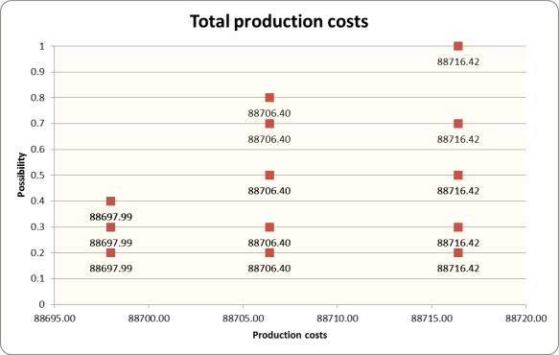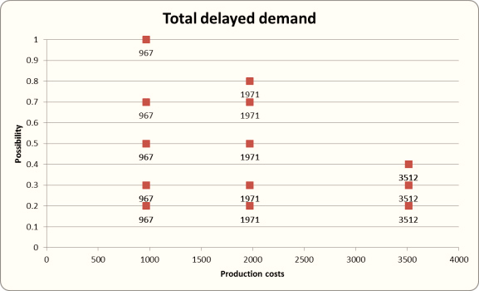These results can be shown graphically as below:-

Fig. 1. Graphical results for total production costs. Fig. 2. Graphical results for total delayed demand

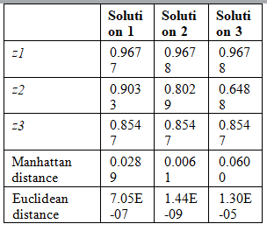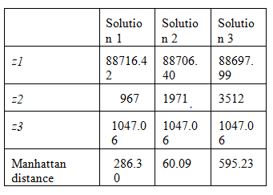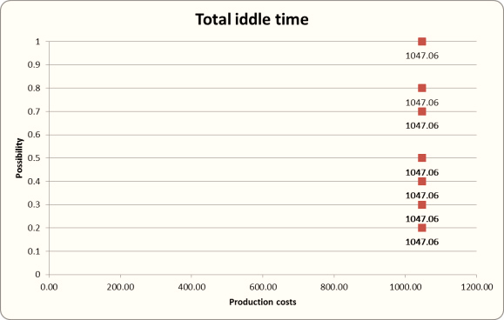Fig. 3. Graphical results for total idle time.



So table-3 and Table-4 shows Manhatten and Euclidean distances with respect to center of gravity of each. So we have obtained all possible set of solutions for each objective functions, each membership function and their corresponding center of gravity.

**3.4 Method of Lead time estimation based on generating fuzzy rules basis and some linguistic rules:-**

In this method there are mainly three steps which provides solution of a given problem in fuzzy environment. They are as follows:-

**1. Fuzzification review:-** In this step all meteorological events having ambiguous characteristics and therefore their domain of change are divided into many fuzzy subsets that are complete, normal, and consistent with each other.

**2. Fuzzy Inference System:-** This step relates systematically pair wise all the factors taking place in the solution, which depends on the purpose of the problem. This part includes many fuzzy conditional statements to describe a certain situation.

For example if N is dependent on M and ‘A’ and ‘B’ are their two physical sets respectively. Then we can write as:

IF M is A (1) THEN N is B (1)

ALSO

IF M is A (2) THEN N is B (2) etc.

3. **Defuzzification:-**

In this method to calculate the deterministic value of linguistic variable N following method must be applied-

$$Nj=\left\{ \sum_{i-1}^{L}{Ni}\right\}/L$$

$$Pj\left(m\right)= {\prod_{i=1}^{m}{µ(mi)}}/{\sum_{j=1}^{L}{\prod{µ(mi)}}}$$

$$N=f\left(m\right)= \sum_{j=1}^{L}{Pj(m)Nj}$$

Where

P(m) = A Fuzzy basis function.

N = particular value of the linguistic variable.

Nj = Support value, in which the membership function reaches its maximum grade of membership.

Then the **center-average method** is selected and applied to defuzzify the proposed problem.

**3.5 Monte Carlo simulation**

Monte Carlo methods are a broad class of computational algorithms that rely on repeated random sampling to obtain numerical results.

Each observation of lead time has obtained through multiple simulation runs, based on obtained data from given values of lead times.

However Results have shown that the results show that the fuzzy lead times are smaller than simulated lead times in all cases. When the number of orders in the MRP system increases, it seems that the existing difference between simulated and fuzzy lead time becomes bigger.

**4.0 CONCLUSION**

This report addressed that how MRP calculations are done when lead time is fuzzy. For this we used three method namely, Multi-objective integer linear programming approach, Lead time estimation based on generating fuzzy rules basis and some linguistic rules and Lead time estimation by Monte Carlo simulation (Less superior).

Every method has its own limitations and assumptions and applicable under specific environment.

The advantages of these methods are related to: The modeling and establishment of the priorities for production objectives that traditionally are measured through costs estimated with difficulty by companies; and considering different values for product lead times associated to different possibility degrees which provide the decision maker with a broad decision spectrum with different risks levels.

**REFERENCES:**

1. Alexandre Dolgui1, Mohamed-A.O.L.2(2008) An Approach for the MRP Parameterization Under Lead Time Uncertainty: Branch and Cut Algorithm. *Seoul, Korea,* IFAC 12849-12854.
2. Bellman, R.E., Zadeh, L.A. (1970) Decision making in a fuzzy environment. Management Science, 17 141–164.
3. Díaz-Madroñero, M., Mula, J., & Jiménez, M. (2014). Fuzzy goal programming for material requirements planning under uncertainty and integrity conditions. *International Journal of Production Research*, *52*(23), 6971-6988.
4. Dolgui A. Prodhon C.(2007) Supply planning under uncertainties in MRP environments: a state of the art.*Elseveir* , 1-26.
5. Moghaddam R.T. Bagherpour M. Noora A.A. Sassani F.(2007) Application of Fuzzy Lead Time to a Material Requirement Planning System*. 8th WSEAS International Conference on Fuzzy Systems, Vancouver, British Columbia, Canada, June 19-21*, 208-213.
6. Mula J., Madronero M. D, Jimenez M.(2015) Material Requirement Planning under Fuzzy Lead Times, *IFAC-PapersOnLine* 48-3 (2015) 242–247.