Xpath

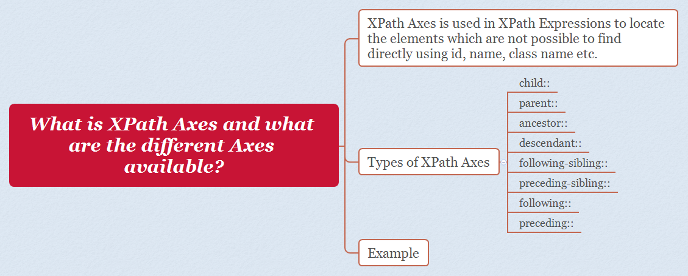

**1.Problem Statement**: Find Element with startname’j’ under web section

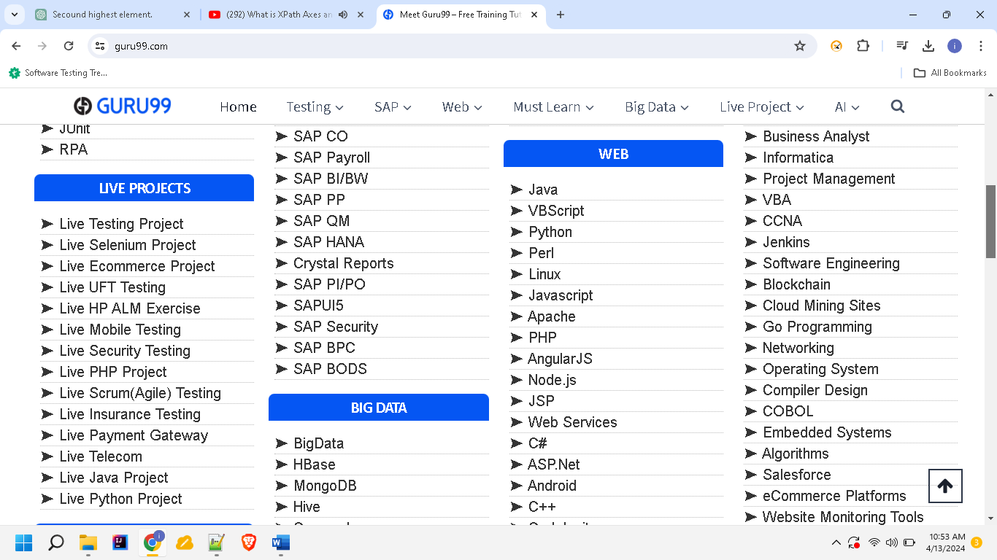

**Sol:** //b[text()='Web']/parent::h4/following::ul[1]/li/*[starts-with(text(), '➤ J')]

**2.Problem Statement**: Find elements after amazontv tab

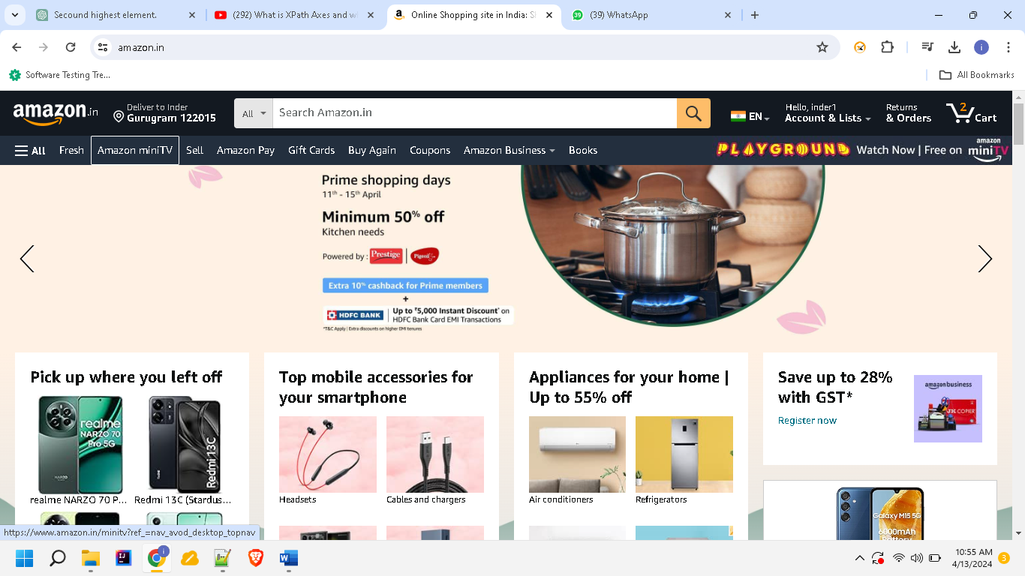

**Sol**: (//*[@class='nav-a '])[position() >= 2 and position() <= 32]

**Find the first element sol**:(//*[@class=’ nav-a ’]))[1]

**3. Problem Statement**: Find xpath for warning section

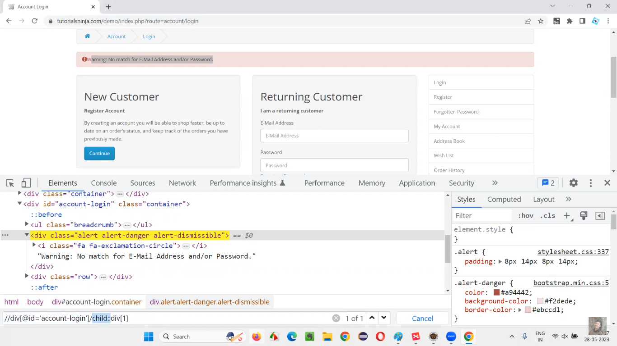

**Sol**: //div[@id=’account-login’]/child::div[1]

**Custom Xpath:**

//*[@type='submit' OR @name='btnReset']

//input[@type='submit' and @name='btnLogin']

//label[starts-with(@id,'message')]

//h4/a[contains(text(),'SAP M')]

//h4[text()=’web’]

//*[@attribute_name1='attribute_value1' or @attribute_name2='attribute_value2]