AIME – Intended Use & System Overview
Version: 1.0 Date: 2026-01-22

1. Document purpose
This document describes the intended use, scope, core features, and high-level architecture of the AIME web application. It is intended to support internal governance, security, and compliance discussions (e.g., data protection, AI governance), and to provide a shared understanding for stakeholders (Product, Engineering, HR, Legal, Security, and Business Leadership).

2. Intended use statement
AIME is an internal web application intended for workplace goal-setting and execution visibility. It provides a unified view of organisational progress toward the company’s Vision, Mission, and strategic priorities. It supports 90‑day (quarterly) goal-setting and execution tracking by organising Objectives, Key Results, Tasks/Initiatives, and supporting artefacts, and by presenting dashboards and drill‑down views tailored to different roles across the organisation.
AIME increases visibility and transparency across teams, helps align individual and group OKRs with organisation-wide priorities, and helps each member understand how their work contributes to the wider picture. The primary aim is improved focus, coordination, and execution.
AIME includes an AI assistant to make interaction faster and simpler—by drafting OKRs, enabling natural-language queries and navigation, summarising relevant information, and proposing user-approved actions (e.g., creating or updating records in AIME or external systems such as Jira).

3. Non-intended use (explicit exclusions)
AIME is not intended to replace human judgement or to perform automated decision-making about individuals. In particular, AIME is not intended for:
- Automated performance appraisal, disciplinary action, promotion decisions, or employee ranking.
- Profiling employees or inferring sensitive personal attributes.
- Autonomous execution of actions without user confirmation (all write operations are proposed and require user acceptance).
- Monitoring beyond what is required for goal-setting, collaboration, and operational visibility.

4. Users and roles
AIME is used by internal staff. Access is role-based and aligned to the organisation’s structure and reporting lines. Permissions are granted on a least-privilege basis and may be scoped to self, team/department, or organisation-wide views depending on the role. Core roles include:
- User: Default role for general staff. Provides the minimum permissions required to use AIME, including managing personal OKRs/OKRTs and viewing shared OKRs and dashboards that the user has been granted access to.
- Leader: Assigned to staff with supervisory responsibilities (e.g., Team Leaders, Heads of Department, Directors, C-suite members). Provides additional visibility for managing and supporting team/department OKRs, including access to team-level dashboards and summaries within the leader’s authorised scope.
- Owner: Provides access to organisation-wide dashboards and aggregated views to support strategic alignment and oversight. Access is intended for designated stakeholders who require a broader, cross-team perspective (subject to policy and permission scope).
- Admin: Provides administrative capabilities required to operate and configure AIME.
      - List all users (fetch full user directory)
      - Update a user’s profile and role
      - Create an Organisation‑type group
      - Update an Organisation‑type group
      - Change a group’s type to “Organisation”
      - Delete any group (no group‑admin requirement)
In Addition to the above following rule is also enforced in Groups
The user that creates a Group becomes the Group’s Admin. A group’s admin can perform the following:
      - Add/Remove members from group
      - Choose a subset of Strategic Objectives from objectives that are shared within that group

5. Core product modules
My OKRs: Create and manage personal OKRs/OKRTs, tasks, progress updates, and notes.
Scheduling: Enable planing, organising and time blocking of tasks. Shows calendar events
Shared / Group OKRs: View and collaborate on team/department OKRs and shared objectives. See what other members have shared
Strategy House View: Connect OKRs to strategic priorities and provide a top‑down view of alignment.
Organisation chart: Provide organisational context for teams and collaboration scope.
Chat (AIME AI Assistant): Natural language interface for drafting, querying, navigation, and proposing actions.

6. AI use cases in AIME
Drafting and refining OKRs
Expand ideas into an achievable Objective with measurable Key Results and actionable Tasks/Initiatives.
- Example: “Can you suggest an Objective and Key Results to achieve financial freedom?”
Natural language navigation and system operations
Navigate AIME modules and retrieve relevant views using conversational commands.
Propose CRUD actions (create/update/delete) with clear Accept/Reject confirmation before execution.
- Example: “Navigate to Shared OKRs and show objectives of the HR department.”
Cross-source search and structured queries
Query across OKRs, initiatives, and KPI datasets to generate summaries and tables.
- Example: “Tabulate shared Objective titles, owner name, and percentage completion, ordered by owner.”

Work-system assistant for Jira and enterprise tools
Retrieve and summarise Jira items; draft proposed updates; propose ticket creation and assignment with user approval.
- Example: “List my pending Jira tickets.”
Voice-to-text
- Convert dictation into queries, updates, and draft OKRs to reduce typing time.
Motivational and educational content
- Generate and present inspirational content to encourage consistency and follow-through in the 90‑day cycle.

- AI-generated content is labelled (“Includes AI Generated Content”).
Figure 1: “AI Generated Content Included” Lebel

7. Human oversight and action control
AIME follows a human-in-the-loop pattern for write operations. The AI assistant may propose actions (e.g., create/update records in AIME or create/update Jira items), but actions are not executed automatically. Users are shown clear Accept/Reject controls describing the effect of the action.
Minimum controls include:
- All external-system writes (e.g., Jira updates) require explicit user confirmation.
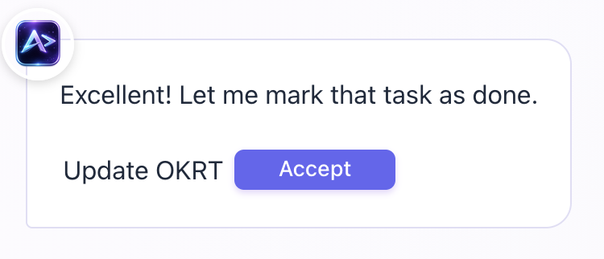
- All AIME data writes via AI require explicit user confirmation.
Figure 2: All AIME Generated actions have “Accept” buttons

- Role-based access control (RBAC) is enforced server-side for all data retrieval and proposed actions.
- Audit logs record proposals and approvals (who requested, what data was accessed, what was approved).

8. High-level architecture overview
AIME consists of a web UI, an application backend, an internal database for OKR data, integrations to enterprise systems, and an LLM-based assistant. The diagram below provides a high-level overview.

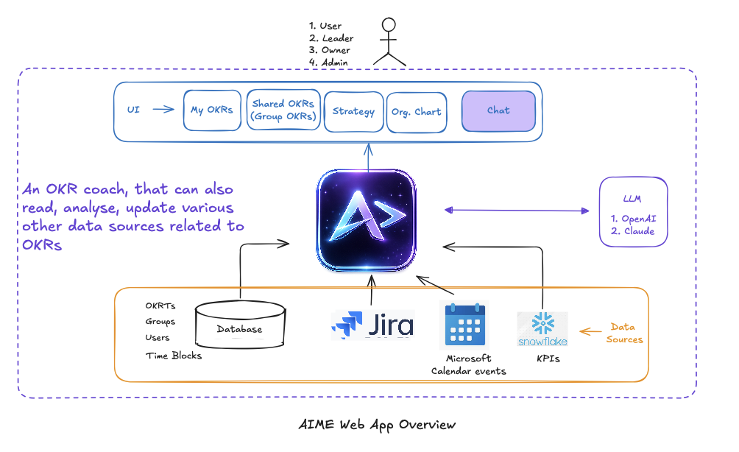
Figure 3: AIME Web App Overview (high-level architecture)
9. Data sources and integrations
AIME uses the following data sources:
AIME database (Neon Postgres): Stores OKRTs, groups, users, time blocks, comments, and related internal metadata. Hosted in the London region.
Jira: Work management system used for tickets and operational execution tracking. Accessed via Jira REST APIs (read and proposed updates).
Microsoft work tools: Calendar and related organisational data used for context (subject to permission scope and availability).
Snowflake: KPI statistics and warehouse data used for performance tracking at group/org level and for dashboards (read-only snapshots as needed).

10. Processing locations (high-level)
AIME processes data across several components. Storage and query execution occur in the database region (Neon Postgres – London). Application logic is executed in Vercel-hosted Next.js API functions (regions: London, optionally Dublin). LLM inference is performed via Anthropic messaging API hosted by Anthropic ( Amazon Bedrock to be considered going forward). Users access AIME from browsers in various locations; client-side rendering and interaction occur on user devices.

11. Data categories and minimisation approach
AIME processes typical employee work data and identifiers (e.g., names, work email, role/team membership), OKR content, and work activity references (e.g., Jira ticket identifiers and statuses). The system is designed to follow data minimisation principles, including:
- Retrieving only the minimum data required for a user’s request.
- Using internal IDs where possible and limiting exposure of direct identifiers to the AI assistant unless necessary.
- Applying role-based scoping so users only access permitted data (self/team/org scope).
- Labeling AI-generated content and presenting drafts for review.

12. Items Under Consideration / To-Do
- Hosting and infrastructure: Evaluate migrating the application runtime and database from Vercel/Neon to AWS(including networking, security controls, and operational ownership).
- LLM platform: Integrate the AI assistant via Amazon Bedrock (model selection, region configuration, and data handling controls).
- KPI integration: Implement read-only integration with Snowflake to retrieve agreed KPI datasets for dashboards and progress tracking.
- AI interaction logging: Design and implement a logging/audit mechanism for AI interactions (requests, data accessed, proposals, user approvals/rejections, and retention).
- Feedback, complaints, and defect tracking: Establish a formal mechanism for user feedback and complaints, plus a defect tracking workflow (e.g., Jira project/queue, triage process, and SLAs/ownership).

Appendix A: Glossary
OKR / OKRT: Objectives and Key Results (and Tasks, where used).
KPI: Key Performance Indicator.
RBAC: Role-Based Access Control; permission rules based on role and scope.
LLM: Large Language Model used to assist with drafting, querying, and proposed actions.
Human-in-the-loop: Design where users approve proposed actions before execution.

