Frequently Asked Questions 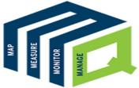
An EASY GUIDE to MQUAD

A mobile-based application specifically designed to cater to the requirements of the Development sector to map, measure, monitor and manage data efficiently.

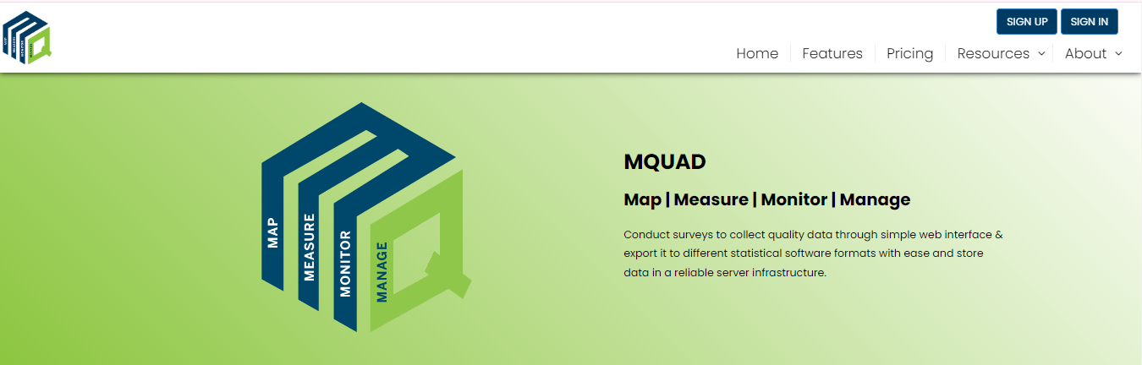

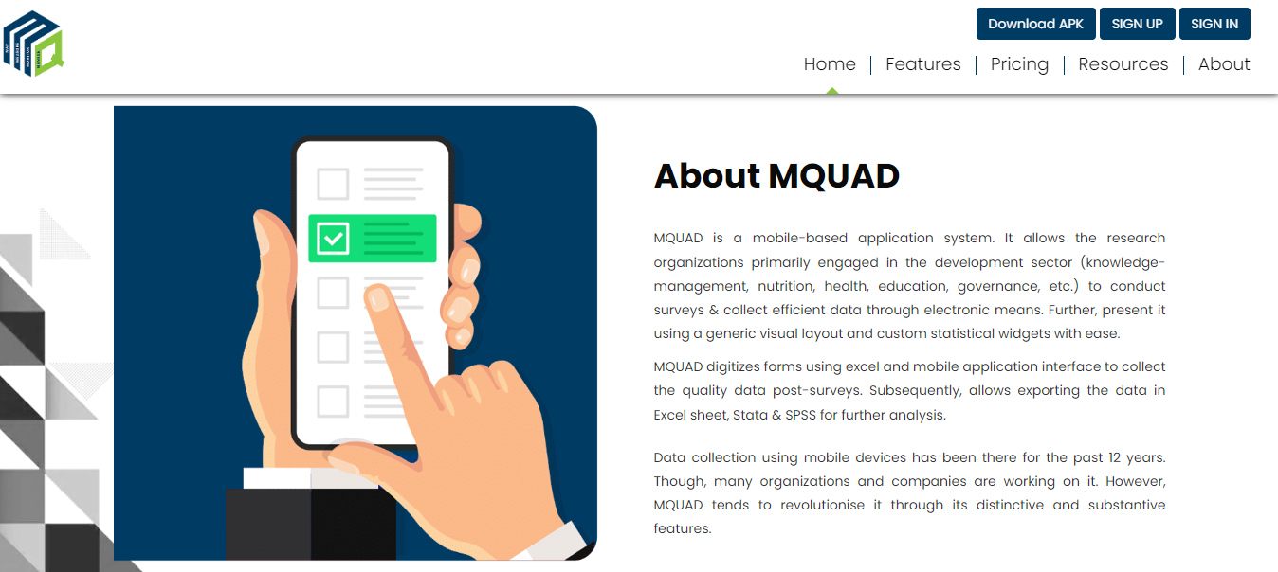 What are the features offered?

Repository Services
MQUAD provides comprehensives solutions to store, exchange and access tools, questionnaires and collected data as part of MQUAD or otherwise.

• Question bank
• Tool archives.
• Data repository.

- Advanced Form Management

State of art functionalities allows user to create, manage and do several other things with menu driven options

• Excel and web-based form development.
• Multi-format look-up functionality.
• Inter-portability.

- Sampling Module

Implements algorithm to draw samples without storing data

• Simple random sampling.
• Systematic random sampling.

- Data Quality Analytics

MQUAD provides a range of data quality parameters including time, GPS, keystroke, etc.

• Timestamp.
• Keystroke.
• Audio.
• Sleep time.
• Hint and error statistics.
• Others.

- User Friendly

No need for users to have advanced technical skills or programming knowledge, hence, user friendly.

• Menu driven.
• Easy to locate functions.
• Rich help files.
• Example excel forms.

- Data Export

MQUAD allows export of data into multiple formats.

• Excel.
• Stata.
• SPSS.
• JSON.

- Support Services

MQUAD has a system to support its users in a quick and transparent way.

• Response within 12 hours.
• Demo videos.
• MQUAD community.

- Do I need to pay for sign up?

- How can I get a demo of MQUAD?

The demo of MQUAD is defined on the demonstration section of home page . Here is a quick overview of the specific features of MQUAD that will enhance your understanding and experience in data collection, management, analysis and reporting.



- Who all can use MQUAD?

MQUAD has a wide variety of users. They use MQUAD in different ways to discover insights.

•Evaculator.
• Market Researchers.
• Psychologists.
• Health Researchers.
• Social Scientists.
• Students and Teachers.
• Policy Researchers.
• Sociologists.

- What are the subscription options available?

- Types of support available from MQUAD to deploy this in my organization.

MQUAD has a wide variety of features.

• Designed for groups and organizations with exceptional management.
• Technical.
• Security.
• End-user support needs.
- What is the maximum number of questions one can build in?

- What type of questions can be developed?

- What are the domains/topics on which validated questions are available?

- How does MQUAD help in data quality assurance?

- How does MQUAD work?

MQUAD work by Conducting surveys to collect quality data through simple web interface & export it to different statistical software formats with ease and store data in a reliable server infrastructure.

- Do I need to know programming to work with MQUAD?

No, it is not compulsory: anyone can use it easily. MQUAD has a wide variety of users. They use MQUAD in different ways to discover insights.

- If I am not a survey expert, what support/resources does MQUAD provide?
MQUAD provides sufficient materials that help to conduct the survey.

• Help File.
• FAQ.
• Video Demonstration.
• sample Question.

- Can I try MQUAD before I take a subscription?

- Can MQUAD be used beyond survey data collection?

- Can I add a logo to the form?
You can add a logo when login MQUAD.

How to sign up for MQUAD?

There is availability of membership to conduct interviews, visualize data and export it for further analysis.
You can become a member by subscribing to Basic, Standard or Advance membership plans.

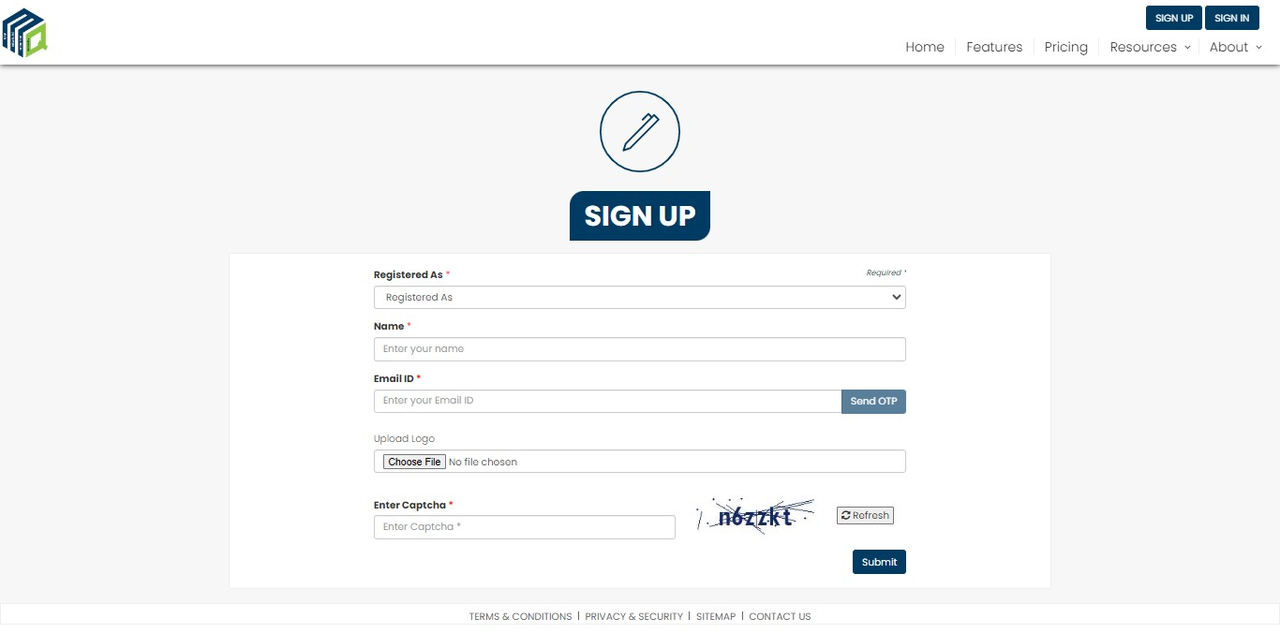

How to login to MQUAD?
You can login with your username and password.

In case, you forget your password, you have an option to Reset it:

- Click Forgot Password
- Enter your email ID
- Tick the captcha
- Submit

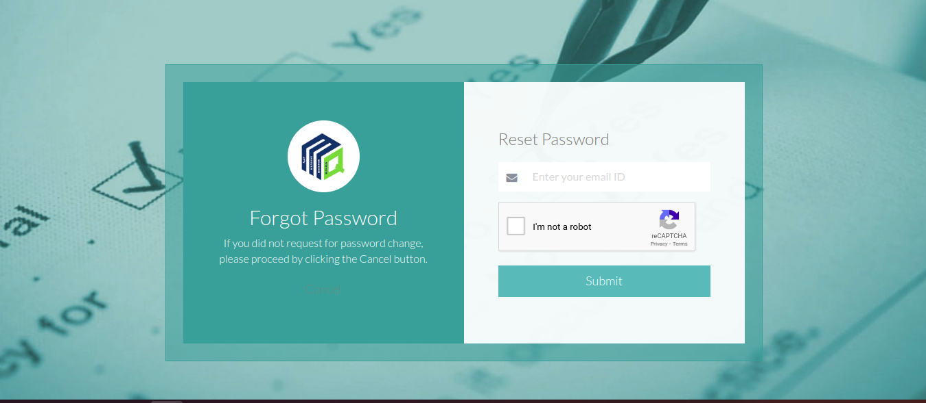
How to create a Form?

Once you login, you are on the Home page

To create a new form:

- Go to Form Builder, select New Form Builder
- Select the Information Area and the Client name.
- Fill up the form name b
- Click on Upload from File and select the excel form
- Click on the Save option to upload.

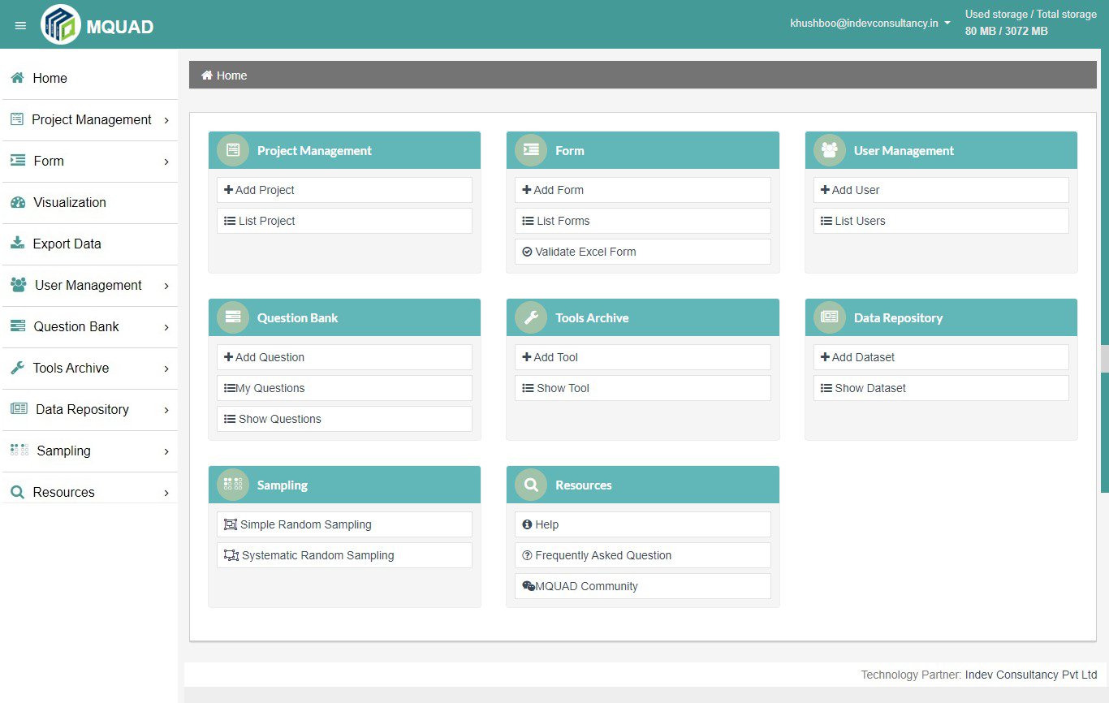

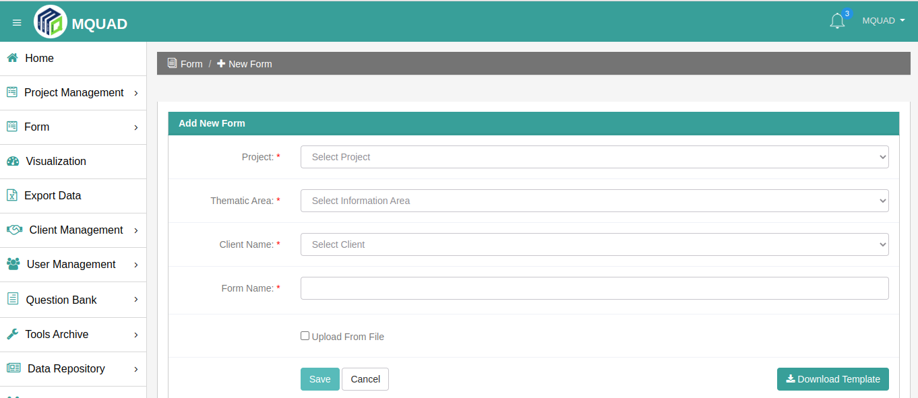

- How to validate a questionnaire Excel Sheet?

To validate a questionnaire Excel Sheet:

- Go to Form Builder, select Validate Excel Form
- Click on Upload Questionnaire and select the Excel File
- Click on the Verify option to upload

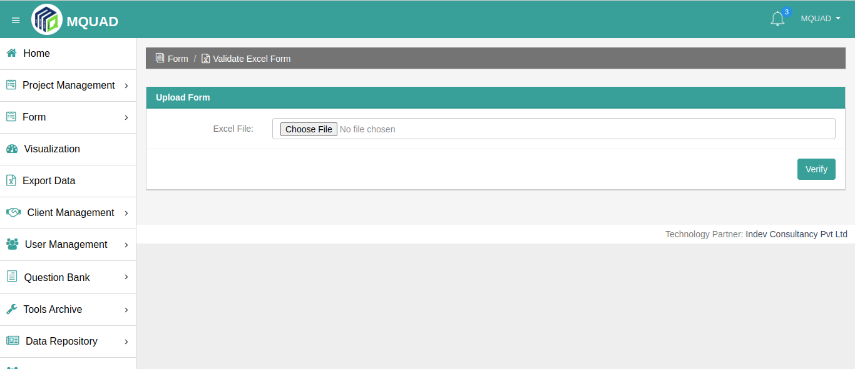

- How to publish a form?

- After creating a Form, go to Form Builder, click on Form List.
- Then, go to the Manage Section and click on the Publish button to Publish.
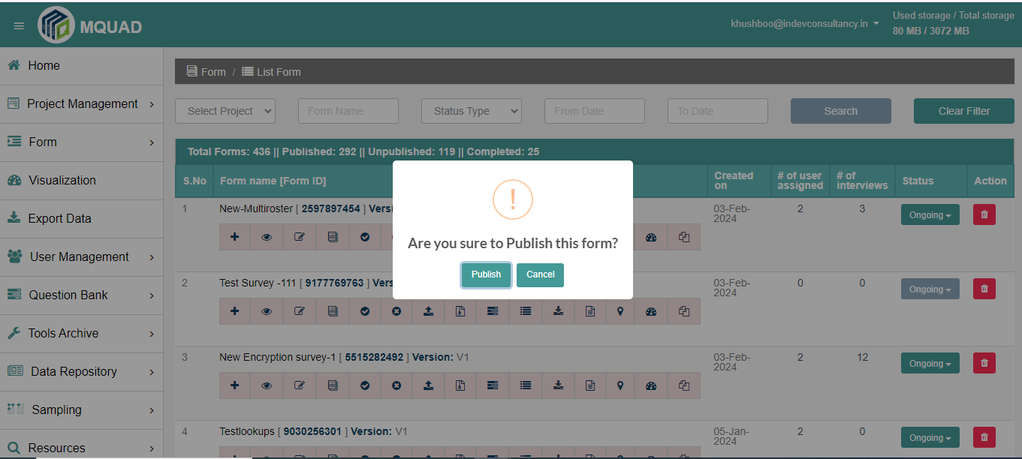

- How to assign a form to the user?

To assign a user:
- select the user
- click on the Submit button to Assign

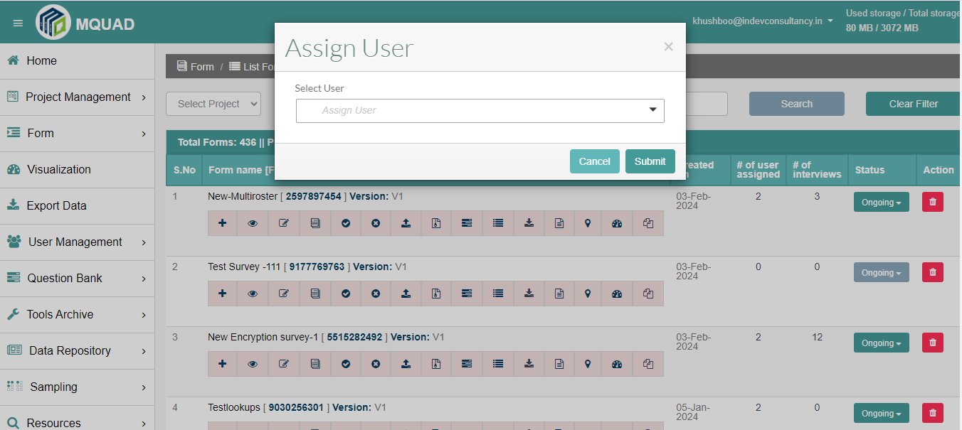

- How to visualize data in MQUAD?

- Data API
- Custom Dashboard

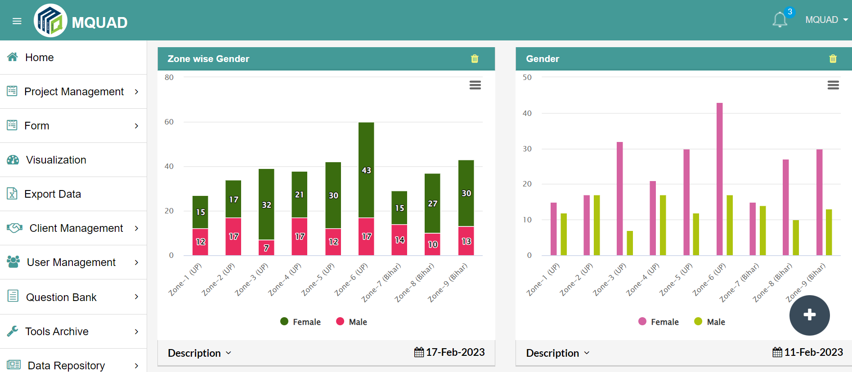

- How to export data in MQUAD and what type of data can be exported?

Select the Export Data option.
You can export data with multiple formats:
- Excel with Label
- Excel without Label
- STATA
- SPSS
- JSON
- PARADATA

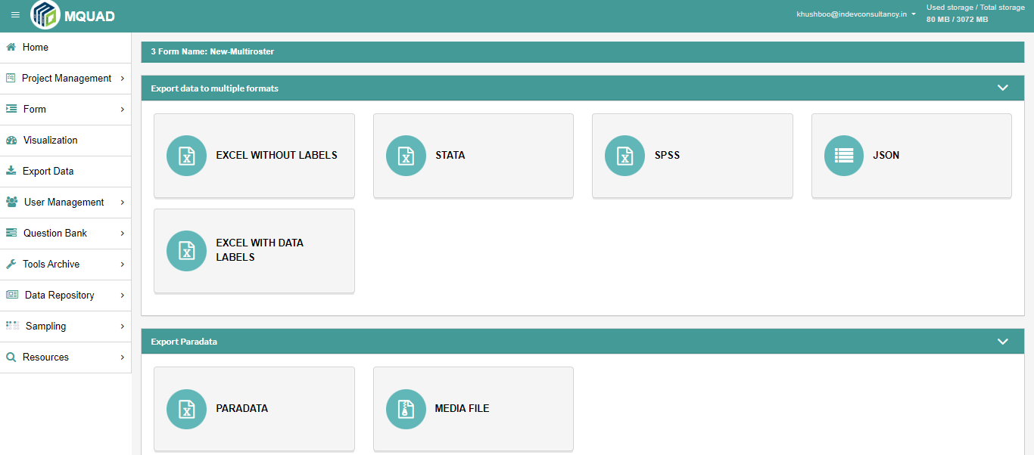

- What is a Advanced Manage Option in MQUAD

You can access the Advanced Manage option:
- Go to Form Builder
- Click List Form
- Click on the Dashboard

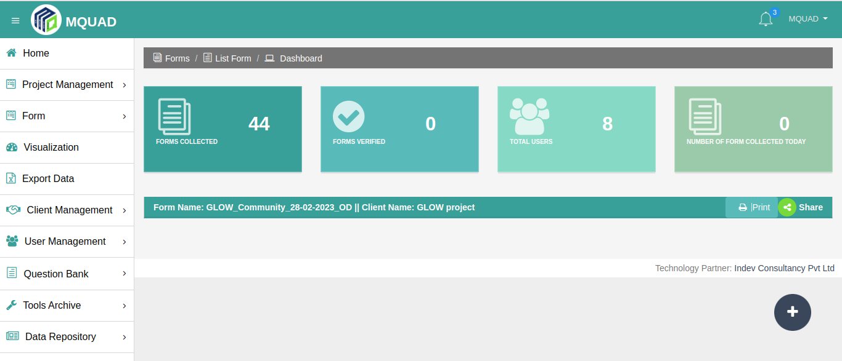

- How to Edit a Questionnaire from the Web?

To edit a Questionnaire:
- Go to Form Builder
- Click on List Form
- Click on Edit Question

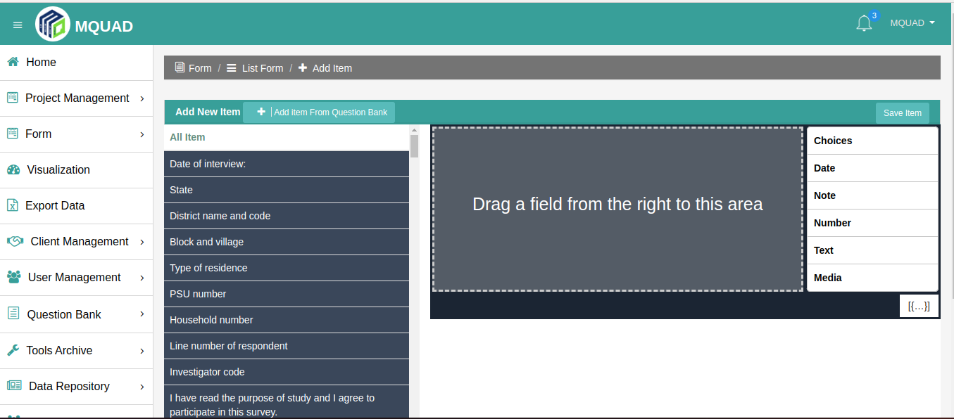

- How to start surveys via the web?

- Select the language and start the interview.

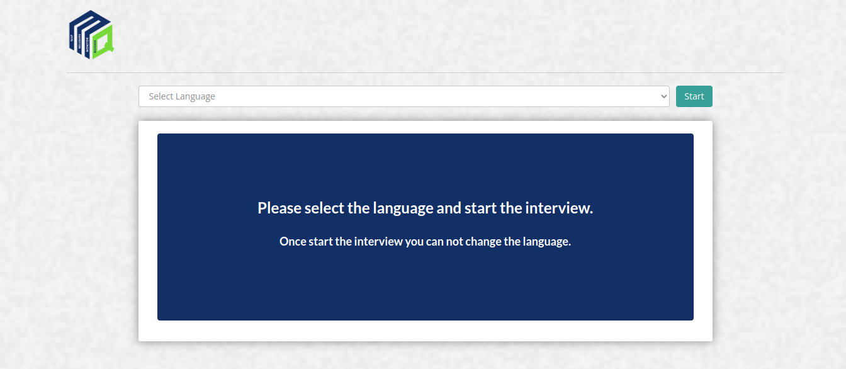

- How to add and list clients?

To Add Client:
- Go to Client Management
- Select Add Client
- Fill up the details
- Submit

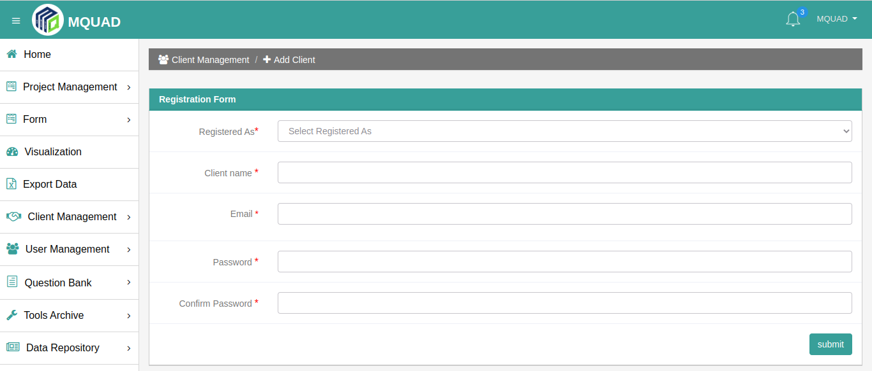

To List clients:

- Go to Client Management
- Click List Clients

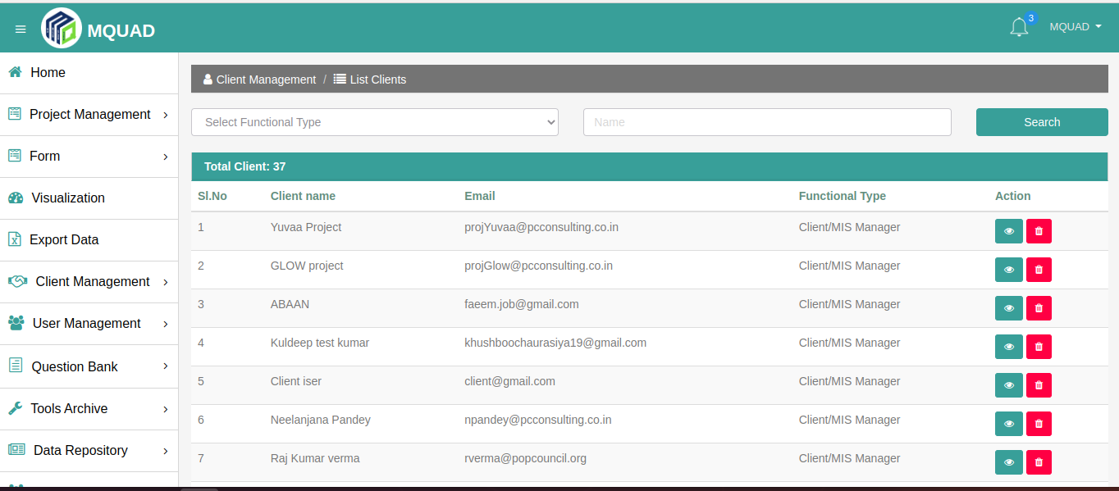

- How to add and list users?

To Add User:
- Select User Management
- Click Add User
- Fill up the details

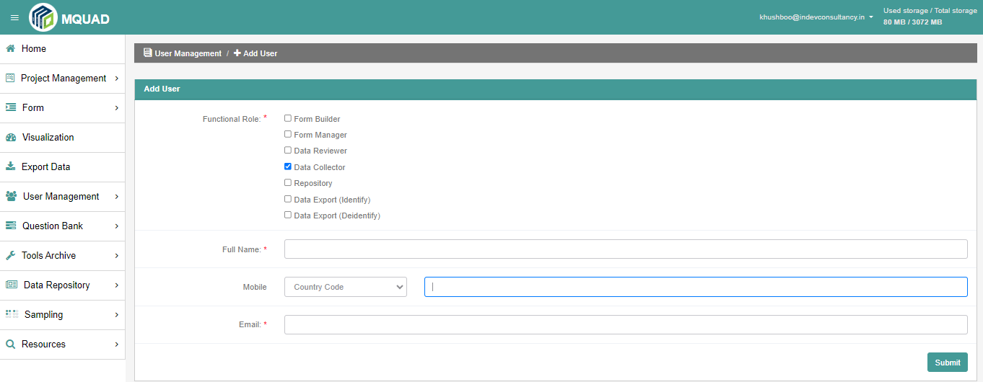

To List Users:
- Select User Management
- Click List Users List

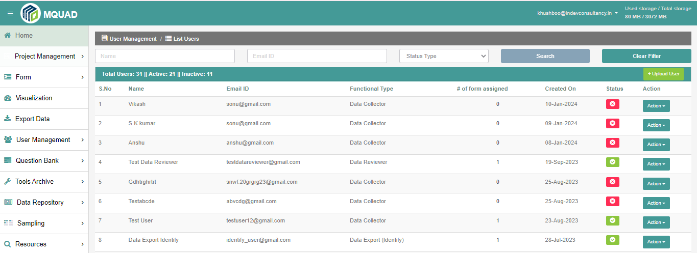

- How to add and show questions?

To Add Questions:
- Select Question Bank
- Click Add Question
- Fill up the details
- Submit

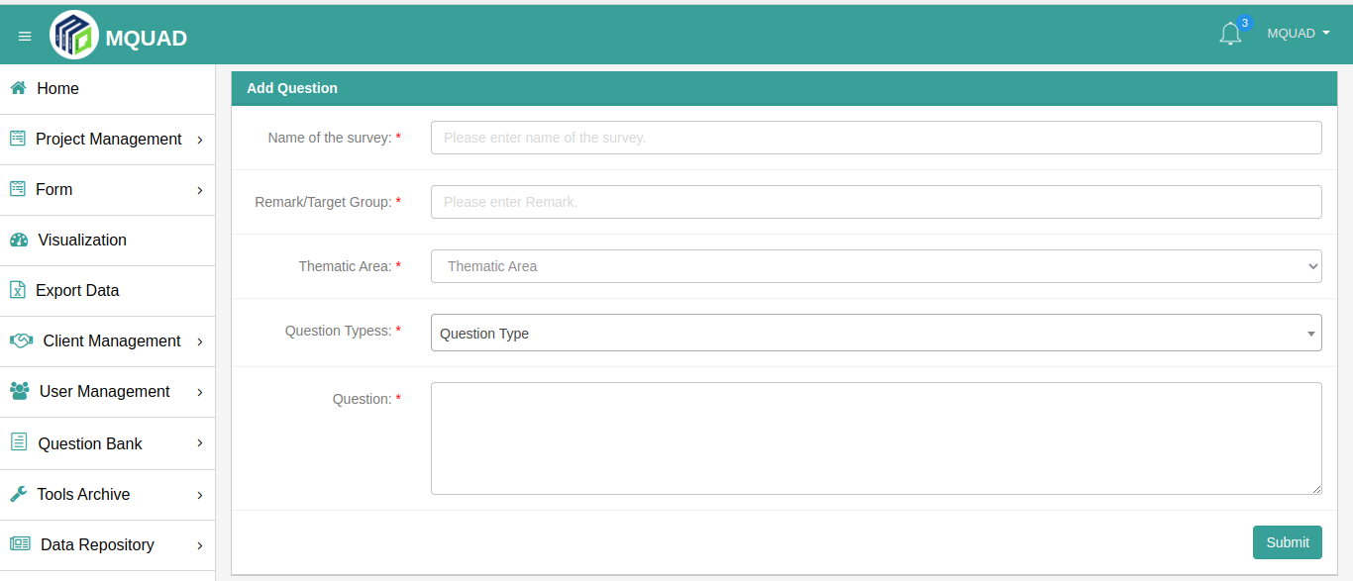

To Show Questions:
- Select Question Bank
- Click Show Questions

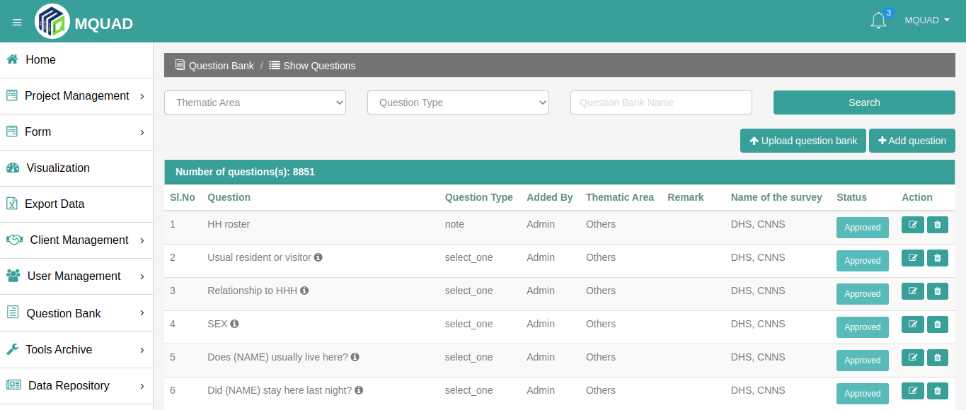

- How to use Tool Archives?

To Add Tool:

- Select Tool Archives
- Click Add Tool
- Fill up the details

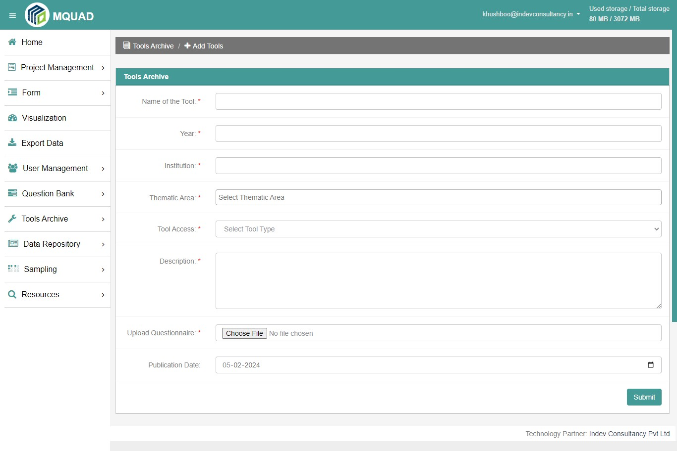

To Show Tools:
- Select Tool Archives
- Click Show Tools

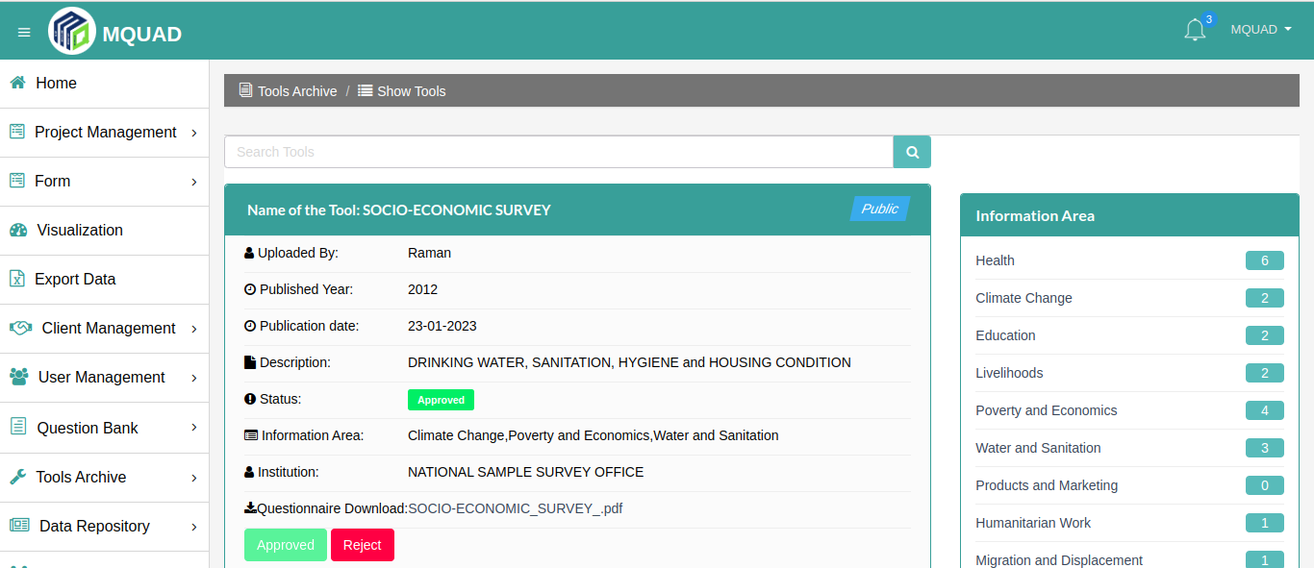

- How is the Dataset added and seen?

To Add Dataset:

- Select Data Repository
- Click Add Dataset
- Fill up the details

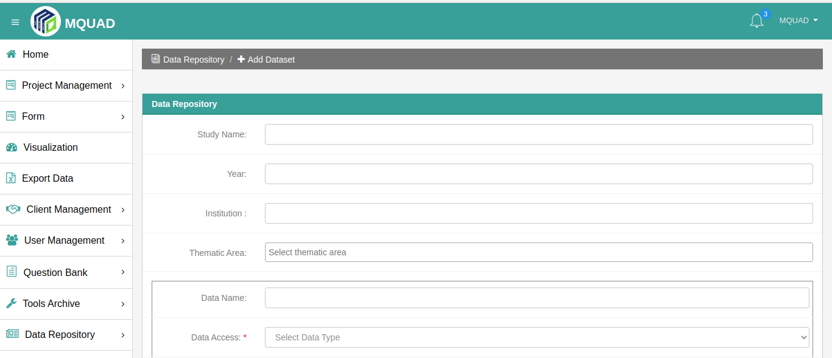

To Show Dataset:

- Select Data Repository
- Click Show Dataset

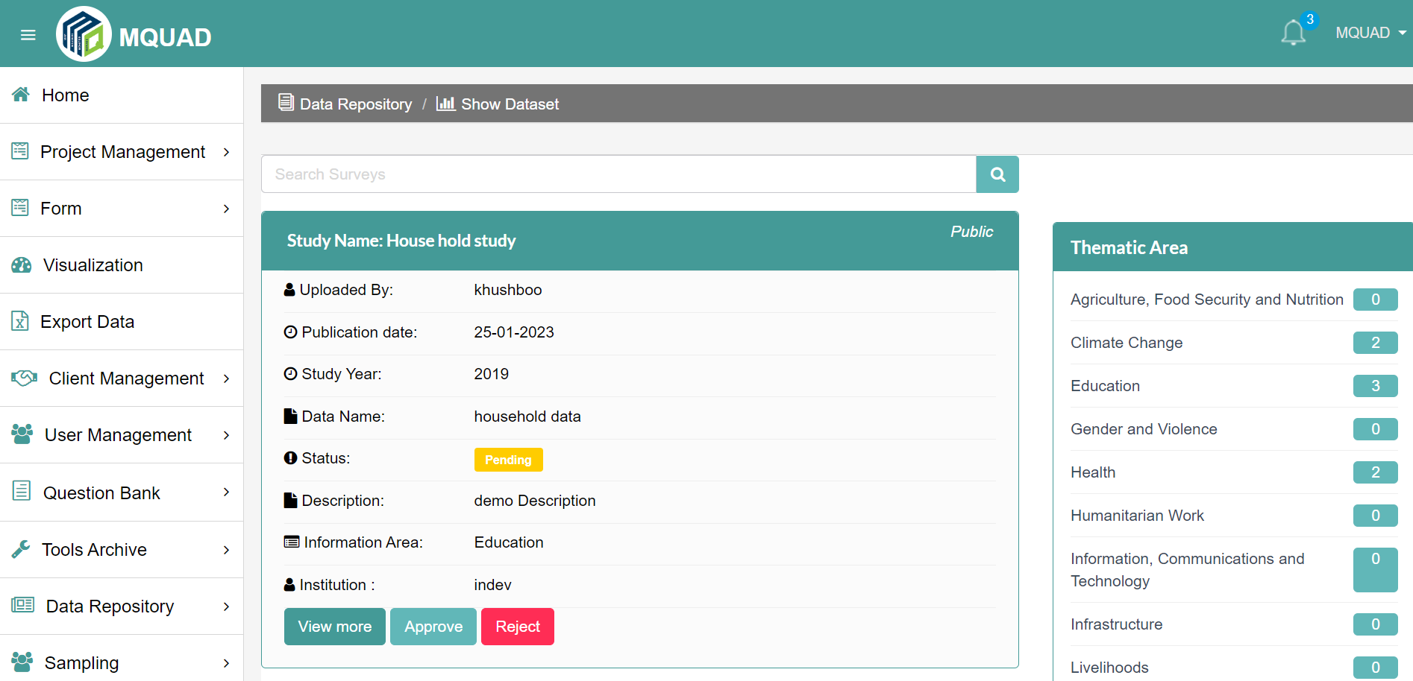

- How to do Sampling?

To do Sampling:

- Select Sampling
- Click Simple Random/ Systematic Random Sampling
- Upload File
- Fill up the details
- Submit

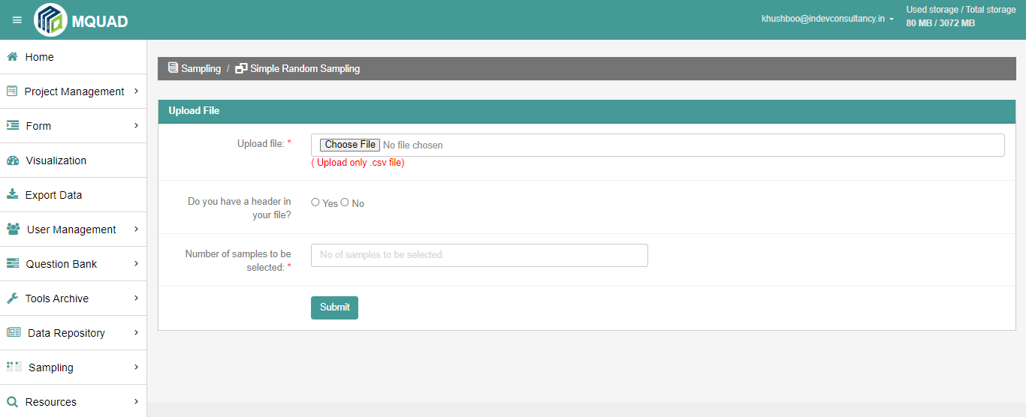

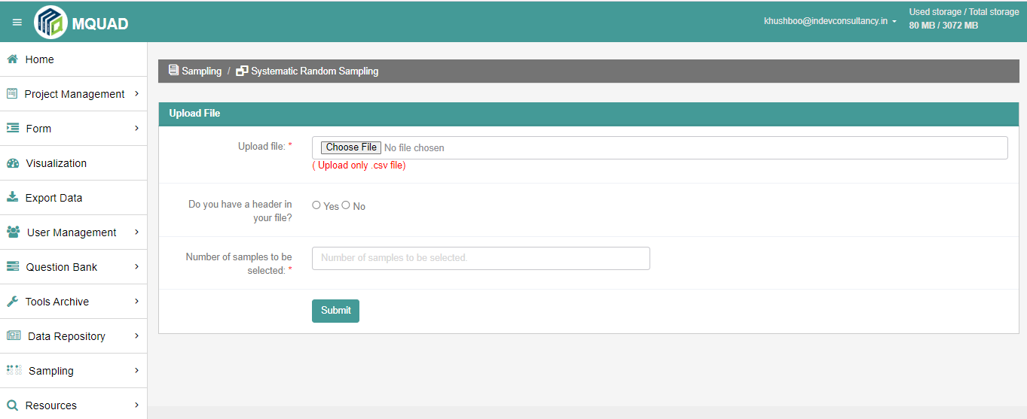

- How to locate an Information Area?

To locate Information Area:

- Select Setting
- Click Information Area

