Select ONE work of art that has not appeared in the course lectures or tutorials, and discuss it from THREE different methodological perspectives.

Different methodological perspectivesenable further examination of the painting *David with the head of Goliath* (1573-1610)*,* by Italian painter Michelangelo Merisi da Caravaggio (1571-1610). *David with the head of Goliath* can be evaluated using biographically based methodologies, providing a detailed exposition of the life of the artist, closely linked by his contemporaries to his style and aesthetics. Social constructs are significant in the analysis of the piece, employing Marxist theory in *David with the head of Goliath*, points out important aspects of the17th century Italian society and the class struggle shown in the characterization of *David* and *Goliath*. Lastly, the role of the museum and the characteristics of the exhibit of *David with the head of Goliath* can shape the interpretation and importance of the piece in contemporary society, this evaluation is addressed through reception theory. Components of Caravaggio’s life and personality in relation to social aspects of the time examined through contemporary notions of art theory canasdasdasdasda broaden the meaning of *David with the head of Goliath*.

*David with the head of Goliath* can be analysed through biographically-based art history methodologies. Written records from biographers on the life of the artist provides deeper meaning to the artwork analysed. Formally written accounts of Caravaggio’s life and work were made by Giovan Pietro Bellori (1613 –1696) and Giovanni Baglione (1566 – 1643). According to Stone, Caravaggio’s biographers had biased opinions about Caravaggio and his work, Baglione a rival painter of Caravaggio on occasion sued the artist for libel and Bellori, contended with the artist’s aesthetics. Merisi’s biographers linked his tumultuous life and behaviour with his artistic reproductions.[1]Bellori wrote ‘*Le Vite de Pittori’,* a 17th century version of Vasari’s *Lives of the Artist.* In his text Bellori describes Caravaggio’s art as *“terribile”* and referred to his religious reproductions with “lack of decorum by filling them with every sort of vulgarity”. [2] *David with the head Goliath* was a piece closely examined by Caravaggio’s biographers. Biographer Filippo Baldinucci (1624-1697) cited the renaissance proverb of “every painter paints himself” pointing at Caravaggio for adopting this notion in his own style of tenebrism influenced by his violent and dark personality.[3] *David with the head of Goliath* is romantically described as Caravaggio’s last painting made in exile as a papal petition for pardon for the murder of Ranuccio Tomassoni. The piece is expressed by Varriano as “Caravaggio’s most autobiographical work”, [4] the artist represents himself as the defeated Goliath in the hands of his young apprentice, Caravaggio used this biblical episode to exemplify personal and psychological struggles. *David* unlike past reproductions is not proud of his role as executioner; he has “Christ-like empathy” and pity for the giant (or Caravaggio). According to Maurizio Marnini the initials depicted in David’s sword are H-ASO. S presumably an abbreviation of St. Augustine’s take on the story, *humilitas occidit superbiam* meaning humility slayeth pride.[5] This aspect points on the artist looking for redemption and accountability for his sins. Biographers take on the life of Caravaggio and his artworks to provide a new meaning, reflecting on his personality and his life as the standpoint of his art.

Aspects of Marxist methodology can also be applied to discuss *David with the head of Goliath.* Marxist theory argues about the impact of high social entities on the masses, *David with the head of Goliath* exemplifies this aspect as the main subject is a story of the Old Testament, religious reproductions were highly affiliated with the Catholic Church in Europe as major patrons of the arts. According to Althusser, the church is an ideological state apparatus which uses materialism to impart beliefs on the lower classes.[6]*David with the head of Goliath* was not made exclusively for the church; however Caravaggio made it as means to earn pardon from Scipione Borghese for his return to Rome due to his criminal sentence. Caravaggio seeks refuge under an entity which had the power not only to redeem his crimes but to save his life.[7]Aspects regarding the reality of Roman society during Caravaggio’s time can be observed in his piece as being part of a gruesome scene which displayed the reality of poverty and raw violence at the time. *Goliath* represents a Caravaggio tired of the society in which he lives, there is a strong contrast between light and dark, good versus evil represents the environment of the taverns in which he was usually engaged.[8]Caravaggio was highly criticised for his exchange of the idealised representation of classical figures for the introduction of peasants as seen in the he portrayal of young David dressed in peasant clothes showing humility, an aspect criticised by Bellori referring to his canvasses featuring the “actions of low class people, imitating their every vile gesture”.[9] *David with the head of Goliath* embodies key aspects of the society in which Caravaggio lived showing the importance of the church in relation to the lower classes as seen in the production of his artwork.

Museums in relation to the reception theory play an important part in the interpretationof *David with the head of Goliath.* The pieceis currently displayed at the Borghese Gallery in Italy, founded by Pope Paul V and his nephew Cardinal Scipione Borghese during the 16th and 18th century. The Borghese Gallery is described as the “first gallery in Rome” hosting some of the most iconic pieces of art by artists including Raphael and Bernini.[10] According to the reception theory placement and framing are key aspects to the interpretation of an artwork by the viewer; the museum becomes a frame that forms the perception and interpretation of an artwork on display. Infrastructure of the Borghese Gallery can give a deeper understanding of the reception of the painting in relation to the environment in which it is exhibited. Paola Della Pergola gives a description of the placement of *David with the head of Goliath* located in room XIV on the upper floor or Piano Nobile. The gallery has painted panels with coloured marble floors, walls with columns and baroque ceiling frescoes themed with the statues placed in each room.[11]The upper floor, according to written records received “the most attention” due to its limited accessibility. When describing *David with the head of Goliath* in the gallery, art historian Jason Spiehler describes Caravaggioas the museum’s “bad boy”, and troublemaker who engaged with “thugs”.[12]The information provided by the museum and its infrastructure has an influence in the experience and perception of the artworks, enhancing or diminishing its cultural significance.[13] Caravaggio is regarded in western culture as one of the great masters of art; because of this *David with the head of Goliath* can distort its true significance and mythicize the personality of Caravaggio.

*David with the head of Goliath* is a versatile piece when examined through biographically- based art history, Marxist, and reception theory contexts. The artwork is closely related to Caravaggio’s life and personality as the artist embodies himself as *Goliath,* although accounts of the meaning of his artwork by his biographers might not be exact due to their personal agenda, it allows contemporary readers to acquire some understanding of the piece and the life of the artist. Marxist views in terms of the power of the Catholic church over the lower classes are not only related as a broad aspect of society, it engages closely with the circumstances of Caravaggio and his struggle of acquiring freedom though the reproduction. The reception theory engages with which have a key role in the interpretation of the artwork, the location; architecture and the museum’s description of the piece can influence and distort the meaning of the piece originally intended by Caravaggio.

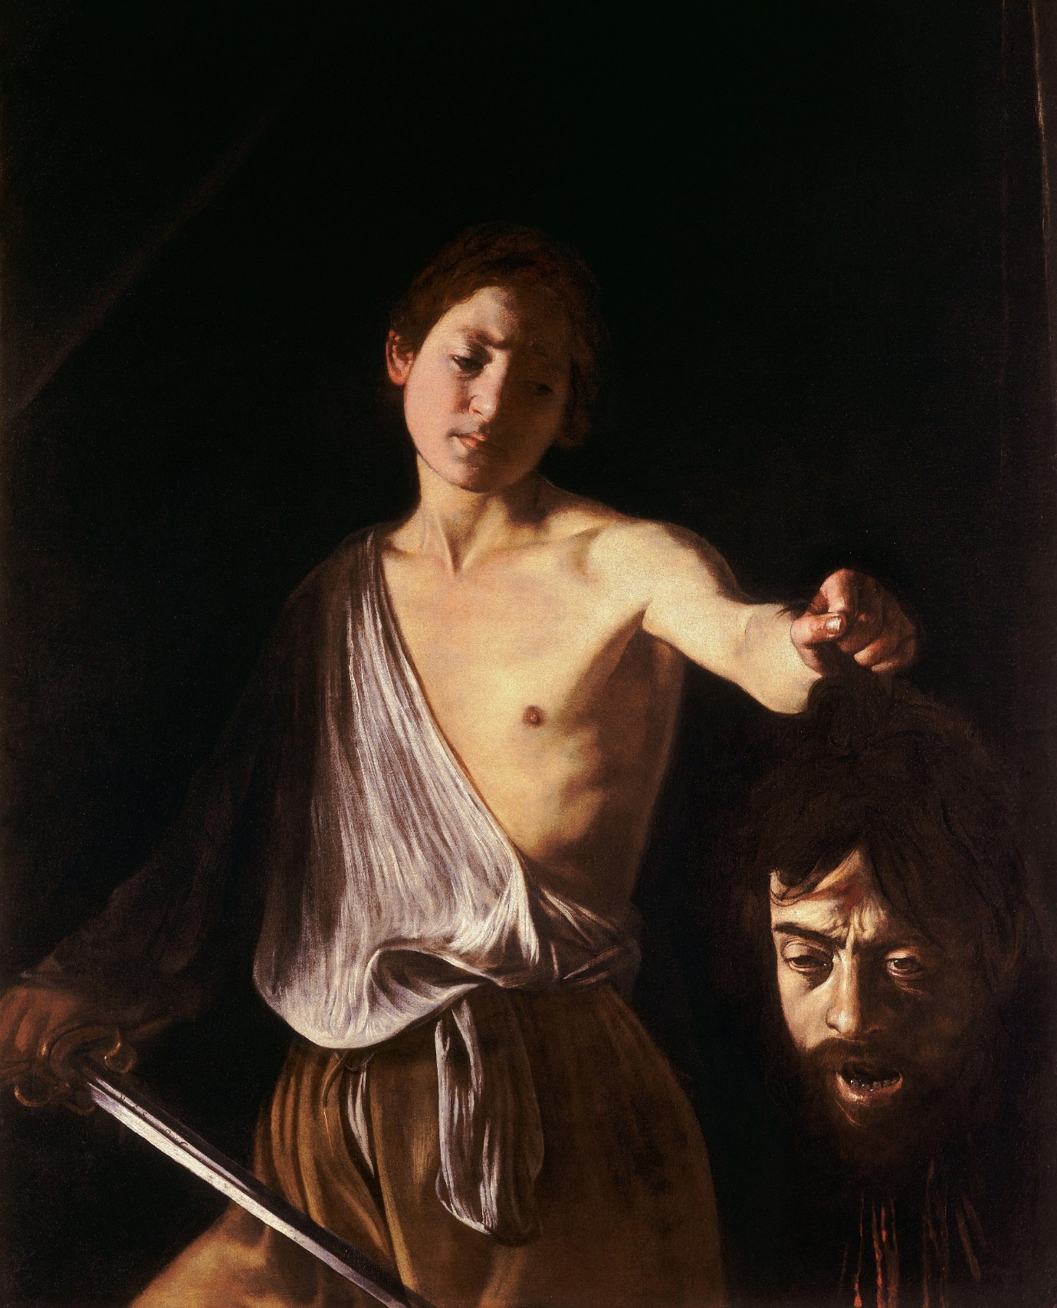

Caravaggio, *David with the Head of Goliath* (1605-1610), oil on canvas, 125 cm × 101 cm.

Source: https://upload.wikimedia.org/wikipedia/commons/6/60/Caravaggio_-_David_con_la_testa_di_Golia.jp

Bibliography

Althusser, Louis. 1971. *Lenin and philosophy, and other essays*. London: New Left Books. https://www.marxists.org/reference/archive/althusser/1970/ideology.htm

Graham-Dixon, Andrew. 2011. *Caravaggio: A life sacred and profane*. 1st American ed. New York: W.W. Norton.

Heath, Christian, and Dirk vom Lehn. 2004. Configuring reception: (dis-)regarding the 'spectator' in museums and galleries. *Theory, Culture & Society* 21 (6): 43-65.

J. B. S.1957. Review of Galleria Borghese, I Dipinti. Vol. I. *The Burlington Magazine 99* (655). The Burlington Magazine Publications Ltd.: 352–52.

Paul, Carole. 2008. *The Borghese collections and the display of art in the age of the grand tour*. Aldershot;Burlington;: Ashgate.

Pergola, Paola Della. 1969. *The Borghese Gallery in Rome* (43). Istituto Poligrafico Dello Stato.

Polinedrio, Veronica. 2011. "Caravaggio and the Head of Goliath*," Kaleidoscope*: Vol. 10, Article 30.

Sohm, Philip. 2002. Caravaggio's deaths, The Art Bulletin 84 (3). College Art Association.

Spiehler, Jason. 2016. *Caravaggio: The Murderer*. Walks of Italy. https://www.youtube.com/watch?v=FKZNfZ4eHpY

Stone, David M. 2006. Self and Myth in Caravaggio’s David and Goliath, *Caravaggio: Realism, Rebellion, Reception*, ed. Genevieve Warwick. University of Delaware Press.

Stone, David M. 2012. Signature killer: Caravaggio and the poetics of blood. *The Art Bulletin* 94 (4): 572-93.

Varriano, John L. 2006. *Caravaggio: The art of realism*. University Park, Pa: Pennsylvania State University Press.

1. David M. Stone, Self and Myth in Caravaggio’s David and Goliath, *Caravaggio: Realism, Rebellion, Reception*, ed. Genevieve Warwick (University of Delaware Press, 2006), p.36
2. Veronica Polinedrio, Caravaggio and the Head of Goliath, *Kaleidoscope:* vol 10, Article 30. (University of Kentucky press, 2012), p 8
3. Philip Sohm, Caravaggio's deaths, *The Art Bulletin* 84 (3). (College Art Association, 2002), p.461
4. John L.Varriano, *Caravaggio: The art of realism*. (University Park, Pa: Pennsylvania State University Press. 2006), p.112
5. David M. Stone, Signature killer: Caravaggio and the poetics of blood. *The Art Bulletin* 94 (4) (College Art Association, 2012), p.583
6. Louis Althusser, *Lenin and philosophy, and other essays*. (London: New Left Books, 1971) https://www.marxists.org/reference/archive/althusser/1970/ideology.htm
7. Andrew G. Dixon, *Caravaggio: A life sacred and profane*. (1st American ed. New York: W.W. Norton, 2011), p.333
8. Veronica Polinedrio, Caravaggio and the Head of Goliath, *Kaleidoscope:* vol 10, Article 30. (University of Kentucky press, 2012), p7
9. Ibid, p.4
10. J. B. S, Review of *Galleria Borghese,* I Dipinti. Vol. I. *The Burlington Magazine* 99 (655). (The Burlington Magazine Publications, 1957) p, 352
11. Paola D. Pergola, *The Borghese Gallery in Rome* (43). (Istituto Poligrafico Dello Stato 1969), p.42
12. Jason Spiehler, *Caravaggio: The Murderer*. (Walks of Italy, 2016) https://www.youtube.com/watch?v=FKZNfZ4eHpY
13. Christian Heath and Lehn V. Dirk, Configuring reception: (dis-)regarding the 'spectator' in museums and galleries. *Theory, Culture & Society* (2004), p. 44