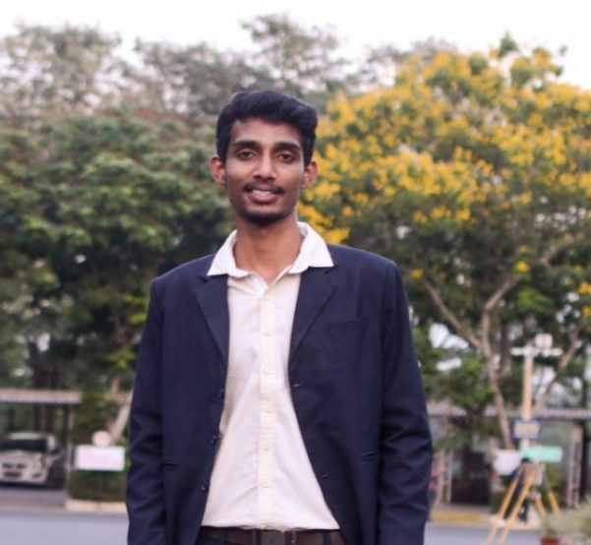

# Experience

10/2021 to Present

**Data Scientist - Daimler Truck Innovation Center India (DTICI, Bengaluru)**

* Building a cloud-based end-to-end ML based **Battery Life Prediction** project for 100+ eCitaro (city-bus, both NMC & LMP) vehicles using Azure Databricks, to help customers in extending battery life.
* Creating **advanced statistics** (affinity analysis) for 20 eBuses for charging system (& EVSE) for deeper system features and performance analysis
* Expertise in ‘*Energy Management System’* & identification of **KPI’s** for performance & issue analysis of eCascadia gen2 vehicles.
* Created common *Power BI dashboard* for Citaro Trucks fleet monitoring and dynamic reporting.
* As an innovation activity, creating a Reinforcement Learning based Battery Cooling Power Prediction model for “optimal energy consumption”.

11/2020 to 10/2021

**PGET/Data Scientist – Mercedes Benz R&D India (MBRDI,** **Bengaluru)**

* Implemented complete Data Pipeline for Battery Health Dashboard using **cTP** data, along with Evobus, discovered numerous kpi’s for finding battery degradation.
* Programmed an automated testing tool for the testing team saving many human working hours by 90% and it’s more efficient in finding the critical **issues** at the earliest by using advanced clustering algorithms on **Multi-Variate** **Time Series Data** using “Dynamic Time Warping-DTW” on MF4, BLF, MDF files from various Data loggers of customer vehicles.
* Being part of e-Powertrain team analyzed data and “By early detection of failure of eAxle & high energy consumption scenarios”, saving **30,000 Euros** in vehicle down time.

08/2019 to 05/2020

**Research Intern – Ericsson, Chennai**

* Master thesis on development & application of *“Risk-free multi agent Reinforcement learning Model”* in Telecom services.
* Developed model using Python, OpenAI-Gym & Tensor flow, this model improved the bandwidth allocation for respective customers & increasing the customer satisfaction.

# Education

2018-2020

**M.TECH: Controls & Automation** – 8.59/10 CGPA

VIT University, Vellore

2014-2018

**B.TECH: Electronics & Instrumentation Engineering -** 7.64/10 CGPA

Bapatla Engineering College, Bapatla

INDHRA KIRANU N A

**Phone:**

+91 8332 832 027

**E-Mail:**

[indhrakiranu39@gmail.com](mailto:indhrakiranu39@gmail.com)

**LinkedIn:**

[www.linkedin.com/in/indhra](http://www.linkedin.com/in/indhra)

# Skill Highlights

* Advanced:
  + Python
  + Spark
  + Numpy
  + Pandas
  + Sickit learn
  + Seaborn
  + Plotly
  + Power BI
  + Tableau
  + Azure Databricks
  + Azure Data Lake
  + CANape & CANdb
* Intermediate
  + MATLAB
  + R
  + Tensor flow
  + GitHub
  + SQL
* Beginner
  + Kanbo – Kanban
* Advanced Statistics
* Problem Solving
* Product Development

# Languages

* English
* German (A1)
* Hindi
* Telugu
* Tamil (Speak)

**Data Scientist** part of core Data Analysis team of ePowerTrain dept. having proven experience in EDA, Data Mining, Feature Engineering, Data processing, implementing Machine Learning algorithms & completing the data pipeline using Big Data Visualizations. Specialized in root-cause analysis of issues & conceived data based business applications.