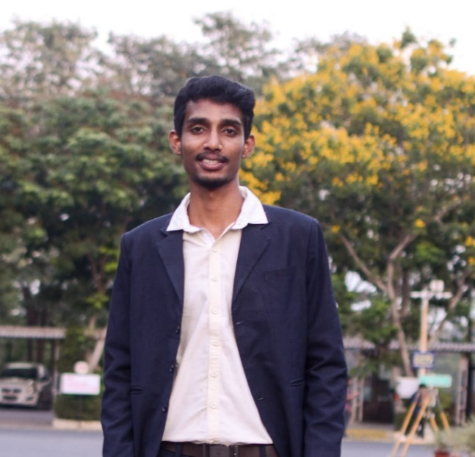

# Experience

10/2021 to Present

**Data Scientist - Daimler Truck Innovation Center India (DTICI)**

* Building an cloud-based end to end **Battery Life Prediction** Machine Learning project for eCitaro vehicles using Azure Databricks
* Developing expertise in ‘*Energy Management System’* & identification of **KPI’s** for performance measure & issue analysis of eCascadia gen2 vehicles
* Involved in visualizing common *Power BI dashboard* for Citaro Trucks GPS PoI’s, using Flee box data
* As an innovation activity, responsible for creating Reinforcement Learning based Battery Cooling Power Prediction model for “Minimizing energy consumption of HVAC systems” by at least 5%.

11/2020 to 10/2021

**PGET/Data Scientist – Mercedes Benz R&D India (MBRDI)**

* Implemented entire Data Pipeline for Battery Health Dashboard using **cTP** data, along with Evobus, discovered numerous kpi’s for finding battery degradation, helping Battery Warranty Team with claims.
* Programmed automated testing tool for testing team saving many human working hours and it’s more efficient in finding the critical **issues** at the earliest by using advanced clustering algorithms on Multi-Variate Time Series Data from various Data loggers**.**
* Part of e-Powertrain team analyzed data, saving **30,000 Euros** in vehicle down time, “By early detection of failure of eAxle & high energy consumption scenarios”.

08/2019 to 05/2020

**Research Intern – Ericsson, Chennai**

* Master thesis on development & application of *“Risk-free multi agent Reinforcement learning Model”* in Telecom services.
* Developed model using Python, OpenAI-Gym & Tensor flow, this model improved the bandwidth allocation for respective customers & increasing the customer satisfaction.

# Education

2018-2020

**M.TECH: Controls & Automation** – 8.59/10 CGPA

VIT University, Vellore

2014-2018

**B.TECH: Electronics & Instrumentation Engineering -** 7.64/10 CGPA

Bapatla Engineering College, Bapatla

**Data Scientist** possessing knowledge in Data Cleaning, processing and implementing Machine Learning algorithms & completing the data pipeline using Big Data Visualizations. Specialized in root cause analysis of issues & conceived new data relevant business applications.

INDHRA KIRANU N A

**Phone:**

+91 8332 832 027

**E-Mail:**

[indhra_kiranu.n_a@daimler.com](mailto:indhra_kiranu.n_a@daimler.com)

**LinkedIn:**

[www.linkedin.com/in/indhra](http://www.linkedin.com/in/indhra)

# Skill Highlights

* Advanced:
  + Python
  + Spark
  + Numpy
  + Pandas
  + Sickit learn
  + Seaborn
  + Power BI
  + Tableau
  + Azure Databricks
  + CANape & CANdb
* Intermediate
  + MATLAB
  + R
  + Tensor flow
  + GitHub
  + SQL
* Beginner
  + Kanbo – Kanban
* Advanced Statistics
* Problem Solving
* Product Development

# Languages

* English
* German (A1)
* Hindi
* Telugu
* Tamil (Speak)