WEEK-00-241401030
PROBLEM-1:
Write an Algorithm and draw a Flowchart to Calculate the area and perimeter of a square.
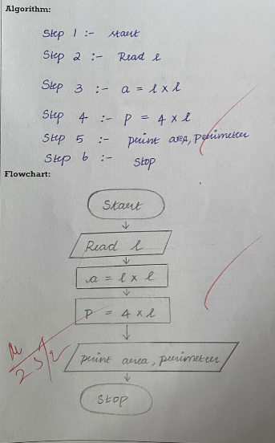
PROBLEM-2:
Write an Algorithm and draw a Flowchart to convert the given days into years & months
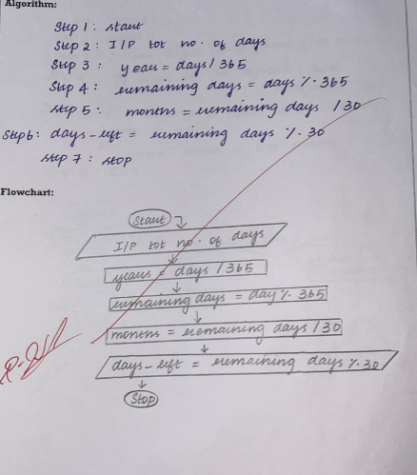
PROBLEM-3:
Write an Algorithm and draw a Flowchart to check whether the given number is Prime or not
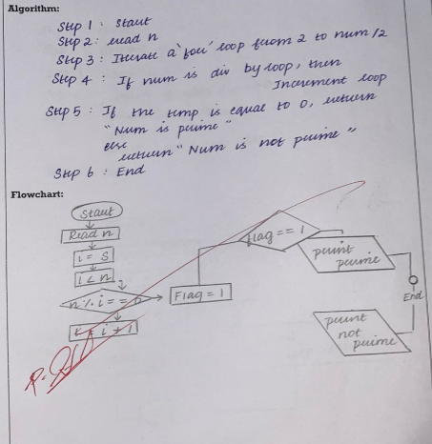
PROBLEM-4:
Write an Algorithm and draw a Flowchart to check whether the given year is Leap year or not
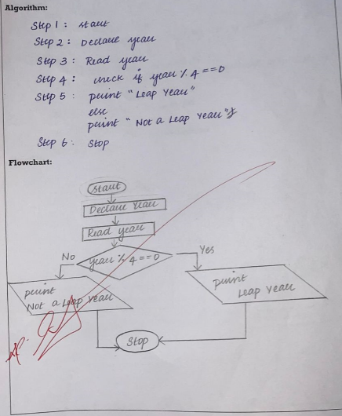
PROBLEM-5:
Write an Algorithm and draw a Flowchart to check whether the given number is palindrome number or not.
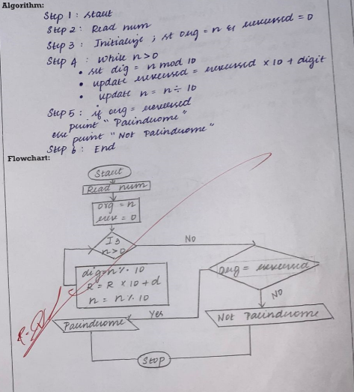
PROBLEM-6:
Write an Algorithm and draw a Flowchart to calculate the sum of digits in the given number.
