**ETHICAL HACKING**

**EXPERIMENT 2 (BATCH FILE EXECUTION)**

**INDHUMATHI V**

**192124215**

**1.create a text document.**

**2.write the following commands.**

* **@echo**
* **echo hello**
* **Pause**
* **echo this is new**
* **echo this is second one**
* **pause**

**3.save file as test.bat**

**4.Run the bat file to get the output**

**BAT FILE**

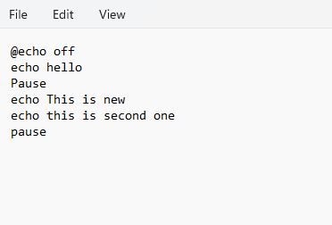

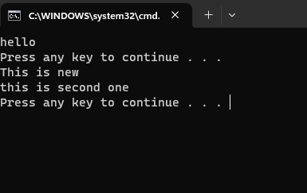**OUTPUT**