**INFORMATION GATHERING USING HARVESTER**

**Ex No :05**

**Date :08-05-2023**

**Aim :**

**To gather information using Harvestor Tool.**

**Procedure :**

* **Open the Kali Linux.**
* **Then Open the Root Terminal.**
* **Then Type theHarvestor -d <DomainName> -l 300 -b all**
* **It will gives all information of that domain.**

**Output :**

**Type command theHarvester -d** [**www.zoho.com**](http://www.zoho.com) **-l 300 -b all**

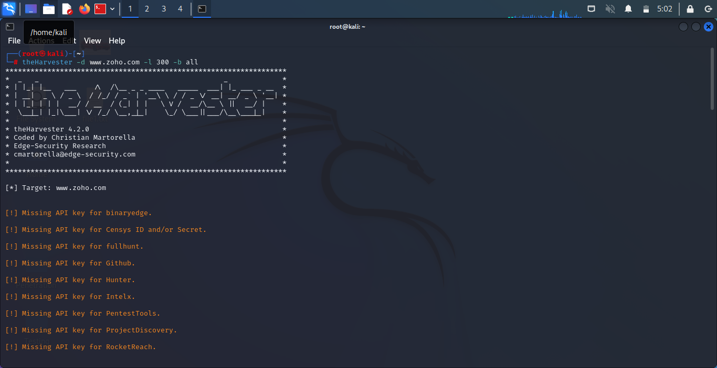

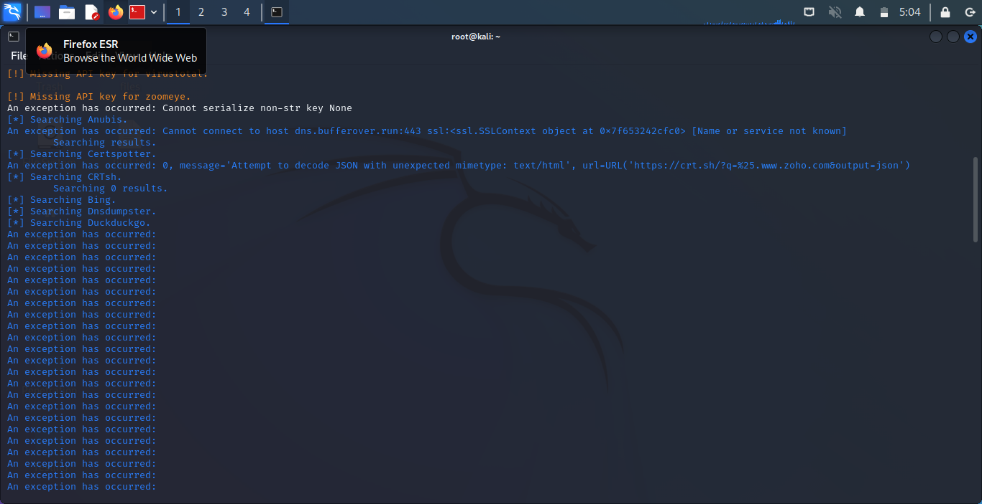

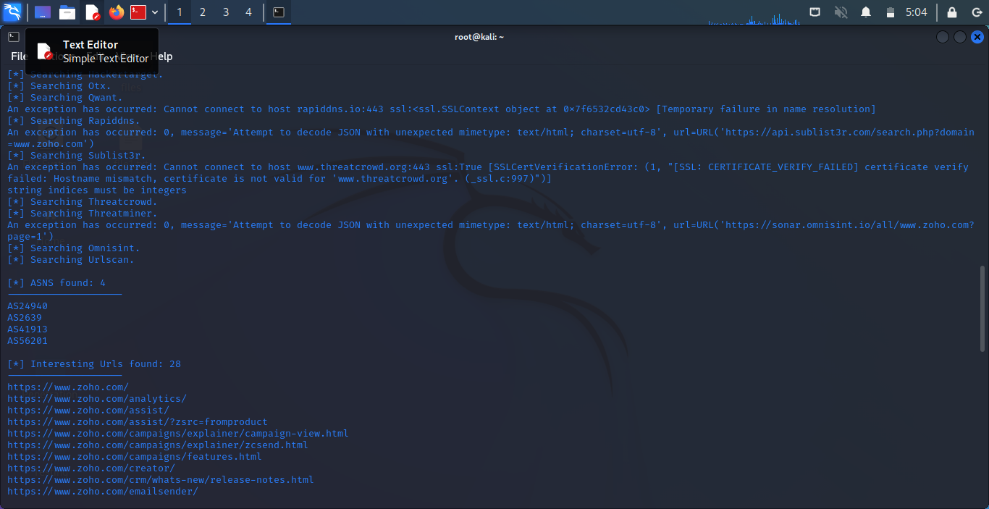

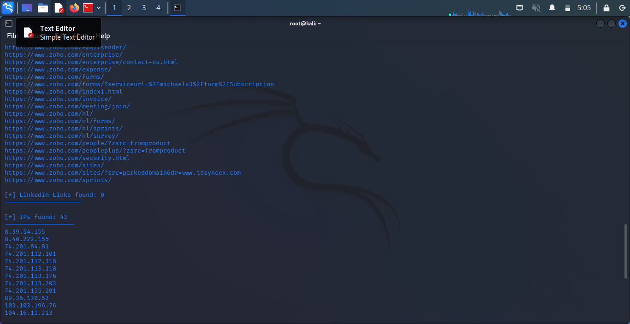

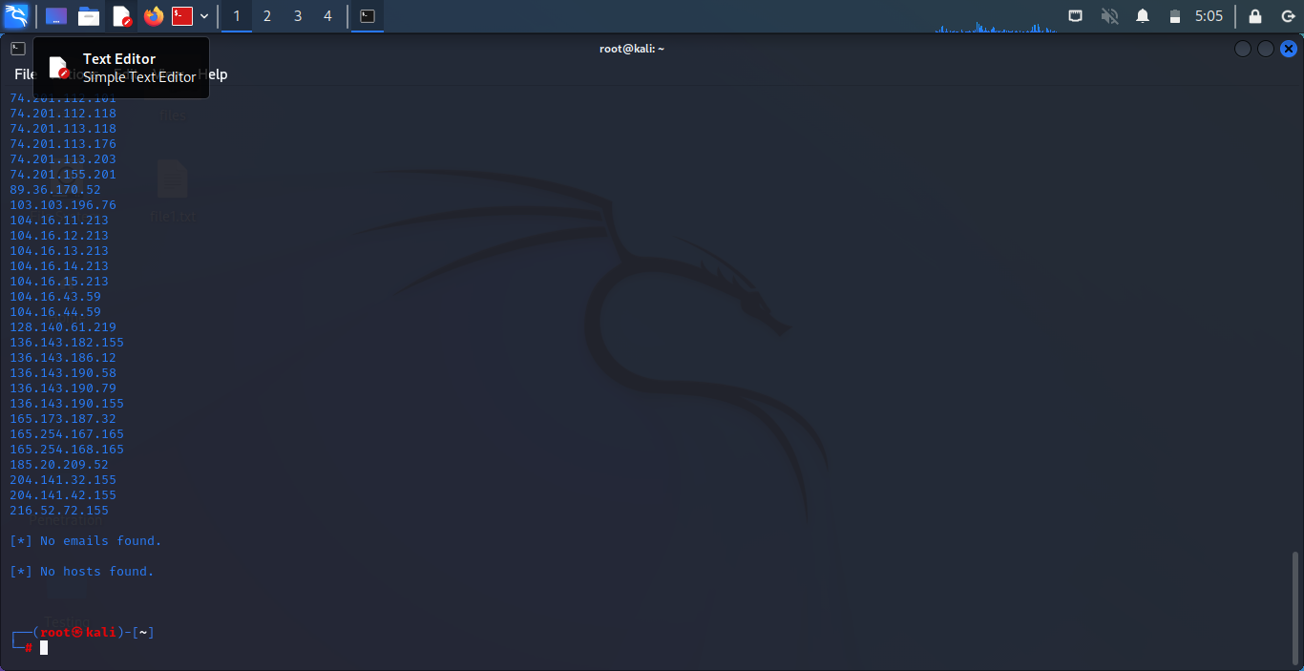

**Result :**

Hence the Information gathering using Harvestor tool is done.