**TRACEROUTE , PING , IPCONFIG , IFCONFIG , NETSTAT**

**Ex No: 8**

**Date:08-05-2023**

**Aim :**

TO execute TRACEROUTE , PING , IPCONFIG , IFCONFIG , NETSTAT Commands.

**Procedure**

* OPEN KALI LINUX.
* OPEN ROOT TERMINAL.
* Type IFCONFIG command to find Linux configuration.
* Open Windows Command prompt.
* Type the following Commands **–** TRACEROUTE , PING , NETSTAT

**Output :**

**tracert saveetha.com**

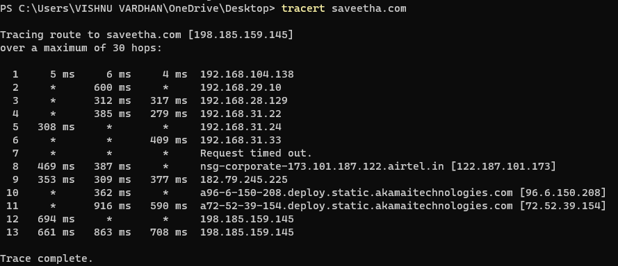

**Windows ipconfig**

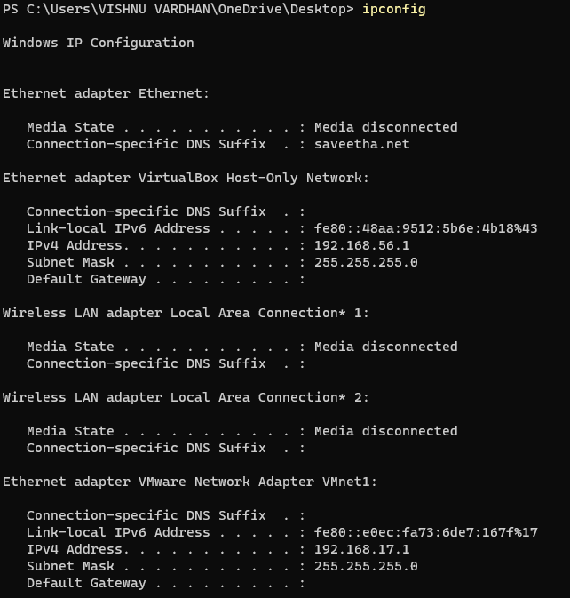

**Linux ifconfig**

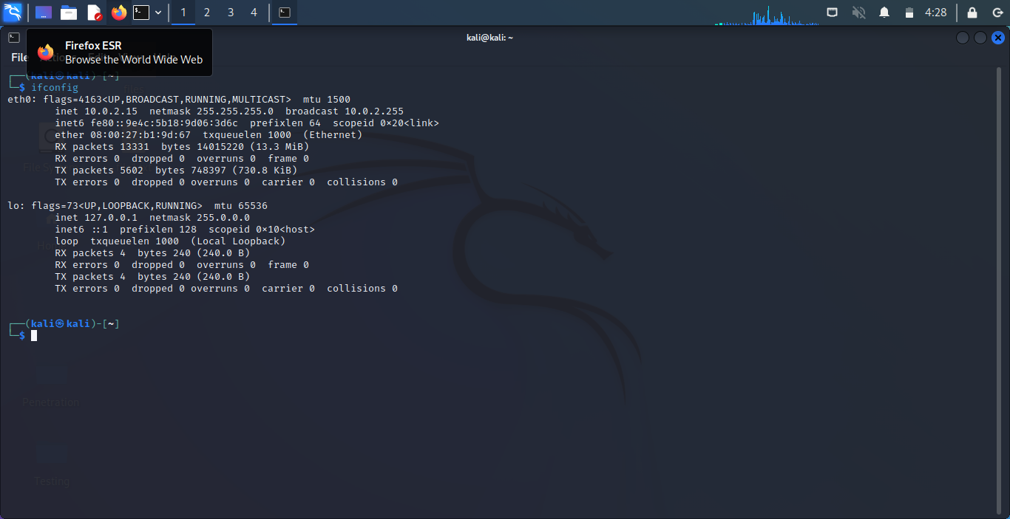

**Ping command**

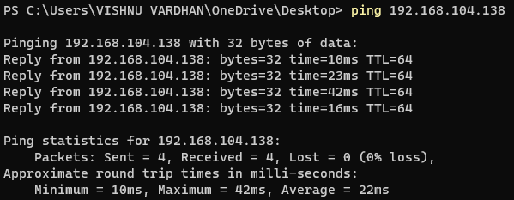

**Netstat command**

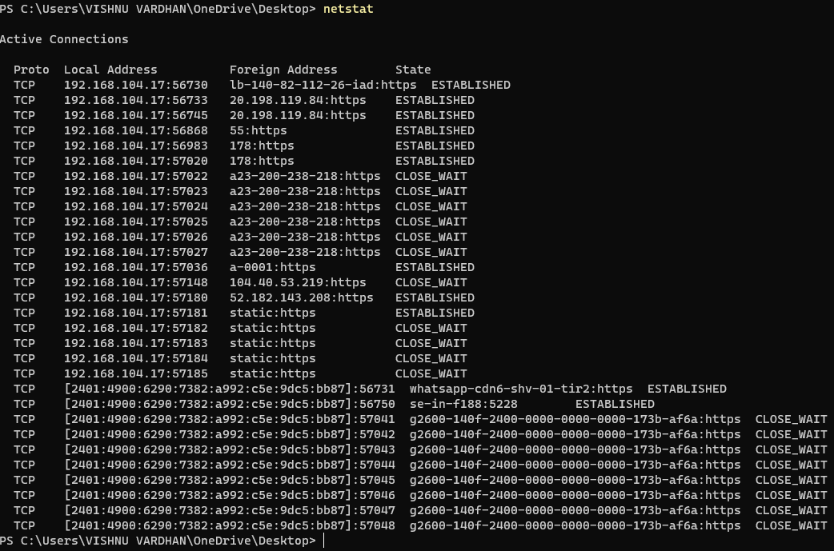

**Result :**

Hence the given commands is executed.