Certificate Generator

Template Selector
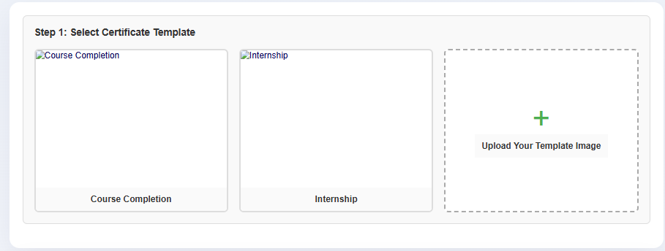

Body Content Selector & Content Text Box
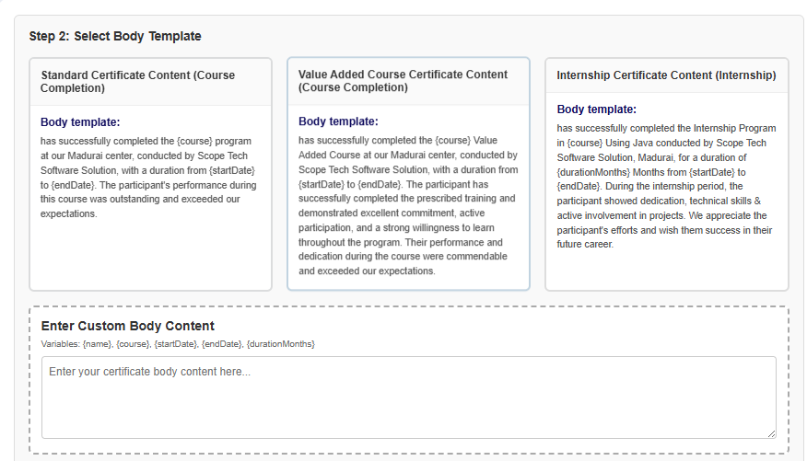

Signature Selector

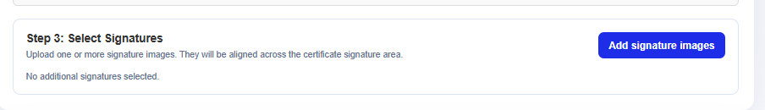

Excel Uploader



Student Details Tables with Sample Data

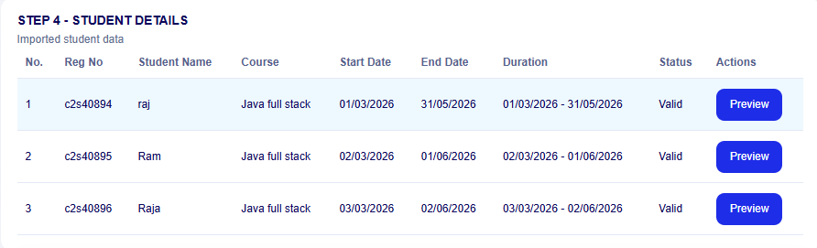

Certificate Preview Box



Download Options(Separate PDF or Whole Zip File) with Reset Button



