Earthquake prediction model using python

Phase 2 Submission Document

Project:Earthquake prediction

Introduction:

* An earthquake prediction model using Python is a computational tool that aims to forecast the occurrence of earthquakes based on various data inputs and statistical analysis. By leveraging Python's programming capabilities and libraries, such as NumPy, Pandas, and scikit-learn, researchers and scientists can develop predictive models that analyze seismic data, geological features, historical earthquake patterns, and other relevant factors.
* These models typically employ machine learning algorithms, such as regression, classification, or clustering, to identify patterns and relationships within the data. By training the model on historical earthquake data with known outcomes, it can learn to make predictions on future seismic events.
* It's important to note that earthquake prediction is a complex and challenging task, as earthquakes are inherently unpredictable natural phenomena. While advancements have been made in earthquake research and prediction, accurate and reliable short-term earthquake forecasting remains elusive.

Content for project phase 2:

Consider advanced techniques such as hyperparameter tuning and feauture engineering to improve the prediction model’s perfomance.

## Data Source:

A good data source for earthquake prediction data wih features like date,time,latitude,longitude,depth,and mangnitude.

1. Seismic Data: Seismic data is collected from various seismic monitoring stations worldwide. This data includes information about the location, magnitude, and time of recorded earthquakes. It forms the foundation for analyzing earthquake patterns and identifying potential precursors.  
  
2. Geological Data: Geological data provides information about the Earth's crust, fault lines, tectonic plate boundaries, and other geological features. This data helps in understanding the underlying causes and mechanisms of earthquakes.  
  
3. Geodetic Data: Geodetic data involves measuring the Earth's surface movements using techniques like GPS, satellite imagery, and ground-based instruments. It provides insights into the deformation and strain occurring in the Earth's crust, which can be indicators of potential seismic activity.  
  
4. Historical Earthquake Catalogs: Historical earthquake catalogs contain records of past earthquakes, including their locations, magnitudes, and dates. Analyzing this data helps identify patterns and trends that can aid in predicting future earthquakes.

1. Data Collection:

Gather earthquake data from sources like the US Geological Survey (USGS).

Collect additional data such as geological features, fault lines, historical earthquake records, etc.

In earthquake prediction, data collection plays a crucial role in understanding seismic activity and developing accurate models. Various sources and methods are used to collect data related to earthquakes. Here are some common approaches to earthquake data collection:  
  
1. Seismic Monitoring Stations: Seismic monitoring stations are strategically placed around the world to detect and record ground motion caused by earthquakes. These stations use seismometers to measure the vibrations and seismic waves generated by earthquakes. The data collected includes the time, location, magnitude, and waveform characteristics of the seismic event.  
  
2. Global Seismic Networks: International organizations, such as the Global Seismographic Network (GSN) and regional networks, maintain a network of seismic stations that continuously monitor seismic activity worldwide. These networks provide real-time data on earthquakes, allowing scientists to analyze and study seismic patterns on a global scale.  
  
3. Satellite Imagery: Satellite-based remote sensing techniques can be used to collect data on surface deformations and changes in the Earth's crust caused by earthquakes. Satellite imagery can provide valuable information about fault lines, tectonic plate movements, and other geological features associated with seismic activity.

2. Data Preprocessing:

Clean and preprocess the data to handle missing values and outliers.

Feature engineering: Extract relevant features from the data.

3. Feature Selection:

Use techniques like correlation analysis to select the most important features.

****Feature Engineering****:

Before selecting features, you may need to engineer new features or transform existing ones to make them more suitable for modeling. For example, you could calculate statistical measures or aggregations of raw data to extract more meaningful features.

****Correlation Analysis****: Calculate the correlation between each feature and the target variable (earthquake occurrence or intensity). Features with high correlations are generally more informative and should be prioritized.

4.Machine Learning Model:

Choose an appropriate machine learning algorithm, such as Random Forest, Support Vector Machine, or Neural Networks.

Split the data into training and testing sets.

Train the model on the training data.

5. Model Evaluation:

Evaluate the model's performance using appropriate metrics (e.g., accuracy, F1-score, ROC-AUC).

Adjust hyperparameters and try different algorithms to improve performance.

6. Deployment:

Deploy the model as a web application or API using frameworks like Flask or Django.

Create a user-friendly interface for inputting data and displaying predictions.

7. Continuous Improvement:

Continuously update the model with new earthquake data to improve its accuracy.

Program:

* **Import the modules and all the libraries**

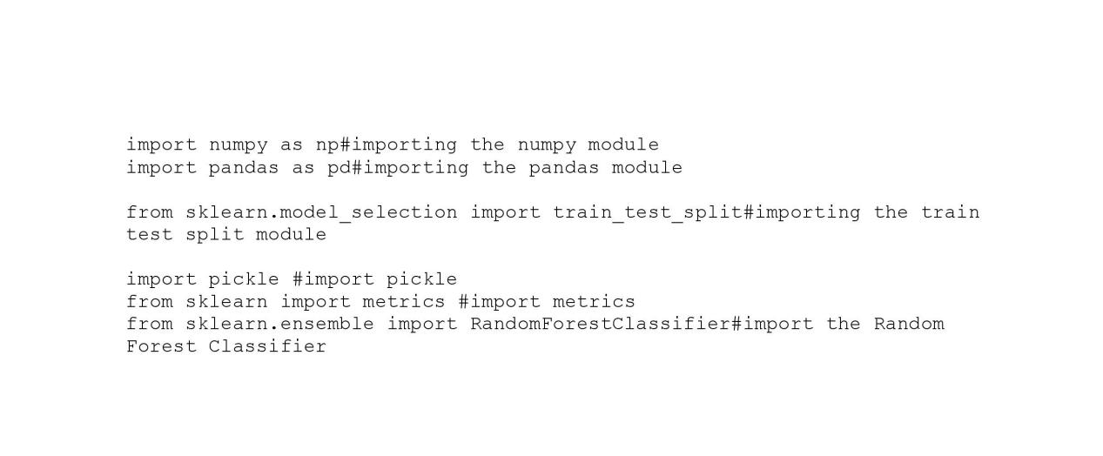

* **Reading the dataset and we are creating a function**

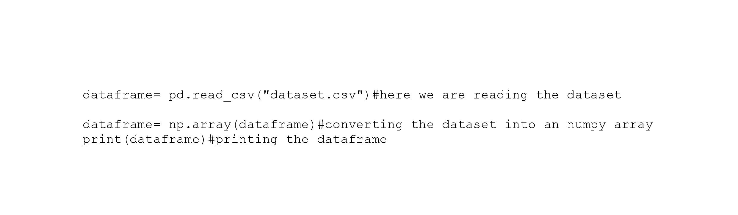

* **Dividing our dataset into X and Y :**

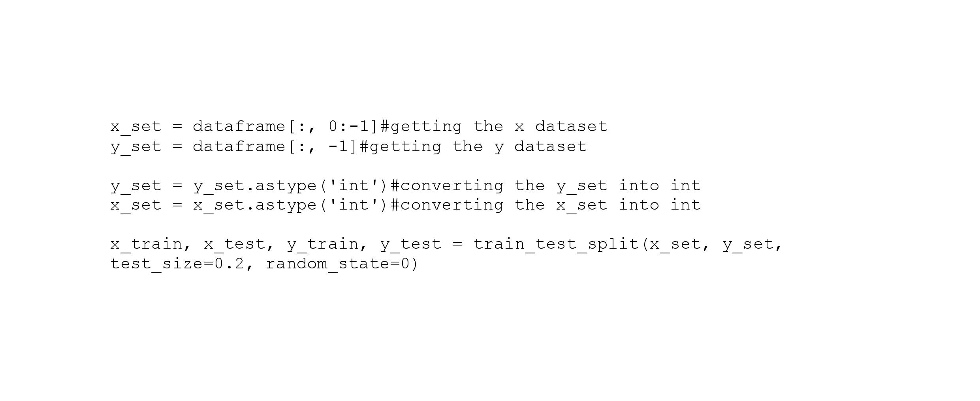

* **Creating our RandomForestClassifier:**

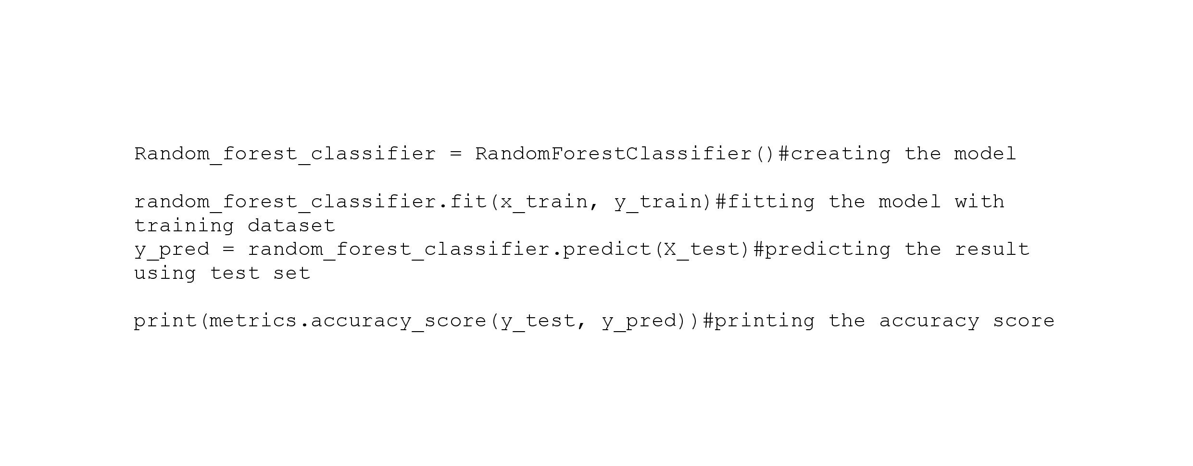

* **Creating our instance for Gradient Boosting Classifier:**

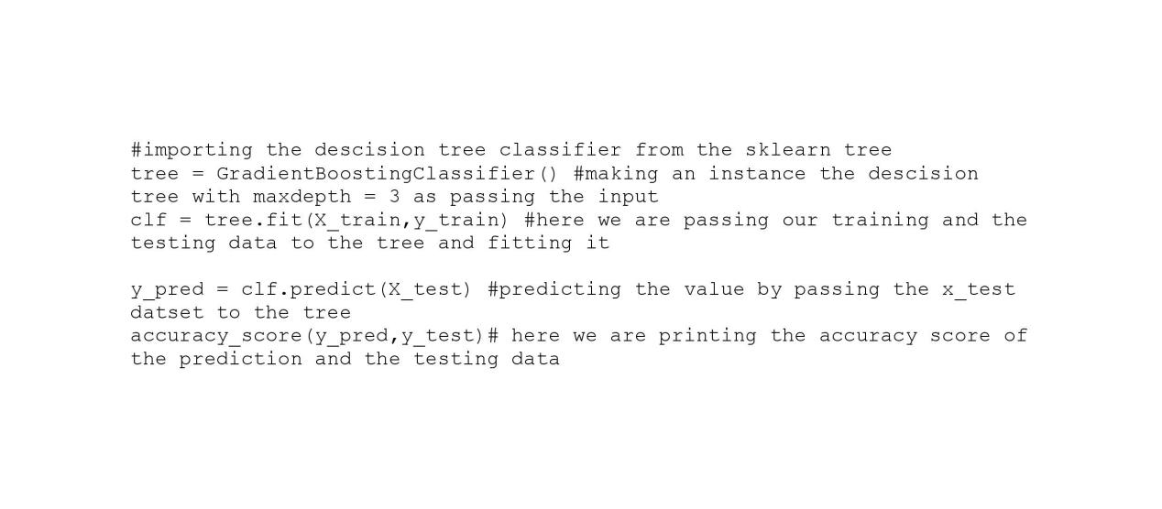

* **Testing data to our model and predict the accuracy:**

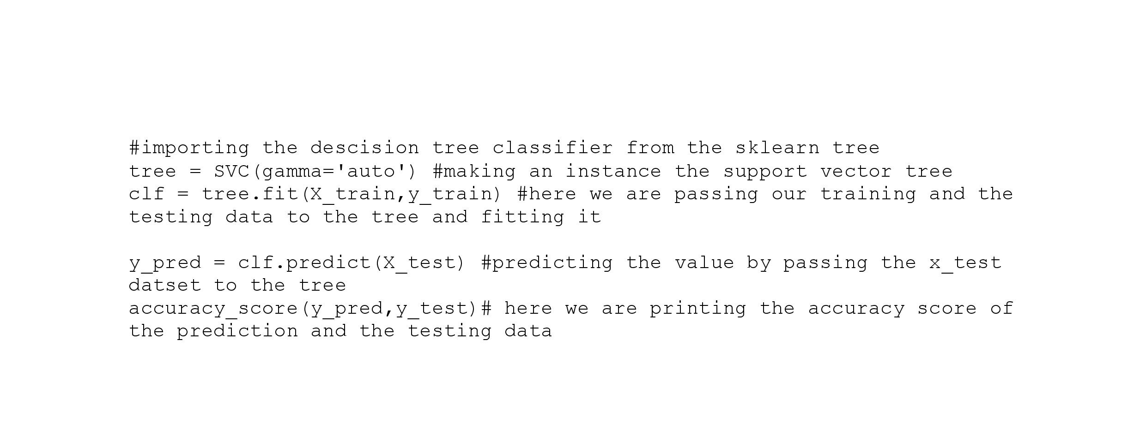

**Output:**

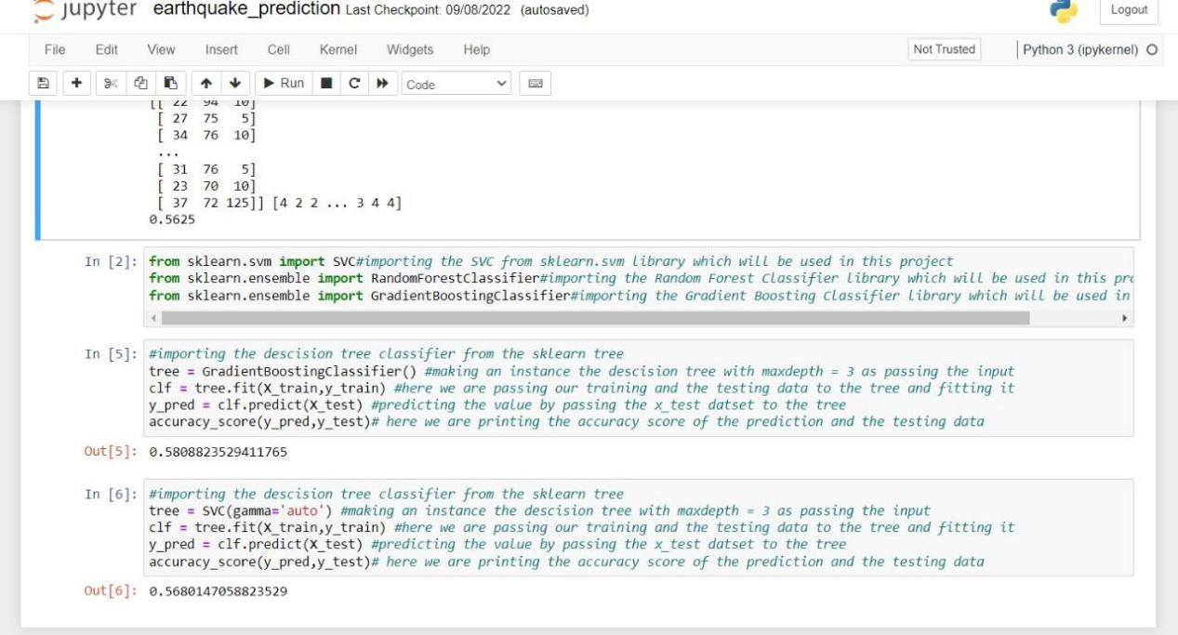

**Conclusion:**

In this Machine Learning project, we built an earthquake prediction system. In this project, we used Random Forest Classifier, SVC, and Gradient Boosting algorithm in this project. We hope you have learned something new from this project