**Earthquake prediction model using py­­thon**

**INTRODUCTION:**

Creating an earthquake prediction model using AI is a complex and on-going challenge. Earthquakes are the result of tectonic plate movements, and predicting them accurately is difficult due to their chaotic and unpredictable nature.

**Project introduction:**

It is well known that if a disaster has happened in a region, it is likely to happen there again. Some regions really have frequent earthquakes, but this is just a comparative quantity compared to other regions. So, predicting the earthquake with Date and Time, Latitude and Longitude from previous data is not a trend which follows like other things, it is natural occurring.

**Seismic Sensor Data**:

AI models can analyse data from seismic sensors to detect patterns and anomalies that might indicate seismic activity.

**Machine Learning Algorithms:**

Algorithms like neural networks and support vector machines can be used to process seismic data and make predictions.

**Historical Data Analysis:**

Studying historical earthquake data can help identify trends and potential risk areas.

**Geospatial Data:**

AI can analyse geospatial data, such as fault lines and geological features, to predict earthquake-prone regions.

**Early Warning Systems:**

AI can be used to develop early warning systems that provide a few seconds to minutes of advance notice before an earthquake strikes.

**Input 1:**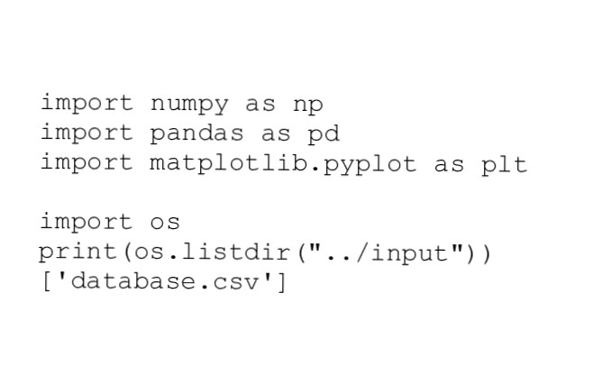

**Input 2:**

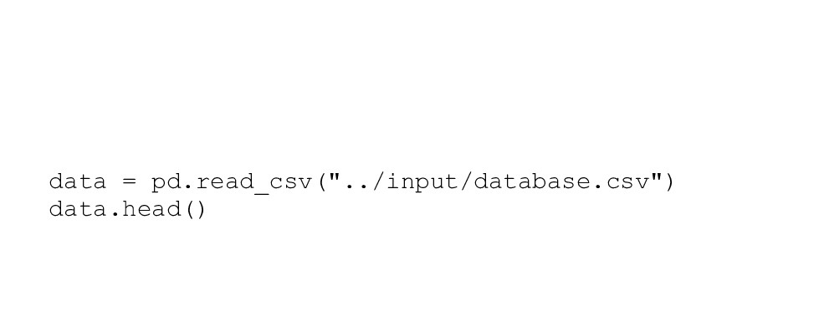

**Input 3:**



**Output 3:**

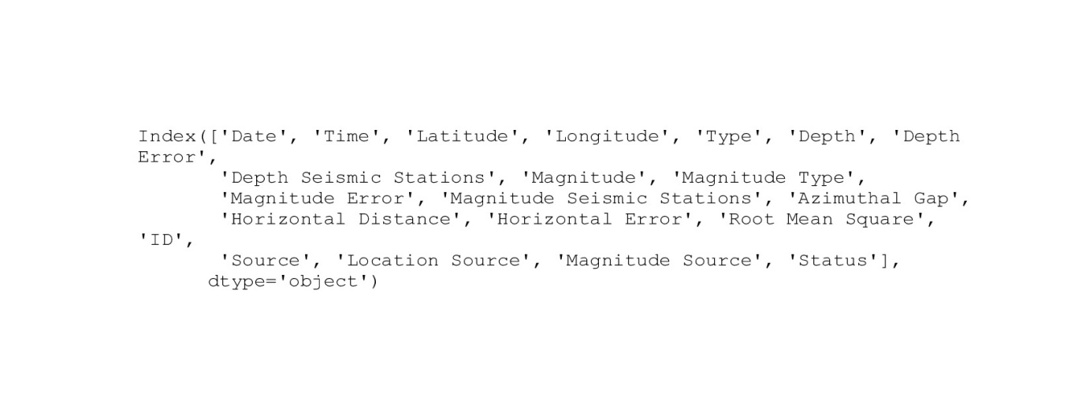

**Input 4**:

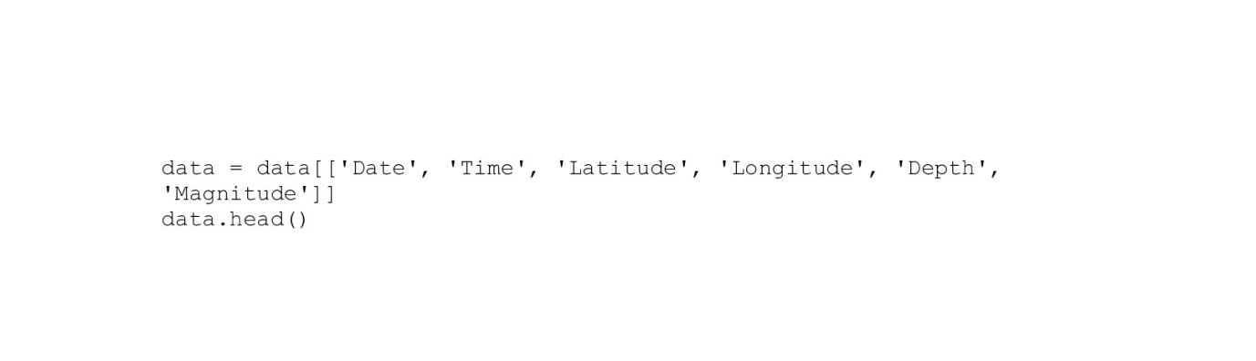

**Output 4:**

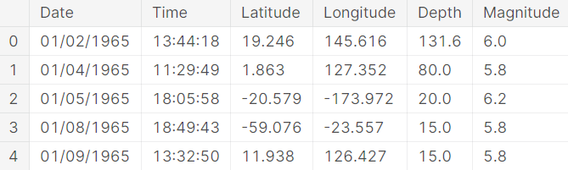

**Input 5:**

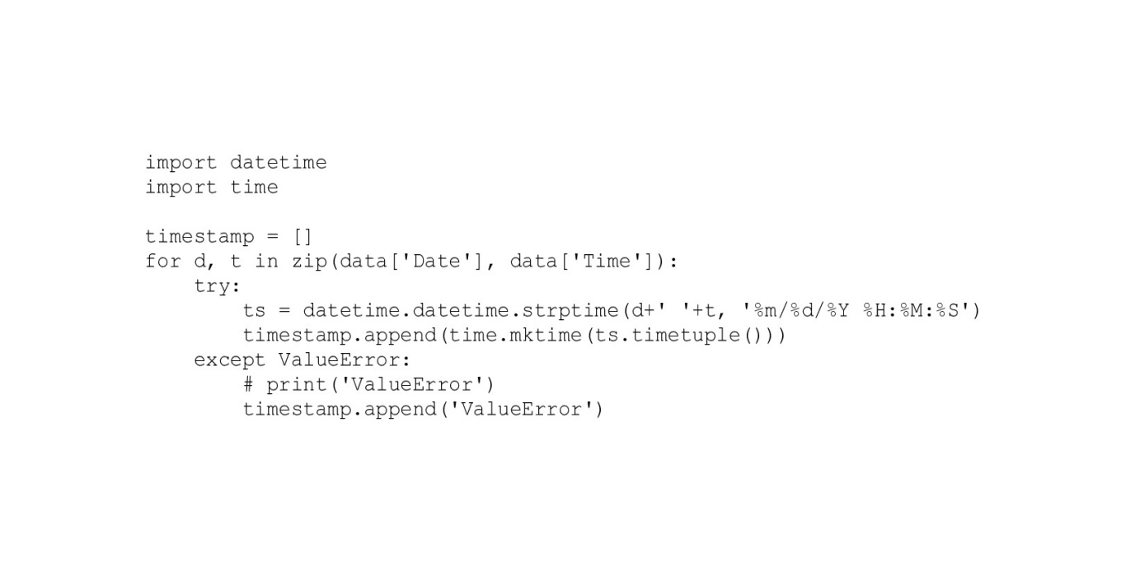

**Input 6:**

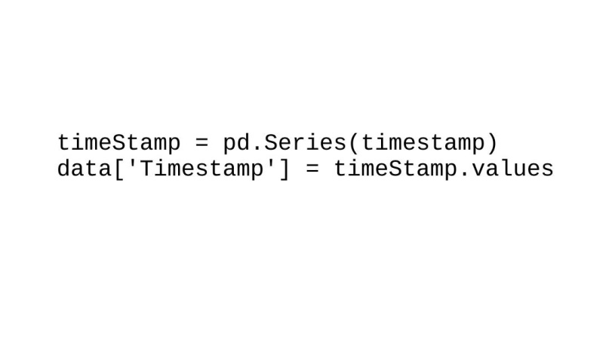

**Input 7:**

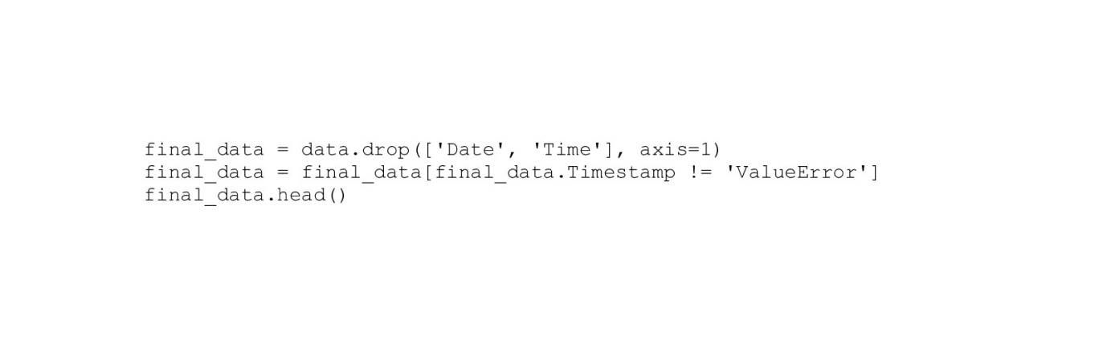

**Output 7:**

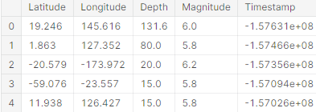

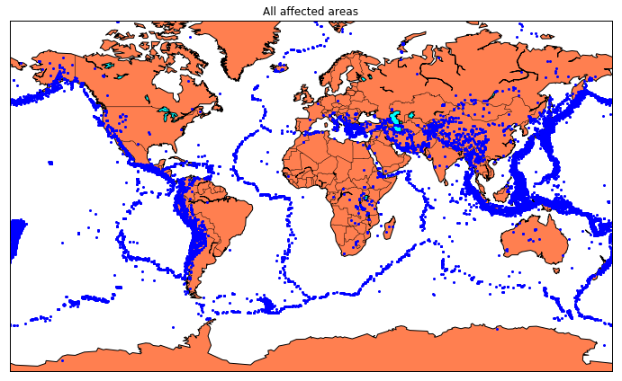

**CONCLUSION:**

It's important to note that while progress has been made in earthquake prediction, it's still an evolving field, and accurate long-term prediction remains a challenge. Public safety agencies and seismologists continue to work on improving these models to mitigate earthquake risks.