SQL Queries
artifact_metadata Table
- List all artifacts from the 11th century belonging to Byzantine culture.
Query:
select * from artifacts_metadata
where century like '11th%' and culture = 'Byzantine';
Output:
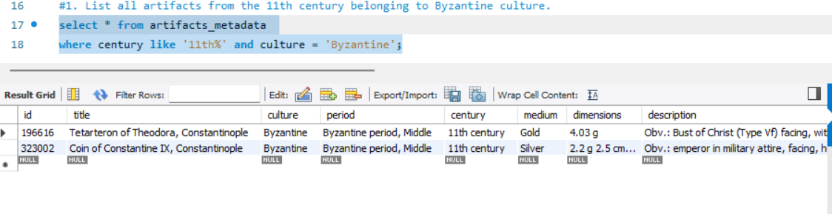
- What are the unique cultures represented in the artifacts
Query:
select distinct culture from artifacts_metadata;
#select Count(distinct culture) as culture_count from artifacts_metadata; o/p:164
#select culture, Count(distinct culture) as culture_count from artifacts_metadata group by culture;
Output:
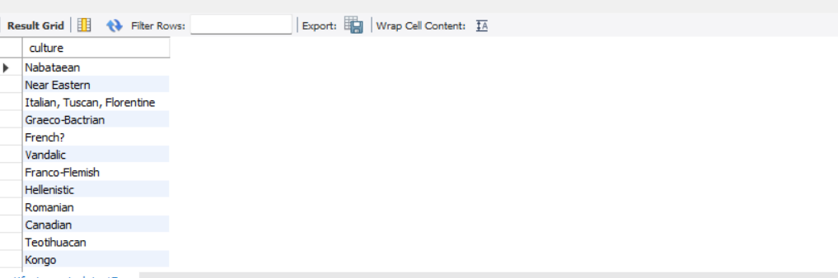

- List all artifacts from the Archaic Period.
Query:
select * from artifacts_metadata
where period = "Archaic period";
Output:
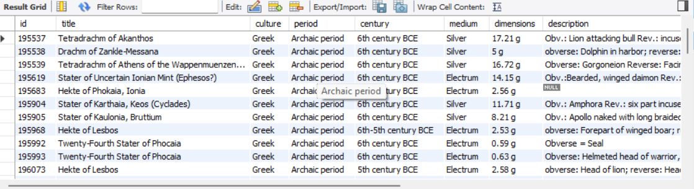

- List artifact titles ordered by accession year in descending order.
Query:
select title, accessionyear from artifacts_metadata
order by accessionyear desc;
Output:
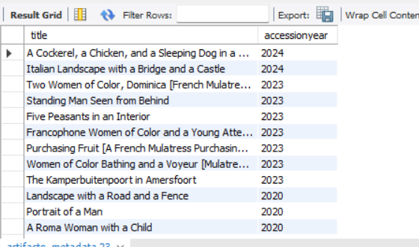

- How many artifacts are there per department?
Query:
select department, count(*) as number_of_artifacts from artifacts_metadata
group by department;
Output:
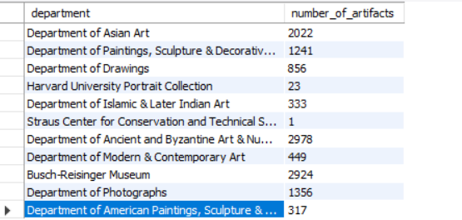

artifact_media Table
- Which artifacts have more than 1 image?
Query:
select * from artifacts_media where image_count > 1;
Output:
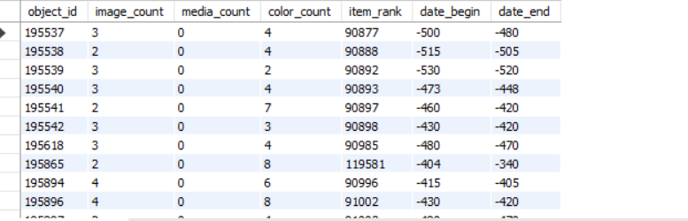

- What is the average rank of all artifacts?
Query:
select avg(item_rank) as Average_Item_Rank from artifacts_media;
Output:
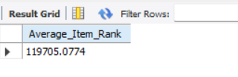
- Which artifacts have a higher colorcount than mediacount?
Query:
select * from artifacts_media where color_count > media_count;
Output:
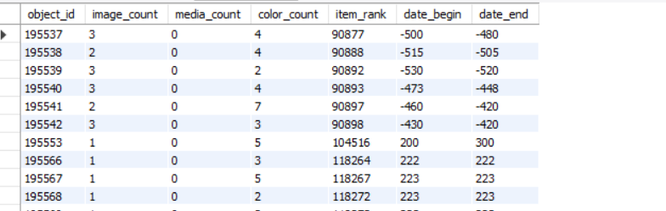

- List all artifacts created between 1500 and 1600.
Query:
select * from artifacts_media
where date_begin
between '1500' and '1600';
Output:
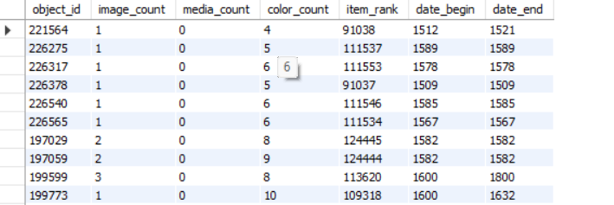

- How many artifacts have no media files?
Query:
select count(media_count) as artifacts_with_no_media from artifacts_media
where media_count = 0;
Output:
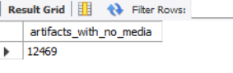
artifact_colors Table
- What are all the distinct hues used in the dataset?
Query:
select distinct hue from artifacts_colors;
Output:
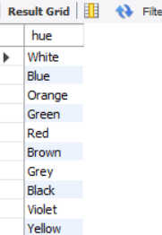
- What are the top 5 most used colors by frequency?
Query:
select hue, count(hue) as frequency from artifacts_colors
group by hue
order by frequency desc limit 5;
Output:
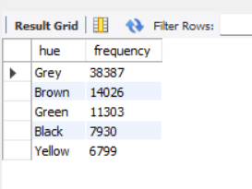
- What is the average coverage percentage for each hue?
Query:
select hue, AVG(percent) as average_coverage_percentage from artifacts_colors
group by hue
order by average_coverage_percentage desc;
Output:
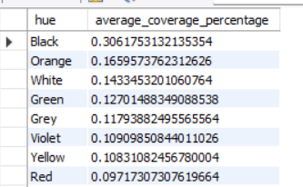
- List all colors used for a given artifact ID.
Query:
select color, hue, percent from artifacts_colors
where object_id = 195538
order by percent desc;
Output:
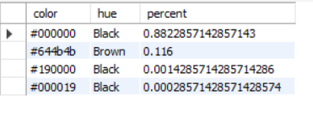
- What is the total number of color entries in the dataset?
Query:
select count(color) as total_number_of_color from artifacts_colors;
#(or)
select count(*) as total_number_of_color from artifacts_colors;
Output:
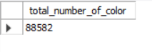
Join-Based Queries
- List artifact titles and hues for all artifacts belonging to the Byzantine culture.
Query:
select title, hue from artifacts_metadata as am
join artifacts_colors as ac on am.id = ac.object_id
where am.culture = 'Byzantine'
order by am.title, ac.hue;
Output:
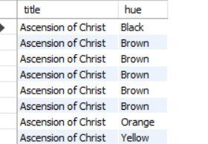

- List each artifact title with its associated hues.
Query:
select title, hue from artifacts_metadata as am
join artifacts_colors as ac on am.id = ac.object_id
order by am.title asc, ac.hue asc;
Output:
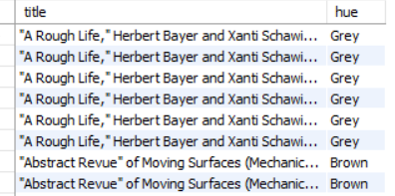
- Get artifact titles, cultures, and media ranks where the period is not null.
Query:
select title, culture, item_rank as media_rank from artifacts_metadata as meta
join artifacts_media as med on meta.id = med.object_id
where period is not null
order by med.item_rank desc, meta.title asc;
Output:
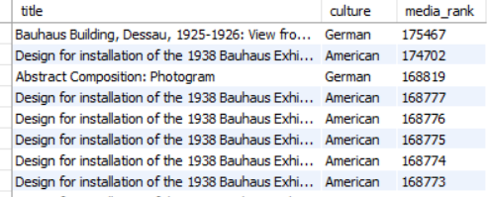

- Find artifact titles ranked in the top 10 that include the color hue "Grey".
Query:
select title, hue, item_rank from artifacts_metadata as am
join artifacts_media as amd on am.id = amd.object_id
join artifacts_colors as ac on am.id = ac.object_id
where hue = 'Grey' and item_rank is not null
order by am.title asc, amd.item_rank asc limit 10;
Output:
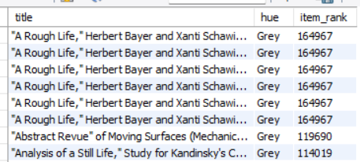

- How many artifacts exist per classification, and what is the average media count for each?
Query:
select classification, count(id) as total_artifacts, avg(media_count) as average_media_count
from artifacts_metadata as am
join artifacts_media as amd on am.id = amd.object_id
group by classification
order by total_artifacts desc;

Output:
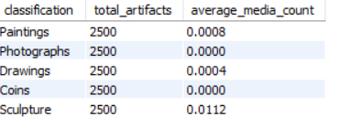
Additional SQL queries
- Find the total number of artifacts and their average display rank for each classification.
Query:
select accessionmethod, avg(media_count) as average_media_per_acquisition
from artifacts_metadata as am
join artifacts_media as amd on am.id = amd.object_id
group by am.accessionmethod
order by average_media_per_acquisition desc;
Output:
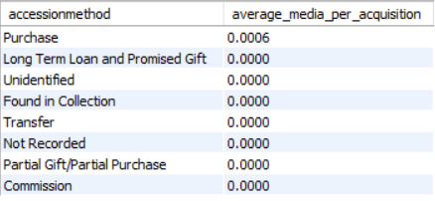
- Find the average `percent` coverage of all colors for artifacts using 'silver' as a `medium`
Query:
select medium, avg(percent) as average_color_coverage from artifacts_metadata as am
join artifacts_colors as ac on am.id= ac.object_id
where medium like '%silver%'
group by medium;
Output:
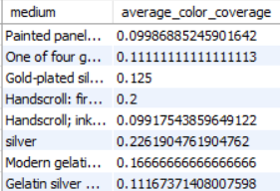

- Calculate the average `rank` only for artifacts that have more than 3 associated images
Query:
select avg(item_rank) as average_rank_multi_image_artifacts from artifacts_media
where image_count > 3;
Output:
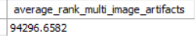

- List the titles of the 10 oldest artifacts (by `datebegin`) that have a `colorcount` greater than 5
Query:
select title, date_begin, color_count from artifacts_metadata as am
join artifacts_media as amd on am.id = amd.object_id
where color_count > 5
Output:
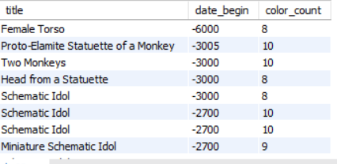

- List all artifacts from the 20th century belonging to Roman and American culture
Query:
select * from artifacts_metadata
where century like '20th%' and culture = 'American';
Output:
