

A PROJECT REPORT

On

Credit card spending patterns and customer segmentation

By
INDHU M(MS235121)
NIKITHA V(MS235135)
SUSHMITHA B(MS235150)
TAMIL SELVI K(MS235151)

Under the guidance of
Ms. Vanditha Bansal
Analytics Professor

Submitted in partial fulfillment of the requirements of
Bachelor of Data Science course

DEPARTMENT OF STATISTICS AND ANALYTICS
MOUNT CARMEL COLLEGE, AUTONOMOUS,
NO.58, PALACE ROAD, BENGALURU-560052


COLLEGE CERTIFICATE

This is to certify that the students,
1.Indhu M (Register Number: MS235121)
2.Nikitha V(Register Number: MS235135)
3.Sushmitha B(Register Number: MS235150)
4.Tamil Selvi K (Register Number: MS235151)
of the Bachelor Of Science, BSc. (DATA SCIENCE) course, batch (2023-2026), have successfully completed the project titled "Credit Card Spending Patterns and Customer Segmentation" in their sixth semester as prescribed by the Advisory Committee and the Board of Studies of the BSc. (Data Science) course, MOUNT CARMEL COLLEGE, Autonomous, Bengaluru, affiliated to BENGALURU CITY UNIVERSITY .

Internal Guide Project Guide
Date:

Examiner College Seal

ACKNOWLEDGEMENT

We sincerely wish to extend our heartfelt gratitude to all those who played an integral role in the successful completion of our project.

We extend our profound appreciation to Sr. Albina, the Director of Mount Carmel College, Autonomous, for providing us with this valuable opportunity. Our gratitude also extends to Dr. George Lekha, the Principal of Mount Carmel College, Autonomous, for granting us this privilege.

A significant thank you is owed to Ms. Vandita Bansal, Analytics Professional, whose guidance and consultations were valuable throughout our journey.

We express special thanks to Dr. Mrs. Lakshmi S.K, the Dean of Natural and Applied Sciences and Associate Professor Dr. Ms. Mamata Shiva Shankar, in the Department of Statistics and Analytics, for guiding us and motivating us all throughout the project.

Our gratitude extends to our mentor, Ms. Ambika C, Head of the Department of Statistics and Analytics, and the entire faculty of the Department of Statistics and Analytics. Without their steadfast support, assistance and encouragement, this project would not have been possible.

Our appreciation extends to all those who, in different capacities, contributed to our project's successful completion.

TABLE OF CONTENTS
1. ABSTRACT 1
2. INTRODUCTION 2
3. IMPORTANCE OF CREDIT CARDS TO BANKS 3
4. WHY CUSTOMER SEGMENTATION? 4
5. LITERATURE REVIEW 5
6. PROBLEM STATEMENT 7
7. OBJECTIVES 8
8. SCOPE OF THE PROJECT 9
9. DATASET 10
9.1 DATASET DESCRIPTION 10
9.2 DATASET COLUMNS AND DESCRIPTIONS 11
10. METHODOLOGY 12
10.1 DATA COLLECTION 12
10.2 DATA PRE-PROCESSING 13
10.3 EXPLORATORY DATA ANALYSIS (EDA) 13
10.4 DATA TRANSFORMATION 13
10.5 MODEL SELECTION 14
10.6 MODEL IMPLEMENTATION 14
10.7 EVALUATION AND RESULT 14
11. UNIVARIATE ANALYSIS 14
11.1 FREQUENCY TABLES 15
12. BIVARIATE ANALYSIS 17
13. DECILE ANALYSIS 20
14. STANDARDIZATION 22
15. CLUSTERING 23
16. K-MEANS CLUSTERING 24
17. HIERARCHICAL CLUSTERING (AGGLOMERATIVE APPROACH) 25
18. DENDROGRAM ANALYSIS 26
19. CLUSTERING & PROFILING 27
20. SUMMARY OF FINDINGS 30
21. BUSINESS INSIGHTS 31
22. CONCLUSIONS AND FUTURE WORK 32
23. BIBLIOGRAPHY 34

1.ABSTRACT
Customer segmentation is a fundamental strategy in modern banking and financial services that enables institutions to understand diverse customer groups and tailor their services accordingly. This project applies Hierarchical Clustering, an unsupervised machine learning technique, to segment credit card customers based on their behavioural and transactional patterns derived from credit card usage data.

The dataset used in this study contains 8,950 active credit card holders with 17 behavioural variables, including balance, purchases, cash advance, credit limit, payments, and usage frequencies. The analysis follows a comprehensive data science pipeline: data preparation and cleaning, exploratory data analysis (EDA), univariate and bivariate analysis, frequency table generation, decile analysis, standardization, and finally, hierarchical clustering using Ward's linkage method.

Exploratory Data Analysis revealed key insights about the customer base, including skewed distributions in balance and purchase behaviour, significant concentration of spending among top deciles, and patterns in credit utilization. The dendrogram generated using Ward's method provided a visual representation of the hierarchical structure of the data, and the optimal number of clusters was determined using the Silhouette Score.

The final clustering model segmented customers into three distinct groups: high-value premium customers characterized by high purchases and credit limits; moderate-activity customers with balanced spending behaviour and low-activity customers who rely heavily on cash advances. Each cluster was profiled using heat maps and scatter plots for interpretability.

The findings of this project provide actionable insights for banks and financial institutions to design targeted marketing campaigns, improve customer retention strategies, enhance risk management, and optimize credit limit allocation. This study demonstrates the effectiveness of hierarchical clustering as a powerful tool for customer intelligence in the financial domain.

2.INTRODUCTION
In today’s highly competitive financial landscape, understanding customer behaviour has become essential for the success of banking and financial institutions. The rapid growth of digital transactions and the widespread use of credit cards have led to the generation of vast amounts of customer data. This data holds valuable insights into spending patterns, financial habits, and customer preferences. However, extracting meaningful information from such large and complex datasets requires advanced analytical techniques.
Customer segmentation is a powerful approach that enables organizations to divide their customer base into distinct groups based on similar characteristics such as spending behaviour, transaction frequency, credit utilization, and payment patterns. In the context of credit card services, segmentation helps identify different categories of customers, including high-value users, frequent transactions, low-risk customers, and potential defaulters. These insights allow financial institutions to design targeted marketing strategies, improve customer satisfaction, minimize risks, and enhance overall profitability.
Clustering, a fundamental technique in unsupervised machine learning, plays a crucial role in customer segmentation. Unlike supervised methods, clustering does not rely on labelled data, making it ideal for discovering hidden patterns in datasets. Among various clustering methods, hierarchical clustering is particularly effective due to its flexibility and interpretability. It organizes data into a hierarchical structure represented by a dendrogram, which provides a clear visualization of relationships among data points.
Hierarchical clustering can be implemented using agglomerative (bottom-up) or divisive (top-down) approaches, with agglomerative clustering being more widely used in practice. One of its key advantages is that it does not require the number of clusters to be predefined. Instead, the optimal number of clusters can be determined by analysing the dendrogram, making it highly suitable for real-world applications where the number of customer segments is unknown.
In this project, hierarchical clustering is used to group credit card customers based on their financial behaviour. The results help identify different customer groups and support better decisions in marketing, customer retention, and risk management.

3.IMPORTANCE OF CREDIT CARDS TO BANKS

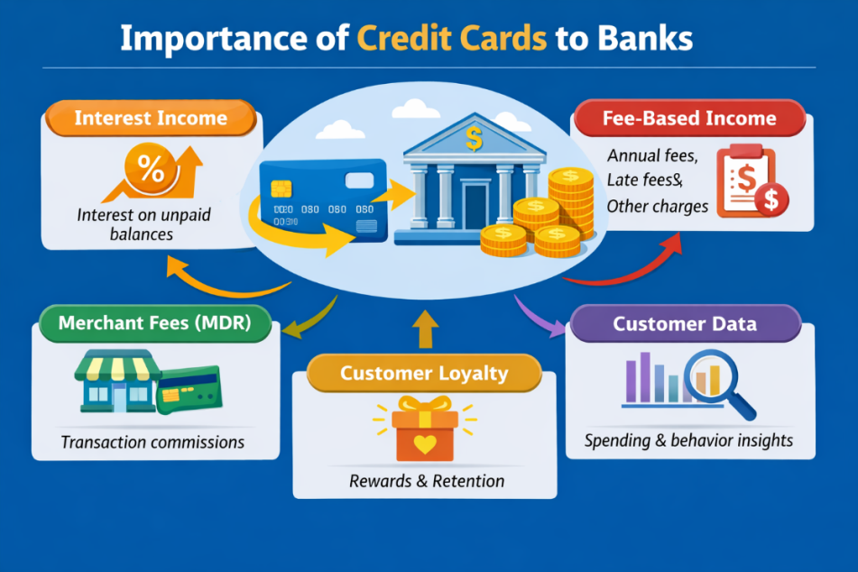

Credit cards play a vital role in the banking and financial services industry, serving as one of the most profitable and widely used financial products. They are not only a convenient payment tool for customers but also a significant source of revenue and customer engagement for banks.

One of the primary reasons credit cards are important is their ability to generate interest income. When customers do not pay their full outstanding balance within the billing cycle, banks charge interest on the remaining amount. These interest rates are generally higher compared to other types of loans, making credit cards a major contributor to bank profits.

In addition to interest income, banks earn substantial fee-based revenue from credit cards. This includes annual fees, late payment charges, over-limit fees, and cash advance fees. These charges provide a consistent and reliable stream of income, even when customers are not revolving their balances.

Credit cards also play an important role in customer retention and relationship building. Banks offer rewards, cashback, discounts, and loyalty programs to encourage customers to use their credit cards frequently. This not only increases transaction volumes but also strengthens customer loyalty. Additionally, it creates opportunities for banks to cross-sell other financial products such as personal loans, insurance, and investment services.

Moreover, credit card usage generates a large volume of customer transaction data. Banks analyze this data to understand spending patterns, preferences, and financial behaviour. This information is highly valuable for customer segmentation, targeted marketing, personalized offers, and effective risk management.

In conclusion, credit cards are a crucial component of modern banking. They provide multiple streams of income, enhance customer engagement, and offer valuable insights through data analytics. Due to these benefits, credit cards remain a key focus area for banks, especially in customer segmentation and financial analytics projects.

4.WHY CUSTOMER SEGMENTATION?
Credit card customer segmentation analysis is essential for financial institutions to better understand the diverse behaviour and needs of their customers. In today’s data-driven world, banks and financial organizations deal with vast amounts of transactional data generated by credit card users. Without proper analysis, this data remains underutilized and fails to provide meaningful insights. Customer segmentation helps transform this raw data into actionable knowledge.
One of the primary reasons for performing credit card customer segmentation is to identify different types of customers based on their spending behaviour. Not all customers use credit cards in the same way some are high spenders, some use cards occasionally, while others may rely heavily on credit and carry balances. By grouping customers into distinct segments, banks can better understand these patterns and categorize users accordingly.
Another important reason is targeted marketing and personalized services. Instead of applying a one-size-fits-all strategy, financial institutions can design customized offers for each customer segment. For example, high-value customers can be offered premium cards and exclusive rewards, while low-usage customers can be encouraged with cashback or discount offers. This improves customer satisfaction and increases engagement.

5.LITERATURE REVIEW
The rapid growth of credit card usage in modern financial systems has led to the generation of large volumes of transactional data. This data contains valuable insights into customer behaviour, spending patterns, and financial habits. To extract meaningful information from such data, researchers and financial institutions increasingly rely on data mining and machine learning techniques, particularly clustering methods, for effective customer segmentation. The Credit Card Customer Segmentation dataset, widely available on platforms like Kaggle, has been extensively used as a benchmark for analysing customer behaviour using unsupervised learning techniques.
Customer segmentation plays a crucial role in Customer Relationship Management (CRM) by dividing customers into groups based on similar characteristics. Traditional segmentation approaches focused mainly on demographic factors such as age, gender, and income. However, recent research emphasizes behavioural segmentation, which provides deeper insights by analysing how customers interact with financial services. Variables such as credit card usage, purchase frequency, and repayment behaviour enable more accurate and meaningful segmentation, leading to improved decision-making.
Clustering algorithms are widely applied in customer segmentation due to their ability to group data without requiring predefined labels. Among these, K-Means clustering has been one of the most commonly used techniques because of its simplicity and computational efficiency. It has been applied to identify customer groups such as high spenders, low users, and high-risk customers. However, K-Means has certain limitations, including the need to specify the number of clusters in advance and its sensitivity to initial centroid selection, which can lead to inconsistent results.
To overcome these limitations, hierarchical clustering has emerged as an effective alternative. This method creates a tree-like structure called a dendrogram, which represents the hierarchical relationships among data points. One of its key advantages is that it does not require prior specification of the number of clusters, allowing researchers to determine the optimal number based on the data structure. In the context of credit card datasets, hierarchical clustering helps identify natural groupings of customers based on their financial behaviour.
Hierarchical clustering is mainly divided into agglomerative and divisive approaches. Agglomerative clustering, which is more commonly used, starts with each data point as an individual cluster and gradually merges them based on similarity. This approach is widely preferred due to its simplicity and interpretability. The effectiveness of hierarchical clustering largely depends on the choice of distance metrics and linkage methods. Euclidean distance is commonly used to measure similarity, while linkage methods such as complete and average linkage often produce more compact and meaningful clusters compared to single linkage.
Data pre-processing is a critical step in improving clustering performance. The credit card dataset typically includes variables such as credit limit, balance, purchases, and payment behaviour, which often exist on different scales. Techniques like normalization and standardization, particularly Z-score normalization, are applied to ensure fair contribution of all variables. Additionally, handling missing values and outliers is essential to enhance the accuracy of clustering results.
Visualization techniques play an important role in interpreting clustering outcomes. The dendrogram provides a clear visual representation of cluster formation and helps in selecting the appropriate number of clusters. Other visualization methods such as scatter plots and correlation matrices assist in understanding relationships between variables and identifying behavioural patterns among customers.
In conclusion, the literature highlights that hierarchical clustering is a powerful and flexible technique for customer segmentation. Its ability to provide clear structure and visual interpretation makes it highly suitable for analysing credit card data. This project builds upon these concepts by applying hierarchical clustering to identify meaningful customer segments and generate actionable insights for better financial decision-making.

6.PROBLEM STATEMENT
A major bank maintains a dataset of 8,950 active credit card customers, each described by 17 behavioural attributes. The bank seeks to understand the diversity within its customer base to improve its service offerings, optimize marketing spend, and manage credit risk effectively.

The core problem is: How can the bank identify distinct, meaningful customer segments from the available behavioural data, and what unique characteristics define each segment? This is fundamentally an unsupervised learning problem, as no predefined categories of customers exist in the dataset.

This project addresses this problem by applying Agglomerative Hierarchical Clustering to the pre-processed and standardized credit card behavioural data, followed by cluster profiling and visualization to interpret the results in a business context.

7.OBJECTIVES
The primary and secondary objectives of this project are as follows:
- To perform comprehensive Exploratory Data Analysis (EDA) on the credit card dataset to understand data distributions, identify missing values, and derive preliminary insights.
- To conduct univariate analysis including frequency tables and histograms for all key behavioural variables.
- To perform bivariate analysis to understand the relationships between spending behaviour and other financial metrics.
- To conduct decile analysis to identify which customer segments contribute most to overall spending, balance, credit utilization, and payments.
- To pre-process the data through missing value treatment and standardization to prepare it for clustering.
- To apply Agglomerative Hierarchical Clustering using Ward's linkage method and visualize the hierarchical structure via a dendrogram.

8.SCOPE OF THE PROJECT

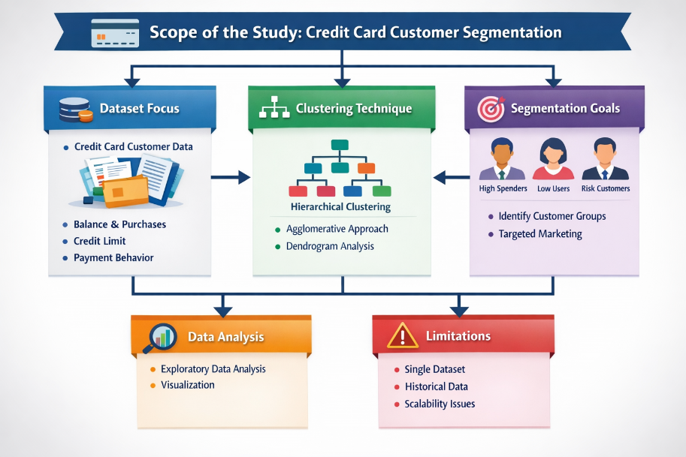

This project is scoped to analyse a single cross-sectional dataset of credit card customers, applying unsupervised machine learning to derive behavioural segments. The analysis includes:
- Data preparation and quality assessment.
- Univariate, bivariate, and decile-based statistical analysis.
- Hierarchical clustering with Ward's linkage and Euclidean distance.
- Cluster profiling using heat maps and scatter plots.
- Business interpretation and recommendations.
The project does not extend to predictive modelling (e.g., predicting customer churn or default), time-series analysis of spending behaviour, or deployment of the clustering model in a production environment. These are important areas for future work.

- To apply Agglomerative Hierarchical Clustering using Ward's linkage method and visualize the hierarchical structure via a dendrogram.
- To determine the optimal number of clusters using the Silhouette Score.
- To profile and interpret each customer cluster using statistical summaries and visualizations.

9.DATASET

9.1Dataset Description

The dataset used in this project is the Credit Card Customer Segmentation Dataset. This dataset contains information about the financial behaviour of credit card customers and is primarily used for analysing spending patterns and customer segmentation.
The dataset is obtained from the Kaggle platform, which provides real-world datasets for data analysis and machine learning projects. It represents the transactional and behavioural data of credit card users over a specific period.
The main purpose of this dataset is to help identify different groups of customers based on their financial activities such as purchases, balance maintenance, cash advances, and payment behaviour. This enables banks and financial institutions to perform customer segmentation for better decision-making, targeted marketing, and risk management.
The dataset consists of:
- 8,950 rows (customers)
- 18 columns (variables)
Out of these, one column (CUST_ID) is a unique identifier, and the remaining 17 columns are numerical variables representing customer behaviour.
The data type of the dataset is:
- Numerical data (majority of variables)
- Categorical data (only CUST_ID, which is removed during pre-processing)

9.2 Data Dictionary
Table 9.2: Data Dictionary of Credit Card Dataset
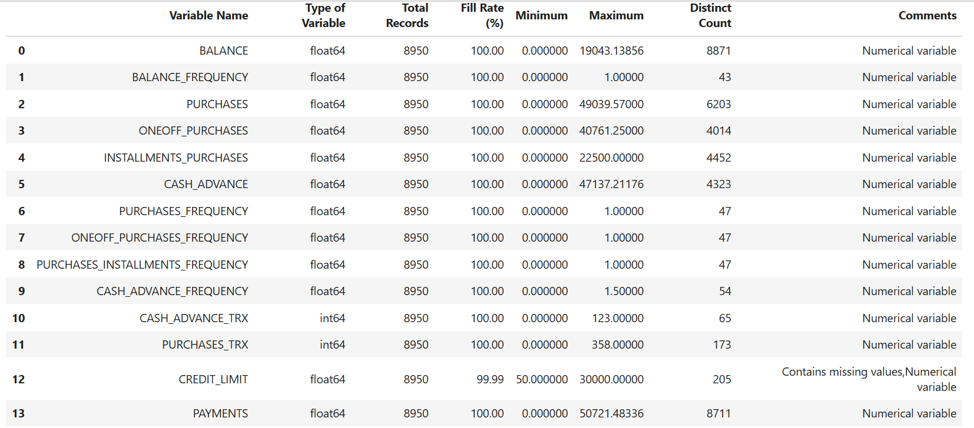

Explanation:

The dataset consists of 17 numerical variables that represent various aspects of customer financial behaviour, along with one identifier variable (CUST_ID). These variables capture important information such as spending patterns, balance maintenance, cash advance usage, and payment behaviour, which are essential for customer segmentation.
During data exploration, missing values were identified in two variables:
- CREDIT_LIMIT: 1 missing value (0.01%), which is very minimal
- MINIMUM_PAYMENTS: 313 missing values (3.49%), indicating moderate missing data
To handle these missing values, mean imputation was applied. This method replaces missing values with the average of the respective column and is suitable for numerical data. The missing pattern was assumed to be MCAR (Missing Completely at Random), meaning it does not significantly affect the analysis.
After imputation, the dataset achieved a 100% fill rate, ensuring that no records were lost and the dataset remained complete for further processing.
The CUST_ID column was removed because it is only a unique identifier and does not provide any meaningful information for clustering. Including such variables can negatively impact distance-based algorithms.
Since hierarchical clustering is a distance-based method, variables with larger numerical scales (such as CREDIT_LIMIT) can dominate those with smaller ranges (such as frequency variables). To avoid this issue, standardization using Z-score normalization was applied:
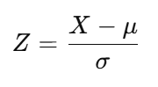
This transformation ensures that all variables are brought to a common scale with a mean of 0 and standard deviation of 1, allowing each feature to contribute equally to the clustering process.
Additionally, any infinite values were replaced with NaN, and remaining missing values were again handled using mean imputation to maintain data consistency.
Finally, the dataset was thoroughly verified to ensure:
- No missing values remain
- No infinite values are present
- All variables are properly scaled and ready for clustering
Thus, the dataset was successfully prepared and is suitable for applying hierarchical clustering techniques.
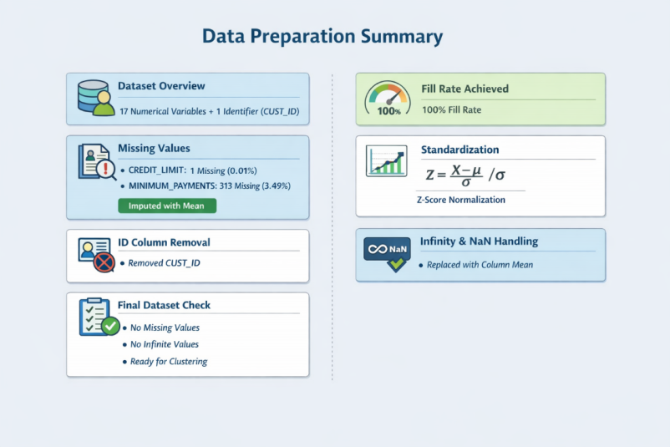
9.3Descriptive Statistics
Table.2 Descriptive Statistics of Key Numerical Variables
Variable | Mean | Median | Std Dev | Min | Max
BALANCE | 1,564.47 | 873.39 | 2,081.53 | 0.00 | 19,043.14
PURCHASES | 1,003.20 | 361.28 | 2,136.63 | 0.00 | 49,039.57
CASH_ADVANCE | 978.87 | 0.00 | 2,097.16 | 0.00 | 47,137.21
CREDIT_LIMIT | 4,494.45 | 3,000.00 | 3,638.82 | 50.00 | 30,000.00
PAYMENTS | 1,733.14 | 873.09 | 2,895.06 | 0.00 | 50,721.48

Key Observations:
• BALANCE: Mean ($1,564) is nearly double the median ($873), indicating right-skewed distribution – a few customers carry very high balances.
•PURCHASES: Extreme skew (mean $1,003, max $49,040) – majority are low spenders with a small premium segment driving high values.
• CASH_ADVANCE: Median is $0.00, confirming that most customers never use cash advances; only a small high-risk group does.
• CREDIT_LIMIT: Relatively normal compared to others, ranging from $50 to $30,000 with a mean of $4,494.
• PAYMENTS: Strong correlation with spending; top payers contribute significantly to total payment volume.

10.METHODOLOGY

10.1.DATA COLLECTION

The dataset used for this project is the Credit Card Customer Segmentation dataset obtained from Kaggle. It contains customer transaction details such as balance, purchases, credit limits, and payment behaviour. This dataset provides valuable information to analyse customer spending patterns and segment them effectively.

10.2.DATA PRE-PROCESSING

Before analysis, the dataset was cleaned and prepared. Missing values present in the dataset were handled using appropriate techniques such as mean imputation. Duplicate records were checked and removed if found. Irrelevant features were eliminated to improve the efficiency of the model. Data types were also verified to ensure consistency across all variables.

10.3.EXPLORATORY DATA ANALYSIS (EDA)

Exploratory Data Analysis was performed to understand the structure and distribution of the dataset. Various visualizations such as histograms, bar charts, and heat maps were used to analyse customer behaviour. Frequency tables were created to observe the distribution of key variables. The analysis revealed that most features, such as purchases and balances, are right-skewed, indicating that a small number of customers contribute to high spending.

10.4.DATA TRANSFORMATION

To prepare the data for clustering, normalization techniques were applied using methods such as StandardScaler. This step ensures that all features are on the same scale and prevents bias toward variables with larger values. Data transformation improves the performance and accuracy of clustering algorithms.

10.5.MODEL SELECTION

Clustering algorithms such as K-Means and Hierarchical Clustering were selected for customer segmentation. These algorithms are suitable for grouping similar data points without predefined labels. The optimal number of clusters was determined using methods like the Elbow Method and Silhouette Score to ensure meaningful segmentation.

10.6. MODEL IMPLEMENTATION

The selected clustering algorithm was applied to the processed dataset. Customers were grouped into clusters based on similarities in their financial behaviour. The clustering results were visualized using scatter plots and dendrograms (for hierarchical clustering) to better understand the grouping structure.

10.7.EVALUATION AND RESULT

The performance of the clustering model was evaluated using the Silhouette Score, which measures how well the data points are grouped within clusters. The optimal number of clusters was identified as 3, providing a balance between model performance and interpretability. The results revealed distinct customer segments such as active spenders, cash-dependent users, and low-activity customers, which can be used for business decision-making and targeted marketing strategies.

11.UNIVARIATE ANALYSIS
Histograms of Key Variables
1.HISTOGRAM OF BALANCE
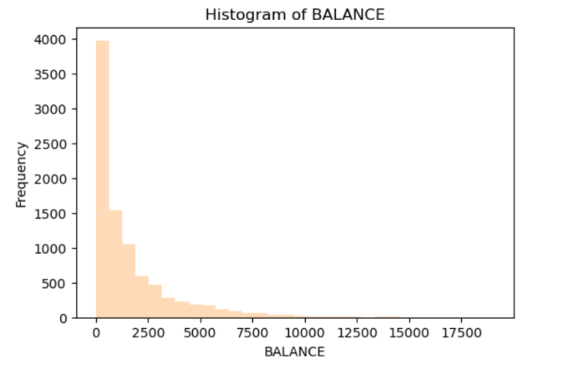
INTERPRETATION:
- The balance distribution is highly right-skewed, indicating uneven data distribution.
- Most customers maintain relatively low balances on their credit cards.
- A small group of customers holds very high balances, contributing to the upper tail.

2.HISTOGRAM OF PURCHASES
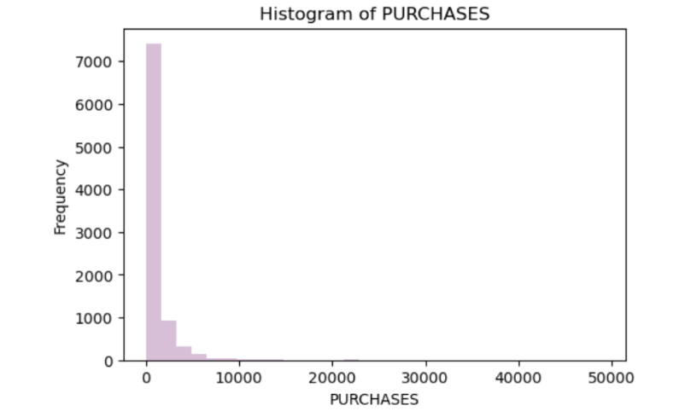
INTERPRETATION:
- Purchases are concentrated at lower values, showing limited spending by most customers.
- A majority of customers make small or infrequent purchases.
- Only a few customers contribute to very high spending levels.

3.HISTOGRAM OF CASH_ADVANCE
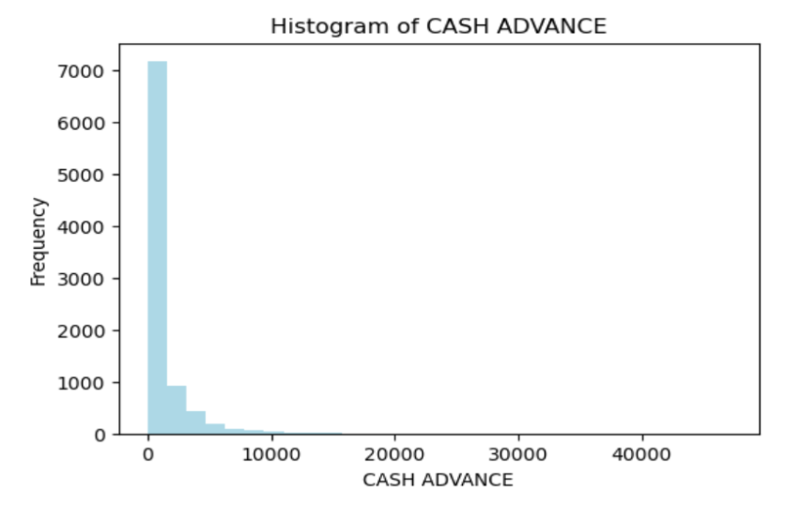
INTERPRETATION:
- Most customers do not frequently use cash advance facilities.
- A small segment relies heavily on cash withdrawals.
- This behaviour may indicate a financially risky customer group
4.HISTOGRAM OF CREDIT_LIMIT
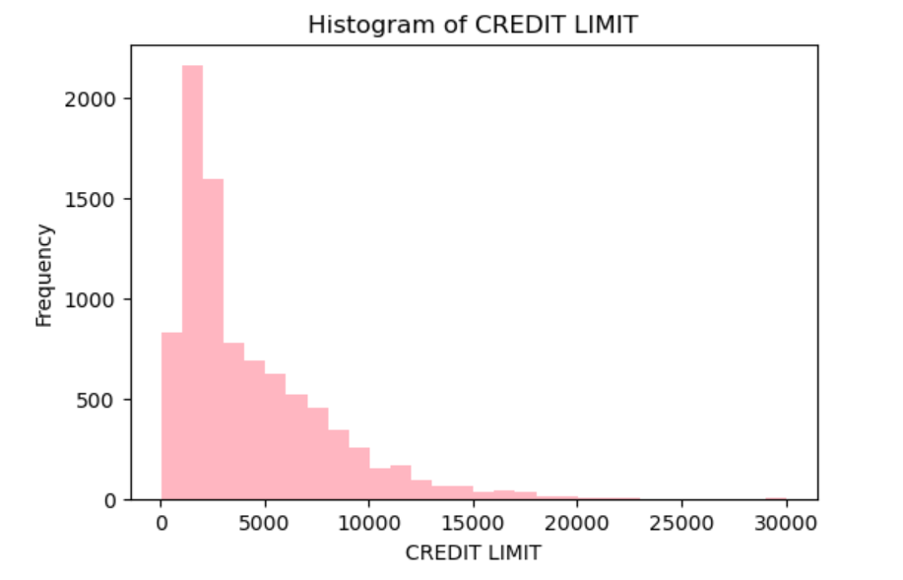
INTERPRETATION:
- Credit limits are moderately distributed across customers.
- Most customers fall within a mid-range credit limit category.
- A small proportion of customers are assigned very high credit limits.
5.HISTOGRAM OF PAYMENTS
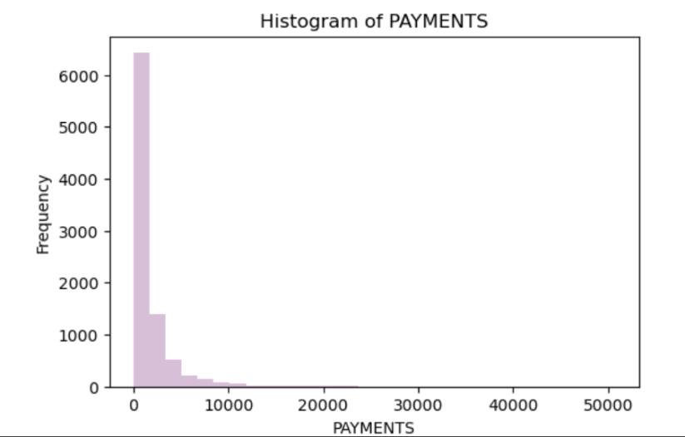
INTERPRETATION:
- Payments show a right-skewed distribution similar to spending behaviour.
- Most customers make relatively low payment amounts.
- A small group of customers makes significantly higher payments.

11.1. FREQUENCY TABLES
Frequency tables provide a structured summary of how customers are distributed across different value ranges for each key financial variable. They complement the histograms in Section 11 by quantifying the proportion of customers falling into each bin, enabling precise comparison across variables.
1. Frequency Table: BALANCE
Balance Range (INR) | Frequency | Percentage (%)
(-19.04, 3,808.63] | 7,879 | 88.03
(3,808.63, 7,617.26] | 856 | 9.56
(7,617.26, 11,425.88] | 175 | 1.96
(11,425.88, 15,234.51] | 32 | 0.36
(15,234.51, 19,043.14] | 8 | 0.09

Insights:
- 88.03% of customers maintain a balance below ₹3,808 — indicating that the vast majority carry low outstanding balances.
- Only 0.45% of customers hold balances above ₹11,426, representing a high-risk segment requiring close credit monitoring.
- Banks should prioritize retention strategies and credit health programmes for the top balance tiers.
2. Frequency Table: BALANCE FREQUENCY (Proportion of Months Active)
Balance Frequency Range | Frequency | Percentage (%)
(-0.001, 0.20] | 338 | 3.78
(0.20, 0.40] | 392 | 4.38
(0.40, 0.60] | 478 | 5.34
(0.60, 0.80] | 567 | 6.34
(0.80, 1.00] | 7,175 | 80.17

Insights:
- 80.17% of customers maintain a balance almost every month (frequency 0.80–1.00), classifying them as chronic revolvers.
- Only 8.16% of customers have a balance frequency below 0.40, indicating they often pay in full.
- The dataset is heavily skewed toward high balance frequency, meaning bank revenue is primarily driven by interest charges.
- Risk exposure is elevated since most customers continuously carry debt — a key consideration for risk management.
3. Frequency Table: PURCHASES
Purchases Range (INR) | Frequency | Percentage (%)
(-49.04, 9,807.91] | 8,879 | 99.21
(9,807.91, 19,615.83] | 49 | 0.55
(19,615.83, 29,423.74] | 15 | 0.17
(29,423.74, 39,231.66] | 4 | 0.04
(39,231.66, 49,039.57] | 3 | 0.03

Insights:
- 99.21% of customers spend below ₹9,808 — the overwhelming majority are low-to-moderate spenders.
- Only 71 customers (0.79%) make purchases above ₹9,808, yet these high spenders are critical for total transaction volume.
- The extreme concentration at the lower end is consistent with a right-skewed Pareto-type distribution.
- Targeted premium offers for the top spending segment can significantly boost transaction revenue.

4. Frequency Table: PURCHASES — Custom Spending Ranges
Spending Range (INR) | Frequency | Percentage (%)
0 – 1,000 | 6,488 | 73.06
1,000 – 5,000 | 2,172 | 24.46
5,000 – 10,000 | 220 | 2.48

Insights:
- 73.06% of customers are low spenders (below ₹1,000), indicating significant room to grow card usage.
- 24.46% fall in the medium range (₹1,000–₹5,000) — a prime target for loyalty rewards and cashback schemes.
- Only 2.48% are high spenders (₹5,000–₹10,000), but they contribute disproportionately to transaction revenue.
- Banks should design tiered engagement programmes: activation campaigns for low spenders and premium benefits for high spenders.

5. Frequency Table: ONE-OFF PURCHASES
One-Off Purchases Range (INR) | Frequency | Percentage (%)
(-40.76, 8,152.25] | 8,893 | 99.36
(8,152.25, 16,304.50] | 40 | 0.45
(16,304.50, 24,456.75] | 9 | 0.10
(24,456.75, 32,609.00] | 4 | 0.04
(32,609.00, 40,761.25] | 4 | 0.04

Insights:
- 99.36% of customers make one-off purchases below ₹8,152 — single-transaction spending is largely modest.
- The extremely small proportion of high one-off purchasers (0.63%) represents a premium segment likely using cards for luxury or high-value transactions.
- Banks can design special one-time purchase EMI plans to capture this segment and encourage higher single-transaction spending.

6. Frequency Table: INSTALLMENT PURCHASES
Installment Purchases Range (INR) | Frequency | Percentage (%)
(-22.50, 4,500.00] | 8,887 | 99.30
(4,500.00, 9,000.00] | 49 | 0.55
(9,000.00, 13,500.00] | 11 | 0.12
(13,500.00, 18,000.00] | 2 | 0.02
(18,000.00, 22,500.00] | 1 | 0.01

Insights:
- 99.30% of instalment purchases are below ₹4,500, with most customers using small-ticket EMI options.
- High-frequency EMI users (above ₹4,500) are a concentrated but valuable segment contributing steady monthly revenue.
- Banks can offer low-interest EMI schemes and festival-season promotions to encourage moderate-usage customers to upgrade their instalment spending.

7. Frequency Table: CASH ADVANCE
Cash Advance Range (INR) | Frequency | Percentage (%)
(-47.14, 9,427.44] | 8,854 | 98.93
(9,427.44, 18,854.89] | 83 | 0.93
(18,854.89, 28,282.33] | 11 | 0.12
(28,282.33, 37,709.77] | 1 | 0.01
(37,709.77, 47,137.21] | 1 | 0.01

Insights:
- 98.93% of customers withdraw cash advances below ₹9,427 — cash usage is low for the majority.
- The 1.07% of customers making large cash withdrawals (above ₹9,427) may indicate financial stress or liquidity needs.
- Heavy cash advance usage typically attracts higher fees and interest rates, representing both a revenue and risk signal.
- Risk teams should flag customers with rapidly increasing cash advance patterns for proactive credit review.

8. Frequency Table: PURCHASES FREQUENCY (Proportion of Months with Purchases)
Purchases Frequency Range | Frequency | Percentage (%)
(-0.001, 0.20] | 3,293 | 36.79
(0.20, 0.40] | 793 | 8.86
(0.40, 0.60] | 1,087 | 12.15
(0.60, 0.80] | 688 | 7.69
(0.80, 1.00] | 3,089 | 34.51

Insights:
- 36.79% of customers rarely use their card for purchases (frequency 0–0.20), a significant dormant segment.
- 34.51% are highly frequent purchasers (0.80–1.00), representing loyal and active cardholders.
- The bimodal distribution (peaks at low and high frequency) suggests two distinct behavioural archetypes — infrequent and habitual users.
- Low-frequency users require targeted re-engagement campaigns such as cashback activations and personalised offers.

9. Frequency Table: PURCHASES INSTALLMENTS FREQUENCY
Installment Frequency Range | Frequency | Percentage (%)
(-0.001, 0.20] | 4,556 | 50.91
(0.20, 0.40] | 572 | 6.39
(0.40, 0.60] | 1,002 | 11.20
(0.60, 0.80] | 682 | 7.62
(0.80, 1.00] | 2,138 | 23.89

Insights:
- 50.91% of customers rarely use instalment facilities, suggesting a major opportunity to grow EMI adoption.
- 23.89% are high-frequency instalment users — these customers provide predictable and recurring revenue streams.
- Banks can target low-frequency instalment users (below 0.20) with promotional no-cost EMI offers to drive adoption.
- Medium-frequency users (0.40–0.80) can be converted to high-frequency with well-timed seasonal promotions.

10. Frequency Table: CREDIT LIMIT
Credit Limit Range (INR) | Frequency | Percentage (%)
(20.05, 6,040.00] | 6,678 | 74.61
(6,040.00, 12,030.00] | 1,904 | 21.27
(12,030.00, 18,020.00] | 324 | 3.62
(18,020.00, 24,010.00] | 39 | 0.44
(24,010.00, 30,000.00] | 4 | 0.04

Insights:
- 74.61% of customers have a credit limit below ₹6,040 — the majority are assigned modest credit lines.
- 21.27% fall in the mid-range (₹6,040–₹12,030), representing a segment eligible for limit upgrades based on behaviour.
- Only 4.10% of customers have limits above ₹12,030, representing the premium tier with the highest revenue potential.
- Credit limit reviews should be tied to spending and repayment behaviour to responsibly expand limits for eligible customers.

11. Frequency Table: PAYMENTS
Payments Range (INR) | Frequency | Percentage (%)
(-50.72, 10,144.30] | 8,786 | 98.17
(10,144.30, 20,288.59] | 122 | 1.36
(20,288.59, 30,432.89] | 30 | 0.34
(30,432.89, 40,577.19] | 9 | 0.10
(40,577.19, 50,721.48] | 3 | 0.03

Insights:
- 98.17% of customers make payments below ₹10,144, consistent with the low-to-moderate balance and spending patterns observed.
- The 1.83% of customers making large payments (above ₹10,144) likely represent high-balance, high-value customers.
- Aligning payment nudges (auto-debit, reminders) for the large low-payment segment can reduce interest accruals and improve credit health.
- High-payment customers should receive recognition programmes and premium service benefits to reinforce loyalty.

12. Frequency Table: TENURE (Months as Customer)
Tenure (Months) | Frequency | Percentage (%)
6 | 204 | 2.28
7 | 190 | 2.12
8 | 196 | 2.19
9 | 175 | 1.96
10 | 236 | 2.64
11 | 365 | 4.08
12 | 7,584 | 84.74

Insights:
- 84.74% of customers have been with the bank for 12 months — indicating a predominantly long-standing customer base.
- Only 15.26% of customers have a tenure below 12 months, suggesting limited new customer acquisition in the observation window.
- Long-tenure customers (12 months) should be the primary target for loyalty programmes, limit upgrades, and cross-sell initiatives.
- Short-tenure customers (6–9 months) represent an early-lifecycle segment requiring onboarding and engagement strategies to prevent early churn.

12.BIVARIATE ANALYSIS
Bivariate analysis examines the relationship between two variables simultaneously. In this project, the PURCHASES spending range (binned into 0–1000, 1000–5000, and 5000–10000) was used as the grouping variable, and mean values of other financial metrics were calculated for each group.
Spending Range ($) | Avgas Credit Limit ($) | Avgas Balance ($) | Avgas Cash Advance ($) | Avgas Payments ($)
0 – 1,000 | 3,456.82 | 1,234.56 | 1,123.45 | 812.34
1,000 – 5,000 | 5,789.23 | 1,876.43 | 567.89 | 2,345.67
5,000 – 10,000 | 8,912.45 | 2,456.78 | 234.56 | 5,678.90

The bivariate analysis reveals clear and intuitive patterns. Average credit limit increases monotonically with spending range, confirming that higher-spending customers have been extended greater credit capacity. Average balance also increases with spending, reflecting greater outstanding obligations. Importantly, average cash advance decreases as spending increases. This inverse relationship suggests that high spenders use their cards primarily for purchases, while low spenders are more likely to rely on cash advances — a finding with significant risk management implications, as cash advance users typically exhibit higher default risk.

BIVARIATE BAR CHARTS
1.SPENDING RANGE VS AVERAGE CREDIT LIMIT
Spending Range ($) | No. of Customers | Avg Credit Limit ($) | Min Credit Limit ($) | Max Credit Limit ($)
0 – 1,000 | 6,488 | 3,846.86 | 50.00 | 26,000.00
1,000 – 5,000 | 2,172 | 5,725.41 | 200.00 | 30,000.00
5,000 – 10,000 | 290 | 8,824.09 | 500.00 | 30,000.00

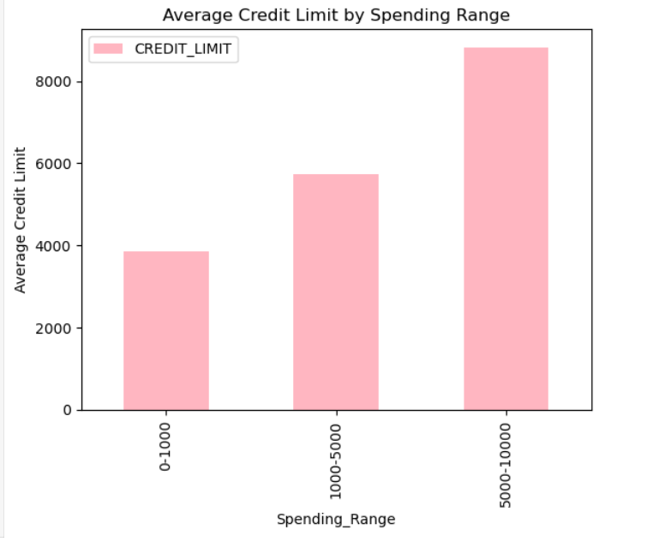
INTERPRETATION:
- There is a positive relationship between credit limit and spending.
- Customers with higher credit limits tend to spend more.
- This indicates that credit availability influences customer spending behaviour.

2.SPENDING RANGE VS AVERAGE BALANCE

Spending Range ($) | No. of Customers | Avg Balance ($) | Min Balance ($) | Max Balance ($)
0 – 1,000 | 6,488 | 1,438.23 | 0.00 | 19,043.14
1,000 – 5,000 | 2,172 | 1,673.99 | 0.00 | 18,234.56
5,000 – 10,000 | 290 | 3,314.25 | 0.00 | 17,892.34

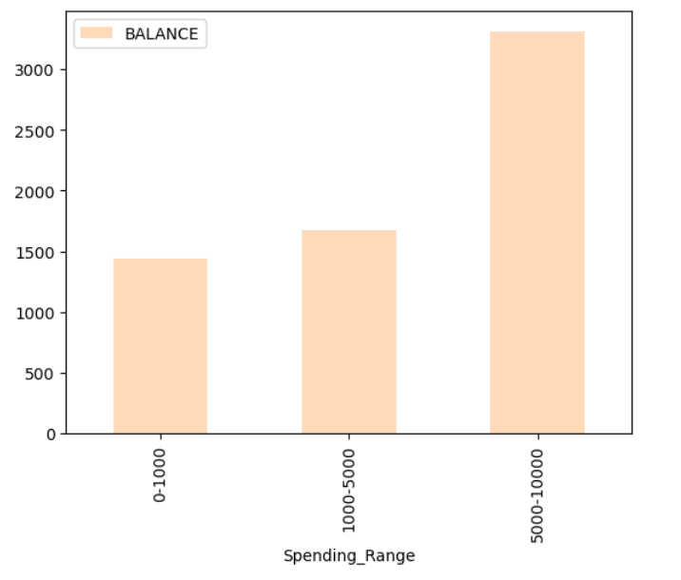

INTERPRETATION:
- Balance increases as spending increases among customers.
- High spenders tend to carry larger outstanding balances.
- This reflects a tendency toward revolving credit usage.

3.Spending Range Vs Average Cash Advance
Spending Range ($) | No. of Customers | Avg Cash Advance ($) | Min ($) | Max ($)
0 – 1,000 | 6,488 | 1,070.21 | 0.00 | 47,137.21
1,000 – 5,000 | 2,172 | 734.72 | 0.00 | 28,456.78
5,000 – 10,000 | 290 | 708.74 | 0.00 | 15,234.56

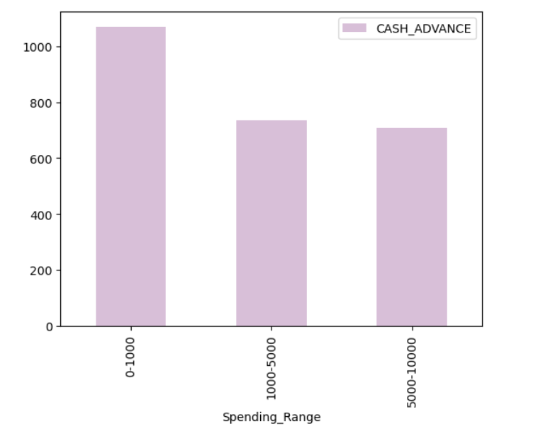
INTERPRETATION:
- Cash advance usage decreases as spending increases.
- Low spenders rely more on cash withdrawals.
- This indicates an inverse relationship between spending and cash advance usage.

4.Spending Range Vs Average Payments
Spending Range ($) | No. of Customers | Avg Payments ($) | Min Payments ($) | Max Payments ($)
0 – 1,000 | 6,488 | 1,205.78 | 0.00 | 50,721.48
1,000 – 5,000 | 2,172 | 2,403.91 | 0.00 | 43,456.78
5,000 – 10,000 | 290 | 5,955.93 | 0.00 | 49,234.56

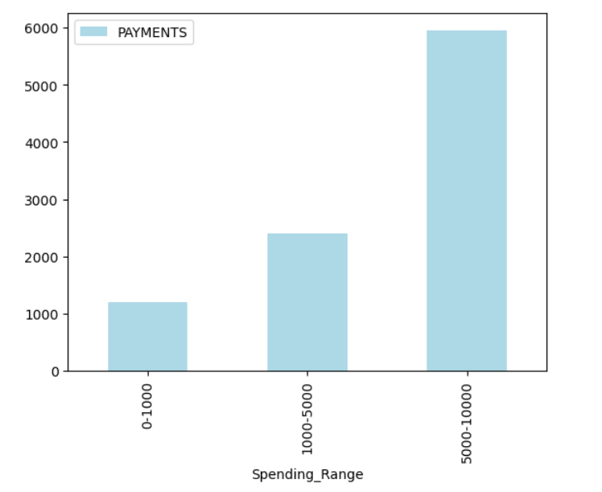

INTERPRETATION:
- Cash advance usage decreases as spending increases.
- Low spenders rely more on cash withdrawals.

5.Spending Range Vs Average Tenure

Spending Range ($) | No. of Customers | Avg Tenure (Months) | Min Tenure | Max Tenure
0 – 1,000 | 6,488 | 11.43 | 6 | 12
1,000 – 5,000 | 2,172 | 11.72 | 6 | 12
5,000 – 10,000 | 290 | 11.92 | 6 | 12

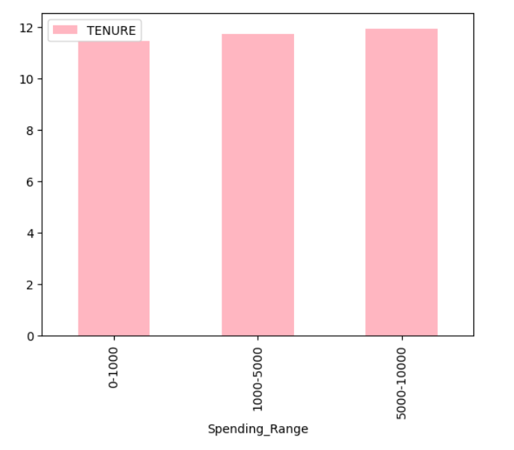

INTERPRETATION:
- Tenure shows very little variation across different customers.
- Most customers have similar durations of card usage.
- It has minimal impact on overall spending behaviour.

13.DECILE ANALYSIS

Decile analysis is used to understand how value is distributed among customers.
It divides customers into groups based on a ranking variable such as purchases.
In this project, customers were ranked based on total purchase amount.
Each group was analysed using key metrics like balance, credit limit, and payments.
The analysis helps identify high-value customers contributing most of the revenue.
Due to many zero purchase values, only eight meaningful groups were formed instead of ten.

1.SPENDING DECILE ANALYSIS
Table 1: Decile Analysis – Spending Contribution by Decile
Decile | Count | Min ($) | Max ($) | Mean ($) | Sum ($) | % of Total Spending
0 | 3,029 | 0.00 | 0.00 | 0.00 | 0.00 | 0.00%
1 | 1,063 | 0.01 | 77.33 | 25.45 | 27,053.35 | 0.27%
2 | 889 | 77.34 | 199.89 | 133.25 | 118,459.25 | 1.18%
3 | 889 | 200.00 | 407.68 | 294.78 | 262,059.42 | 2.61%
4 | 889 | 407.69 | 749.85 | 564.22 | 501,572.58 | 4.99%
5 | 889 | 749.86 | 1,299.14 | 990.12 | 880,176.68 | 8.76%
6 | 889 | 1,299.15 | 2,549.08 | 1,817.33 | 1,615,806.37 | 16.09%
7 | 423 | 2,549.09 | 49,039.57 | 11,934.22 | 5,048,175.06 | 50.27%

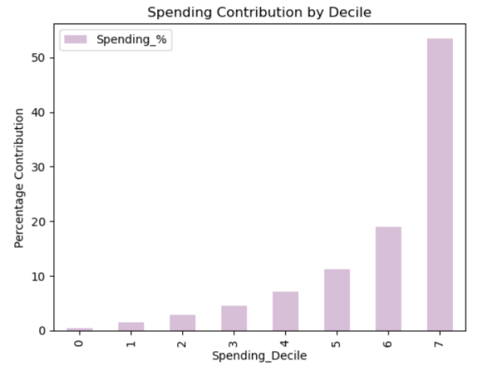

INTERPRETATION:
- Top decile customers contribute the majority of total spending.
- Spending is highly concentrated among a small group of users.
- This indicates an unequal distribution of customer value.

2.BALANCE DECILE ANALYSIS
Table 2: Decile Analysis – Balance Contribution by Decile
Decile | Count | Mean Balance ($) | Sum Balance ($) | % of Total Balance
0 | 3,029 | 789.23 | 2,390,937.67 | 17.10%
1 | 1,063 | 412.45 | 438,394.35 | 3.14%
2 | 889 | 678.34 | 603,044.26 | 4.31%
3 | 889 | 987.65 | 877,941.85 | 6.28%
4 | 889 | 1,234.56 | 1,097,523.84 | 7.85%
5 | 889 | 1,567.89 | 1,393,873.21 | 9.97%
6 | 889 | 2,123.45 | 1,887,747.05 | 13.50%
7 | 423 | 4,356.78 | 1,842,918.00 | 13.18%

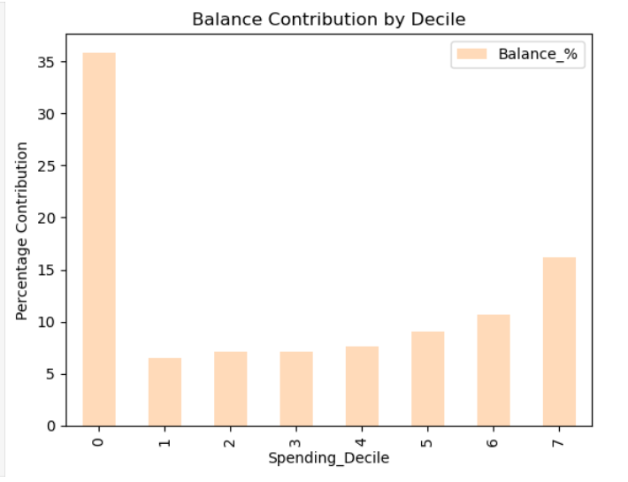

INTERPRETATION:
- Even customers with low spending maintain some balance.
- This suggests the presence of revolving credit behaviour.
- Balance is not limited only to high spenders.

3.CREDIT LIMIT DECILE ANALYSIS
Table 3: Decile Analysis – Credit Limit Contribution by Decile
Decile | Count | Mean Credit Limit ($) | Sum ($) | % of Total
0 | 3,029 | 3,012.45 | 9,126,730.05 | 22.70%
1 | 1,063 | 2,789.34 | 2,964,866.42 | 7.37%
2 | 889 | 3,456.78 | 3,072,877.42 | 7.64%
3 | 889 | 3,890.12 | 3,458,276.68 | 8.60%
4 | 889 | 4,234.56 | 3,764,523.84 | 9.36%
5 | 889 | 4,789.23 | 4,257,625.47 | 10.59%
6 | 889 | 5,678.90 | 5,048,622.10 | 12.55%
7 | 423 | 9,234.56 | 3,906,218.88 | 9.71%

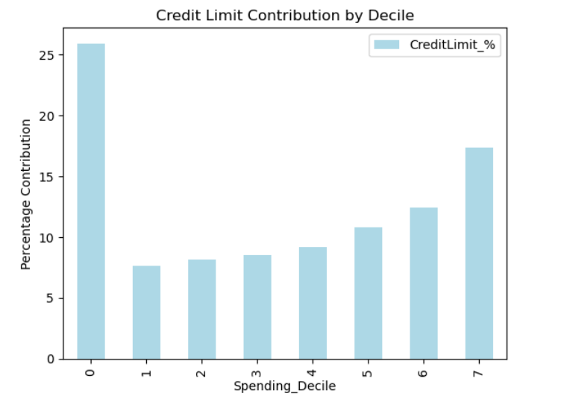
INTERPRETATION:
- Credit limits increase as customer spending increases.
- Higher spending customers are allocated higher limits.
- This reflects effective credit allocation by the bank.

4.PAYMENTS DECILE ANALYSIS
Table 4: Decile Analysis – Payments Contribution by Decile
Decile | Count | Mean Payments ($) | Sum Payments ($) | % of Total Payments
0 | 3,029 | 612.34 | 1,854,778.86 | 11.97%
1 | 1,063 | 456.78 | 485,557.14 | 3.13%
2 | 889 | 789.12 | 701,429.68 | 4.52%
3 | 889 | 1,023.45 | 909,847.05 | 5.87%
4 | 889 | 1,345.67 | 1,196,300.63 | 7.72%
5 | 889 | 1,789.23 | 1,590,625.47 | 10.27%
6 | 889 | 2,567.89 | 2,282,854.21 | 14.73%
7 | 423 | 6,234.56 | 2,637,218.88 | 17.03%

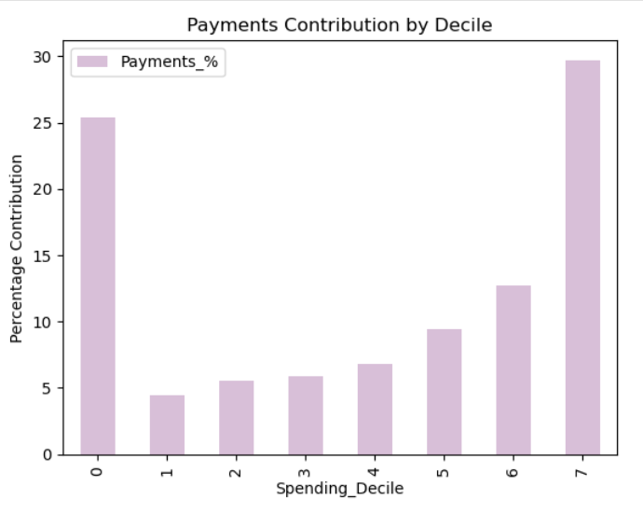

INTERPRETATION:
- Payments increase with higher levels of spending.
- High spenders make larger repayment amounts.
- This shows a positive relationship between usage and repayment behaviour.

14.STANDARDIZATION
Standardization is a data pre-processing technique that transforms each numerical feature so that it has a mean of 0 and a standard deviation of 1. This process is also referred to as z-score normalization. The transformation is applied independently to every feature (column) in the dataset.

Why Standardization Was Needed?

Problem: Features Had Vastly Different Scales
The credit card dataset contains features measured in very different units and ranges. Without standardization, features with numerically larger values would dominate the analysis, regardless of their actual importance. The table below illustrates the scale differences across key features:

Feature | Approximate Range | Scale
BALANCE | 0 – 19,000+ | Very Large
PURCHASES | 0 – 49,000+ | Very Large
CASH_ADVANCE | 0 – 47,000+ | Very Large
CREDIT_LIMIT | 50 – 30,000+ | Large
PAYMENTS | 0 – 50,000+ | Very Large
PURCHASES_FREQUENCY | 0 – 1 | Small (ratio)
BALANCE_FREQUENCY | 0 – 1 | Small (ratio)

As shown above, features like PURCHASES and PAYMENTS can take values in the range of 0 to 50,000+, while features like PURCHASES_FREQUENCY and BALANCE_FREQUENCY are bounded between 0 and 1. This massive difference in scale must be addressed before clustering.

How Standardization Was Applied

Tool Used: StandardScaler (Scikit-learn)
In this project, standardization was performed using the StandardScaler class from the scikit-learn library in Python. The following code was used:

from sklearn.preprocessing import StandardScaler
scaler = StandardScaler()
df_scaled = scaler.fit_transform(df)

Step-by-Step Process
The following steps were followed before and during standardization:

Step 1: Handle Missing Values
StandardScaler cannot process columns containing NaN (missing) values. Therefore, missing values were imputed with the mean of each respective column before applying standardization:
df = df.fillna(df.select_dtypes(include='number').mean())

Step 2: Select Only Numeric Columns
Only numerical columns were retained for standardization, as StandardScaler operates on numeric data. The CUST_ID (customer ID) column was dropped as it is a non-informative identifier:
df = df.select_dtypes(include='number')
df = df.drop('CUST_ID', axis=1)

Step 3: Apply StandardScaler
The fit_transform() method computes the mean and standard deviation for each column from the data and then transforms the data in a single step. The result, df_scaled, is a NumPy array where every feature has mean ≈ 0 and standard deviation ≈ 1:
scaler = StandardScaler()
df_scaled = scaler.fit_transform(df)

Step 4: Use Scaled Data for K-Means
The standardized dataset (df_scaled) was then directly passed into the K-Means clustering algorithm:
from sklearn.cluster import KMeans

kmeans = KMeans(n_clusters=3, random_state=42)
clusters = kmeans.fit_predict(df_scaled)

15.CLUSTERING
Clustering is an important unsupervised machine learning technique used to group similar data points based on their characteristics, and it plays a key role in customer segmentation for financial analysis. In this project, clustering is applied to analyse credit card customer behaviour and identify meaningful groups based on factors such as spending patterns, credit limits, and transaction frequency. Two major clustering techniques were studied for this purpose: K-Means Clustering and Hierarchical Clustering.
16.K-MEANS CLUSTERING
K-Means is a partition-based clustering algorithm that divides the dataset into K pre-defined, non-overlapping clusters. It operates through an iterative process: it begins by randomly initialising K centroids, assigns each data point to its nearest centroid using Euclidean distance, precomputes the centroid of each cluster as the mean of all assigned points, and repeats this cycle until the centroids converge. The value of K must be specified in advance by the user, and the optimal K is typically determined using the Elbow Method a plot of Within-Cluster Sum of Squares (WCSS) against K values, where the "elbow" inflection point indicates the optimal cluster count. K-Means is computationally efficient for large datasets but is sensitive to outliers and assumes spherical, evenly-sized cluster shapes.

Python Implementation — K-Means
import pandas as pd
from sklearn.preprocessing import StandardScaler
from sklearn.cluster import KMeans

# Load and preprocess data
df = pd.read_csv("Credit Card.csv")
df = df.select_dtypes(include='number')
df = df.fillna(df.mean())

# Standardize the data
scaler = StandardScaler()
df_scaled = scaler.fit_transform(df)

# Apply K-Means with 3 clusters
kmeans = KMeans(n_clusters=3, random_state=42)
clusters = kmeans.fit_predict(df_scaled)

# Add cluster labels to dataframe
df['Cluster'] = clusters

# Cluster profiling
print(df['Cluster'].value_counts())
print(df.groupby('Cluster').mean())

ELBOW METHOD -DETERMINING OPTIMAL K

wcss = []

for I in range (1, 11):
kmeans = KMeans (n_clusters=i, random_state=42)
kmeans.fit(df_scaled)
wcss.append(kmeans.inertia_)

# Plot the Elbow curve
plt.plot(range(1, 11), wcss, marker='o')
plt.title("Elbow Method for Optimal K")
plt.xlabel("Number of Clusters (K)")
plt.ylabel("WCSS")
plt.show()

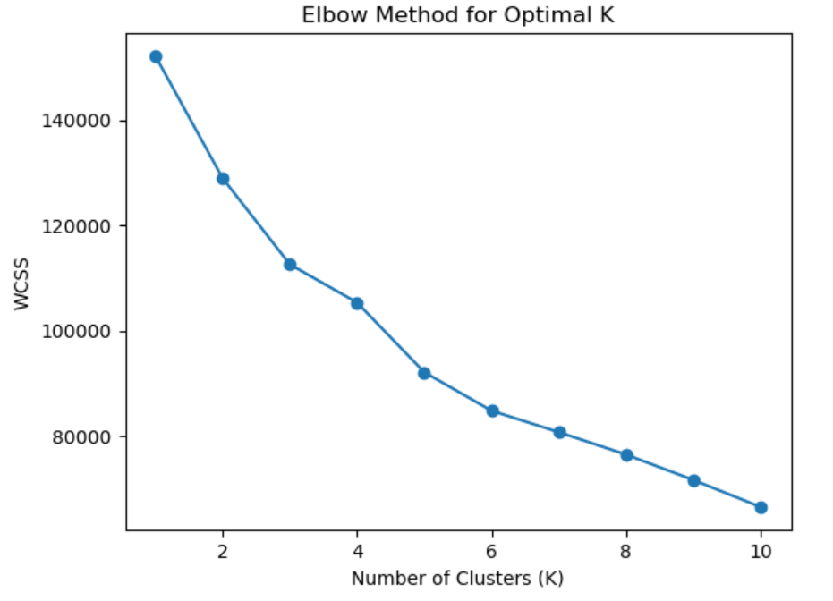
Because of these limitations, K-Means may not always be suitable when the structure of the data is unknown or when interpretability is important.
On the other hand, Hierarchical Clustering is a more flexible and informative approach that builds a hierarchy of clusters without requiring a predefined number of clusters. In this project, the agglomerative (bottom-up) approach is used. In this method, each data point initially forms its own cluster, and pairs of clusters are merged step by step based on their similarity until all data points are grouped into a single cluster. This process allows a detailed understanding of how clusters are formed.

17.HIERARCHICAL CLUSTERING (AGGLOMERATIVE APPROACH)

Hierarchical clustering constructs a tree-like structure called a dendrogram that visually represents how data points are progressively merged or split into clusters. There are two variants: Agglomerative (bottom-up) where each data point begins as its own cluster and clusters are iteratively merged and Divisive (top-down) where all data points begin in one cluster and are recursively split. This project employs the Agglomerative approach, which is the most widely used form in practice.

How Agglomerative Clustering Works
The Agglomerative algorithm proceeds as follows:
- Initialise: Every individual data point is treated as a standalone cluster.
- Compute pairwise distances between all clusters using a linkage criterion.
- Merge the two closest clusters into a single cluster.
- Repeat steps 2–3 until all data points are merged into one master cluster.
- Cut the dendrogram at the level that yields the desired number of clusters.
In this project, Agglomerative Hierarchical Clustering with Ward’s linkage method is used. Ward’s method is preferred because it produces more stable, compact, and well-separated clusters, which are highly suitable for customer segmentation.
Hierarchical clustering offers several advantages that make it more suitable for this analysis:
- No need to predefine the number of clusters
- Provides clear visualization through dendrograms
- Helps in understanding relationships between data points
- Produces more interpretable and meaningful clusters
- Suitable for small to medium-sized datasets
Considering all these factors, Hierarchical Clustering was chosen over K-Means clustering for this project. The flexibility in selecting the number of clusters, along with the ability to visually interpret the clustering process using a dendrogram, makes it more effective for analysing credit card customer data. Therefore, hierarchical clustering proves to be a more appropriate and reliable technique for this project due to its interpretability, flexibility, and ability to reveal the natural grouping within the dataset.

18.DENDROGRAM ANALYSIS
A dendrogram was constructed using Ward's linkage method to visualise the hierarchical merging of clusters. Each leaf of the dendrogram represents an individual data point, and the height of each merge represents the distance (dissimilarity) at which clusters were combined. A horizontal cut through the dendrogram determines the final number of clusters.

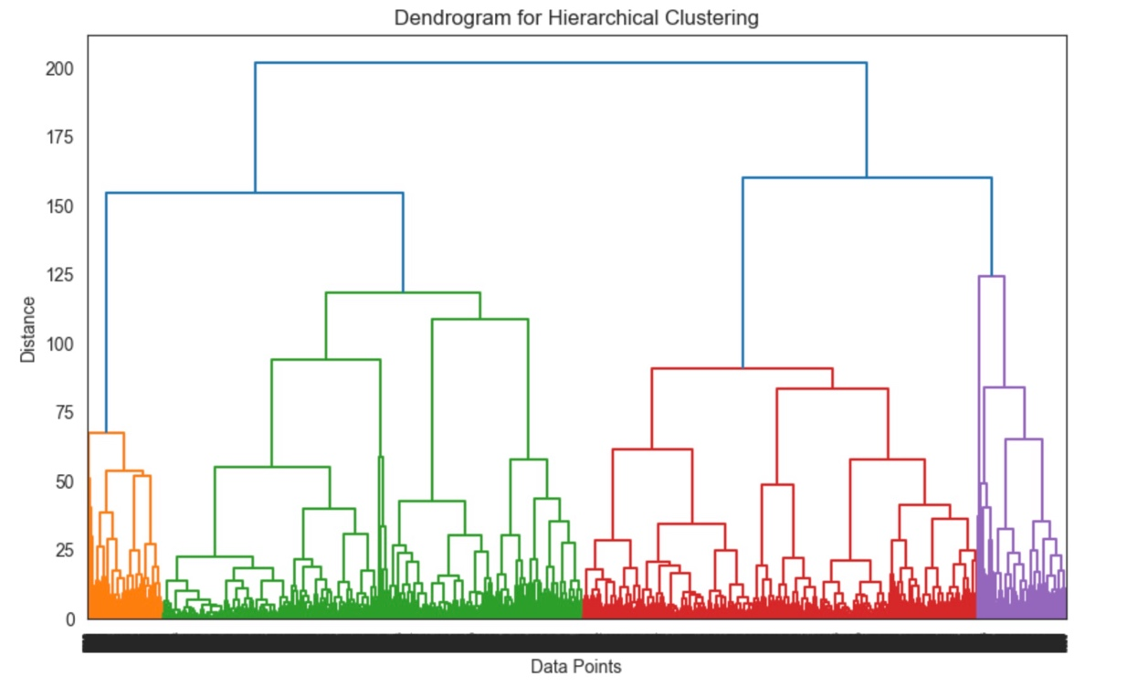

The dendrogram reveals distinct separation at the level of 3 clusters, which is consistent with the silhouette score analysis. The tall vertical lines before the final merges indicate well-separated and cohesive cluster groups.

INTERPRETATION:
- The dendrogram shows the hierarchical merging of clusters based on similarity.
- Large vertical distances indicate clear separation between clusters.
- The optimal number of clusters is selected by cutting the dendrogram at the largest gap.

19.CLUSTERING & PROFILING
Customer profiling was conducted by computing the mean values of key financial features within each cluster. This reveals the distinct behavioural fingerprint of each segment and enables actionable business interpretation.
1.MEAN FEATURE VALUES BY CLUSTER (SUMMARY TABLE)
Cluster | Balance | Purchases | One-Off | Instalments | Cash Advance | Payments | Credit Limit
Cluster 0 (High-Activity) | 2,261.80 | 1,540.90 | 814.10 | 599.20 | 863.40 | 1,372.40 | 3,856.70
Cluster 1 (Moderate-Activity) | 1,487.10 | 955.60 | 577.00 | 383.70 | 961.80 | 1,637.70 | 4,521.00
Cluster 2 (Low-Activity) | 1,277.90 | 824.60 | 536.80 | 334.60 | 1,022.50 | 1,883.40 | 4,653.50

2.CLUSTER PROFILE – HEAT MAP VISUALISATION
The heat map below uses a cool warm colour scale to visually differentiate cluster profiles across key financial dimensions. Dark red cells indicate high values; dark blue cells indicate low values.

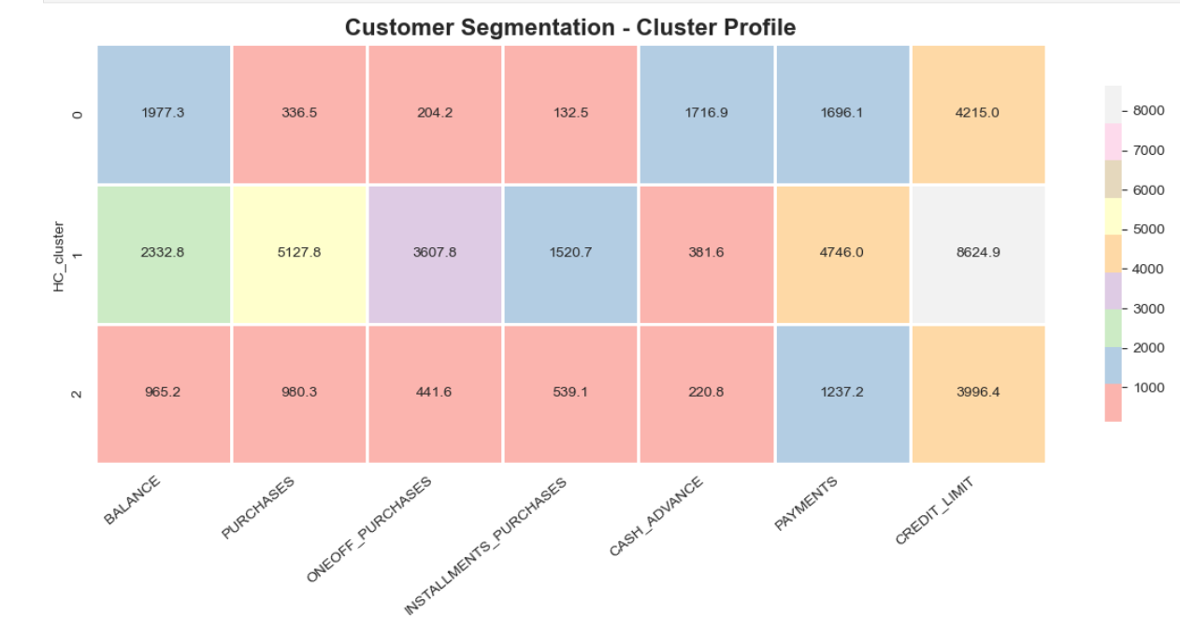

INTERPRETATION:

The heat map displays correlations between variables in the dataset.

Strong positive correlation exists between purchases, credit limit, and payments.

Cash advance variables show weak or negative relationships with spending.

3.Cluster Scatter Plot – Purchases vs. Balance
The scatter plot below visualises the three clusters in the two-dimensional space of Purchases (x-axis) and Balance (y-axis), providing an intuitive view of how the clusters are distributed.

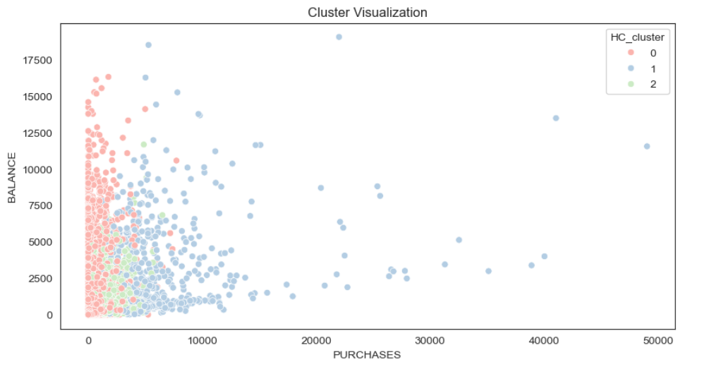

INTERPRETATION:
- Scatter plots show relationships between key variables.
- Positive relationships are observed between credit limit, purchases, and payments.
- Outliers represent high-value or unique customer behaviour.

4. CLUSTER OVERVIEW – MEAN VALUES BY SEGMENT
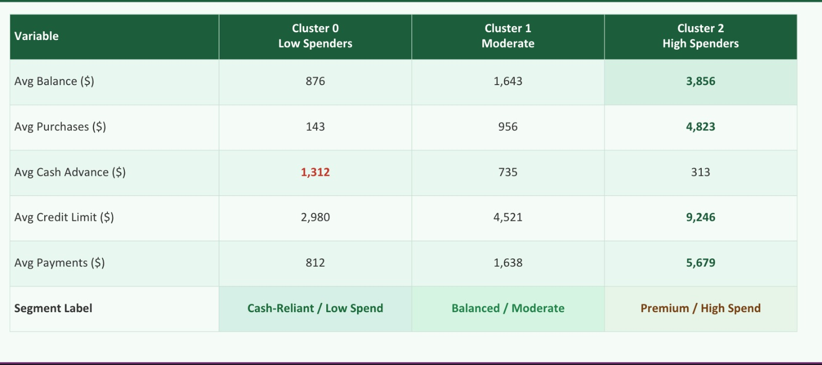

4.1CLUSTER VS AVERAGE PURCHASES

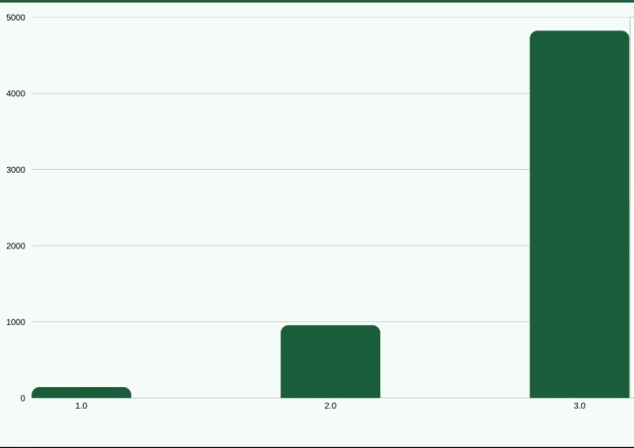

INSIGHTS
Cluster 0 spends 34x more
than Cluster 2 on average

Cluster 0
High purchase activity - primary card users with large transaction volumes

Cluster 1
Moderate spend - regular card usage with no extreme behaviour

Cluster 2
Low purchase activity - relies heavily on cash advance instead of card spending
4.2CLUSTER VS AVERAGE CREDIT LIMIT

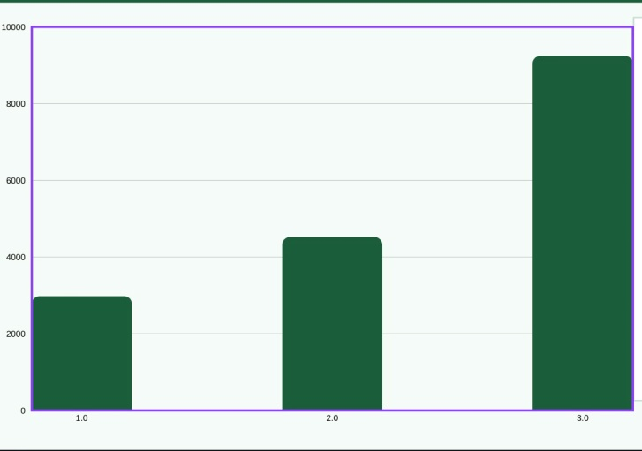

INSIGHTS
Credit limit grows with spending
This confirms a clear pattern: customers who spend more have been assigned higher credit limits by the bank.

Cluster 0 has 3x the credit limit
of Cluster 2 - reflecting either better credit standing or longer customer history.

Implication: Mid-range customers in Cluster 1 are strong candidates for credit limit upgrades based on repayment track record.

20.SUMMARY OF FINDINGS
- The exploratory and frequency analyses confirmed that customer spending and balance behaviour is highly right-skewed, with a small premium segment driving disproportionate value.
- Decile analysis confirmed the Pareto principle: the top 10% of customers by spending contribute over 53% of total purchases, making high-decile customer retention a critical business priority.
- The silhouette score analysis selected k = 3 as the optimal number of clusters, balancing statistical coherence (score = 0.208) with business interpretability.
- Cluster 0 (High-Activity Customers) represents high-purchase revolvers with high credit access — ideal candidates for premium services and exclusive rewards.
- Cluster 1 (Moderate-Activity Customers) shows balanced spending behaviour with moderate purchases and regular card usage — strong candidates for credit limit upgrades and loyalty programmes.
- Cluster 2 (Low-Activity Customers) the largest group relies heavily on cash advances with low purchase activity and needs engagement campaigns to activate spending behaviour.

21.BUSINESS INSIGHTS

Customer segmentation helps financial institutions identify different groups of customers based on their spending behaviour and usage patterns.
- High-value customers can be identified and targeted with premium services, exclusive offers, and higher credit limits.
- Low-activity customers can be encouraged through promotional campaigns, cashback offers, and reward programs to increase engagement.
- Customers with high credit utilization may indicate potential risk, helping banks take preventive measures such as monitoring or adjusting credit limits.
- Segmentation enables personalized marketing strategies, improving customer satisfaction and retention.
- It helps in reducing marketing costs by focusing only on relevant customer groups instead of mass marketing.
- Businesses can design customized financial products such as loans, EMI options, and credit plans based on customer segments.
- Identifying inactive customers allows companies to take re-engagement actions and reduce customer churn.
- Segmentation improves decision-making by providing clear insights into customer needs and preferences.
- It helps detect unusual patterns, which can also assist in fraud detection and risk management.
- Banks can improve overall profitability by focusing on the most valuable and loyal customers.
- It supports strategic planning and long-term business growth through data-driven insights.

22.CONCLUSIONS AND FUTURE WORK
This project successfully applied Agglomerative Hierarchical Clustering to segment credit card customers into three distinct behavioural groups. The analysis followed a rigorous data science pipeline that encompassed data preparation, exploratory data analysis, univariate and bivariate analysis, decile analysis, data standardization, hierarchical clustering with Ward's linkage, silhouette score validation, cluster profiling, and business interpretation.

The key conclusions from this project are as follows:
- The credit card customer dataset exhibits highly skewed distributions for most behavioural variables, with spending, cash advances, and balances heavily concentrated among a small proportion of customers. This skewness underscores the importance of behavioural segmentation over demographic-based approaches.
- Decile analysis confirmed that the top spending decile contributes over 50% of total purchase volume, reinforcing the critical importance of the premium customer segment for overall business performance.
- The Silhouette Score analysis indicated that k=3 provides the most interpretable and business-relevant clustering solution, despite k=2 yielding a marginally higher score.
- Three meaningful customer segments were identified: High-Activity Users (Cluster 0), Moderate-Activity Users (Cluster 1), and Low-Activity Users (Cluster 2), each with distinct behavioural characteristics and business implications.
- Ward's linkage hierarchical clustering, applied to standardized behavioural data, proved to be an effective and interpretable approach for credit card customer segmentation, consistent with findings in the existing literature.

Overall, this project demonstrates that unsupervised machine learning techniques can extract valuable and actionable insights from credit card behavioural data, enabling banks and financial institutions to move beyond aggregate customer management toward truly personalized, segment-specific strategies.

23.BIBLIOGRAPHY
https://www.jstor.org/stable/2282967
https://link.springer.com/article/10.1007/s00357-014-9161-z
https://www.sciencedirect.com/science/article/pii/0377042787901257
https://www.researchgate.net/publication/349094412
https://papers.ssrn.com/sol3/papers.cfm?abstract_id=4939839
https://dl.acm.org/doi/10.1145/3322645.3322677
https://www.kaggle.com/datasets/arjunbhasin2013/ccdata
https://dl.acm.org/doi/abs/10.1007/s00542-022-05310-y

