**SOCIAL MEDIA TREND ANALYSIS**

create database social_media_analysis;

use social_media_analysis;

sp_rename 'Viral_Social_Media_Trends' , 'social_media_posts'

Select * from SYS.tables;

Select * from social_media_posts;

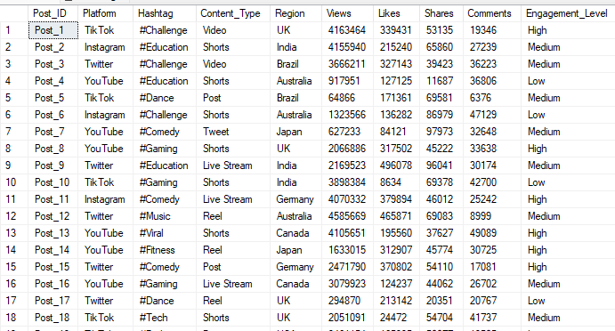

--1. Basic Statistics of all fields (Data Exploration-Basic Stat Queries)

select count(*) as 'Total post taken for analysis' from Social_Media_Posts



select count(Post_ID) as 'Total Posts',

avg(Views) as 'Average Views',

avg(Likes) as 'Average Likes',

avg(Shares) as 'Average Shares',

avg(Comments) as 'Average Comments'

from social_media_posts;



select Platform,

count(Post_ID) as 'No.of.Posts'from Social_Media_Posts

group by Platform;

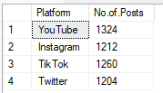

**Business Insights**

--2. Most viral hashtags (by views and engagement)

select Hashtag,sum(Views) as total_views,

avg(Likes+Shares+Comments) as avg_engagement_per_post

from social_media_posts

group by Hashtag

order by total_views desc;

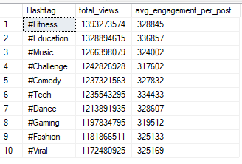

Notable Insights:

Fitness hashtag tops among all the hashtags followed by Education,Music i.e the contents related to these hashtags attracts more social media users.

--3. Best-performing content types

select Content_Type,

avg(Views) as avg_views,

avg(Likes) as avg_likes

from social_media_posts

group by Content_Type

order by avg_views desc;

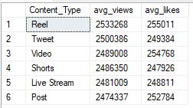

Notable Insights:

The Instagram Reels were found to be interesting by the users followed by tweets and videos

--4. Regions with highest engagement levels

select Region,count(Post_ID) as post_count,

avg(Views) as avg_views,

avg(Likes + Shares + Comments) as avg_engagement

from social_media_posts

group by Region

order by avg_engagement desc;

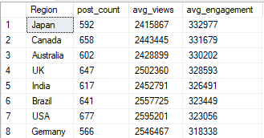

Key Insights:

The Japanese were found to be using Social Medias extensively followed by Canada,Australia and so on..where India stands in fifth place.

--5. Most popular platform in each region

Select Region,Platform,count(Post_ID) as post_count

from social_media_posts

group by Region, Platform

order by Region, post_count desc;

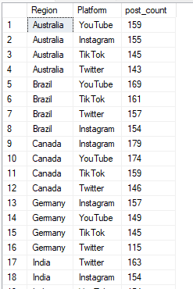

Key Insights:

The query displays the most engaged social platforms in each Country based on the number of post_count in the platforms. Australians,Brazilians,Germans had most post counts in Youtube whereas Canadians had most post in Instagram whereas Indian used Twitter as their popular Social platform.

--6. Comparing metrics by engagement level

select Engagement_Level,

avg(Views) as avg_views,

avg(Likes) as avg_likes,

avg(Shares) as avg_shares,

avg(Comments) as avg_comments

from social_media_posts

group by Engagement_Level;

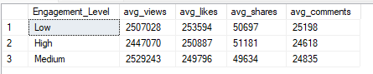

Key Insights:

There is no significant difference between any of these engagement levels(like,share,comment).The angagement activities depends on the individual users wish.

--7. Identify "controversial" content (high shares but low likes)

Select Region,

Post_ID,

Platform,

Hashtag,

Shares,

Likes,

(Shares/Likes) as share_ratio

from social_media_posts

where Likes > 0

order by share_ratio desc

offset 0 rows fetch next 3 rows only;

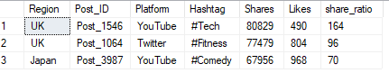

Insights:

The top 2 controversial posts were in UK followed by Japan having hashtags Tech,Fitness,Comedy.

--8. Comparing how the same hashtag performs across platform

select Hashtag,Platform,AVG(Views) as avg_views

from social_media_posts

group by Hashtag, Platform

order by Hashtag, avg_views desc;

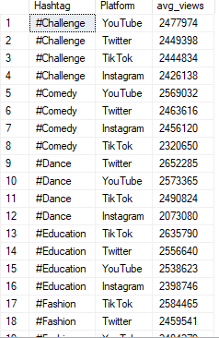

Insights:

The above query fetched how the same hashtags were popular in different social media platforms.

--9. Most used platform in India

select Platform,

count(Post_ID) as post_count,

sum(Views) as total_views,

avg(Likes + Shares + Comments) as avg_engagement

from social_media_posts

where Region = 'India'

group by Platform

order by post_count desc, total_views desc

offset 0 rows fetch next 3 rows only;

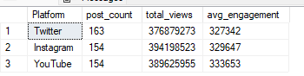

Key Insights:

Twitter is the common popular platform followed by Instagram,You Tube in India.

--10. Comparing how hashtags perform differently across regions

select Region,Hashtag,

avg(Views) as avg_views,

avg(Likes + Shares + Comments) as avg_engagement

from social_media_posts

group by Region, Hashtag

order by Region, avg_engagement desc;

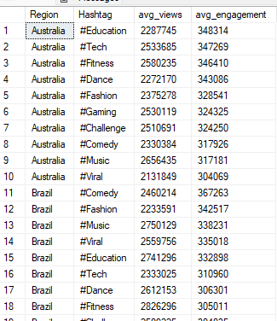

The above query fetched datas of count of each hashtags used in all the countries.

--11.Calculation of shares per view ratio (indicator of virality)

select Post_ID,

Platform,

Hashtag,

Views,

Shares,

round(Shares * 100.0 / Views, 2) as shares_per_100_views

from social_media_posts

order by shares_per_100_views DESC

offset 0 rows fetch next 10 rows only;

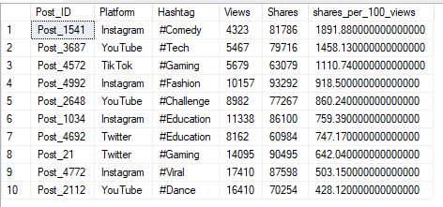

Key Insights:

The Viral contents were most shared in the Instagram with hashtags of comedy, fashion, education, viral.

--12. Identifying platform-specific engagement patterns

Select

Platform ,

sum(case when Engagement_Level = 'High' then 1 else 0 end) as 'no.of.posts'

from social_media_posts

group by Platform

order by [no.of.posts] desc;

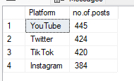

Key Insights:

You Tube attracts more users and hence had higher number of posts with highest engagement (like, share, comment) followed by Twitter, Tik Tok, Instagram.