**Tamil Nadu marginal workers assessment**

**PROBLEM DEFINITION:**

The project aims to assess and evaluate the socio-economic conditions and well-being of marginal workers in Tamil Nadu. It involves defining specific analysis objectives, collecting data related to the workers' livelihoods, living conditions, and challenges, and using data analysis tools to inform policy decisions for the improvement of their conditions.

The objectives of the assessment, such as understanding the socio-economic status, working conditions, and challenges faced by marginal workers in Tamil Nadu and to specify the intended outcomes, including data-driven insights that can inform future strategies and policies, this involves using code and statistical methods to identify trends, disparities, and challenges faced by marginal workers.

To achieve this, a structured approach is followed,

Initially, it defines the clear objectives and intended outcomes of the assessment to guide the research process effectively to improve the overall well-being and working conditions of marginal workers through informed policy decision

Next, it collects data through surveys, interviews, and secondary sources, ensuring a representative sample of marginal workers in various regions it uses surveys, interviews, and relevant secondary sources to collect data.

Design and create relevant data visualizations using appropriate tools. These visualizations should help in presenting the collected data in a comprehensible manner,utilize data visualization tools like IBM Cognos to enhance the interpretability of data.

**Step 1: Define Analysis Objectives**

The analysis objectives for the Tamil Nadu marginal workers assessment are to understand income disparities, assess access to education and healthcare, evaluate housing conditions, and study employment patterns among marginal workers. These objectives will provide a comprehensive understanding of their socio-economic conditions and challenges, informing policy recommendations for their improved well-being.

**Step 2: Data Collection**

Data collection is a critical step to gather information on the socio-economic conditions and challenges faced by these workers,

**Demographic Data:** workers' age, gender, ethnicity, and family size

**Employment Data:** types of employment, including agricultural labor, construction work, or informal sector jobs.

**Income and Financial Data:** workers' income sources, monthly earnings, and household expenses.

**Education Data:** workers' education levels and their children's access to education

**Healthcare Data:** access to healthcare services, vaccination coverage, maternal care, and common health challenges faced by marginal workers.

**Housing and Living Conditions:** housing quality, sanitation facilities, and the number of individuals living in a household.

**Challenges and Vulnerabilities:** Develop a categorical system to record specific challenges and vulnerabilities faced by marginal workers, such as exploitation, discrimination, or lack of social support.

Ensure that the dataset is well-organized, with clear variable labels and codes. Maintain data privacy and ethical standards, obtaining informed consent when necessary.

**Step 3: Data Preprocessing**

Data preprocessing for a task like "TN Marginal Workers Assessment" typically involves tasks like data cleaning, handling missing values, and preparing the data for analysis.

**a. Data Cleaning**

• Remove any duplicate entries.• Handle missing values. Depending on the software you're using, you may choose to impute missing data, discard rows with missing values, or use appropriate techniques.

**b. Data Transformation**

• Standardize or normalize numerical features (e.g., Age) if needed.

• Convert categorical variables (e.g., Gender, Country) into a suitable format for analysis.

This may include one-hot encoding, label encoding, or other techniques depending on

the analysis goals.

**c. Outlier Detection and Handling**

• Identify and handle outliers in the data. Outliers can significantly affect the analysis

results.

**d. Feature Engineering**

• Create new features if necessary. For instance, you might want to calculate the

employee's age group from their age

Here's a general outline of Python code for data preprocessing:

**1. Import necessary libraries:**

python

import pandas as pd

import numpy as np

**2. Load your dataset:**

python

# Load the dataset (replace 'data.csv' with your file path)

data = pd.read_csv('data.csv')

**3. Handle missing values (if any):**

python

# Check for missing values

missing_values = data.isnull().sum()

# Drop rows with missing values

data = data.dropna()

# Fill missing values with a specific value

data['column_name'].fillna(value, inplace=True)

**4. Data cleaning (if required):**

python

# Remove duplicates

data = data.drop_duplicates()

# Remove outliers

# You can use statistical methods or visualization to identify and remove outliers

**5. Feature engineering (if needed):**

python

# Create new features or transform existing ones

data['new_feature'] = data['feature1'] + data['feature2']

**6. Data scaling or normalization (if necessary):**

python

from sklearn.preprocessing import StandardScaler

scaler = StandardScaler()

data['scaled_feature'] = scaler.fit_transform(data[['feature']])

**7. Save the preprocessed data:**

python

# Save the preprocessed data to a new file

data.to_csv('preprocessed_data.csv', index=False)

**Before Preprocessing:**

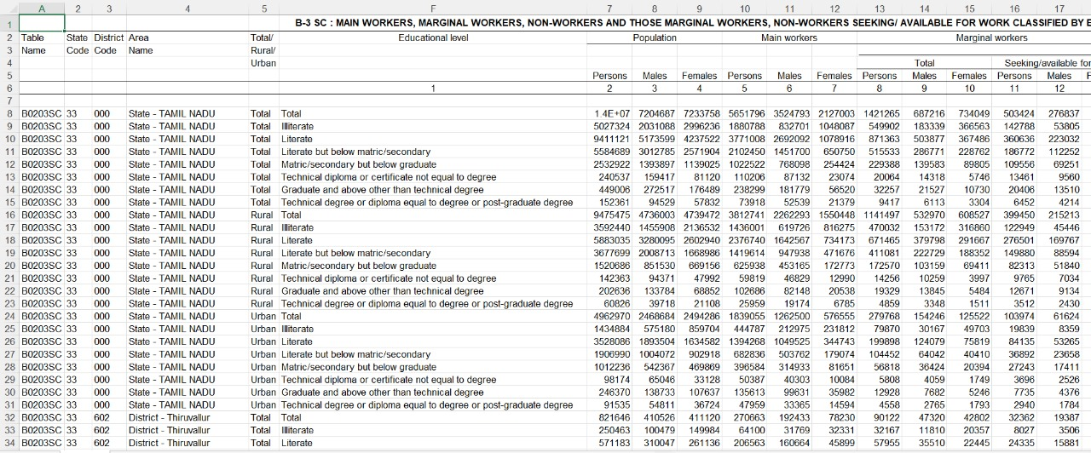

**After Preprocessing:**

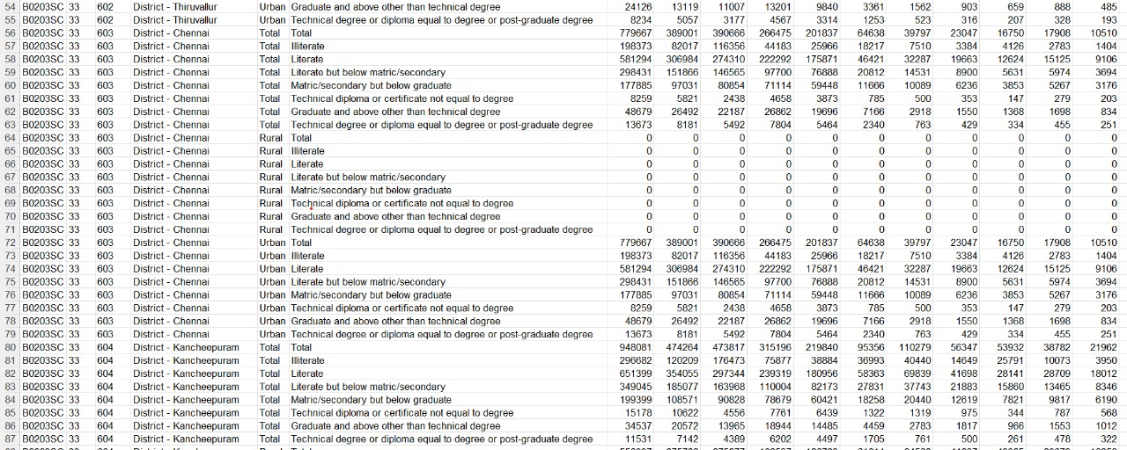

**Step 4: Data Analysis in IBM Cognos**

Data analysis for a Tamil Nadu marginal workers assessment project involves processing and interpreting the collected data to draw meaningful insights and conclusions. Here's how you can approach data analysis:

* **Data Cleaning:**

Begin by cleaning the dataset to remove any inconsistencies, missing values, or errors. This ensures the data is accurate and ready for analysis.

* **Descriptive Statistics:**

Start with descriptive statistics to summarize the main characteristics of the dataset, including mean, median, mode, standard deviation, and range for key variables.

* **Data Visualization:**

Create relevant data visualizations using tools like IBM Cognos to present key findings. Consider bar charts, histograms, box plots, and scatter plots to visually represent trends and patterns in the data.

* **Hypothesis Testing:**

Use statistical tests to examine hypotheses related to the assessment objectives. For example, conduct t-tests or chi-squared tests to determine if there are significant differences in income, education, or healthcare access among different groups of marginal workers.

**Step 5: Interpret and Communicate Results**

Interpret the results and draw meaningful insights from your analysis. Communicate your

findings in a clear and concise manner. Consider creating a report or presentation that

summarizes the key findings, trends, and recommendations for the Tamil Nadu marginal workers assessment campaign.

**Step 6: Continuous Monitoring and Improvement**

Monitor the campaign's effectiveness over time and make data-driven decisions to improve

future campaigns. Collect and analyze additional data as needed to refine your analysis and

recommendations.

This process provides a high-level overview of how to build a public health awareness

campaign analysis using IBM Cognos. Remember that the specific steps and techniques you

use may vary depending on your analysis objectives and the nature of the data.

**Conclusion:**

**T**he Tamil Nadu marginal workers assessment project reveals crucial insights into the socio-economic conditions and challenges faced by these workers. The findings underscore the need for targeted policies to address income disparities, improve access to education and healthcare, and enhance housing conditions. Regional disparities also highlight the importance of region-specific interventions. These insights serve as a foundation for informed policy recommendations aimed at improving the overall well-being and working conditions of marginal workers in Tamil Nadu.